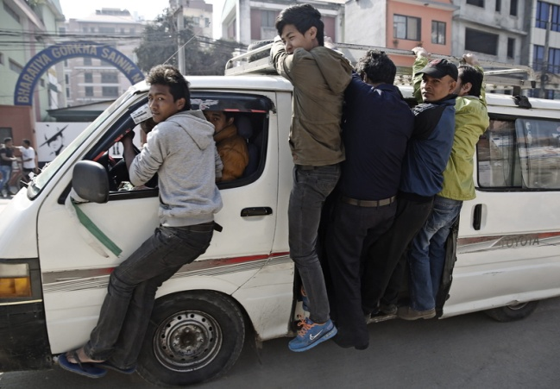

People riding an overcrowded bus due to petrol shortage

