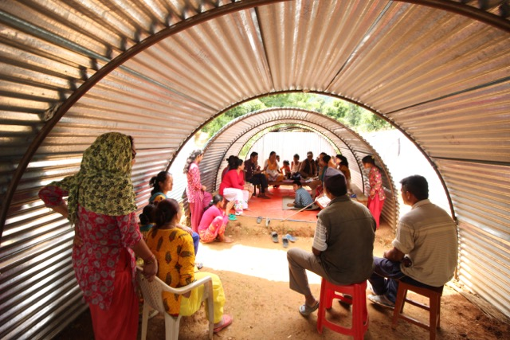

Office space built for a Grantee in Sindhupalchowk , and now they can have their meetings and meet people of the community

