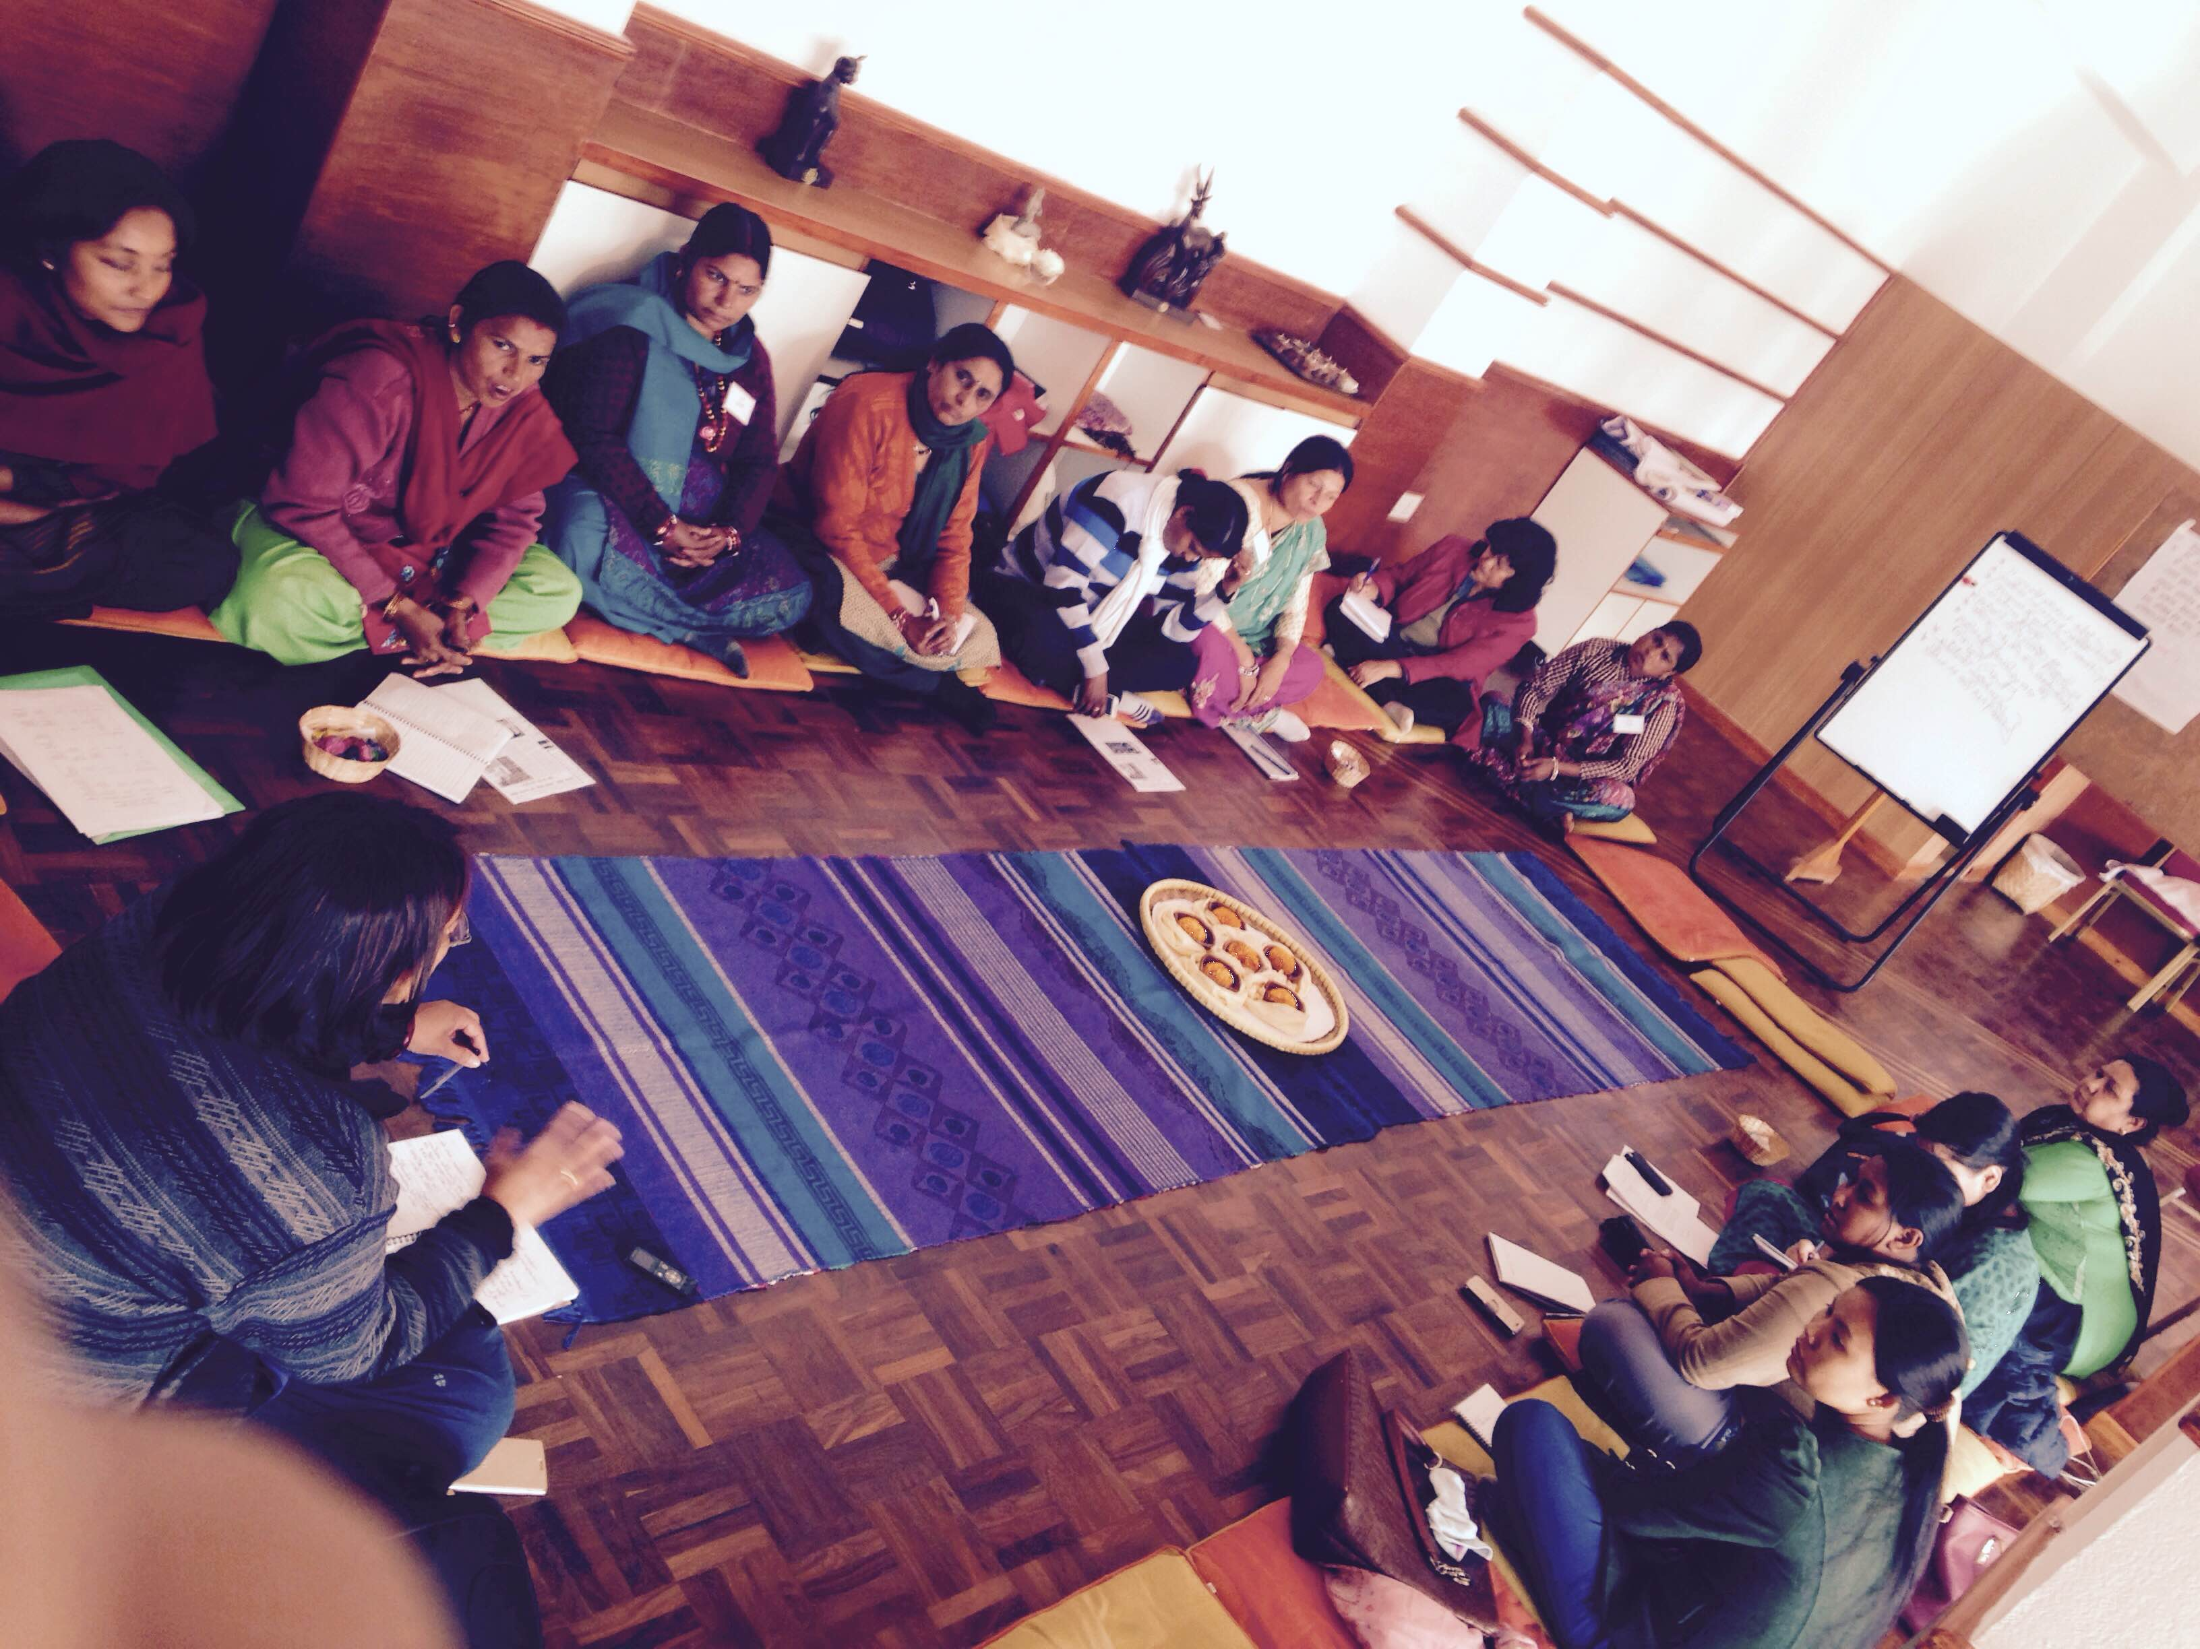

Grantee representatives from Madhes engage…

