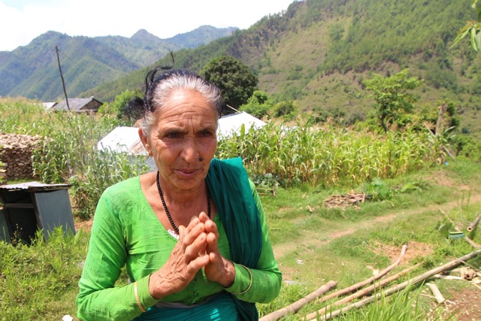

Dal Maya Bastakoti's (R – please note the corn in the background) friend and mentor, Meera Devkota (76 years), Chair of the Mother's Group of Masel VDC in Gorkha District died as her 3 storied home collapsed while she was locking her door to go out together with Dhal Maya. Dhal Maya is emotional and speechless today.

