Osh playground items and costs
D – diameter, m – meter, sq.m – square meter, p – pieces, s – som
# | Item | Equipment | No of units | Costs, materials (som) | Costs of services (som) | Total, som | Total, USD
1 | Swing double (children 3-7 yo) | 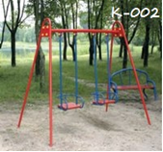 | 2 | 40d * 12m * 170s = 2,040  50d * 2m * 220s = 440  20d* 12m * 80s = 960  fittings 4m * 120s = 480  Paints = 250  Boards and sheet, bolts and nuts = 2,000  Total: 6170s * 2 = 12,340 | 6500 | 18,840 | 325
2 | swing, rocker | 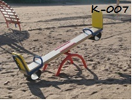 | 1 | Bar 4м = 800s  Pipe 40d, 4m * 170s = 680s  Pipe 15d, 6m * 60 = 360s  Metal elbow 5, 1m * 170 = 170s  Paints = 250s,  mount = 500s  Total: 2,760 * 2 = 5,500s | 2700 | 8,200 | 141
3 | Slide | 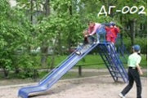 | 2 | 32d * 12m * 125s = 1,500  25d * 8m * 105s = 840  15d *24m = 1,440s  Sheet thickness 2,5 х2*2800s = 5,600s  Paints - 2 * 250 = 500s,  Pillars/ladder for installation = 2,000s  Total: 11,280 * 2 = 23,760 | 13000 | 36,760 | 634
4 | Carousel | 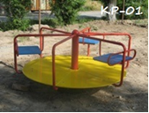 | 1 | Pillar for installation (bearrings – 1,000, channel = 1,000s, pipe 300 + pipe 300) = 2600s  Pipe 25d, 18m * 105s = 1,890 s  Pipe 15d, 12 m * 60s = 720s  Board stand, sheet = 3,000s, cross section pipe 25d, 18m * 100s = 1,800s  Concrete = 1,000s,  Total: 11,000s | 5000 | 16,000 | 276
5 | Carousel for children with disabilities | 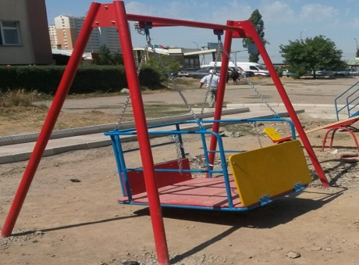 | 1 | Pipe 50, 145m*220=3300  Pipe 20, 6m*80 = 480s  Pipe 15, 10m*60=600s  Chain and mount = 2000s  Hinge 80*2 = 160s  Board = 750s  Paints = 250s  Sheet = 740s  Total: 8,280s | 4000 | 12,280 | 212
6 | Sandbox | 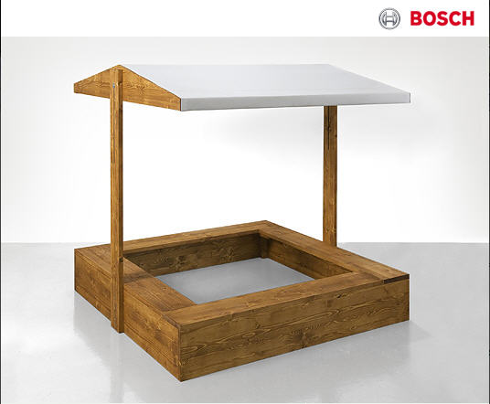 | 2 | Board 4м * 6p * 250 = 1,500s  Uzbi 750s  Rail 600s  Nail screws = 150+100 = 250s  Total: 3,100 * 2 = 6,200 | 3000 | 9,200 | 155
7 | Sandbox for children with disabilities | 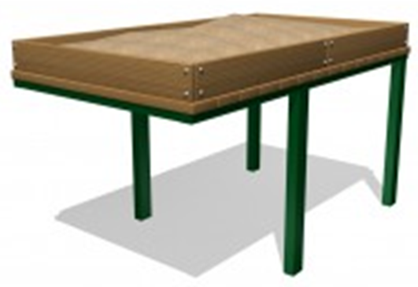 | 2 | Metal elbow 5, 3m * 170 = 510s  Board 1 * 0,50 = 1800s  Paints = 250s  Let cross-section pipe 6*4, 3m * 150s = 450s  Nail screws = 250сом  Total: 3,260 * 2p = 6,520s | 3000 | 9,520 | 164
8 | Running tracks:  1. for children for children 8 yo  2. for children over 8yo (3 meters each) | 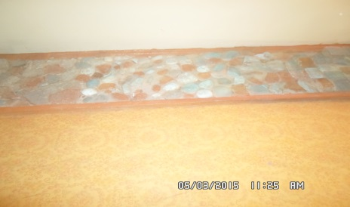 | 2 | 1,000 | 500 | 1,500 | 26
9 | horizontal bar adapted for children with disabilities | 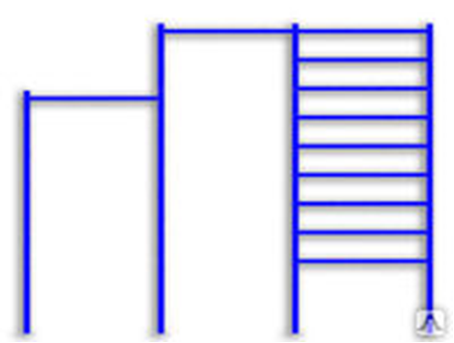 | 1 | Pipe 32, 12m * 125 = 1,500s  Pipe 20, 12m * 80 = 1,440s  Paint 250s  Mount 500s  Total: 3,690s | 1800 | 5,490 | 95
 | TOTAL |  |  |  |  | 117,790 | $2,332

Information about Kelechek-Health Prom
Registered name: | Общественный Фонд “Келечек-Хелспром”
Short name in English: | Kelechek-HealthProm ("Kelechek + HP”)
Date organisation was founded: | February 2011
Mission | Our mission is to empower our beneficiaries by equipping them with the confidence, skills, knowledge and tools to improve the quality of their lives and to help others. We focus on supporting the most vulnerable among children, youth and women. The children and youth who benefit from our work are vulnerable because their physical, emotional, cognitive and social development is held back due to disability, social exclusion and poverty. The women who receive support through our work are often heads of households with a disabled member and live below the poverty line in rural parts of the country.
Business address: | Public Foundation "Kelechek + HP"  54 Radisheva Street  Bishkek 720005, Kyrgyz Republic
Telephone number: | 00996 312 893395
Email: | kelechek.hp@gmail.com
Websites: | http://kelechekplus.kg/  http://kelechekhp.weebly.com/
Director: | Azat T. Israilov
Project leader: | Azat T. Israilov

Information about the grants Kelechek-HP has received over the last three years

Name of Project | Donor | Grant Amount | Start and end date of project
Supporting children with disabilities in Kyrgyzstan | Big Lottery Fund | 500,000 GBP | September 2013-September 2016
One School for All | Soros Foundation Kyrgyzstan | 16,000 USD | August 2014 - May 2015
Provision of Basic Education for Children with Disabilities Living in Institutional Care | Soros Foundation Kyrgyzstan | 21,049 USD | September 2013-June 2014
Accessible School Buildings and Right to Education | Democracy commission at the US Embassy in Bishkek, Kyrgyz Republic | 2,305 USD | September 2013-February 2014
Preventing Institutionalization of children, especially with disabilities, and creating conditions for their rehabilitation” | Ministry of Social Development of Kyrgyzstan | 419,870 Kyrgyz soms | August 2012-August 2013
Prepare socially active citizen to address the issues of disabled children in the Talas Region | Soros Foundation Kyrgyzstan | 9,968 USD | November 2011-April 2012

Information about the project

Name of the project | Let All Kids Play - Building Playgrounds for Disabled Children in Kyrgyzstan
Start and end dates of the project | July 2015 - September 2015
Total project budget (in USD) | $ 2,332
Regional cover of the project | Osh city

Budget for Osh playground
No | Budget item | cost per unit  in local currency  (som) | cost per unit  USD ($) | No. of units | Total  (som) | Total  USD ($)
1 | swings | 9420 | 162 | 2 | 18840 | 325
2 | swing, rocker | 8200 | 141 | 1 | 8200 | 141
3 | slides | 18380 | 317 | 2 | 36760 | 634
4 | carousel | 16000 | 276 | 1 | 16000 | 276
5 | carousel for children with cerebral palsy | 12280 | 212 | 1 | 12280 | 212
6 | sandbox | 4500 | 78 | 2 | 9000 | 155
7 | sandbox (for children with disabilities) | 4760 | 82 | 2 | 9520 | 164
8 | running tracks | 750 | 13 | 2 | 1500 | 26
9 | horizontal bar adapted for children with disabilities | 5490 | 95 | 1 | 5490 | 95
10 | transportation of the equipment | 1500 | 26 | 3 | 4500 | 78
 | Admin costs
11 | Staff (project management, accounting, reporting) | 2500 | 43 | 3 | 7500 | 129
12 | Transport | 0 | 0 | 0 | 0 | 0
13 | Communications | 500 | 9 | 3 | 1500 | 26
14 | Tax | 1000 | 17 | 3 | 3000 | 52
15 | Bank fees |  |  |  |  | 20
 | TOTAL |  |  |  |  | $2332

*The playground equipment's costs include materials and professional construction by local companies.

