PROFILE OF GIRLS’ POWER INITIATIVE (GPI)
NIGERIA
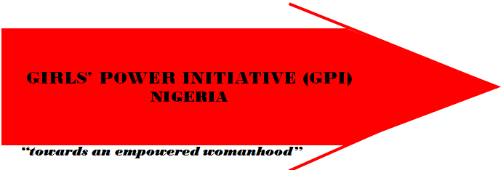

Girls’ Power Initiative (GPI) Nigeria is a Nigerian not-for-profit, non-partisan, Non
Governmental Organization founded by Bene Madunagu and Grace Osakue in1993. Her core comprehensive sexuality education programmes and other related and relevant activities however began in 1994. The organization focuses on the education on sexual and reproductive health for girls and women and enterpreneural skills building for in and out of school young girls to enable them achieve financial empowerment. GPI also focuses on leadership skills building for young girls and provision of education on issues of gender, decision making on issues of family planning/contraception use, maternal and child health as well as research and community interventions on harmful traditional and contemporary practices and violence against girls and women
.
GPI’s focus is to assist young girls to live healthy lives and achieve their full potentials, towards an empowered womanhood thus reduce the level of poverty. It also includes assisting young girls to overcome the risks of early sexual activity, unwanted or unintended pregnancy, sexually transmitted infections (STIs )including HIV/AIDS, unsafe abortions, all forms of sexual abuse and harassment as well as other forms of gender-based violence and exploitation.GPI vigorously promotes gender equality and equity and works with adolescent girls to develop their leadership and capacity to respond to, and work for social transformation towards gender and social justice

LOCATION/CENTRES:
GPI first started with two centres in Benin-City, Edo State and Calabar, Cross River state. By 2001 fiscal year GPI increased its physical locations or centres to four with the two new centres in Asaba, Delta State and Uyo, Akwa Ibom State. The National Secretariat/Headquarters of GPI is in Calabar in Cross River State.

Lega Status
GPI is registered with the Corporate Affairs Commission No. 10290, 1997) and was awarded a Special Consultative Status with the Economic and Social Council of the United Nations (ECOSOC) in 2001.
.
GPI’S VISION: A sustainable feminist institution leading transformation of patriarchal values in Nigeria
GPI’S MISSION: To empower children and young females with accurate information and skills from a gender perspective for social action
GPI Core Values
- Team work - We are committed to harnessing internal and external human resources and expertise and capacity for better outcomes of our interventions in achieving our mission

- Passion – We bring and channel our feelings, emotion and zeal to the work that we do knowing that we are dealing with issues and expecting changes on issues that affect the psyche of our target audience

- Upholding Feminist Ideology- We bring to our work, knowledge, attitude, behavior and practices that reflect and promote equality and social justice

- Equal opportunities for all – We are committed to practices and interventions that are non discriminatory and promote the social development of girls and young females regardless of residence, social and economic background.

- Integrity – We are committed to demonstrating high level of honesty, accountability, truthfulness, honour, reliability, uprightness through consistency of actions and operations. We will let our words be our bound under any circumstance
Overall Organizational Objectives
- To increase leadership and life management skills through providing a forum and safe space for girls to exchange ideas, seek solutions to their problems and receive support to develop.
- To increase the awareness of adolescents, parents, guardians, teachers, media persons and the public on the issues of sexuality, gender and human rights of girls and women.
- To reduce the social, cultural and religious practices, myths, patriarchal values and norms that violates the rights of the girl child.
- To increase the capacity of adolescent girls to overcome the challenges of growing up female in Nigeria and become catalysts for social change.
- To increase the institutional capacity of GPI as a prime resource for the promotion of Sexual and Reproductive Health and Rights (SRHR) for adolescent girls from a gender perspective in Nigeria.
- To increase policy advocacy capacity of stakeholders to advance the sexuality, Human Rights and Sexual Health of adolescent girls in Nigeria.

GPI STRATEGIES
GPI programme strategies and activities are directed at the 4 spheres of
influence on girls thus:

i. INDIVIDUAL LEVEL: To empower young girls as social change agents through enterpreneural skills building to reduce poverty, provision of information on reproductive health and human rights to reduce unplanned pregnancies, unsafe abortions, STIs, HIV/AIDS, violence against girls and women and sexual abuse.
ii. SOCIAL NETWORK LEVEL: At the level of the parents, other family members, and peers to strengthen positive relationships among girls and immediate social relations to provide the necessary support for their positive growth, development and wellbeing.
iii. COMMUNITY LEVEL: Direct and indirect interventions aimed at creating new and broader enabling environment and opportunities for girls' action towards changing discriminatory practices, beliefs and policies that put girls and women at risk and perpertuate poverty, and create awareness on health challenges faced by girls and women for necessary action
iv. INSTITUTIONAL LEVEL: This is focused on creating changes through activities and advocacy for policy changes that impact systemic practices and norms that affect girls, women and their communities.

GPI Strategies
The following strategies are used to achieve the stated objectives:
1. Education and Capacity/Skills Building
(a) Education for girls
(b) Public education through media programmes
(c) Enterpreneural Skills for economic empowerment of girls and their families
(c) Capacity building and internship programme for young women located in similar organizations in Nigeria and other parts of Africa

2. Advocacy and Policy
3. Networking, Coalition, Collaboration
4. Gender Training Institute
5. Services (counseling/referral and library services)
6. Research and Documentation and community interventions
7. Organizational Institutionalization.
8. Educational/skills building sessions with media practitioners

GPI ACTIVITIES
- Weekly lessons for girls on reproductive health issues
- Economic Skills Training
- Schools Outreach programme
- Research and Community Intervention/Social Work
- Counselling/ Hospital and other referrals/home visits
- Library services
- Disseminating of information through:
  - Media programmes
  - Production of SBC/IEC materials
- Quarterly Newsletter
- Internship programmes
- Workshops/Trainings
- Youth Talent festivals
- Gender Development Institute
- Community intervention/Social work
- Economic skills training
- Life management skills development
- Networking and collaborating with other NGOs

Most Important accomplishments of GPI
- Award by the MacArthur Foundation of $350,000 as the Most Creative and Innovative Institution on Sexuality Education for adolescent girls in Nigeria - 2012
- International award won for excellence and innovation in Sexuality Education (2007) by The World Association for Sexual Health (WAS)
- Organized a national training in collaboration with International Women’s Health Coalition (IWHC) in 2007 to increase the capacity of youths across Nigeria on economic skills and Feminist activism.
- Award from One World UK for the development of the out-of-school version of the electronic version of the Family Life and HIV/AIDS Education (eFLHE) for Nigeria – 2012
- Award by Butterfly Works and One World UK for successful Implementation of the electronic version of the Family Life and HIV/AIDS Education (eFLHE) curriculum in Cross River State - 2012
- Acquired a Permament secretariat with conference halls, skill training units, resource center, library, Administrative block in 2010
- 20 years of positive development and institutionalization
- Have a Memorandum of understanding (MOU) with Ministry of Education since 2004 on Implementation of the Sexuality Family Life and HIV/AIDS Education curriculum in secondary school in Cross River State. Have reached over 30,000 students and trained over 540 teachers
- Successfully graduated over 1200 adolescent female beneficiaries in Cross River, Edo, Akwa Ibom and Delta States centers respectively, having grown from the initial group of 15 girls in July 1994 to an organization that today reaches out to approximately 50,000 adolescent girls directly and indirectly every year, particularly in the Niger-Delta zone of Nigeria, Many adolescents and their social networks are reached through centre based lessons, school holiday programmes, radio and television programmes and regular quarterly newsletter among other strategies used to reach out to adolescents.
- Developed 8 volumes of Reproductive health education series for young people in addition to the 3 volumes of revised edition of GPI training manual to meet the age-specific needs and experiences of adolescents aged between 10 and 18 years.
- Chair, Gender Tecnhical Working Group (TWG) in Cross River State since 2009
- Selected as a member of the National Adolescent Health and Development Working Group (NAHDWG) to review the Nigerian National Adolescent Health Policy in 2006.
- Selected by Ford Foundation, East Africa, to train Ford grantees from Kenya and Tanzania in 2006 as well as supporting the period of internship of 7 of the young women
- Coordinated a national coalition on increased access to women’s health from 2010-2012

Research and Publications:
- Culture and adolescents concerns on sexuality - 1996
- Understanding and knowing your body – 1996
- Myths and Facts about contraceptives, drugs and Sexually Transmitted Diseases including HIV/AIDS – 1998
- Questions adolescents ask about their sexuality and answers – 1998
- Assertiveness Vol. 1 – 1999
- Self Identity – Vol. 2 - 1999
- Body Image – Vol. 3 – 1999
- Violence against girls – 1999 GPI Training Manual – 1999
- GPI at Five – 1999
- ABC of relationships – 1999
- Adolescents and sexual health problems – 2000
- Assessing the Impact of GPI lessons on adolescents girls - 2000
- Life Management for adolescents -2000
- Beijing + 5: Assessing the health and rights of women: General
- Issues, Adolescent Reproductive health and rights, Violence against girls and women
- Trafficking in Girls – 2002
- GPI song book – 2002
- GPI training manual Levels 1, 2 and 3 – 2003
- GPI at 10 – 2004
- Sexuality education series for young persons:
  - No. 1 - Decision Making: Postponing sexual activities
  - No. 2 What you need to know about Sexually Transmitted Infections including HIV/AIDS
  - No. 3 – My body my responsibility: Growing up healthy
  - No. 4 –Interpersonal relationships
  - No. 5 – Questions Adolescents Ask
  - No. 6 - Foundations of Human Sexuality Education
  - No. 7 – Young People and the Mediaa
  - No. 8 – Adolescents Digest

COORDINATION
GPI co-ordinates and houses Cross River State Coalition AgainstTrafficking in Persons (CATIP)
Akwa Ibom state Coalition Against trafficking in Persons (AKS CATIP)
Network to Curb Sexual Abuse (NETCUSA)

GPI NETWORKS WITH:
  - Civil Society Network on HIV/AIDS in Nigeria (CISNHAN)
  - Campaign Against Unwanted Pregnancy (CAUP)
  - National Coalition Against Traffic in Persons
  - Women in Law and Development (WILDAF)
  - Budgeting and Transparency Accountability Network
  - Community Partnership Group on Girls and women Empowerment
  - National Coalition for Youth Friendly Health Services in Nigeria
  - FEMNET – The African women’s Development and communication Network
  - AMANITARE – National Colaition on Increased Acess to Health Services for women and girls in Nigeria
  - Gender Rights Initiative (GRI)
  - Nigerian Partnership for Safe Motherhood
  - Cross River State Gender Technical Working Group
  - National Adolescents Health and Development Working Group

STRENGTHS:
- A team of trained, committed and effective leadership, management and staff
- Unique participatory information, education and communication on sexuality, sexual and reproductive health and rights issues from a gender perspective

GPI CONTACT ADDRESSES
- Akwa Ibom State Centre
101 Aka Road, Uyo, Akwa Ibom State
Email: gpiuyo@gpinigeria.org

- Benin Center
No. 67 New Express Road Off Amadasun Street, Off Upper Ekewan Road,
Ugbighoko Benin City
Tel: (234) 52 – 255162
Email: gpibenin@gpinigeria.org
gpibn@alpha.linkserve.com

- Asaba Centre
No. 16 Ezenei Aveneue, Asaba, Delta State.
Tel: 234 – 8023345741
Email: gpiasaba@gpinigeria.org

- National Headquarters/Calabar centre
Anyamurua Residential Estate
UNICAL Post Office, Calabar Nigeria
Tel: (234) 87 – 230929, 08033578595
Fax: (234) 87 – 236298
Email: gpicalabar@gpinigeria.org
gpi_hqcal@yahoo.co.uk
Website: http://www.gpinigeria.org

FUNDING SUPPORT FROM:
- Ford Foundation
- MacArthur Foundation
- Empower
- Amanitare

GPI Activities in Pictures
Community Social Action by GPI girls and staff
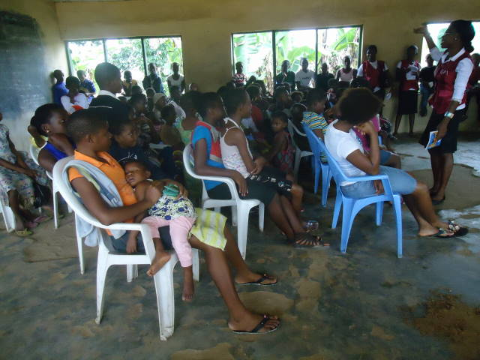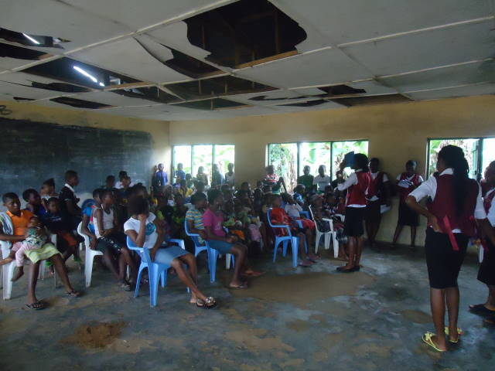

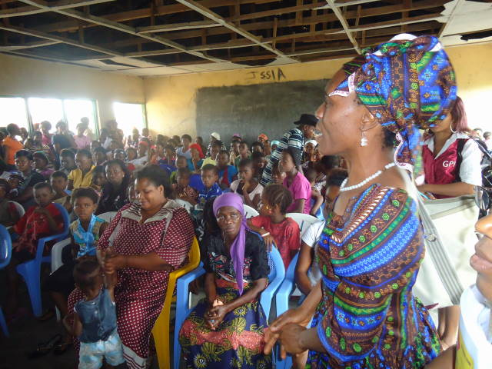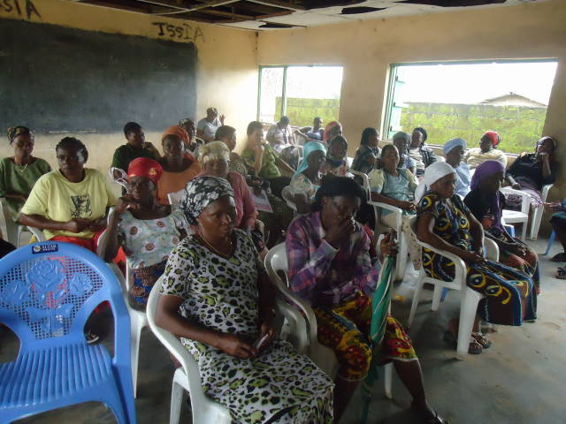

Capacity Buidling for different stakeholders on Reproductive Health and Family Life and HIV Education
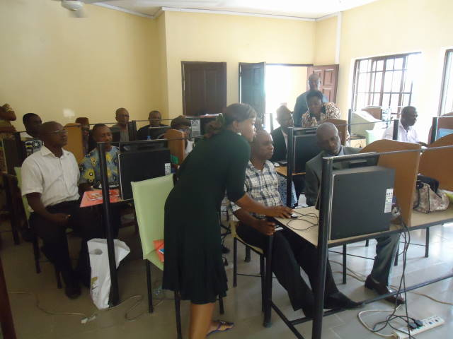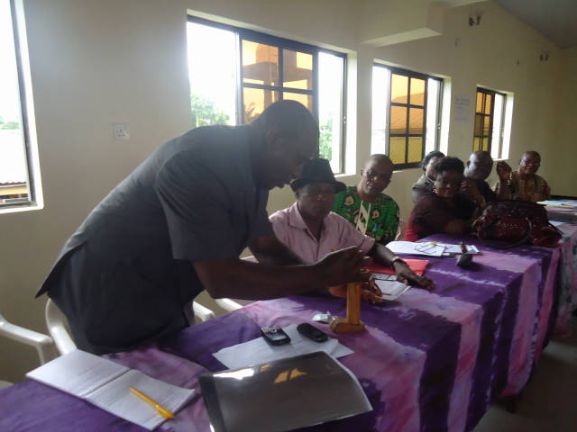
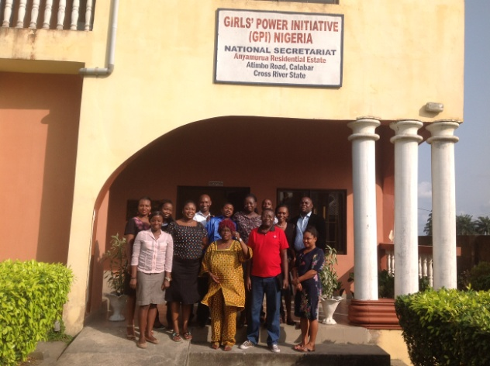 Some GPI Staff at the GPI headquaters

GPI girls during lesssons at Center and graduation ceremony
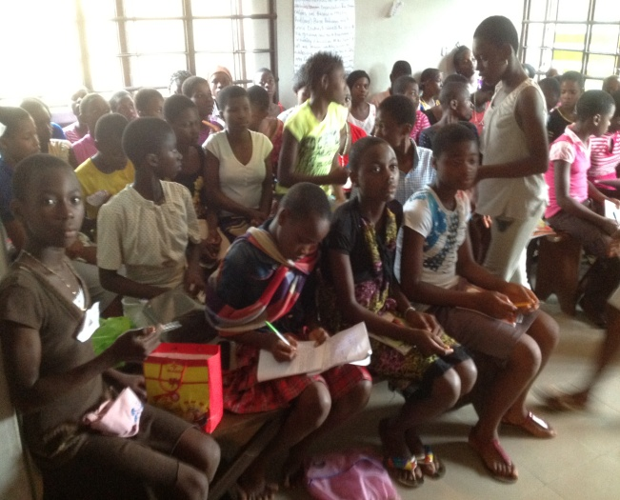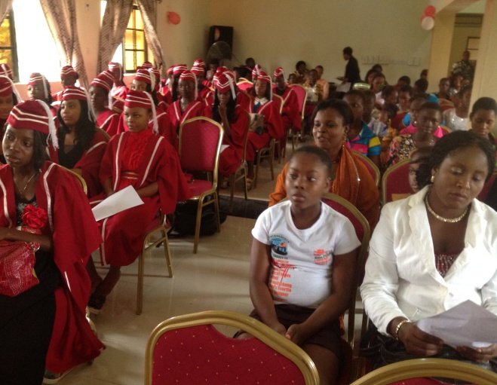
Training Girls on different Economic skills
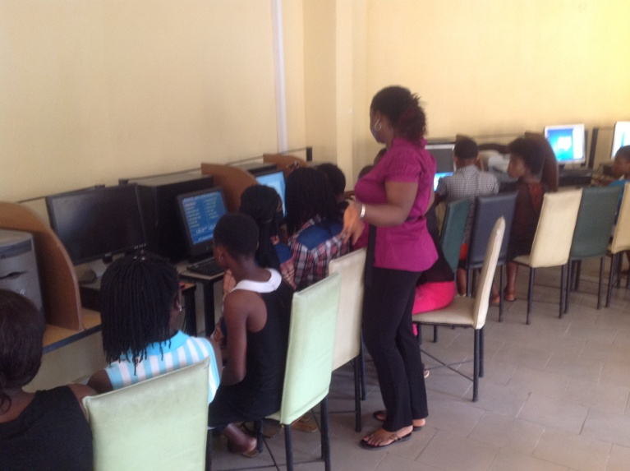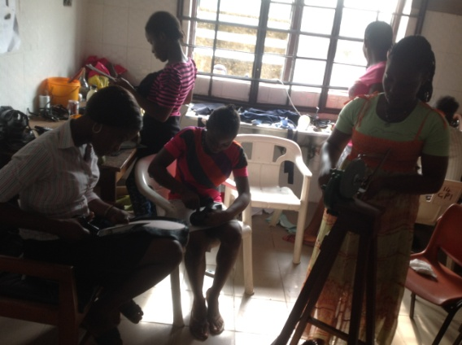
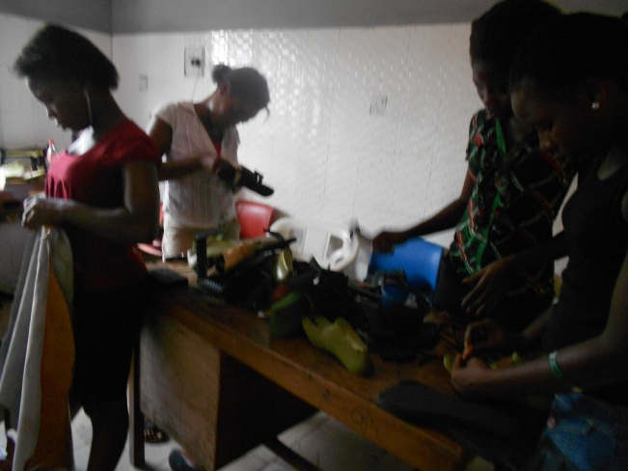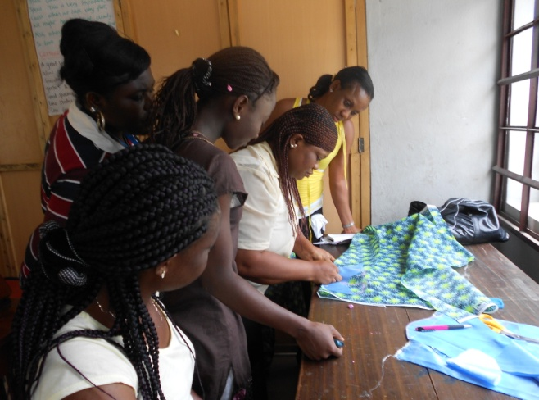

Research in Communities - FGDs with different groups
