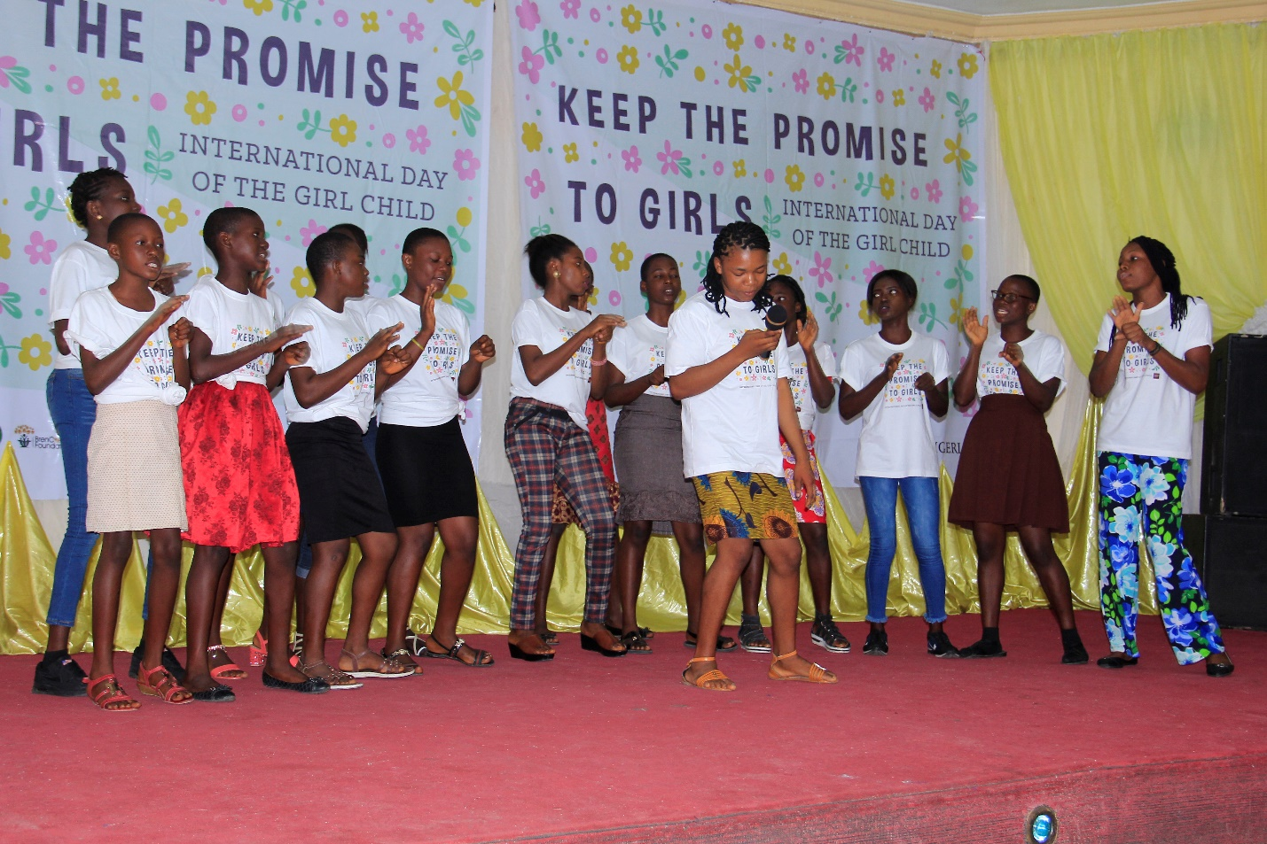
GPI girls doing a presentation to celebrate 2018 International day of the girl child

