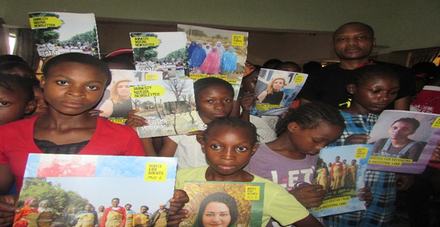
GPI Girls celebrate Human Rights Day!

GPI girls showing solidarity during human rights day.

