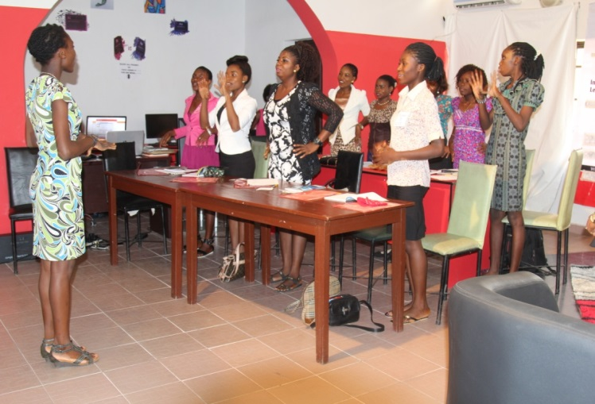
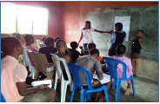
Members of GPI Alumni Association training
A GAA member facilitating weekly safe space lessons for girls at Ifondo community

