Supporting the Reintegration of Former Combatants in Colombia

through the Inclusion of Women and Faith Actors

Key Partners & Sponsors

Current Financial Sponsors

- The Harry R. Halloran Jr. Fund (donor advised fund at TPF Special Assets Fund)
- Dr. Scholl Foundation
- The Journalists’ and Writers’ Foundation (Istanbul, Turkey)

Sample of Active Partners

Colombian Agency for Reintegration (ACR)
Reconciliación Colombia
Women’s Ecumenical Peacebuilding Collective (GemPaz)
PactoColombia
Cofraternidad Carcelaria
Alcaldía de Medellín
Vivamos Juntos
National Organization of Colombian Indigenous (ONIC) and regional partners (OIA/CRIC)
International Center for Transitional Justice
Process of Afro-Colombians (PCN)
University of the Andes (and others)
SembrandoPaz
JustaPaz/CEDECOL
PosConflicto

ICRD Mission - To Prevent and Resolve Ethnic, Tribal and Other Identity-Based Conflicts that Exceed the Grasp of Traditional Diplomacy by Including Religious Considerations as Part of the Solution.

Program Objectives: Assist with the stable and enduring reintegration of former combatants into conflict-affected communities by engaging Colombia’s diverse religious and women’s leadership in order to: 1) Conduct reconciliation processes that identify shared values to begin healing historic wounds and overcoming seemingly intractable social and political identity divisions; 2) Increase the conditions of stability necessary for the introduction of economic and vocational programs that will be critical to successful reintegration, and; 3) Bridge the gap between civil society and the government to ensure the sustainability of reintegration in areas with the greatest risk for continued violence and illicit economies.

Overview
The International Center for Religion & Diplomacy (ICRD), in collaboration with Colombian partners including women’s groups, faith actors, and government agencies, has launched a two-year pilot program designed to fill a critical gap in the Colombian government’s effort to reintegrate demobilized combatants. Colombian religious and women’s groups, uniquely influential and with broad social and geographical reach, will be the primary implementing partners, using cultural and spiritual values to:
- Promote practical reconciliation between ex-combatants and receiving communities;
- Build networks of support for transitioning former combatants and provide links for increased vocational and educational opportunities for them and their communities;
- Create a values-based, replicable methodology for confronting issues of violence and instability that might arise in the broader Colombian context, and;
- Provide an additional and innovative framework for use by the Government of Colombia in its reintegration planning and implementation.

Program Description
The Problem - The ongoing peace talks between the FARC and the government of Colombia (GOC) may yet bring an end to decades of violent conflict between them, which has been the source of extreme collateral damage in Colombian society. However, the GOC must find a way to deal with its historical failure to reintegrate former combatants into civil society in any stable and enduring fashion. The greatest risk is that many will end up contributing to a different threat, what the GOC calls “new emerging criminal bands” (BACRIM), which are disproportionately comprised of “demobilized” former fighters and deeply involved in the pervasive Colombian narco-networks. Most analysts agree with Colombia’s former Representative of the U.N. High Commissioner for Human Rights, who confirms that:
“The groups that have emerged after the demobilization of paramilitary organizations constitute the greatest threat to the rule of law and the protection of human rights.”
The extreme nature of the violence in Colombia makes the reconstitution of society extremely difficult. Colombia is also Latin America’s largest producer of drugs, which in large part finances all of the armed actors. Former combatants have the training and experience that greatly facilitate participation in illegal activities, and even those who actively seek a legitimate way out of the armed groups find that they are broadly stigmatized – rejected by both conflict-scarred communities and a distrustful business community. This exclusion has been widely cited as a primary reason for failed reintegration efforts.
“If by reintegration, you mean returning to what we had before we took up arms – well we simply wouldn’t do that.” – J. Patton interview with a jailed former guerrilla leader.

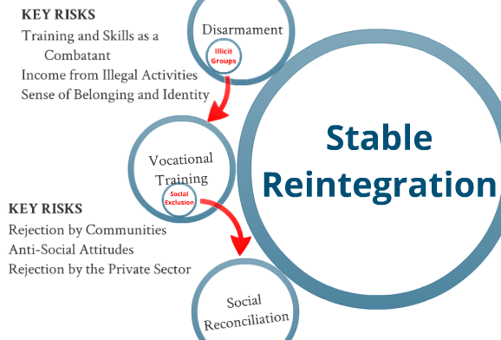
Current Responses – Around 40,000 ex-combatants have participated in the government reintegration program in the last decade. According to GOC figures, by the time that the majority should have graduated in early 2012, only 818 were “successfully reintegrated.” Approximately 27,000 remained reliant on GOC services. The rest were unaccounted for. Using public metrics, demobilized combatants at that time were three times more likely to be murdered than complete the program, six times more likely to be convicted of a crime, and almost 19 times more likely to simply abandon the GOC reintegration program. The capabilities and methodology of the program has improved notably in the last few years, but certain key weaknesses persist.
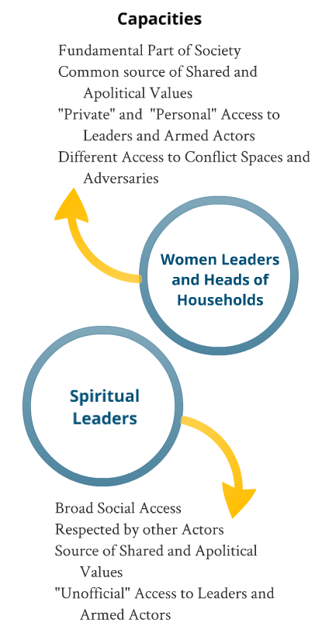
The GOC’s Agency for Reintegration (ACR) program was originally designed to draw individuals away from the fighting ranks. Social reconciliation between combatants and communities has not been a central aspect of the program. ACR leadership acknowledges unacceptably high attrition rates, particularly in the psycho-social program that deals with personal trauma. Social stigmatization, the scarcity of rural training centers, and the lure of profitable narco-networks have all historically contributed to faltering participation. Recidivism of those who successfully complete the program has been tied directly to social and private sector stigmatization. ACR is taking these needs very seriously, but currently employs a social restitution plan that depends on good will, rather than reconciliation, to facilitate acceptance of former combatants. ICRD has become one of ACR’s primary strategic partners in exploring and implementing a more comprehensive and intentional response to the need for social reconciliation: including drawing together what relevant methodologies and partners already exist in Colombia for processes of truth-telling, forgiveness and restitution, and reconstructing mutually beneficial relationships. ICRD was recently brought into the consulting body for a national-level, private-public partnership initiative to convene regional and national dialogues about reconciliation.
ICRD’s Value-Added - Both the government and the private sector lack an effective bridge to the diversity of communities that will either receive or reject former combatants. ICRD’s counterparts provide the perfect locus for engagement. The roles of women, religious institutions, and religious clergy and laypeople extend across the deep divisions that the violence has produced in the fabric of Colombian society. The family is a core social institution in Colombia, often seen as a source of inviolable loyalties and values, with women at its center. In many cases, women represent entire communities as heads-of-households, where the men have either been killed or joined the combatants. Importantly, a significant proportion of women form the ranks of the guerrillas, and demobilized female combatants have different needs than their male counterparts.
By the same token, the physical and spiritual reach of religious leaders into both the ranks of state institutions and local communities positions them perfectly to support and inform the delicate processes of social reintegration – able to work with all sides of the conflict equation as a neutral party. Empathy, forgiveness through restitution, and healing reconciliation – which will provide the basis for restored relationships in Colombia – are values that are deeply associated with religion and family. Religious actors have played a key role in every major peace initiative with leftist guerrillas and in the collective demobilization of the AUC in Colombia, but they often fall too easily into easy political characterizations of the conflict and its history, and they have not been systematically engaged as a collaborative national network, which can articulate and apply shared social values to advance reconciliation, broadly networked across distinct faith traditions.

Activities - This is a pioneering effort in capitalizing on the synergy between women’s networks and religious networks in advancing inter-faith collaboration in the social reconciliation required to successfully reintegrate those who lay down their arms, incorporating all of Colombia’s faith traditions, including native indigenous practices, and integrating them with Government efforts.
“We need to understand that those who gather at a table to develop ideas for peace are doing God’s work, even if they don’t come with a Bible under their arms.” – an Evangelical leader reflecting on working with Indigenous and other non-Christian spiritual leaders.

Throughout the first implementation phase of the program, spanning the period between March 2014 and March 2015, ICRD has conducted dozens of consultations and workshops with spiritual and women leaders, with civil society leaders in local communities, with government programming officers and with former combatants. These workshops have laid the groundwork for subsequent training of select local partners on the practical methodologies for conducting reconciliation between former combatants and conflict-impacted communities. While initially focused on three regions, the pilot process is will cover six regions having distinct demographic makeups and risk factors, as well as being identified by ACR as areas where significant numbers of former combatants will potentially reintegrate. Additionally, the pilots are intended to develop a broad region-to-region support network to give methodological input for wide application in distinct contexts, while simultaneously expanding the government’s toolkit for effective reintegration programming.

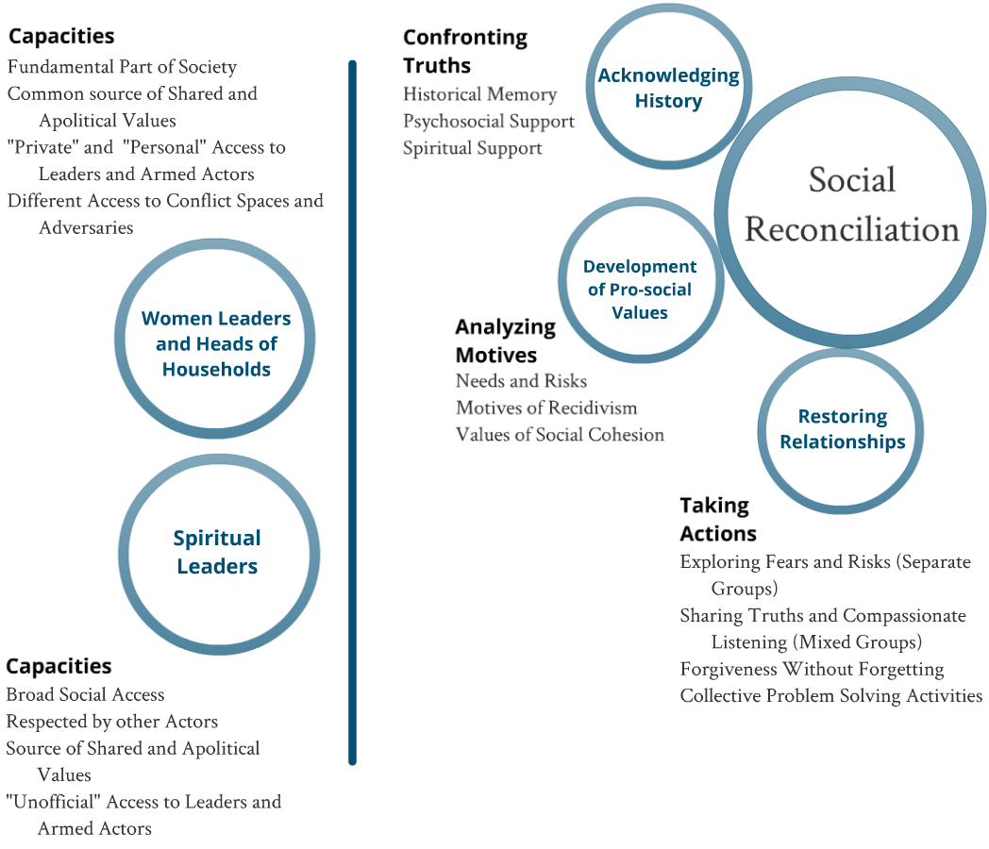
Progress To Date
Methods for Promoting Social Reconciliation

In partnership with the GOC, Colombian non-governmental organizations and academic institutions, ICRD has engaged spiritual and women leaders in the three initial pilot regions to advance a three-step process: 1) assess needs and risks related to conflict and reintegration in their particular context; 2) train facilitators in the skills necessary to engage individuals and groups of perceived adversaries in the delicate process of reconciliation; and 3) work toward bringing these groups together to ultimately define the restitution and collaboration that will lead to restored communities.

In addition to the capacitation of local reconcilers, ICRD has two macro objectives: 1) an inter-faith discussion on shared values and collaborative action for social reconciliation, and; 2) the formulation of a Colombian reconciliation framework that evokes those shared social values, but is expressed in a non-doctrinal language. This will allow the broadest range of civil society to access the concepts, while those spiritual leaders involved may adjust their articulation to express the doctrinal language that will mobilize their own communities of worship.

Advances Toward Strategic Objectives

Preliminary (strategic development and base-line development):
- Dozens of small-group meetings with national-level business, government, and NGO leaders;
- Consultation with a group of twenty former Latin American presidents (the former president of Colombia who is part of the group requested cooperation between ICRD and his organization, which is currently working with victims of violence);
- Broad consultation in three pilot areas, guided by organizations with which ICRD had existing relationships;
- Contracting of a highly-placed assessor of the peace process and the application of the justice guidelines relating to demobilized individuals, to conduct a general base-line of actors, capacities and collaboration in the three initial pilot regions.
“We are victims of violence, and that makes it difficult. But if we religious women cannot find a way to reconcile with our enemies, to make peace – who will offer that example? The pain will never cease!” – a Catholic member of the Women’s Ecumenical Peacebuilding Collective.

I. National-level Steering Committee on Reconciliation, Faith and Pluralism:
- The Colombian Agency for Reintegration (ACR) has formally accompanied the work of ICRD since February 2014, and joint programming is being developed in all three pilot areas;
- ICRD conducted eight seminars hosted by Universities - including the Advanced Military Academy and the keynote address at Central University and Tadeo Lozano University on the occasion of the 30th Anniversary of the Day of Journalism;
- The above seminars on the importance of social exclusion as a factor in recidivism, and the need for community reconciliation, reached approximately 100 academic leaders, 80 military commanders, dozens of key journalists, and roughly 1500 students and members of civil society;
- At the recommendation of the highest leadership, ACR is actively exploring funding (with INGOs and the Colombian President’s Office of International Cooperation [APC]) to facilitate the specific reconciliation partnership with ICRD;
- In early 2015, ICRD was formally invited to join the Technical Committee of Reconciliación Colombia – a major Public-Private collaboration which convenes national dialogues to discuss and strategically plan around issues of reconciliation;
- In particular, ICRD sits on the Steering Committee for the project “Cree en Reconciliación,” engaging religious communities in dialogue about the spiritual motives and social role of religion in advancing reconciliation processes;
- ICRD is the sole international representative invited as a panelist for Reconciliación Colombia’s first national-level conference with hundreds of civil society and private sector attendees.
“It is important for us to convene a dialogue at the national level about how our spirituality can be extended beyond healing sick individuals, and help create harmony in a sick society.”
– an Indigenous Shaman (spiritual leader) reflecting on their role in reconciliation.

II. Regional-level Steering Committees on Reconciliation, Faith and Pluralism in the three pilot areas:

General
- Day-long planning workshops with: Catholic and Protestant women who lead religious peacemaking organizations; Indigenous leadership; former combatant groups; evangelical leaders; implementing organizations working on transitional justice, reintegration, and reconciliation; political and business leaders;
- Six workshops on conflict analysis, reintegration risks, and spiritual sources for reconciliation with approximately 80 regional evangelical leaders;
- Co-sponsorship of a national conference of women ecumenical leaders, together with US Institute of Peace, convening 60 women peacemakers from eight distinct conflict-impacted regions of the country (who in turn represent 300 women peacemakers);
- Two multi-day Training of Trainers with the Ecumenical Women’s Peacebuilding Collective (GemPaz): one on conflict analysis and assessment of reintegration risks and challenges, held in Bogota; and one on restorative justice and reconciliation practice, held in Palmira, Valle del Cauca (60 women leaders were trained, a replica methodology was employed with over 250 additional members of the Collective in eight regions of the country. Six counterpart organizations participated in the trainings).

Greater municipal region of Medellin (and Department of Antioquia);
- Two workshops on conflict analysis and reintegration risks with indigenous spiritual and political leaders (reaching 35 regional indigenous leaders);
- One workshop with 14 male and female indigenous shamans from 5 regional groups on the role of the indigenous spiritual cosmo-vision (particularly healing and harmony) in reconciliation;
- Multiple seminars and workshops with local Catholic and Protestant leaders, resulting in concrete action plans for two communities to address: 1) social rejection and 2) private sector rejection as factors for failed reintegration;
- Two workshops with jailed former combatants: one on reintegration risks and the need for reconciliation; one (co-sponsored with the Cofraternidad Carcelaria) on responsibility, restitution and reconciliation;
- Including the above, ICRD has currently incorporated the inputs of over three dozen former combatants (nation-wide);
- Formal integration of ACR “promotores” – former combatants now working to help the GOC demobilize and reintegrate others – in ICRD’s planning workshops and collaboration on engagement with the former combatant community to advance the aforementioned work.

Montes de Maria (Departments of Sucre and Bolivar):
- In Feb 2015, ICRD formally launched its partnership in Montes de Maria with Ricardo Esquivia, Director of SembrandoPaz, former head of JustaPaz and CEDECOL, and an internationally recognized Mennonite peacemaker (see: Tanenbaum Peacemakers in Action Award);
- ICRD is building on Ricardo’s nearly two decades of experience conducting reconciliation in Montes, by openly incorporating a pluralist spiritual aspect to the framework for the first time;
- The first ICRD co-financed workshop with religious reconcilers and communities (facilitated by SembrandoPaz and an ICRD volunteer) took place in mid-May 2015.

Department of Cauca;
- ICRD launched the regional pilot program in north Cauca in May 2014, conducting multiple conversations with geographically dispersed faith communities and leaders, municipal leaders, and agricultural communities in the area of illicit crop cultivation;
- Three workshops leading to a locally-driven “Pact for the Construction of a Laboratory for Post-conflict” in the highly conflict-impacted towns of Corinto and Silvia;
- The subsequent formation of Working Groups to address local challenges relating to stability, reintegration, and reconciliation. 20 Municipal leaders, 15 religious leaders, 8 indigenous leaders, and 25 additional core Working Group members took part (notably including leaders of Victims’ Groups) and the work was presented to over 300 civil society members in nearby communities;
- Formal engagement with the Regional Committee of Indigenous in Cauca (CRIC), representing a majority of the large and disproportionately conflict-impacted indigenous population in Cauca;
- Active planning with the Director of the regional ACR office on collaborative programming, including facilitating the integration of ICRD into the Regional Peace Table (a Department-wide, government-sponsored working group on related themes).

Plan for the Coming Year
As the program has gained momentum, the hiring of part-time staff in Colombia was made possible. Two professionals were engaged by virtue of their experience and their interest in the focus of the program. An additional scholar with field analytical experience, conflict mapping expertise, and professional credentials that include working for the Colombian government to interview conflict detainees, compile portions of the official “historical memory” reporting, and evaluate the Havana process between the GOC and the FARC has volunteered to conduct monitoring and evaluation activities, in order to ensure program impact. ICRD plans to conduct, at a minimum, the following program activities in FY2015-16:
- Two national Steering Committee events;
- Two workshops each with three distinct groups of former combatants, in or out of the justice system, one from each pilot region (six workshops);
- One partner co-facilitated community outreach workshop in two communities in three regions each (six workshops);
- Support for formal partner-facilitated Working Group processes on conflict mitigation in at least two pilot communities (northern Cauca and a neighborhood in Medellin);
- Support for a partner-facilitated Pluralist Working Group in Montes de Maria, where our key partner has over 15 years of reconciliation experience and wishes to add the spiritual aspect to the methodology – this will likely take the form of 3-4 workshops, plus support for local outreach and development of a community engagement center;
- Two multi-day formal Reconciliation and Reintegration training workshops in two communities in three regions each (twelve workshops - involving an estimated 100 former combatants, 120 community and religious leaders, and 1000 community members);
- Continued expansion of engagement with religious and spiritual leaders and the development of a replicable model for reconciliation based on shared values for social cohesion;
- One panel series with Colombian representatives to be held in Washington, DC to inform policy-makers with respect to the challenges of the post-Havana Peace Process, with a particular focus on reintegration and reconciliation.

ICRD will provide a broader conflict analysis and complete intervention strategy upon request.
Fuerzas Armadas Revolucionarias de Colombia – the largest guerrilla force in the country.
(Dec 2011) Fox News. Colombia’s Former Combatants Turn to Crime as Jobs are Tough to Find. Available online at: http://latino.foxnews.com/latino/news/2011/12/31/colombias-former-combatants-turn-to-crime-as-jobs-are-tough-to-find/
Over 55,000 combatants have been demobilized since 2003, either collectively as part of the agreement with the AUC (auto-defense paramilitary groups), or individually from the FARC and the ELN (the second largest guerrilla force).
Some estimate that between 35% and 40% of the FARC are female combatants.
Including Indigenous and Afro-traditionalist communities.

