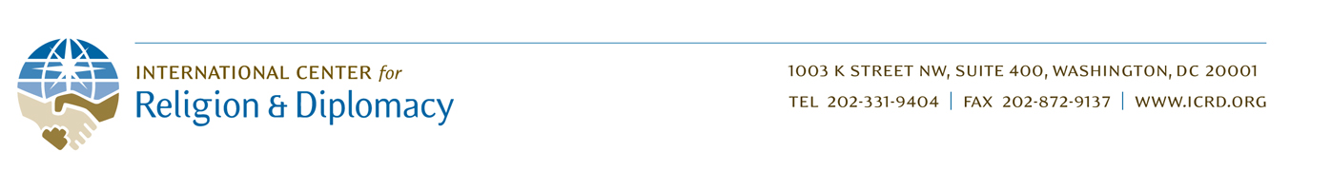

Dear Supporters of Peace and Reconciliation in Colombia,

First: My sincere gratitude to all of you for your generosity. While we still have a way to go to meeting our fundraising goal, the support you have given is already having an impact. Your contribution is enabling me to travel to Colombia this week to conduct a training workshop of 6-8 diverse women faith-leaders from different regions of the country who are undertaking the difficult, dangerous, but critical work of reconciling former combatants with conflict affected communities.

The overarching strategic objective of this workshop is to articulate a concept of reconciliation that has accessibility to all of the Colombian people, but at the same time a spiritual foundation that could serve to mobilize religious communities - articulated in "non-religious" language so that it is not exclusive.

Other objectives for this workshop include the following:
- Distill an integrated concept of reconciliation that includes recognition, responsibility, forgiveness, restitution/reparations, and building new relationships;
- Identify best practices in reconciliation work and accompanying risk-factors; and,
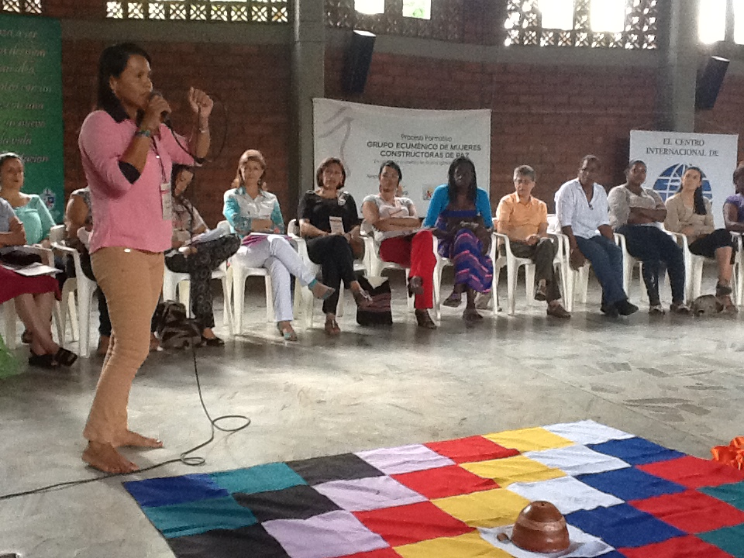
- Identify the spiritual content in each of the above.

The outcome of this workshop is twofold: 1) participants will have deepened there knowledge of their own and others’ reconciliation practices; and 2) participants will have jointly created a rough “guide” for implementing reconciliation practices in their respective communities, while advancing dialogue across regions.
“As victims of violence, it is difficult – but if we [religious women] cannot reconcile with our enemies, who will offer that example? [Violence] will never end.”
–Member, GemPaz

I want to thank you again, and express to you the importance of reconciliation in Colombia.

With Deep Gratitude and Warmest Regards,

James Patton
– Executive Vice President, ICRD

