Learning Step by Step

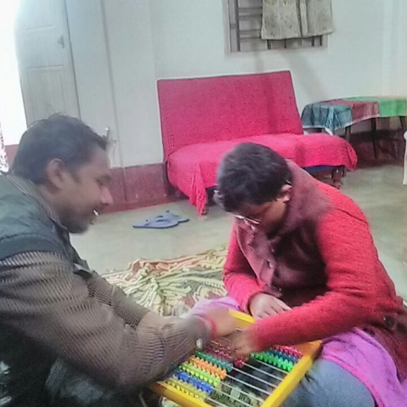
14 years old Tanisha (name changed) lives in Agartala, Tripura with his parents. Her father is a teacher in a govt. school and is the sole earning family member. Tanisha has Aphakia (absence of the lens of the eye) with partial hearing impairment along with intellectual disabilities and attention deficit hyperactivity disorder (ADHD). Tanisha’s father felt helpless that he is not able to help his daughter in understanding concept and teach.

At present Tanisha has poor concentration. Though she has a good memory but needs to work on semantic skill i.e. understanding meaning in different types of words, phrases, narratives, signs and symbols. She can count till 20 but fumbles a lot. Also because of poor vocabulary, she is not able to communicate much and at times keep repeating words. Though she follows instructions but needs a verbal prompt to do activities. Her parents’ dream of seeing her independent in activities of daily living and that she can concentrate better.

After enrolment under the project special educators has been working on engaging Tanisha different activities to improve her concentration as well as introduce her to the new concept like counting till 30 and additions using the abacus. Over the next three months, rehabilitation professional will work with Tanisha and help her make her independent in other activities of daily living like dressing herself etc. Step by step Tanisha is learning and moving forward in her life.

