From Home to School
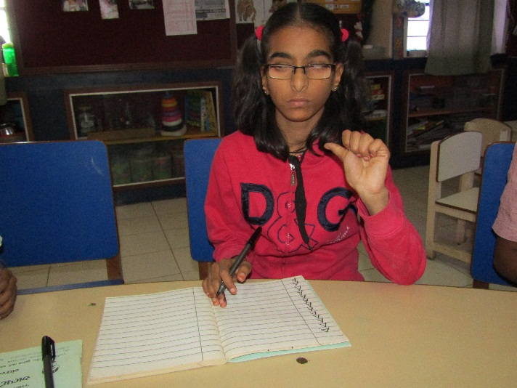
Away from her family for a better future, 14 years old Prachi (Name Changed) resides at Lioness Karnavati hostel for girls with disabilities, Vastrapur, Ahmedabad. Prachi was born deafblind (Low vision with moderate to profound hearing impairment).
Challenges of co-parenting can increase the amount of stress on marriage especially when there is a child with a disability at home. Family dynamics are further affected if one of the parents are addicted to alcohol or other drugs. There have been several cases wherein due to alcoholism, the addicted partner is not able to play their role and resort to aggression and physical abuse when drunk. This is what happened to Prachi’s parents. 6 over ago her parents separated because of Prachi’s father’s increasing alcohol addiction.
Been a single mother with no permanent source of income, it became difficult for Prachi’s mother to take proper care of her and provide for her needs. It was while visiting a civil hospital, one sensitized medical practitioner referred the concerned mother to Sense India’s partner organisation in Ahmedabad which runs a centre for children and young adults with deafblindness. Prachi was enrolled at the centre and started receiving the necessary services.
Before joining the programme though Prachi was independent in her daily living activities, she remained confined within the home and excluded from other children in the neighbourhood. Due to her deafblindness, she was not enrolled in any school and her mother was apprehensive to enrol her. Her only friends were papers and crayons colour.
Over the years Prachi has learnt to stay in a hostel and adjust with other girls. She now socializes with fellow hoteliers. On the academic front, Prachi has learnt to count, is able to identify colours, shapes, animals and vegetables. At the centre, she is getting regular training in sign language. Seeing her progress she has been enrolled in an inclusive school, where she is following the 4th-grade curriculum and has started to read and write. Her mother was given guidance in applying for Prachi’s disability certificate, school health card, bus pass and Aadhar card.
From living in isolation to a girl who now loves to explore the garden, visit restaurants and play games with her classmates Prachi’s mother is overwhelmed with her progress. She adds, “Prachi’s journey from her home to school is commendable. It is nothing short of a miracle for me that my daughter is learning.”

