A JOURNEY OF STRENGTH

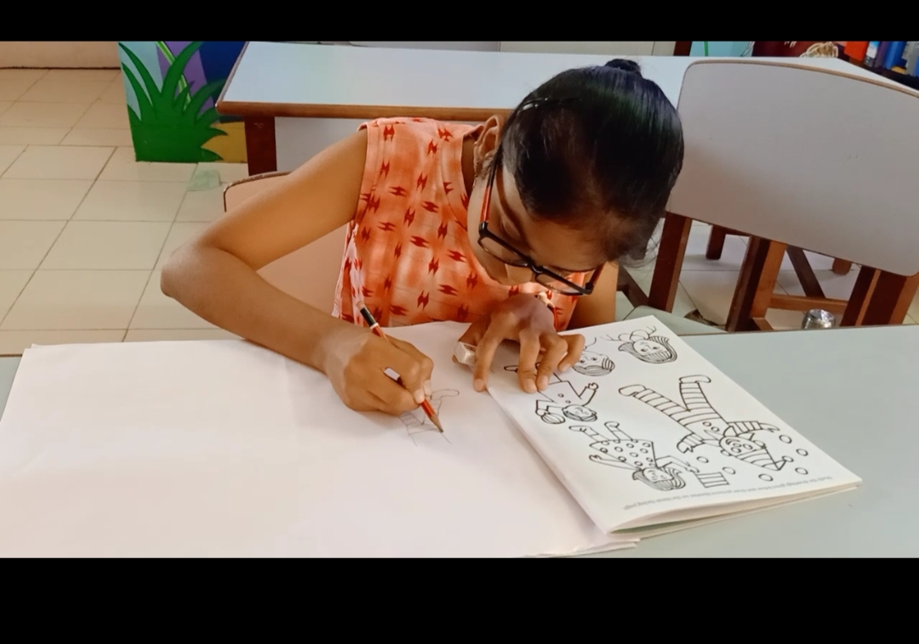

Maheshwari is a 14 years old girl from a small village, Boriya near Ahmedabad in Gujarat. She has low vision and bilateral moderate hearing loss since birth due to Rubella Syndrome. She stays in a hostel for Girls with Disabilities from Monday to Friday and in the weekend go to meet her family. Her parents work in a farm. Her father lost his job during Covid-19 in Ahmedabad which forced him to shift to village and work in farms to ern his daily wages to meet family needs.
Maheshwari joined the deafblind centre in Ahmedabad in February 2021. During that time, she didn’t like to talk to anybody except her mother and brother. She is independent in her daily living activities. Though, she has been enrolled in mainstream school but she is faces difficulty in coping with curriculum as she is unable to read from the black board and understand what teacher is saying.
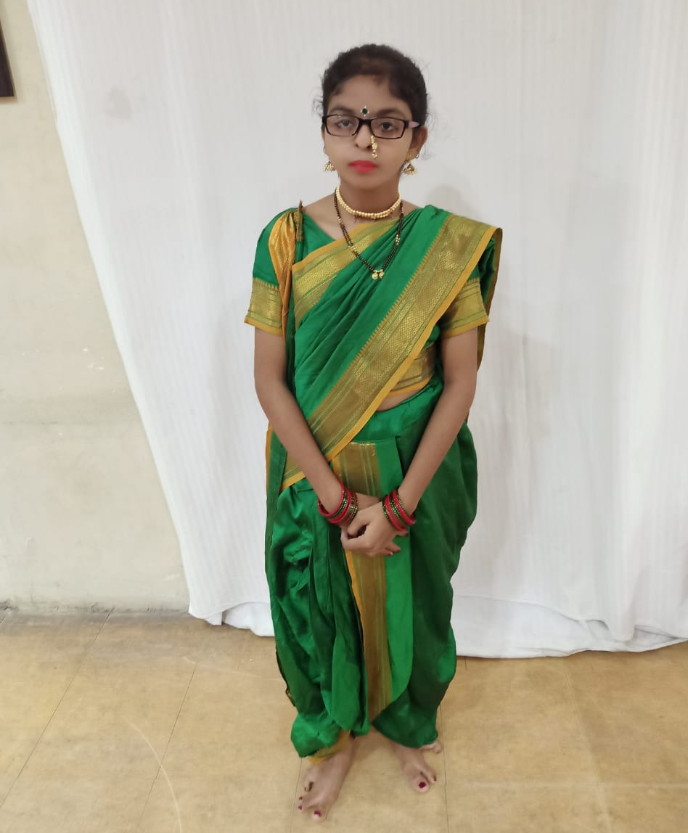
After joining the programme, Maheshwari learnt to sit and mingle with other class mates and play with them. She learnt to express her needs to teachers. She uses sign language and speech for communication. Maheshwari regularly wears hearing aid and glasses. Maheshwari loves to chat with other girls, watch dance programs. She even participates in drama.

Now, Maheshwari is confident in communicating with other students and hostel mates. She is staying independently in hostel and participates in various group activities of the centre. Her parents are very supportive.

His proud father and says "Maheshwari is learning new skills and is becoming smarter day by day.”

The support received from donors through Global Giving has helped Sense India to provide the required resources and training to so many children with deafblindness and multiple disabilities like Maheshwari to enable them to access education and bringing them closer to their dreams.
We thank Global Giving providing such a platform to fulfil the mission of the Non-Profit Organisations like Sense India.

SENSE INTERNATIONAL INDIA
2nd Floor, Administrative Block,
Andhajan Mandal Campus Opp. IIM,
Vastrapur, Ahmedabad- 380015
Phone: +91 79 26301282 | E-mail: info@senseintindia.org

