Gram Sudhar Lower Secondary School, Gokarna, Kathmandu
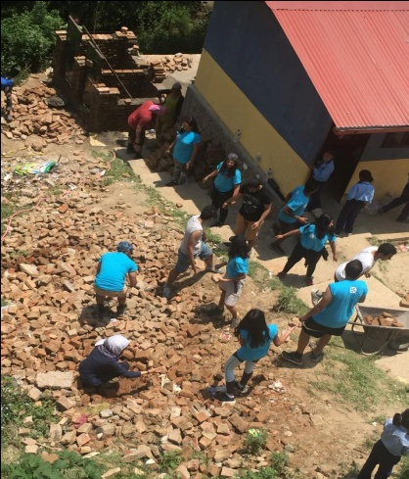
Partnership for sustainable Development Nepal is working rural part of Nepal to get better life of communities since 2002. It has various objective and plan to support necessities of the communities which lead to their better life and specially focus on the communities which are vulnerable and deprived from the all aspects such as education, health and sanitation.
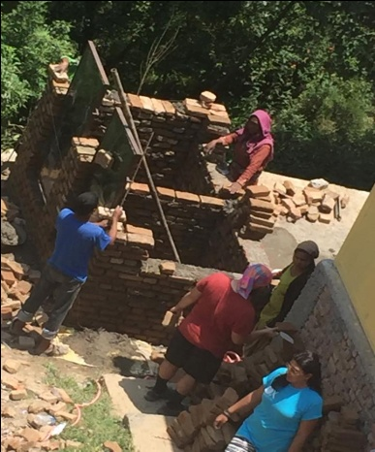
After the earth quake, PSD initiated to raise the fund to support an infrastructure development of school. So far we able to support Mahendra Lila Secondary School, Bigyan Primary School, Maikot Secondary School, Jyoti Lover Secondary school, Tri- Ratna Cooperative school, Nabin Gram Siksha Mandir and now we are supporting Gram Sudhar Lower Secondary school, at Gokarna, Kathmandu to create sound environment. Furthermore, we tried to support them to provide better education by holistic approach, which leading them to creativity, leadership and enthusiasm too. To create the sound education environment, we provided the education materials such as books, stationery goods, laptops, sports gears etc and also support to build class room buildings, toilets and play ground too.
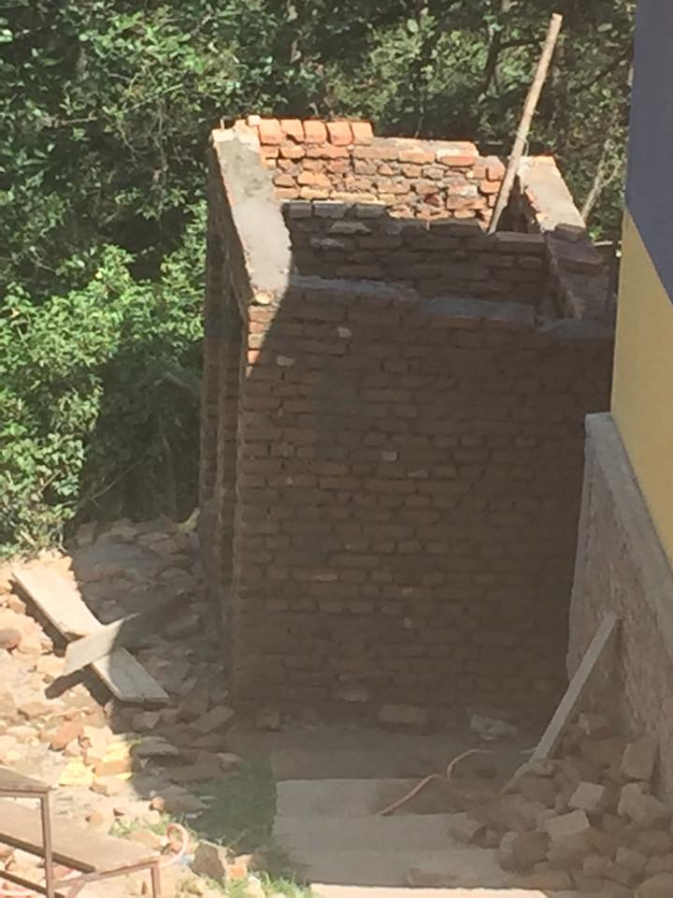
In this time, PSD provided the support to the Gram Sudhar Lower Secondary School, Gokarna as per the PSD’s aim and neediness of this school. To perceive the needs of this school is various, like sanitation, drinking water, proper place to get education (buildings), lack of materials and learning environment too. So, PSD just focused the work with this school as per priorities as well as the financial status due to the lack of fund to support them to flourish all over the aspects. Having said that PSD does not mean to support the other issues, it is still looking for the helping hand to support the vulnerable community indeed.
As per the priorities for the health and sanitation, PSD support to build toilets (we already supported to build 4 rooms building last year) with the help international well-wisher, who were involved in construction the toilets buildings, who had already support to us during the earthquake period to support the community to get better life.

School building damaged by earthquake

