Progressing reconstruction of school building
Mahendra Lila Higher Secondary School, Nawalpur, Gorkha
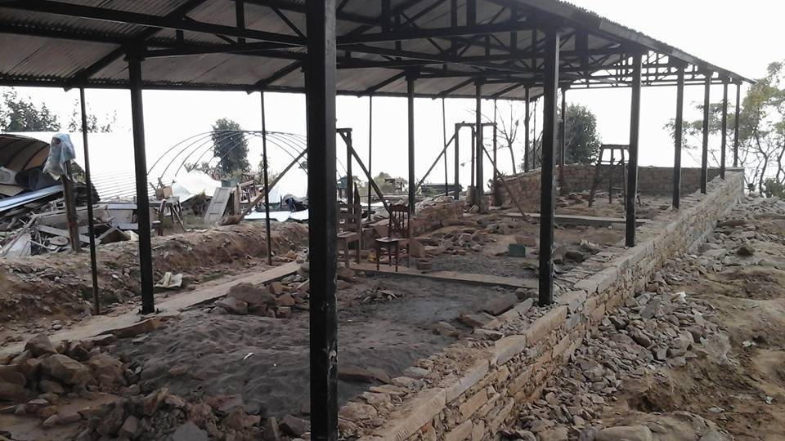
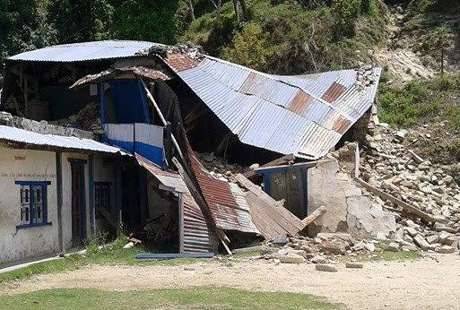
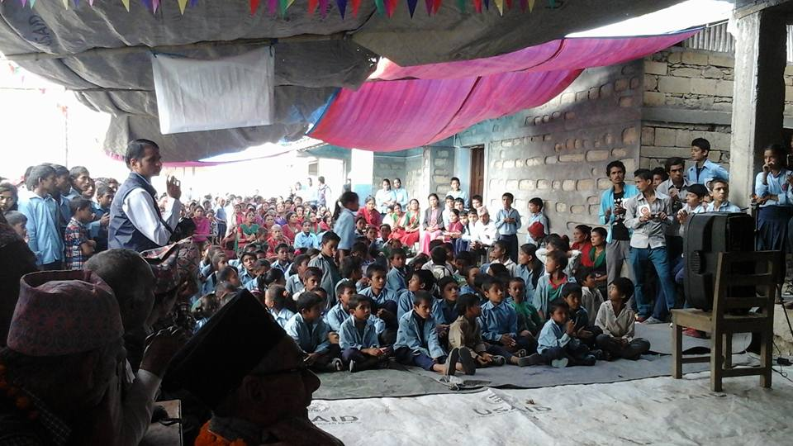
We are happy to report about our progressing reconstruction of a school building for the Mahendra Lila Higher Secondary School in Nawalpur, Gorkha. This school teaches about 500 girls and boys who had lost most of their school buildings during the earthquake in April 2015 and since then had to hold classes in improvised shelters. The reconstructed school building will facilitate the students’ education and also indirectly benefit 1175 households in the community. When we visited the construction site one of the students, Merina Dhakal, told us how much the school means to the children: “We were hopeless about our future as the school building was damaged by the earthquake. The school was built when we desperately need it to continue our study, at least it has started to be rebuilt, making our hope comes true.”
School building damaged by earthquake
Despite roads impaired by rain and political protests delaying our activities, we could make progress and the students are cheerfully watching their school developing. With the support of many community members the building materials like cement, bricks, iron bars and truss were brought from Narayangard in Chitwan, 4 hours driving from the school. As you can see in the picture above, we already built the metal frame and roof and started building the rock walls up to the plinth level. Above the plinth level bricks will be used to make the wall. During the coming weeks the walls will be finished, the classrooms will be furnished and library facilities will be arranged. We will complete the reconstruction by the end of December.
School building under construction
The school teachers, students, guardians and the School Management Committee are pleased about having joined their efforts with PSD Nepal and their international supporters. The School Management Committee would furthermore be happy to welcome international volunteers to stay with the community and help teaching the students. During our visit at the project site, the students expressed their great thankfulness to their international donors and local facilitators. The Assistant Head Master, Mr. Ram Prasad, told us: “We were dreaming about the new school after the destruction caused by massive earthquake. Now PSD has made our dream come true. The only block was built in this location to remember the previous school, even though rest of the buildings has been moved towards newly bought land on realizing the vulnerable land.” The Chairperson of the School Management Committee, Mrs. Laxmi, expressed her gratitude towards the international supporters: “We are very happy to have such kind people on the other corner of the world to help us when we were desperately looking for help. Really, the newly made school will be a divine gift for us.”
Besides this school rebuilding project, we are currently also reconstructing another building for the Bigyan Primary School in Harmi Bhanjhyang, Gorkha, in a likewise manner. Once the building for the Mahendra Lila Higher Secondary School is finished, we want to continue our work with other damaged schools and hope for continued support from the donor community for that.
During my visit to the school, I talked with the 13-year-old Merina about how she experienced the earthquake, the school’s condition and the latest progress. With anxious words she described how she was at home with her parents on that Saturday. Out of the blue she felt the terrible shakes as everything around her were trembling. At first she didn’t recognize what it could be. As her father pulled her in a rush to take her to the open farm, for the first time she heard the word earthquake. Everyone around watched in shock how their houses started to fall down. Merina was very worried about the completely collapsed school: “We were hopeless about our future since our classrooms are not standing at all. We think that we no longer can study for years as every infrastructure were damaged. We were waiting for the miracle to happen in our school to make the situation better.” When I asked her about relief programs she replied that some organizations were there to help. “Among them, PSD Nepal provided us with some tents, solar lights and with those tents we were able to make TLCs. As we were studying under the tents, once we heard that PSD Nepal was going to fund for the construction of the new building, we found our self in the heaven as our dream was going to materialize.”
Merina said that the donors did a divine deed and she realized that this sense of humanity has not come to an end. “PSD Nepal who has been assisting us with various means, once again became the subject of thankfulness as it assembled kind hearted people and through their joint hands efforts we are going to have a new school building. This project proved that ‘A friend in need is a friend in deed’.”

