Completed reconstruction of school building

Mahendra Lila Higher Secondary School, Nawalpur:

We are happy to report about our completion of the project which is really focused on the needy people that was our objectives. As per our earlier report we already submitted our progression of the reconstruction building and the community’s view too. Now, we completed the reconstruction of a building for the Mahendra Lila Higher Secondary School in Nawalpur, Gorkha. When completed this school, we see the cherished face of the students, teachers, parents and community as a whole because it benefit to all the stakeholders which were directly or indirectly involved. Regarding the school building it build to create sounds environment for the students to learn the lessons as well as creativity. For this purpose one room is decorated by animals and birds as well as globe too where they can learn by seen not just only read, it is specially focused for the primary students. In addition, we focused to the students for their regular classes without any fear so our volunteers take a music classes for them to rid off their nightmare because they still have fear of tremor. Obviously it’s hard to completely rid off the nightmare especially for the kids. Further more, volunteers and teachers work together to teach the students where they can share their feelings, knowledge and it’s a way to exchange their culture too, which is benefited for both side. Regarding Teachers, students and community, they praised our work and expected to get this kind of projects again which they feel this project for them and way to show their dream. After completion the school building they said that “we are going to alive with our hope” which is bring us by PSD. School parents said that “now our children get dream”.

We are pleased to inform you that the above stated project that you kindly sponsored has now been completed. Please find attached with this report a photo of the completed project. The construction of new school building before the onset of monsoon season has added joy among the students, teachers and even parents. Previously, many parents were reluctant to send their students to study in improvised shelters. The construction of new building has ensured regular classes in comfortable classrooms and provided security and a feeling of safety to everyone. Moreover, it has created positive and pleasant learning environment in the school. Now our second project will be providing other facilities and completing other school which we have been building beside this school. Your continues support will be very appreciated by teachers, students and parents. Our effort will be continue to support other school to complete in this phase so Please donate more fund so that we can give completion building to schools.

Glimpse of school building. 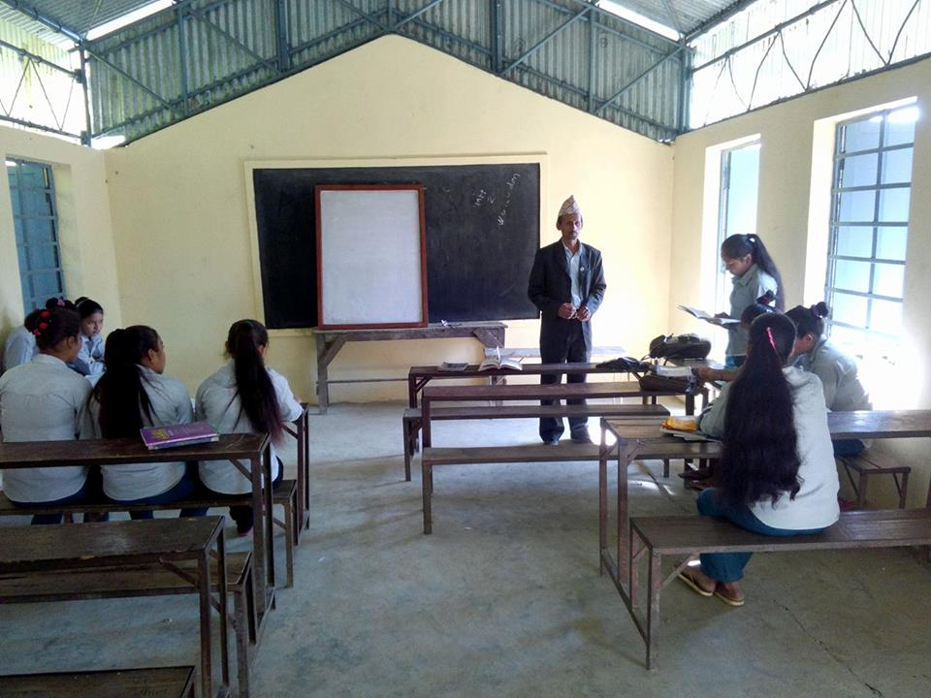

Teacher is teaching in newly built building which we have supported fully

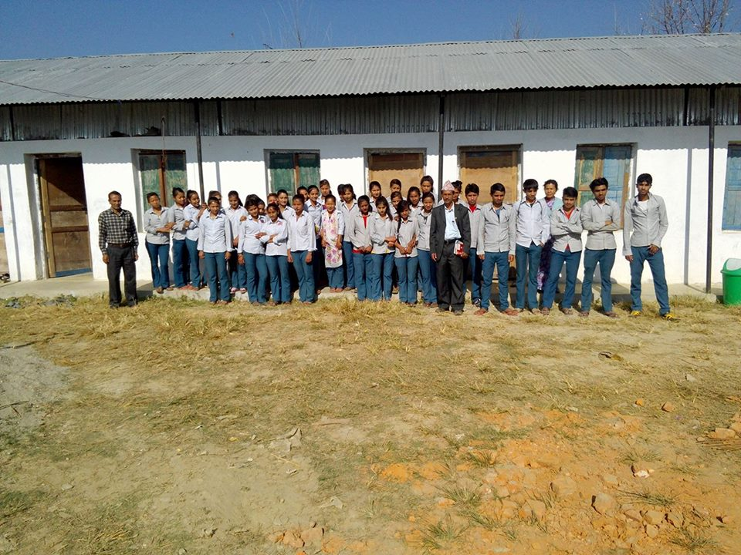
Teachers and students in-front of newly built building which we have supported fully

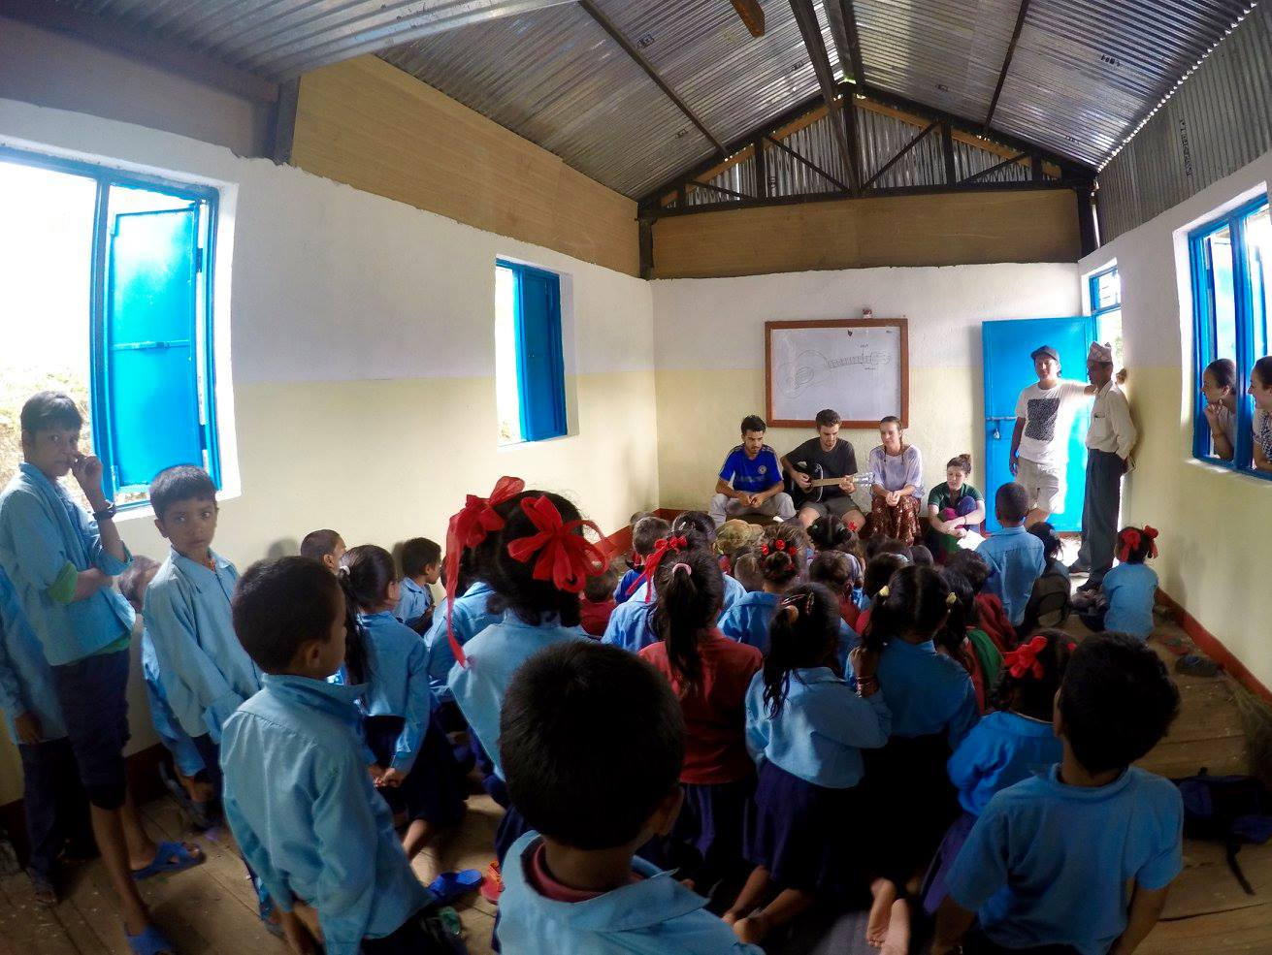
Students are having music classes from our Volunteers in one of the room we built

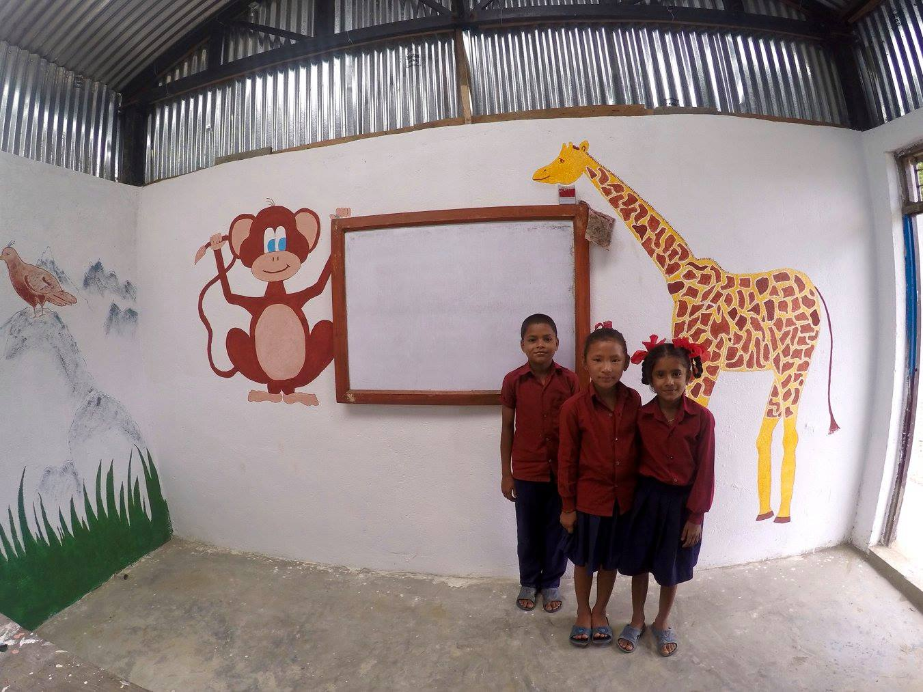
Decorated room with students
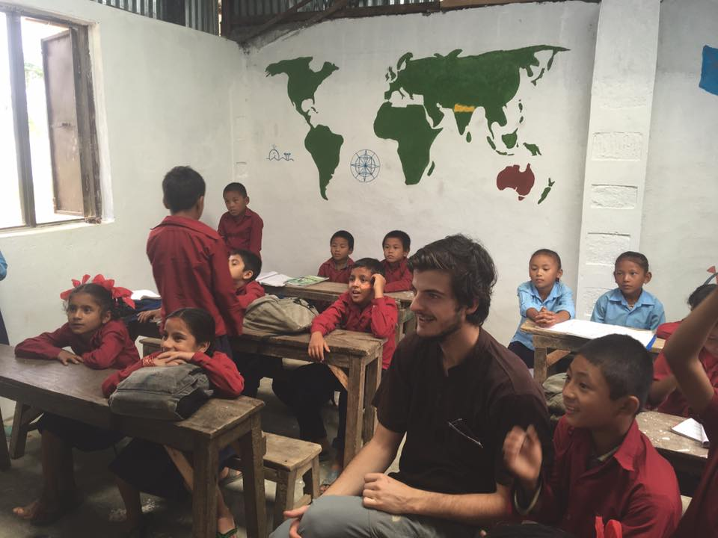
Volunteers are teaching in newly built room.

