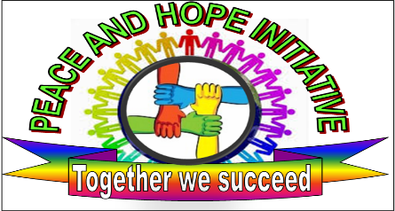

Peace & Hope Initiative Organization

“KURANEZA Early Childhood Development concept note”

Early childhood, the period from birth to six years, is a significant and unique time in the life of every individual. Every child needs and has the right to positive experiences in early childhood. As with every other phase in life, positive supports and adequate resources are necessary to make the most of this period. Provision of such supports and resources should not be conditional on the expectations of the economy, society or other interests

Location: Contact
GASHARU Cell Albert Musabyimana 0788312740
KINYINYA Sector Legal Representative and Founder
GASABO District

KG386, KIGALI, RWANDA
sairah442@gmail.com
http://www.peaceandhopeinitiative.org/

PART I: General information about Peace and Hope Initiative
1 | Full name of the organization | PEACE AND HOPE INITIATIVE (P&H)
2 | Legal status | Local Non-Government Organization :  N0 54/NGO/RGB/2014
3 | Public benefit status | Marginalized and disadvantaged children mostly orphan and children living with vulnerability within the age range of 3 years to 6 years and their parents/Caregivers
4 | Address | GASABO, Kinyinya
5 | Telephone/Fax | (+250)0788312740
6 | Website | www.peaceandhopeorganization.org
7 | Full Name Authorized Representative | MUSABYIMANA Albert /Legal Representative
9 | Full name contact Person | MUSABYIMANA Albert
10 | Contact info Contact Person | (+250) 0788312740
11 | Organization e-mail | info@peaceandhopeinitiative.org

Basic Project information
1 | Title of proposed project | Kuraneza Early Childhood Development (ECD) Expansion Project
2 | Location | GASABO District
3 | Project period | Started in 2012, expansion planned for 2015 (depending on funding)
4 | Total Budget (in RWF) | RWF 40,000K (c. 58,000 USD)

PART II: Project proposal

- Overall goal of the Project
Peace & Hope Initiative Organization (P&HO) is forwarding in a project proposal with an initiative of caring, educating and improving the standard of living of children from pre conception to six years with a primary focus on expanding access to and improving quality of:
- Pre-primary education for children from 3 to 6 years to prepare for school;
- Antenatal, post-natal preventive and basic health care services which improve child survival rates (including breastfeeding);
- Nutrition services, which improve children’s physical development;
- Services for the prevention of mother to child transmission of HIV (PMTCT) and pediatric HIV care and support services;
- Water and sanitation services, which provide a hygienic environment for children;
- Single and younger mothers economic empowerment (through IGA, i.e. income generation activities)

The initiative is targeting marginalized and disadvantaged children, mostly orphans and children living with vulnerability within the age range of 3 years to 6 years and onwards. The project intends to help children especially in rural area of Gasabo District, where poverty has prevailed most. The project’s objectives are based on caring, counselling, educating and empowering orphans and integrating Children living with vulnerability for a better future, hence increasing social and economic developments in the community and Rwanda at large. The project intends to give peace and hope to the orphans and vulnerable children (OVCs) and people living with HIV/AIDS (PHAs) through education including nursery, health, hygiene and HIV prevention programs to parents and legal guardians in the community.
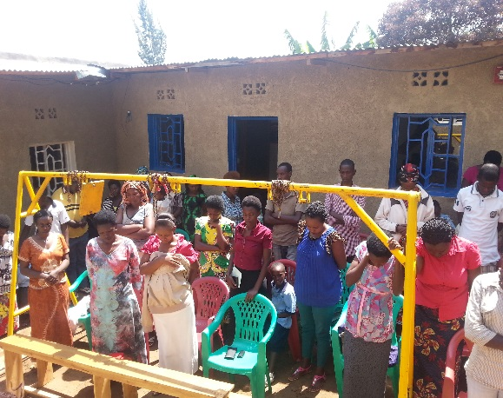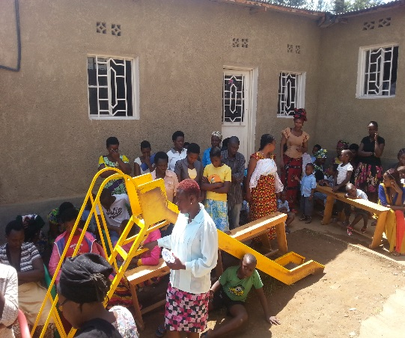
Peace & Hope Initiative calls single and Young Mothers, mostly underage girls, that “Parents are the primary educators of the child and have a pre-eminent role in promoting her/his well-being, learning and development”.

- Project Rationale
Evaluations of quality Early Childhood Development (ECD) programs globally have demonstrated that investments in ECD are among the most cost-effective investments a country can make and that ECD returns to investment are higher than for any other age group intervention .Further to this, investment in ECD enhances the child’s survival, growth and development and this is especially so for the marginalized and disadvantaged children.
There is strong evidence that the early years of life play a major role in a child’s development. Risk factors for poor development include poor maternal nutrition, lack of stimulation and learning opportunities, and exposure to violence, but protective factors such as breastfeeding and maternal education can reduce these negative effects.
Over 40% of children under five years in Rwanda are experiencing developmental delays which may become irreversible. So, investments in pre-primary care and education in Rwanda would be an effective means of ensuring that all children will be prepared to start primary school at the right age and to combat the current primary school drop-out rate (12.2%) and repetition rates (14%).
Rwanda has made enormous strives forward in improving access to education for girls and boys at all levels with a primary school net enrolment of 98% for girls, 95% for boys (2012 Rwanda Education statistics). This has put Rwanda on track to achieve the education-related Millennium Development Goals. However, the pre-primary net enrolment rate of 13.2% for girls and 12.3% for boys is still to be improved.
ECD is thus an important element for Rwanda to achieve its vision of becoming a middle-income country by 2020 through its contribution to the development of a strong human capital base of innovative and industrious people who can work efficiently in different spheres of the economy.
Peace and Hope Initiative was established for targeting marginalized and disadvantaged children, mostly orphans and children living with vulnerability largely birthed by underage girls, within the age range of 3 years to 6 years and onwards, to ensure access to basic early childhood education, nutrition and health care, through KURANEZA Early Childhood Development (ECD) Center.
In Gasabo district a high number of children are not attending pre-primary schools/nurseries due to the nature of its geography, poverty, expropriation, limited number of nursery schools. Children are also less frequently in nursery school due to work in agricultural activities. Another reason is the lack of knowledge of the importance of ECD by mothers, caregivers and the community.
Peace & Hope Initiative (P&H) is forwarding a project proposal to expand the KURANEZA Early Childhood Development Centre by offering ECD services to children as well as empowering the community with emphasis on orphans and PHAs in Gasabo area. This includes providing them with food, clothes, medical services as well as good hygiene and education among other basic needs. Children and mothers will be provided with education from nursery and others ECD catch up programs. This will enable them to obtain ECD necessary services and skills to promote ECD in the community. Counselling services will be provided to orphans and vulnerable children (OVCs) and people Living with HIV/AIDS (PHAs) to reduce their worries about the future to enable them to complete their education, find work and accomplish their goals in life.
The initiative is targeting caregivers, parents who have children in centre and their children, Kuraneza ECD Centre committee members as well as local leaders involved in child development.

PEACE AND HOPE INITIATIVE Achievement
From 2012, P&H increased the sense of hope and mobility in the Gasabo district, KINYINYA sector community, and built and operated a Peace and Hope Nursery School through KURANEZA ECD CENTER.
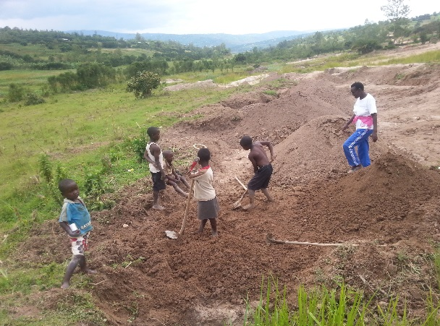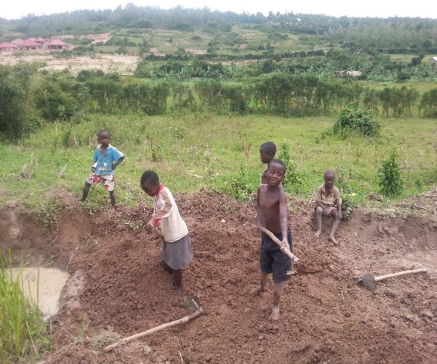
Before the start of the Project, the parents and caregivers of GASHARU Cell stated “Yes, there is need for solving food security and economic problems but at the same time we must work on children's issues—so that our children and us will not have to come back and keep working on the same food security and economic problems again in the next ten to twenty years.
Then our problems will not go into the circle again and again. To stop this cycle of suffering in the long term we should start now to educate parents on how to develop our children." The motivation of villagers to work to improve the lives of their children as expressed in this quote has been one of the inspirations for the Kuraneza - Early Childhood Development centre in initiating and continuing with this project.

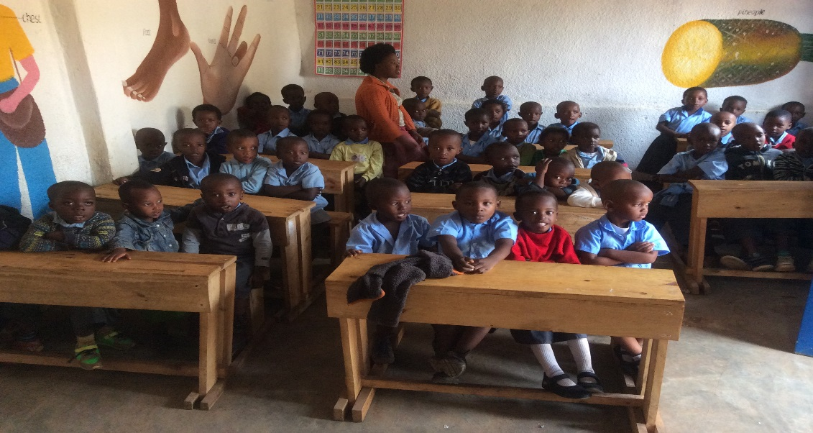
We have currently 118 children especially OVCs attending the nursery school, we had to limit the number due to the capacity of existing premises and we hope to enroll more kids (that are currently on the waiting list) after the planned expansion of our premises.

3. Project Objective

The project will engage in the following :

- Pre-school programs
- Nursery school
- Nutrition services
- Hygiene, water sanitation services
- Health care and counselling

- Community programs
- Door to door Awareness campaign
- Community training on ECD programs (focusing on nutrition, health care, hygiene and sanitation)
- Community Mother Leaders

- Supporting and advocating single and younger mothers economic empowerment initiatives
- Expanding and improving Kuraneza - Early Childhood Development centre’ infrastructure

4. Expected Outcome and Output Indicators

Output indicators | Outcome indicators
The project will be in position to enroll 200 children at the beginning of 2015 | Parents learn about and become more engaged in Early Childhood Development, support other parent in the community with no means to pay for nursery school
30 nursery caregivers well skilled | Increased child performance/ reduce of primary drop-out rates
Raising ECD awareness to 100 local community leaders | Contribution to the ECD policy (Foundation issue)
Kuraneza ECD school training tools kits and reading materials | Better information and education onf ECD provided to community

Main Risks and Challenges

- Lack of motivation among members: Members are and will continuously be trained by Peace and Hope Initiative Organization to mitigate any potential lack of motivation and to increase group collaboration through meetings. Members are and will continuously be involved through the whole phase of the project to increase ownership
- Lack of ownership by Local Authority: Involvement of local authority

- P&H & Community Contribution
The community will contribute to the projects by having two parent leaders on the Boards of Directors as well as participating in pre-school programs. The motivation has been done house to house by Peace & Hope Initiative Organization to make parents understand that they have to try to work hard in order to be able to feed their children after coming from the center.

- PROJECT JUSTIFICATION
The project needs at least $58,000 of new funding to kick-off the expansion of the nursery to be able to cater for 200 kids (new building with classrooms and furnishing), community sensitization and workshops on health care, nutrition, hygiene and HIV prevention. The project will be under the management of Peace and Hope Initiative Organization for effectiveness and management with consistent reporting and government inspection. The project is among few projects that provide this kind of program in Rwanda.

- PROJECT SUSTAINABILITY
To make the project sustainable in the long-run, there will be admission of children whose parents can afford to pay fees for their kids attending the Kuraneza nursery school and benefit from the ECD services provided (self-sponsorship). This is intented to subsidise the attendance of vulnerable kids and orphans who will still be catered for despite not being able to afford pre-primary school education.
The project is among a few projects that provides this kind of program in vulnerable community with many child-headed households. The existing schools in the country lack initiatives to help such people living with vulnerability, HIV/AIDS and orphans.

Mr. Albert MUSABYIMANA
Legal Representative and Founder

