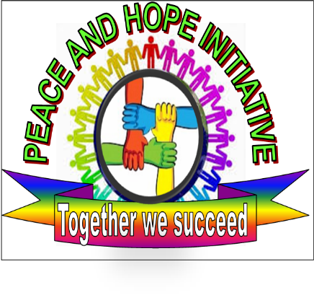

Peace & Hope Initiative Organization

2015 Make a Wish for Christmas to Vulnerable Children and Childless Elderly.

“The Peace and Hope Initiative Organization plans such event after it was found that many young vulnerable people are at risk of running away from home during festival period and that can result in many other unbearable risks”.

Localization: Contact:
GASHARU Cell Albert Musabyimana 0788312740
KINYINYA Sector Legal Representative and Founder
GASABO District

KG386, KIGALI, RWANDA
sairah442@gmail.com
http://www.peaceandhopeinitiative.org/

Peace and Hope Initiative Organization

PARTI: General information about Peace and Hope Initiative
1 | Full name of the organization | PEACE AND HOPE INITIATIVE
2 | Legal status | Local Non-Government Organization
3 | Public Benefit status | The Peace and Hope Initiative is a Rwandan NGO established by the heads of child headed families who were forced to play a parental role for their younger siblings after the 1994 Genocide. The organization aims to ensure that poor and vulnerable children will have access to basic needs including a proper education, good nutrition and health care. The organizers also strive to encourage Childless Elderly (INCIKE) and motivate Single and Young Mothers.
4 | Address | GASABO District , KINYINYA SECTOR and GASHARU CELL
5 | Telephone/Fax | (+250)0788312740
6 | Website | www.peaceandhopeorganization.org
7 | Full Name Authorized Representative | MUSABYIMANA Albert /Legal Representative
8 | Contact Info Authorized Representative | (+250) 0788312740
9 | Full name contact Person | MUSABYIMANA Albert
10 | Contact info Contact Person | (+250) 0788312740
11 | Other relevant information | Email : sairah442@gmail.com

Basic Events information
1 | Title of proposed Report | Make a Wish Christmas for Vulnerable Children & Childless Elderly
2 | Location(s) | GASABO, KINYINYA GENOCIDE Survivors Village and Abroad
3 | Events period | 4 Hours
4 | Total Budget (in RWF) | N/A

PART II: Project to be Visited and Launched by Visitors

- Over all goal of the Events.
Make a Wish Campaign for Christmas to Vulnerable people aimed to wish Christmas to the community for just reminding them what happened before 1994 TUTSI Genocide, It was a big pleasure to celebrate Xmas with their entire families and those who unable to do it and come and join the families with capability and after losing the entire families no one cerebrated it either is Childless elderly, Child headed households or traumatized due to what he saw during 1994 Rwanda TUTSI Genocide.

Peace and Hope Initiative organized this events for just wishing the Good growth of vulnerable children from the single and young mothers who got unplanned pregnancies because they had to assume a role of parenting their young brothers and sisters actually needed to be parented.

Peace and Hope Initiative aimed to recall that before the 1994 Genocide against Tutsi Rwandans used to come together and share Christmas meal while at the same time upholding their unity as well as helping one another.

- KINYINYA GENOCIDE SURVIVORS Village Background
The Genocide of 1994 was planned and executed with such atrocity that within 100 days it took the lives of more than million people of Rwanda. The survivors of the massacres were mainly orphans, Childless Orderly ( INCIKE ) many of whom found themselves as children suddenly heads of the household; widows, grandmothers living along without children or family, women infected with AIDS as the result of victimization by rape, and those left handicapped either physically or mentally. These massacres have left a population traumatized, destitute, homeless and penniless, without the means to survive on their own.

After the Genocide, orphans and INCIKE (Childless Elderly) were left as heads of their households, responsible before their time for the care of their sisters and brothers as well as for other family members. These children found themselves alone, traumatized, without care or support from their parents or any parent-like figure, and without the financial resources to ensure that they would be taken care of. They suffered tremendously to survive and to keep their families together, assuming responsibilities far beyond what any child should ever have to assume. Their own childhoods were sacrificed, and their futures were extremely uncertain.

. 2.1. KURANEZA Early Childhood Development Project
« “Education is the movement from darkness to light”

In the 1994 Rwanda Tutsi Genocide, Many children lost their parents and extended families. The elder had to assume a role of parenting their younger siblings since their parent’s deaths in the 1994 Rwanda Genocide actually needed to be parented and They also traumatized by what they have seen during the killings . Since Genocide ended, many orphans have been helped by kindness people to grow up by depending on food donation which is not sustainable. This vulnerability often resulted unwanted pregnancies within the community from young girls due to that poverty living in and they don’t care about Education of these vulnerable children. We who got a chance to go in school at the same time parenting, we wish to help those vulnerable Kids through Education which can help to break free the poverty cycle since 1959 where our parents not allowed to go in school due to Genocide Ideology.
It is in this situation we have started a project of caring these vulnerable Children especially young girls to prevent them the similar situation because a girl who attends school reduces her chances of getting unwanted pregnancies, HIV by 60%; if she attends advanced school, by 85%. The Graduation of the KURANEZA Nursery School will be also done on the same day.
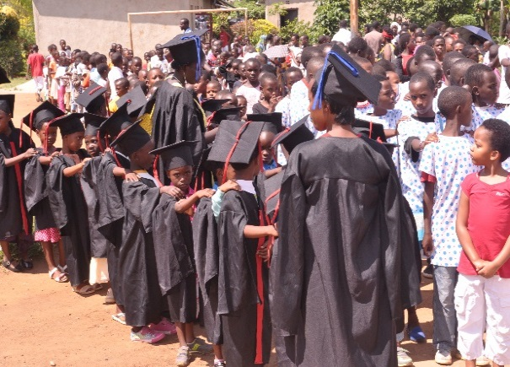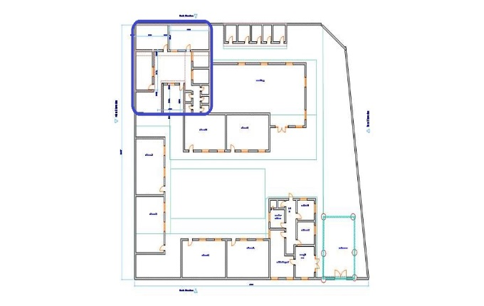
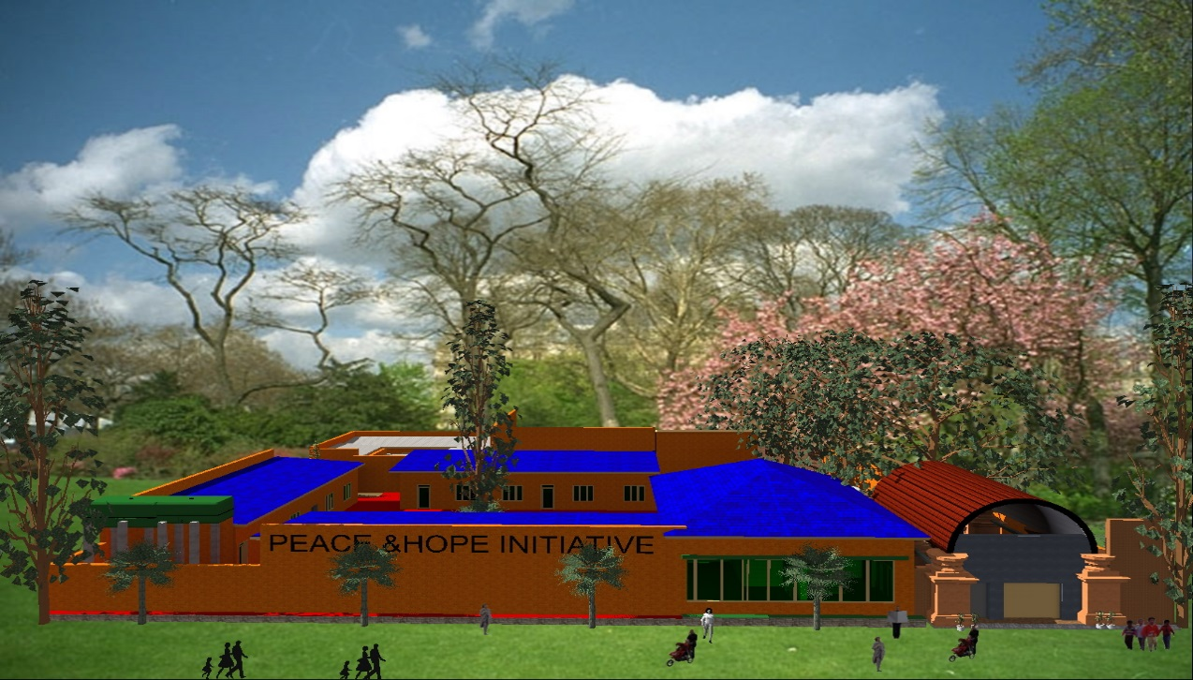
The Kuraneza Early Childhood Development (ECD) project plans to extend and provide care and basic education to 200 vulnerable kids of 3-6 years. The Kuraneza nursery supports underprivileged kids of underage and single mothers, orphans and from families living with HIV/AIDS in poverty-stricken in the vulnerable Communities. Effective Early Childhood Development helps kids at risk of poor development due to a lack of parental care and learning opportunities to break free from the poverty cycle in Rwanda.

Childless Elderly Care program’s house Project

In response to the continuation of desperate circumstances facing this group of INCIKE & HIV Positive. We have an idea of conceiving the Project in order to follow up those INCIKE by building the a house of them which Generate revenue-generating income for helping them instead of waiting the donations or support without knowing where and when will come from and sustain them for the long term where they are still on this world .
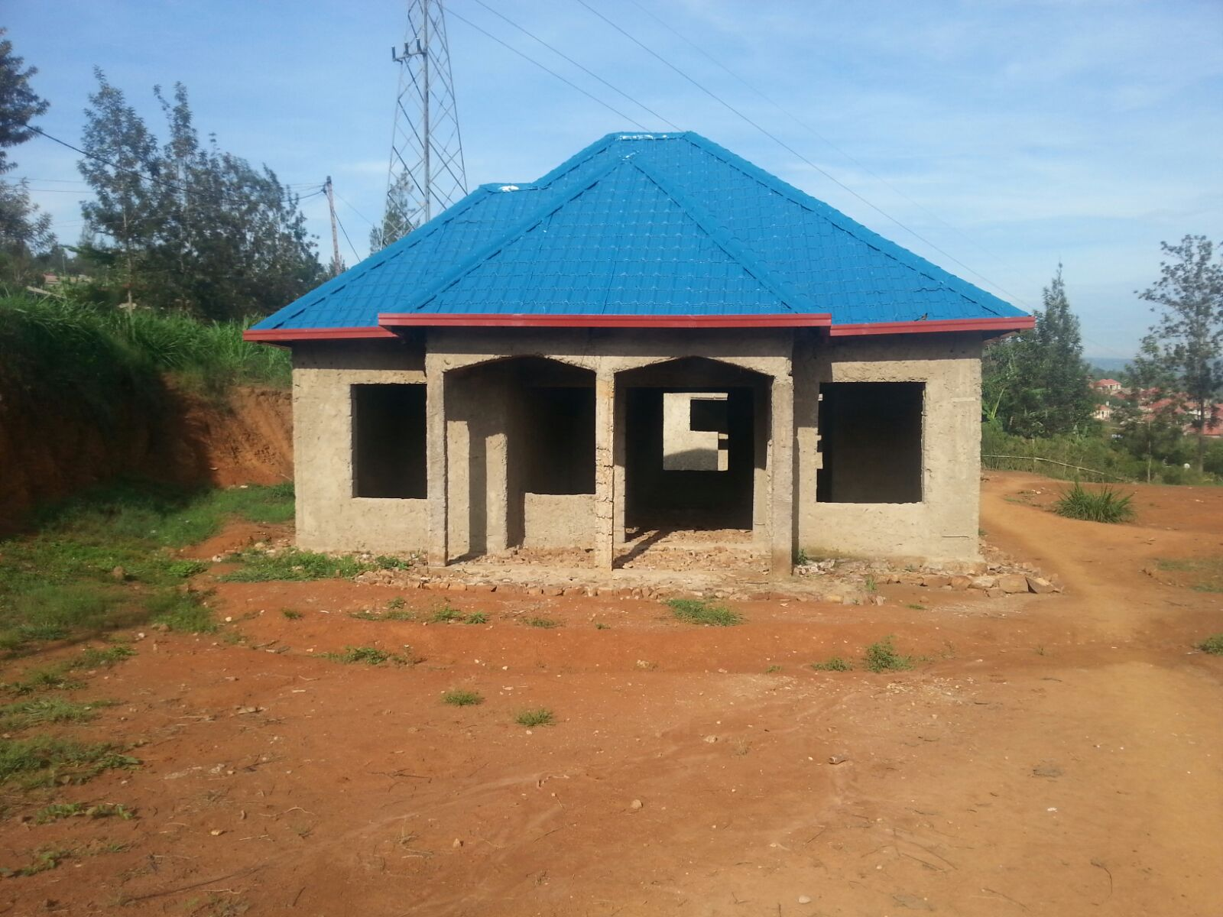
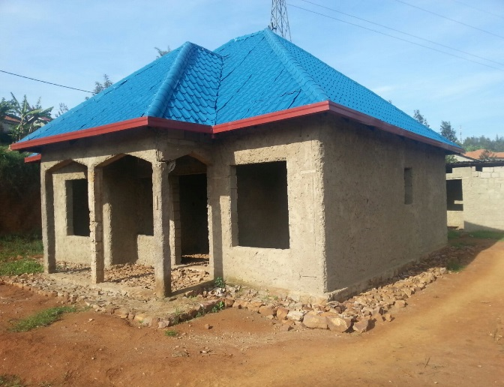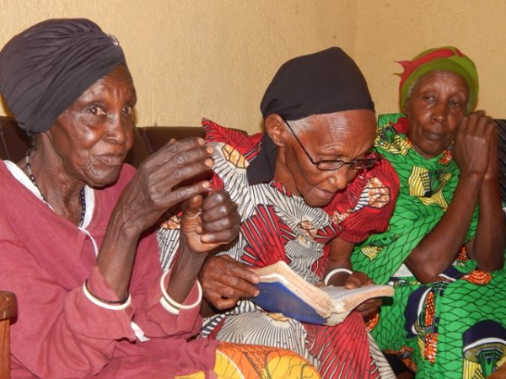
At their Age it is not safe to stay in the house without someone to follow them and help them. This is the main role of this house. The house will be rent ( 100,000-150,000)

2.3. Proper water for Community and for INCIKE Project

INCIKE is a Kinyarwanda (language of Rwanda) word, from the verb “gucika” which means to be extinct or uprooted. In the context of the Genocide in Rwanda, INCIKE is this group of mostly elderly survivors above 60 years old, who have lost everyone in their family and are left all alone. The conditions they live in are utterly catastrophic. They are always going to draw water in 2 KM and it is difficulty to go with a small Jerkin and stick to draw water.
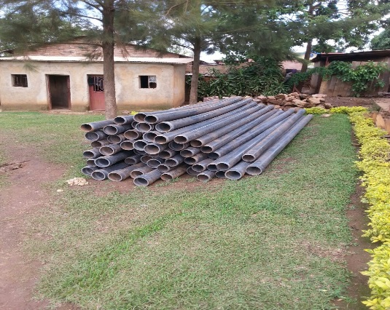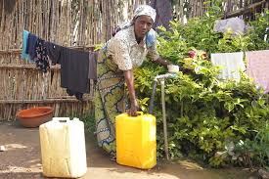
We got the support of giving the 6 oldest INCIKE the proper water at their house for facilitating them not to go far with five litters Jerkin which makes them to go more than five times to draw water in difficulty ways.

.Single and Young Mothers Empowerment Project

The number of single and young mothers is in the increase in the recent years due to the consequences of 1994 Rwanda Genocide. Most women have had no option but to take over a number of roles which should have been men’s responsibility due to HIV/AIDS, economic hardships early pregnancy and cultural ties.
In the rural area over the number of women has outnumbered that of men. This has made many women vulnerable to men as such some women have had a low bargaining power and inability to resist men’s advances.
If something is not done to improve the status of women cases of domestic violence, child neglect and negligence will continue to be in the increase within KINYINYA Sector on allegation of having multiple lovers where these Kids on the photos are from one young lady with different husband. Most single and young mothers have had it overwhelming providing for their families with an income of less than a dollar a day and hence increase in unwanted pregnancies, abandoned children and general crime rates.
Those who begin small businesses have ended up closing them and giving up this is because of doing business the wrong way.
Peace and Hope Initiative - Comes in to fill the knowledge gap that single and young mother face, they need knowledge and skills for their enterprises to succeed.
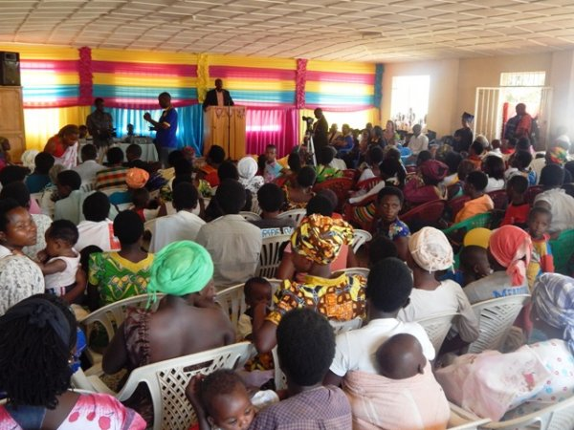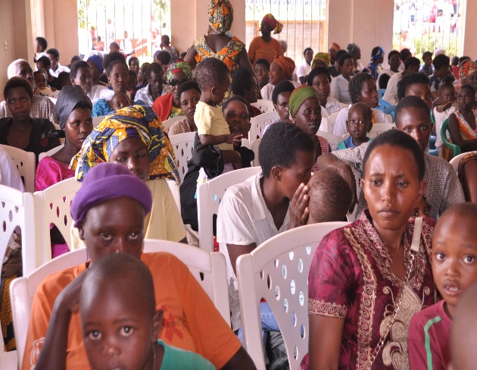
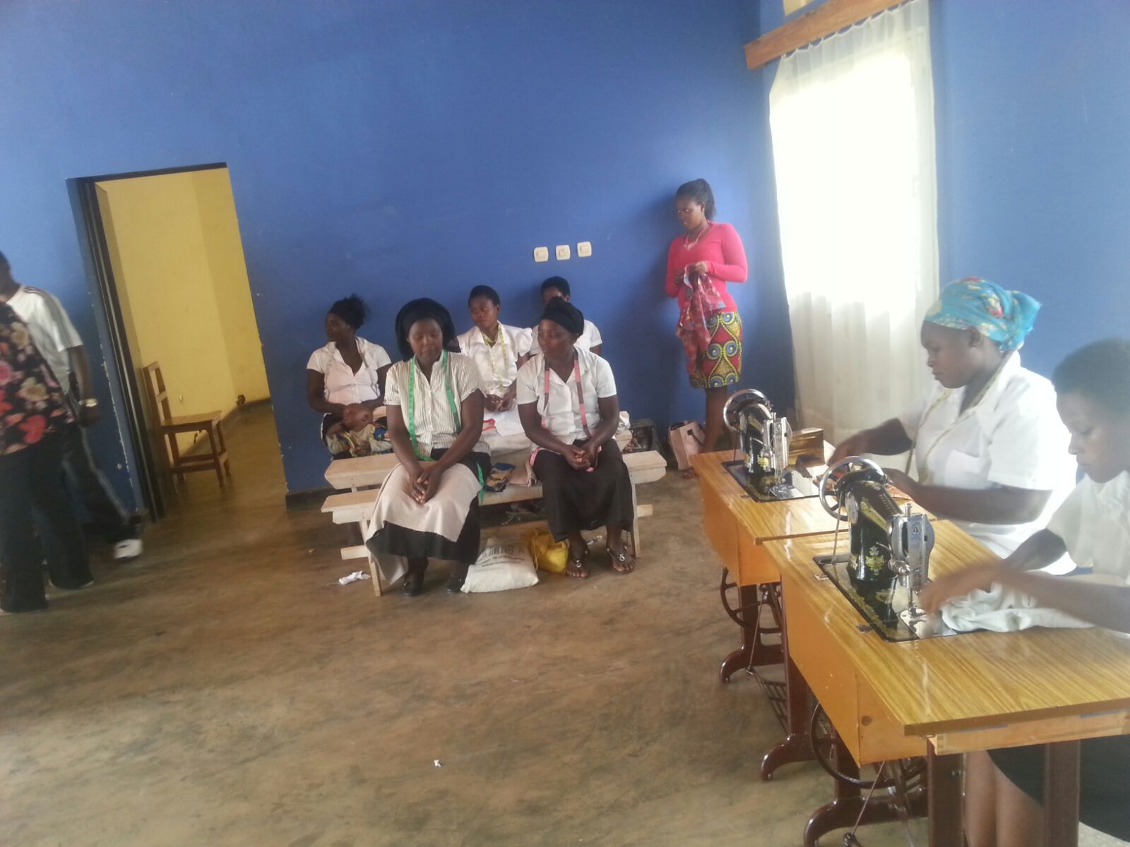

- Christmas meal and Gift to vulnerable poor Families

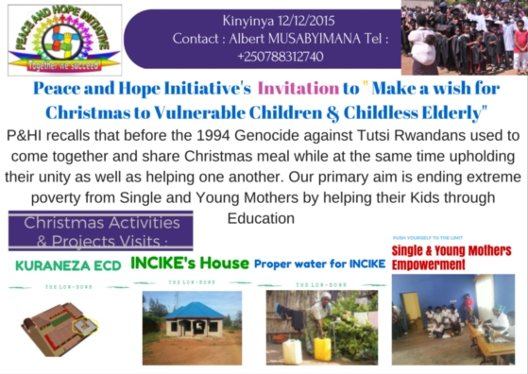
I would like to share the progress of Make a wish for Christmas which will take place on 12/December and share this good news of GlobalGiving accepted to facilitate the Donation allover the world .
In partnership with globalgiving #UK to facilitate remote people who ever wishes to donate and Support the vulnerable Children, I know that your (love/kind thoughts) and well wishes is with the work of Peace and Hope Initiative. To know more detail click on: http://www.globalgiving.co.uk/projects/ecd-nursery-extension-for-200-vulnerable-rwandan-kids/updates/
Know that I will truly appreciate your gift and I plan to use it to (KURANEZA (Good Growth) Early Childhood Development Center for ending #Extreme poverty from Single and Young Mothers which can be only found in Education of their Kids
Let's get together soon to celebrate the Christmas on 12/12/2015. Thanks, again for your very love, kindness and understanding you show to Peace and Hope initiative

Fundraising for KURANEZA Early Childhood Development

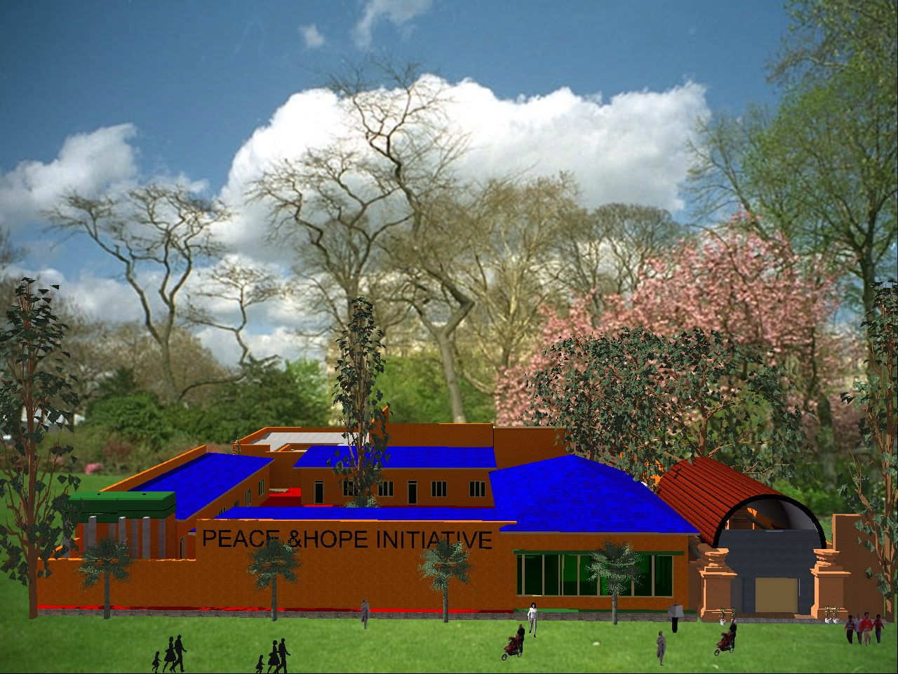
In the Kuraneza nursery kids are provided basic care and education, nutrition, counselling, water and sanitation services through skilled caretakers during the key developmental stages of their childhood. Currently c. 118 kids attend the nursery and the aim is to expand the capacity to cater to 200 kids. Your Voice for the expansion would be highly appreciated and beneficial for kids in the area as more of them could attend the nursery. Improvement in the kids' development, wellbeing and learning ability will increase their chances to successfully pass primary school and succeed in higher education, which is essentially the key to escape poverty

Preared by Peace and Hope Initiative Committe
Verfied by Legal Representative Albert MUSABYIMANA

