Ending Extreme poverty from Single and Young Mothers through Education of their Kids

In the 1994 Rwanda Tutsi Genocide, Many children lost their parents and extended families. The elder had to assume a role of parenting their younger siblings since their parent’s deaths in the 1994 Rwanda Genocide actually needed to be parented and They also traumatized by what they have seen during the killings . Since Genocide ended, many orphans have been helped by kindness people to grow up by depending on food donation which is not sustainable. This vulnerability often resulted unwanted pregnancies within the community from young girls due to that poverty living in and they don’t care about Education of these vulnerable children. We who got a chance to go in school at the same time parenting, we wish to help those vulnerable Kids through Education which can help to break free the poverty cycle since 1959 where our parents not allowed to go in school due to Genocide Ideology.
It is in this situation we have started a project of caring these vulnerable Children especially young girls to prevent them the similar situation because a girl who attends school reduces her chances of getting unwanted pregnancies, HIV by 60%; if she attends advanced school, by 85%.
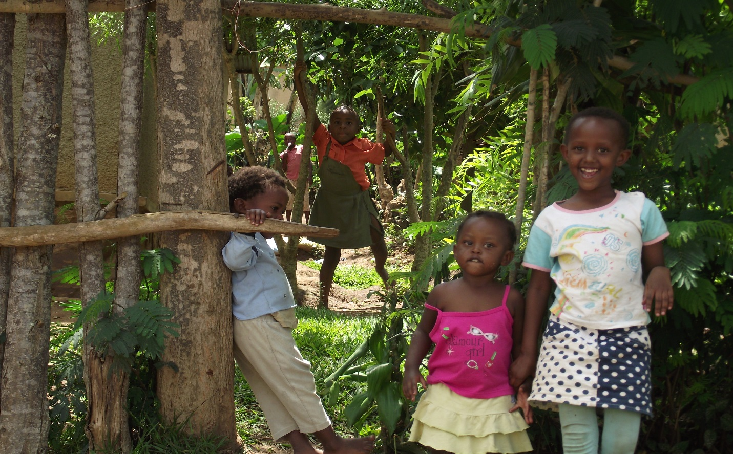
The Visit done by Peace and Hope Initiative for encouraging vulnerable Families .
The number of single and young mothers is in the increase in the recent years due to the consequences of 1994 Rwanda Genocide.
Most women have had no option but to take over a number of roles which should have been men’s responsibility due to HIV/AIDS, economic hardships early pregnancy and cultural ties.
In the rural area over the number of women has outnumbered that of men. This has made many women vulnerable to men as such some women have had a low bargaining power and inability to resist men’s advances.
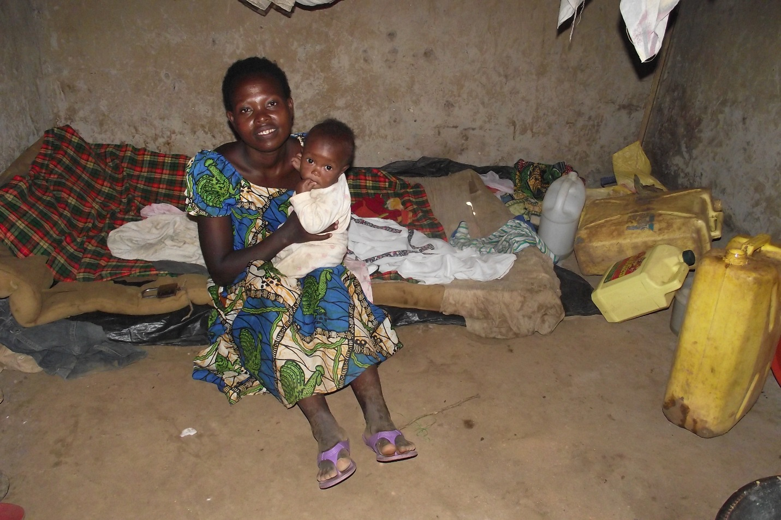
She is living with HIV and she has 3 Kids from different man
If something is not done to improve the status of women cases of domestic violence, child neglect and negligence will continue to be in the increase within KINYINYA Sector on allegation
of having multiple lovers where these Kids on the photos are from one young lady with different husband. Most single and young mothers have had it overwhelming providing for their families with an income of less than a dollar a day and hence increase in unwanted pregnancies, abandoned children and general crime rates.
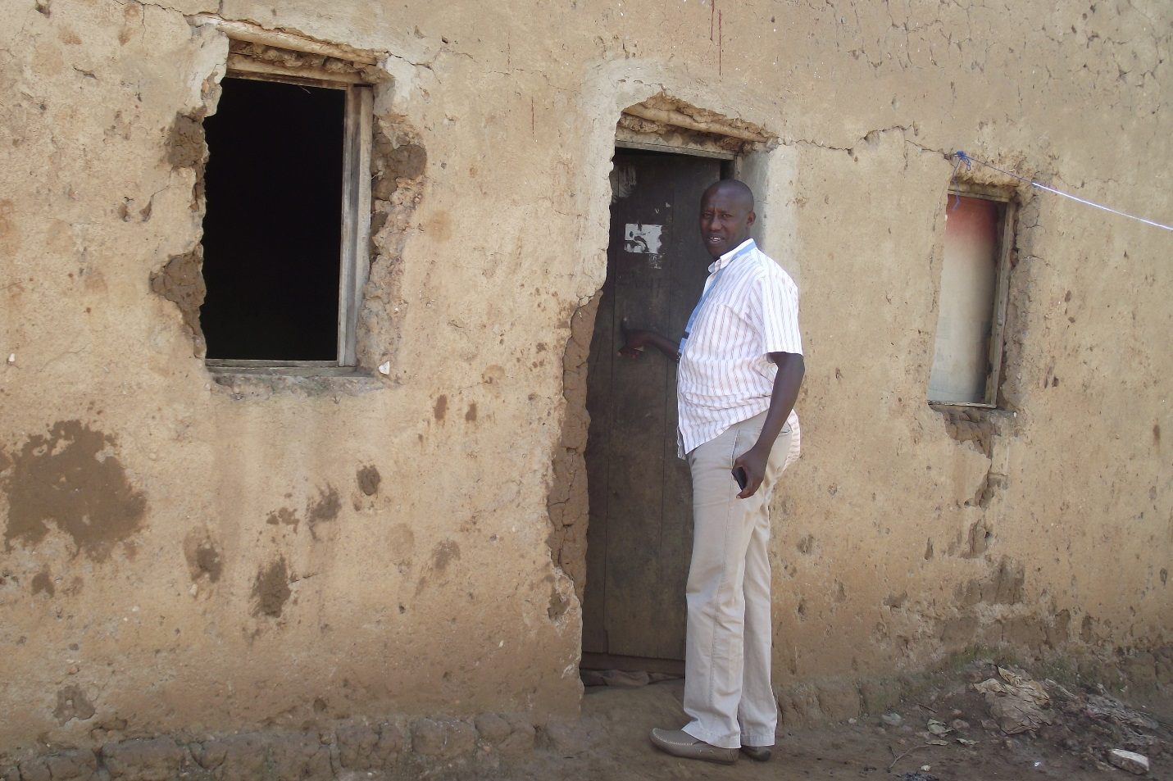
Legal representative & Founder always going to visit poor families for vulnerable children Selection to get basic Education at KURANEZA ECD Center!
Those who begin small businesses have ended up closing them and giving up this is because of doing business the wrong way.
Peace and Hope Initiative - Comes in to fill the knowledge gap that single and young mother face, they need knowledge and skills for their enterprises to succeed.
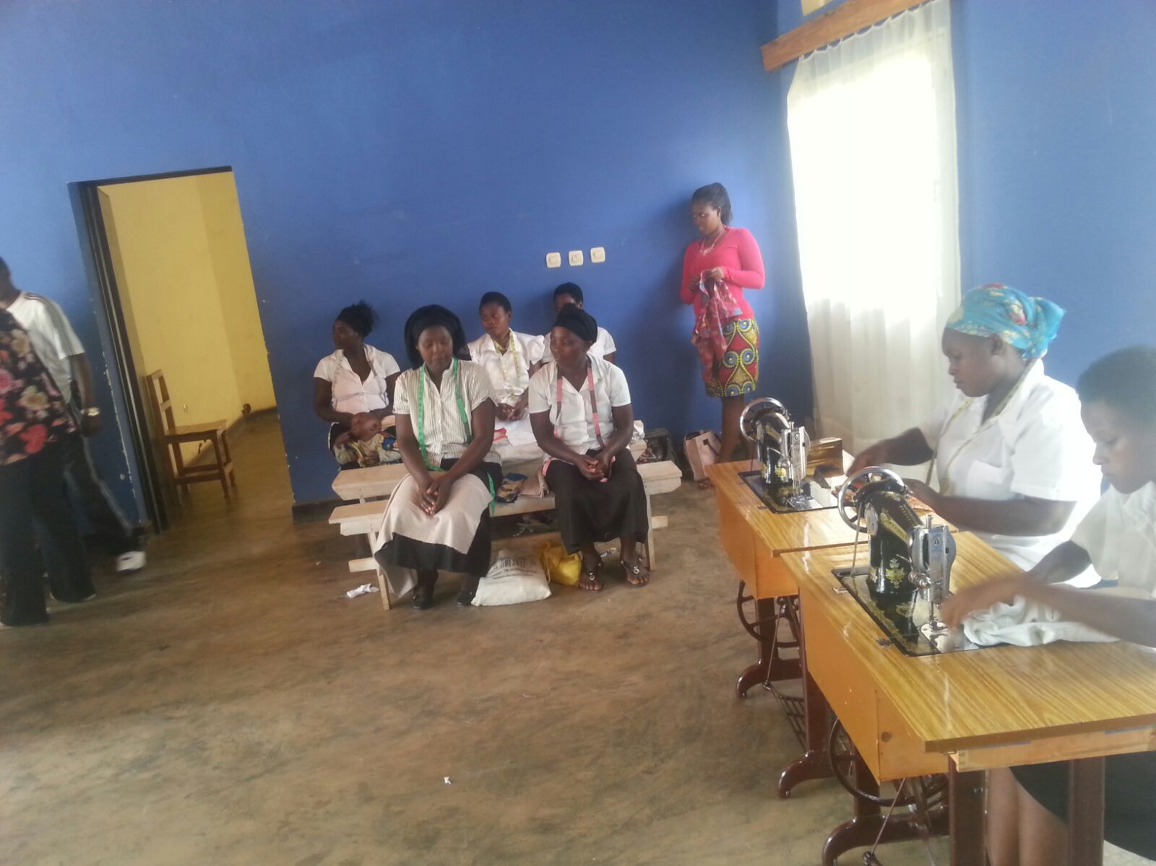
Single and Young mothers being trained by Peace and Hope initiative to get skills to get at least something to feed their Children coming from the School.
Instead of working hard in the business it’s important that these individuals work hard on themselves, be equipped with the necessary tools and skills for entrepreneurial development. It is where we have approached UNLAK and supported Trailer Machine which will help Single and Young mothers from vulnerable communities to help them from fighting extreme poverty.
Due to heavy hungry from the Single and young mothers, the kids go all over the hill for looking a job or something to eat which will finally end both hungry and unwanted pregnancies .
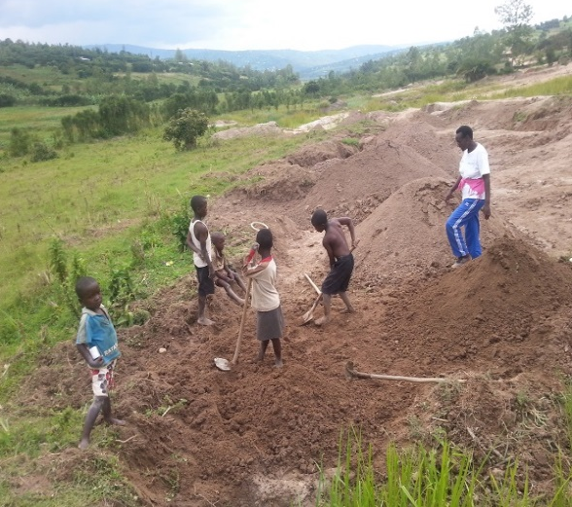
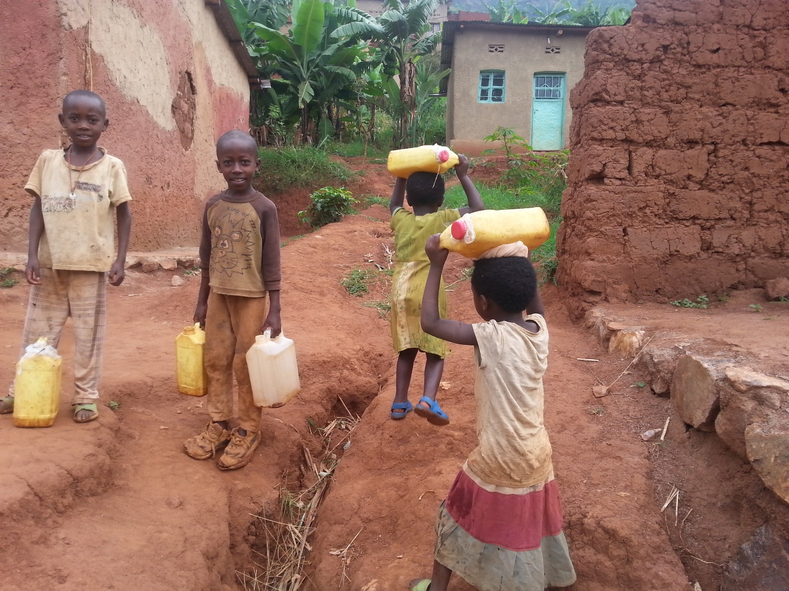
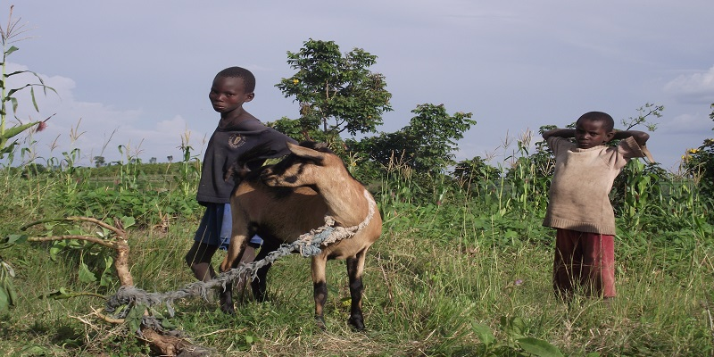

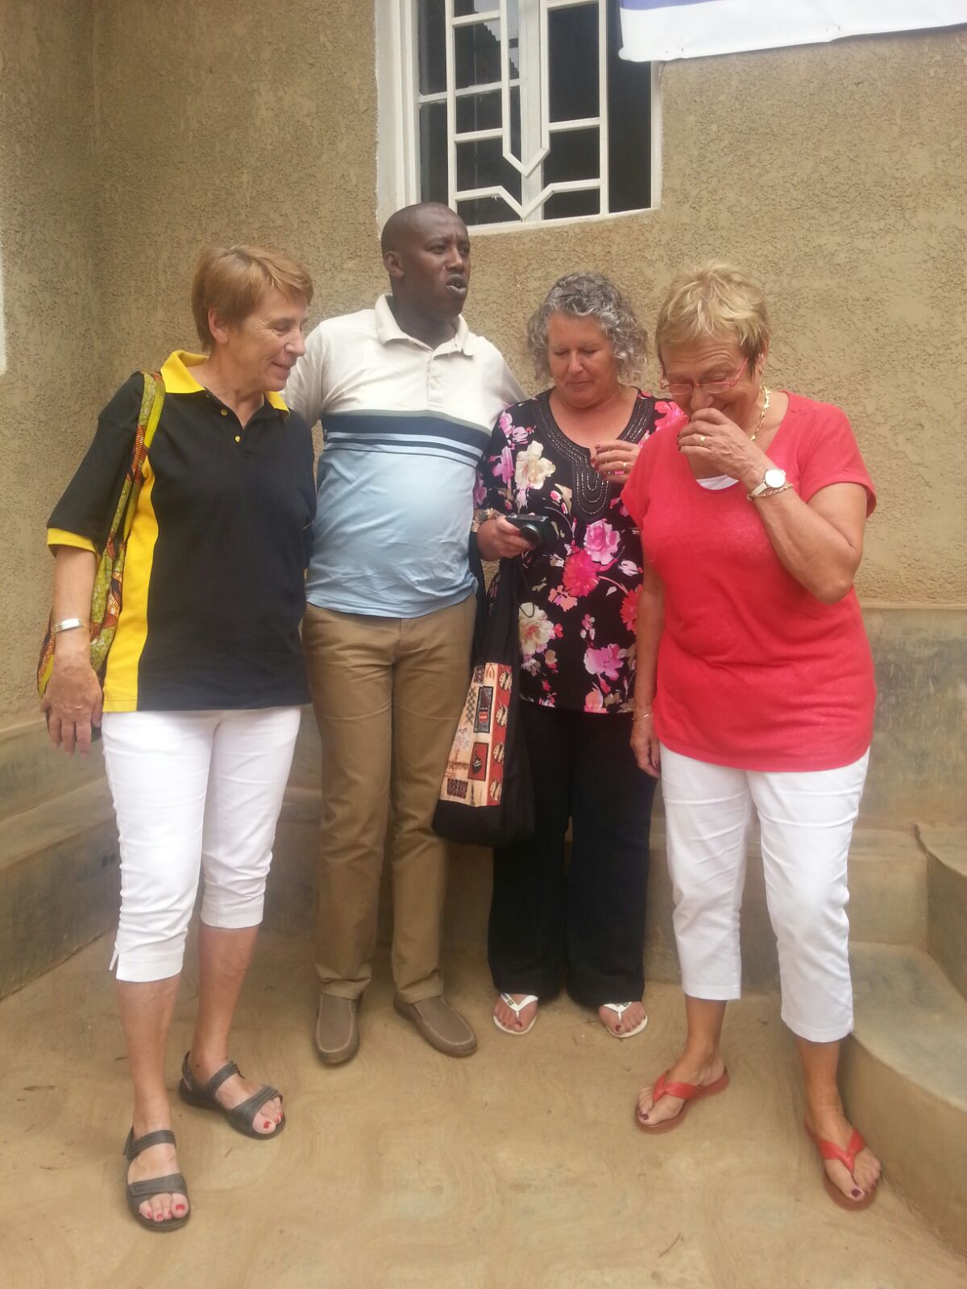
They got emotional after visiting Peace and Hope Initiative & accepted to come and Cerebrate Christmas with Vulnerable Children

This group of women and some men exists as a charity club that sponsors three different groups in need a month. We socialize with one another, plan fund raising events and sponsor benefit concerts to raise the funds that support the charities. The women are from all over the world and are here in Kigali and Rwanda for a number of reasons. Many work for the Embassies. Many work for NGO's-(non-governmental organizations), some are pastors wives's and missionaries.
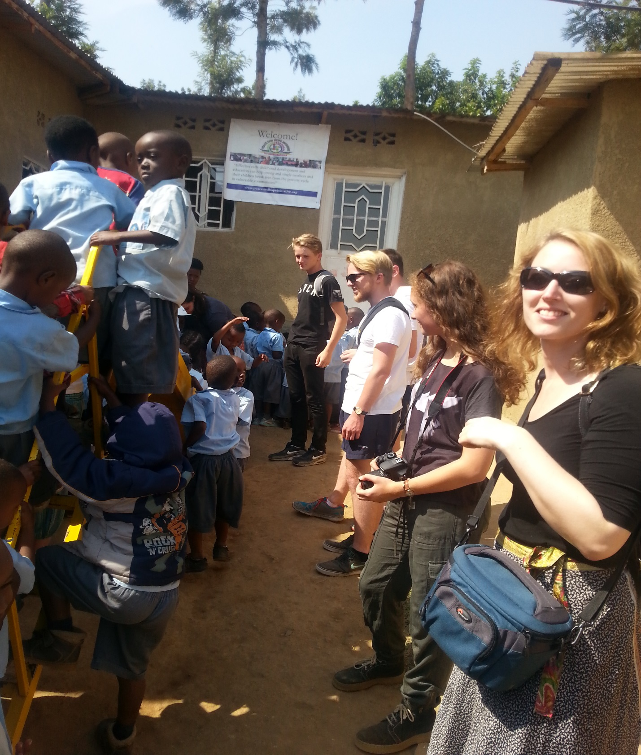
Students from UK visiting our Center where the Vulnerable Kids are getting Basic Education.

Make a Wish Campaign for Christmas to Vulnerable people aims to wish Christmas to the community for just reminding them what happened before 1994 TUTSI Genocide, It was a big pleasure to celebrate Xmas with their entire families and those who unable to do it and come and join the families with capability and after losing the entire families no one cerebrated it either is Childless elderly, Child headed households or traumatized due to what he saw during 1994 Rwanda TUTSI Genocide.

Peace and Hope Initiative aims to organize this events for just wishing the Good growth of vulnerable children from the single and young mothers who got unwanted pregnancies because they had to assume a role of parenting their young brothers and sisters actually needed to be parented and Childless Elderly mainly called “ INCIKE “

Peace and Hope Initiative aimed to recall that before the 1994 Genocide against Tutsi all Rwandans used to come together and share Christmas meal while at the same time upholding their unity as well as helping one another.

