Registration of new vulnerable children 2016
- Background of Peace and Hope Initiative
The Genocide of 1994 was planned and executed with such atrocity that within 100 days it took the lives of more than million people of Rwanda. The survivors of the massacres were mainly orphans, many of whom found themselves as children suddenly heads of the household; widows, grandmothers living along without children or family, women infected with AIDS as the result of victimization by rape, and those left handicapped either physically or mentally. These massacres have left a population traumatized, destitute, homeless and penniless, without the means to survive on their own.
After the Genocide, an estimated 8000 orphans were left as heads of their households, responsible before their time for the care of their sisters and brothers as well as for other family members. These children found themselves alone, traumatized, without care or support from their parents or any parent-like figure, and without the financial resources to ensure that they would be taken care of. They suffered tremendously to survive and to keep their families together, assuming responsibilities far beyond what any child should ever have to assume. Their own childhoods were sacrificed, and their futures were extremely uncertain.

In 2002, 8 years after the Genocide, the first houses in the village de Kinyinya were constructed by IBUKA to accommodate the families who were living in the village in tents at the time. In 2005, 90 other houses were build and the orphans who were head of households, the widows, the grandmothers, and those afflicted with AIDS and physical or mental handicaps as the result of the genocide were placed here. In June 2006, 11 duplexes were finally completed and put at the disposal of people who had no homes and whom were living in very vulnerable circumstances. In total, the village of Kinyinya is composed of 128 houses inhabited by the total of 525 people.
The inhabitants of the village were chosen from among the most deprived and vulnerable people of each sector of the city of Kigali, approximately 2 families per sector. Finally, some of these people had a safe, secure place to call home. Unfortunately, whereas in Kigali there might be the means to do and odd-job for money, to beg, to be given charity or some food, on the outskirts in Kinyinya these people now found themselves isolated. There was no livelihood for the people who were relocated here, no means to provide food, education, medicine, or employment. Several children died of malnutrition and disease in 2006 after the first year after relocation.

The state helped with schooling only until the end of high school. Food was only provided on a sporadic basis, by the PACFA and the Banks of Rwanda. This precarious situation could not continue. In response to this life-threatening situation, the orphans in charge of their respective households formed an organization in 2012 known as “Peace and Hope initiative ” The goals of this organization were to develop a plan to garner resources so to enable these orphans to support themselves psychologically, address the health needs of the orphans, aid in education, teach about health, and work on developing sustainability projects so that they could feed themselves and provide livelihood for themselves and their families.
In response to the continuation of desperate circumstances facing this group of orphans as well as the community of Kinyina at large, the idea was conceived of to begin This Initiative in order to develop some projects in the community at large that would be revenue-generating, self-sufficient and sustainable in the long term.
These families formed a group to try to help to resolve some of the life-threatening economic issues that were facing them.
- 60 child-headed households.
- 20 families where the household head is infected with AIDS.
- 15 families of grandmothers living along without family.
- 15 families with members who are physically or mentally handicapped.
- 10 families with members who are psychologically severely traumatized as a result of the events experienced during the genocide
- 8 families who are normal and able to take care of themselves.

In total, there are 128 families with no means of support.
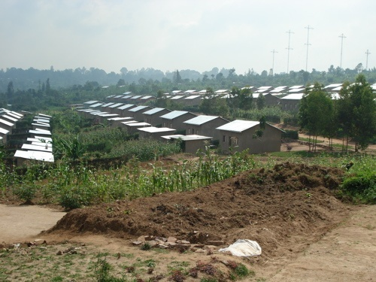
All of the members in the village of Kinyinya were placed here as the result of the donations from benefactors with participation from the government of Rwanda.

The Reason of Peace and Hope Initiative

Peace and hope Initiative is made up of the Heads of child Headed households who have playing the parental role of the younger siblings since our parents deaths in the 1994 Rwanda Genocide. The orphans often had to assume a parental role for their younger brothers and sisters while still being kids themselves. The lack of education and resources left them very vulnerable. This vulnerability often results in unwanted pregnancies, and the young, mostly single mothers not being able to provide sufficient childhood care/education. We who have been helped to assume both responsibility (Progressing our studies and parenting). We thought the below Project:
- KURANEZA Early Childhood Development
The Kuraneza Early Childhood Development (ECD) started in 2012 with 48 vulnerable Kids from vulnerable Families, in 2013 the number increased to 78 Kids and many poor families came to know the role of Education where we limited the number due to our premises , currently provide care and basic education of 118 vulnerable kids of 3-6 years . The Kuraneza nursery supports underprivileged kids of underage and single mothers, orphans and from families living with HIV/AIDS in poverty-stricken from vulnerable Communities. Effective Early Childhood Development helps kids at risk of poor development due to a lack of parental care and learning opportunities to break free from the poverty cycle in Rwanda.

How will this project solve this problem?
The Kuraneza (meaning "good growth") project offers early childcare and education enabling underprivileged kids to learn and play in a safe and caring environment. Kids are provided education, nutrition, counselling, and water and sanitation services through skilled caretakers during the key developmental stages. The project supports kids from families with no means to afford to pay for a nursery school/kindergarden. Currently 118 kids attend the nursery, the aim is to expand the capacity to 200.The project aims to reduce vulnerability of 200 kids in this area of improvement in the kids' development, wellbeing and learning ability will increase their chances to successfully pass primary school and succeed in higher education, which is essentially the key to breaking the poverty cycle.

What is the issue, problem, or challenge?
In the 1994 Rwanda Genocide many kids lost their parents and extended families. The orphans often had to assume a parental role for their younger brothers and sisters while still being kids themselves. The lack of education and resources left them very vulnerable. This vulnerability often results in unwanted pregnancies, and the young, mostly single mothers not being able to provide sufficient childhood care/education. The project strives to offer basic education and childcare to 200 young kids.

Vulnerable mothers praying for P&H Initiative
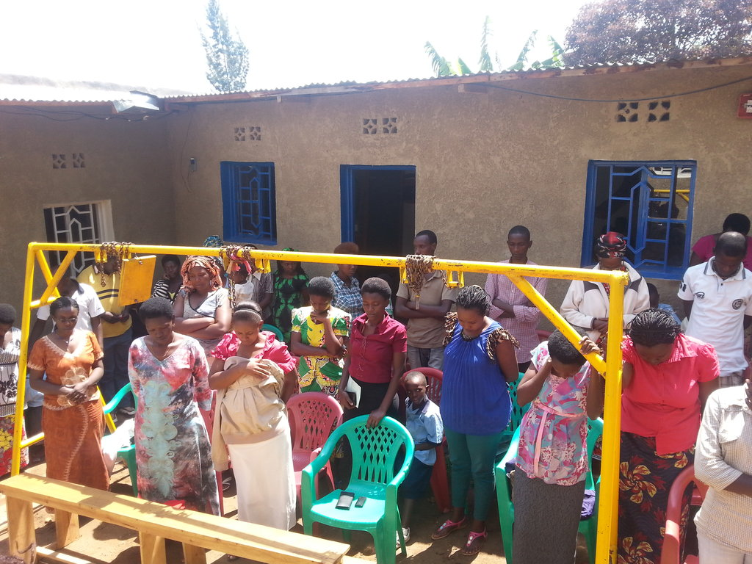
The Child Headed Households who have been playing a parental role after losing their parents and got undesirable pregnancies are praying to sustain our initiative to support their children

Graduation from Kuraneza nursery school

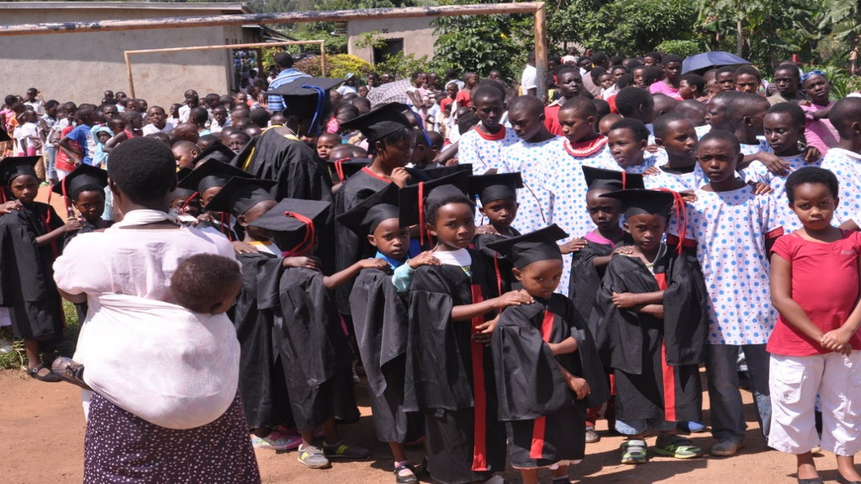
Children graduated in 2014

Student learning basic math

Caregivers and Founder of Peace &Hope playing
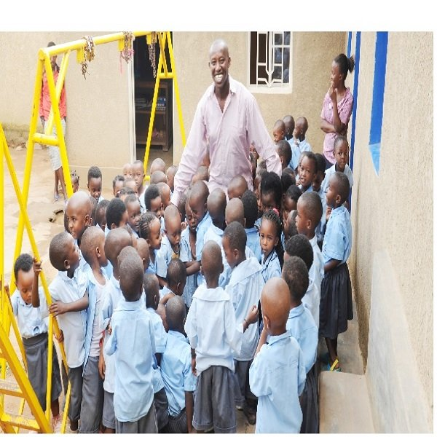
The vulnerable children are happy to stay with caregivers and Peace &Hope Initiative members at KURANEZA Early Childhood Development Center.

Vulnerable children with new sports wear
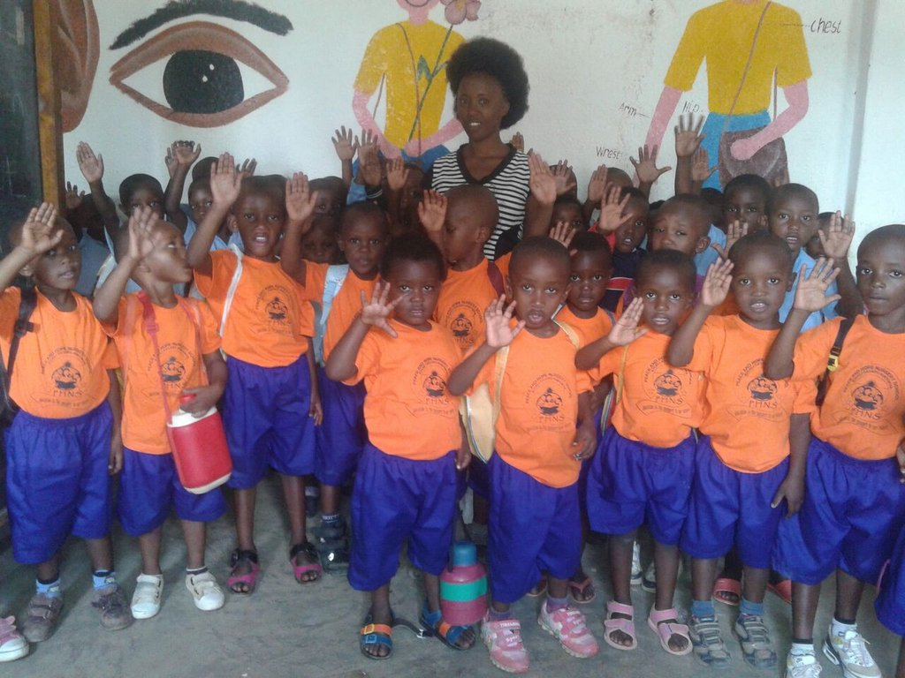
The photos has been taken after getting sportswear gifts. Play is an important medium through which the child interacts with, explores and makes sense of the world around her/his.
Food sharing
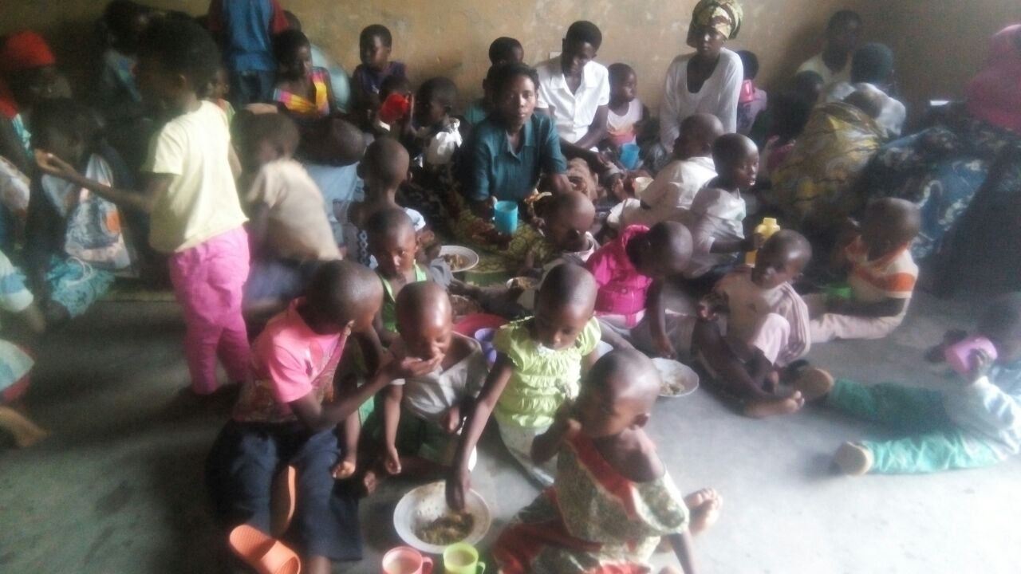
Sharing Food for those who are not able to get daily food!

Legal Representative interviewed by AFRICA AS ONE
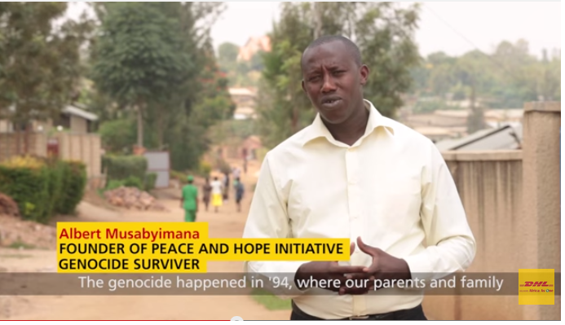
Albert Musabyimana, a survivor of the terrible genocide that took place here, in which he lost his whole family. He is the founder of the Peace and Hope Initiative which helps vulnerable members of the community and he is truly an inspirational man.

Albert MUSABYIMANA
Legal Representative
Peace & Hope Initiative
Tel: + 250788 312740
Skype: albertm246
www.peaceandhopeinitiative.org

https://www.facebook.com/pages/Peace-and-Hope-Initiative-Organization/432327800238840?ref=hl

KIGALI - RWANDA

