UPDATING YOU

It’s a motive of a big happiness for our foundation, telling you about the updates in these last weeks that we had with our kids and moms. First we are premiering a new big location more spacious and safe. Thanks to the big efforts of our team work, we are proud to say that on our new renewed location the kids and mums now have more space to share, learn and develop

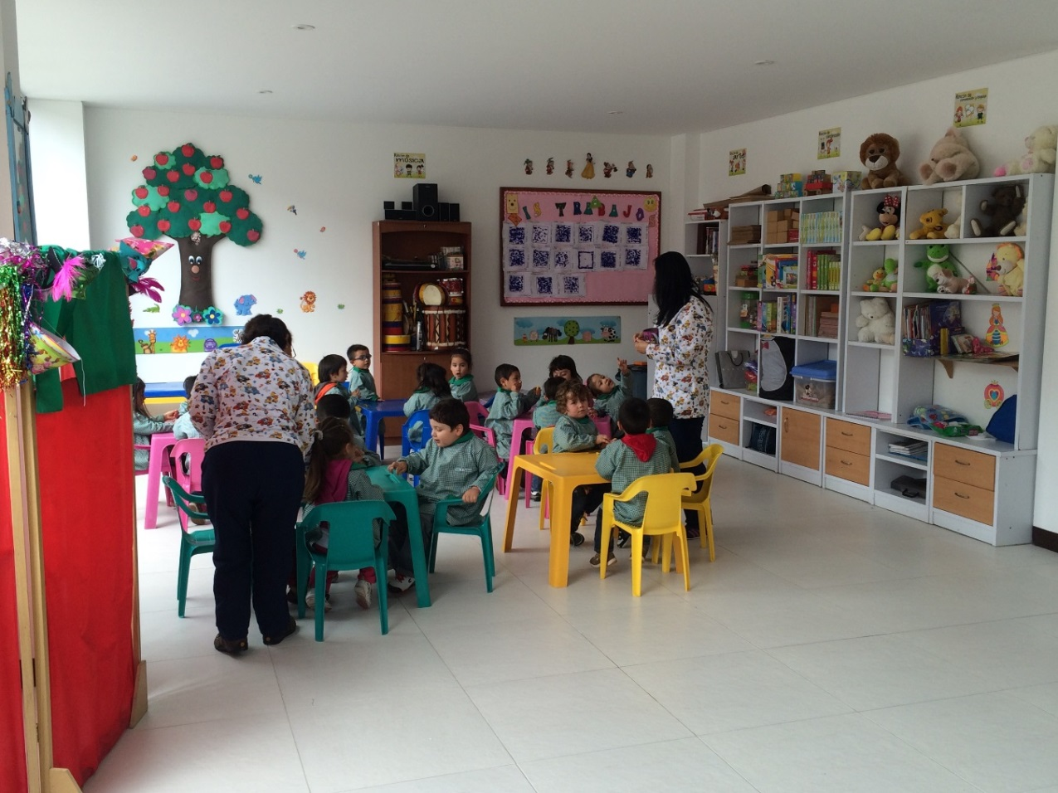

We continued providing markets to help our families in their nutritional process. We keep expanding catering of markets for the moms; these markets came to the foundation thanks of the low prices of Food Bank and these are organized for The Amiguitos Royal Foundation and then they are delivered for each center and finally get to our families.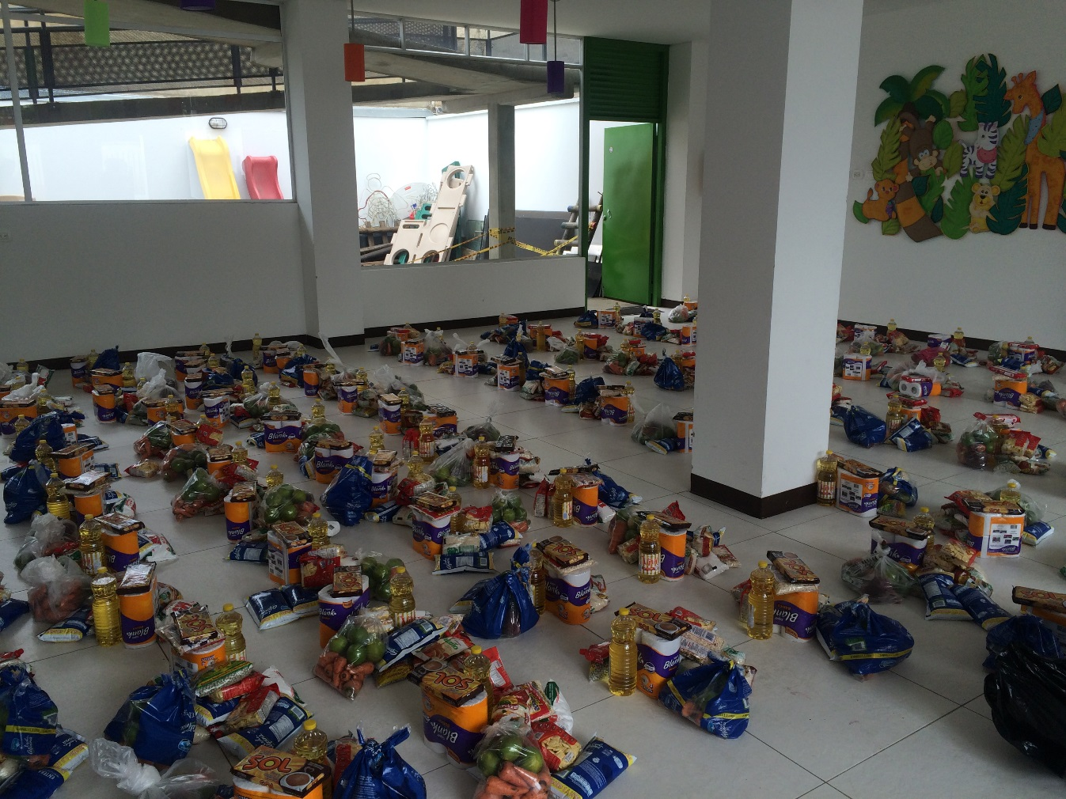

Due to the big weather changes that we have presented in Colombia, the respiratory and diarrhea illness has being increased, that’s the reason that we started to reinforced educative workshop for prevent the possible illness.

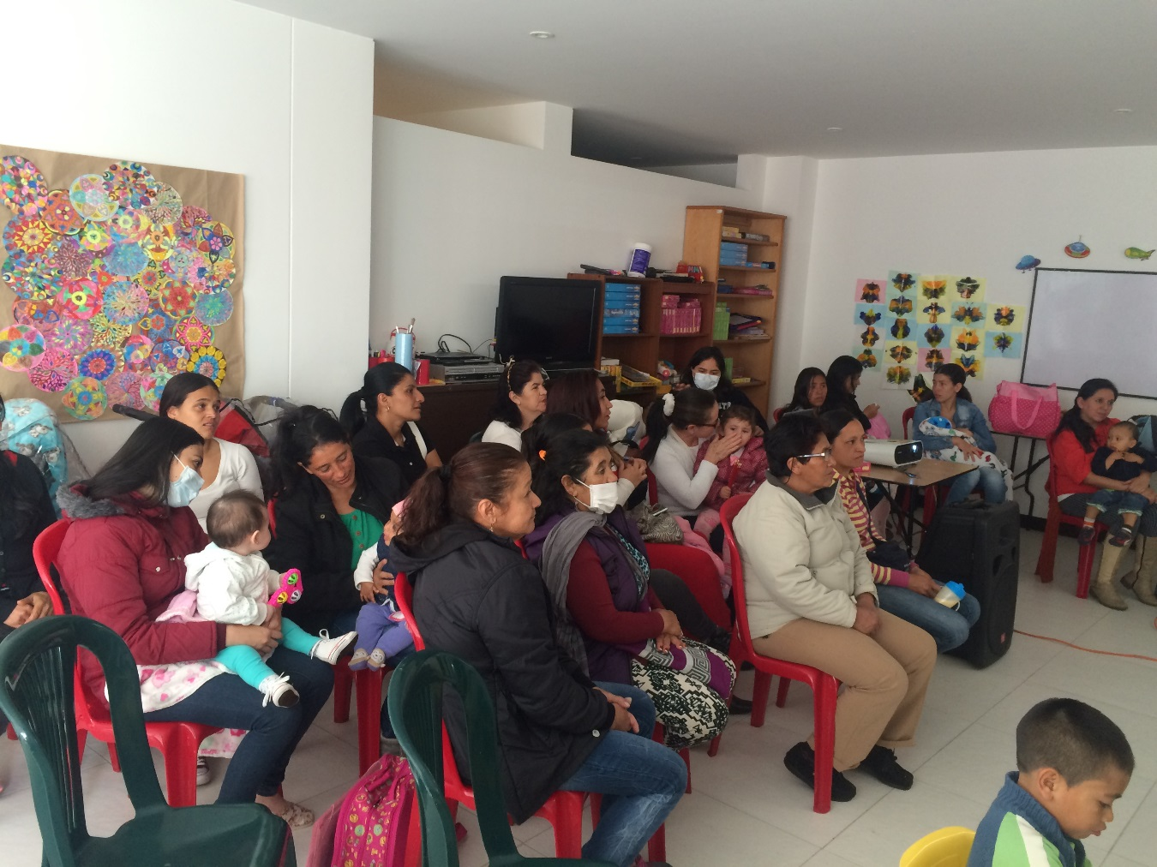

Thanks to all of you for being part of our project, without you none of our dreams would have come true

