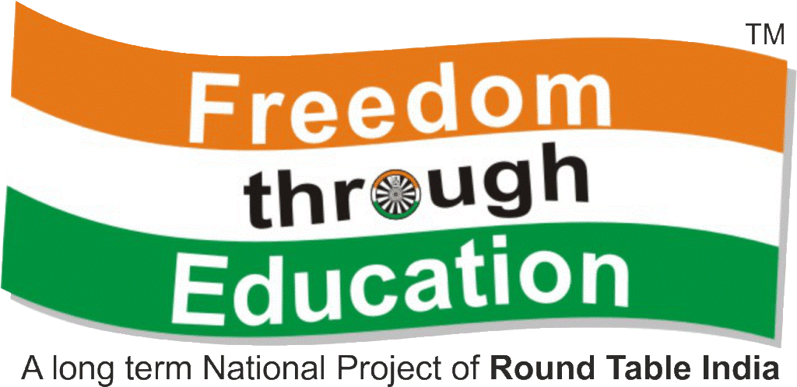

INVITE TO JOINTLY COLLABORATE

A N D

BUILD SCHOOLS FOR UNDERPRIVELEGED

Submitted By

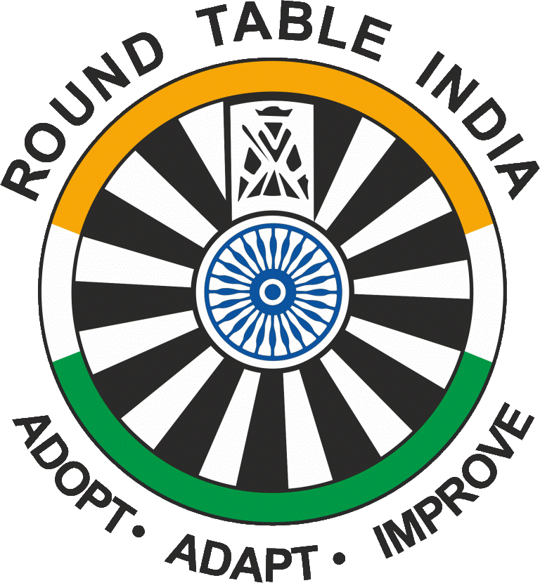

R o u n d T a b l e I n d i a



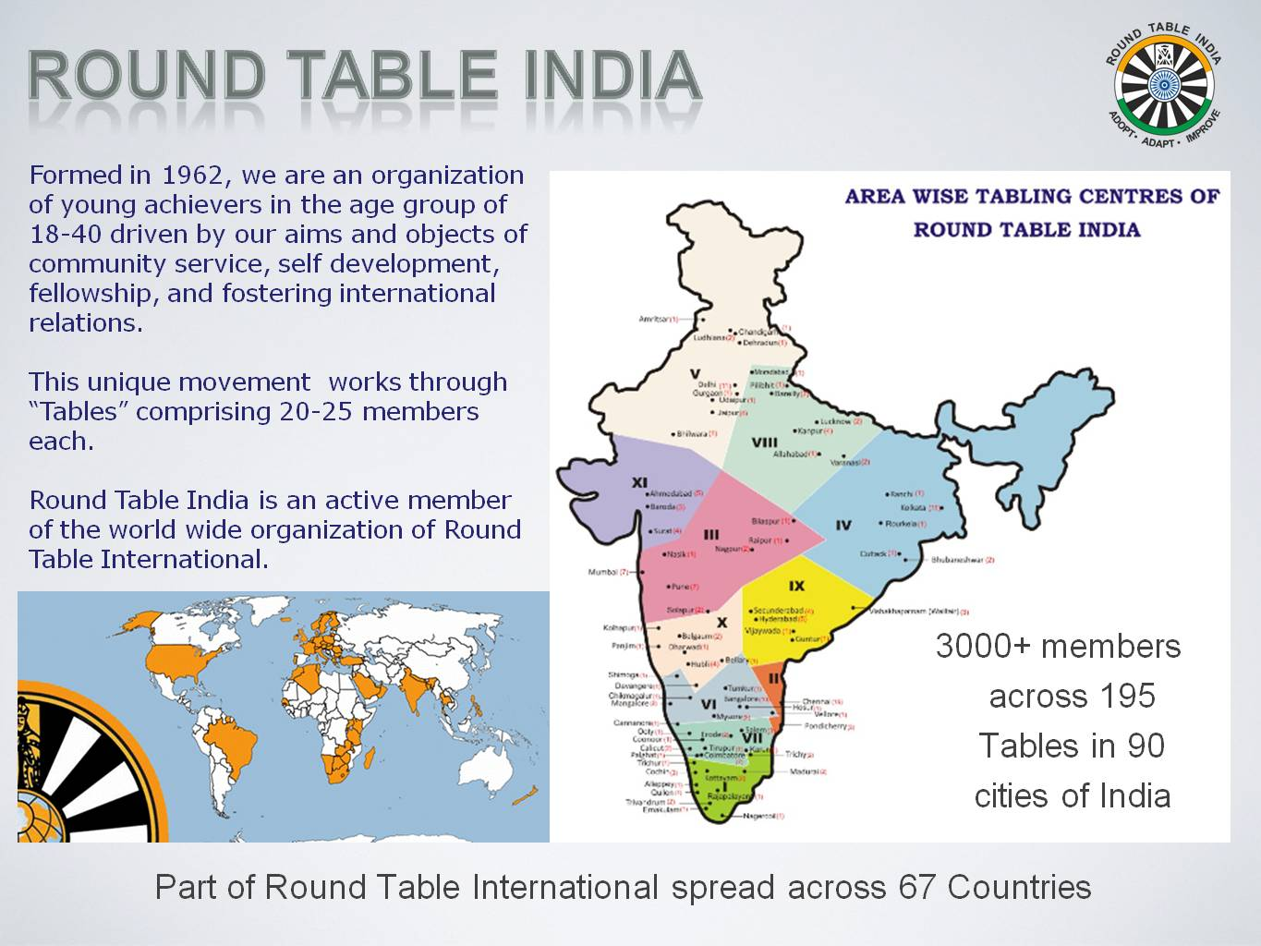
“To build a Country, build a Schoolhouse”
- Prof. Amartya Sen

In 1998, ROUND TABLE INDIA adopted “FREEDOM THROUGH EDUCATION”
as its National Project in pursuit of educating underprivileged Children.
During Last 15 Years, across India, we have built

- 1691 Schools
- 4609 Classrooms
- At an Outlay of Rs 124 Crores.
- Benefitting 5.1 Million Children over 25 years of Life Cycle of these Schools.
Data updated as on 30th June 2013

Z E R O O V E R H E A D
Every Rupee donated is used for Brick and Mortar construction… No Admin Costs.
Administration cost is met by Members’ Annual Subscription Fees.
Maximum leverage of donations deployed.

ABOUT FREEDOM THROUGH EDUCATION (FTE)

Even after 65 years of independence, Millions of Indian children have never, ever been to school. Illiteracy is a self-fulfilling curse that perpetuates the chain of poverty, degradation and child labor. To reach out to this group of underprivileged children, since the year 1996, RTI across the country started adopting projects aimed at providing quality school infrastructure, and then in 1998 this project was formalized and thus born the National Project of Round Table India “Freedom Through Education” - In pursuit of educating underprivileged children

Round Table India’s focus on Infrastructure-Building is aimed at promoting Education for Posterity and hence RTI has put in colossal efforts to build FTE School Blocks across the nation.

What exactly do we do through FTE And Our School Building Model ?

UNDER THE FTE PROGRAM, our Members (called Tablers) identify needy Schools for underprivileged that are operating from dilapidated or open structures; schools that have land available but little resources to take up big ticket expenditures like Construction. It is here that RTI steps in and builds School Blocks with Amenities across India to help such efforts and hands over newly constructed quality school Blocks to the school bodies.

Following are some of the bare necessities that are facilitated vide Freedom Through Education

- Build Quality School Buildings | - Deep Tube-wells for Sanitation
- Build Toilets | - Lights & Fans
- Classroom Furniture | - Science Laboratories
- Filtered Drinking Water System | - Library Rooms
- Computer Rooms

FTE Performance till 30.06.2013 is:

No. of Schools | 1691
No. of Classrooms | 4609
Total Outlay | Rs.124 crore
Impact to Society | Infrastructure built to impact  5.1 million children in India

ONE CLASSROOM A DAY EVERYDAY
During first 10 years of FTE, we built on an average one classroom a day everyday.
Since 2008, our focus has moved to a more holistic educational environment.

Principal Donors
P&G Shiksha
Infinity Foundation
New Business School, Amsterdam
Round Table India Foundation

Other Corporate and Institutional Donors
JM Financial, Azim Premji Foundation, AOL, Bajaj Allianz, DTDC, HP Compaq, SOTC, ITC, etc.

International Partnerships
Round Table Netherlands, Round Table Great Britain & Ireland, CORDAID, NOVIB

Large Scale Government Partnerships
Government of Andhra Pradesh, Sarva Shikshan Abhiyan and Government of Karnataka, Government of Tamil Nadu & Government of Gujarat

It’ll be a great day when education gets all the money it wants, and the forces have to hold a fundraiser to buy guns.


RTI is selected by P&G as a Primary Partner for SHIKSHA initiative.
P&G has contributed Rs. 12 crores since 2010.

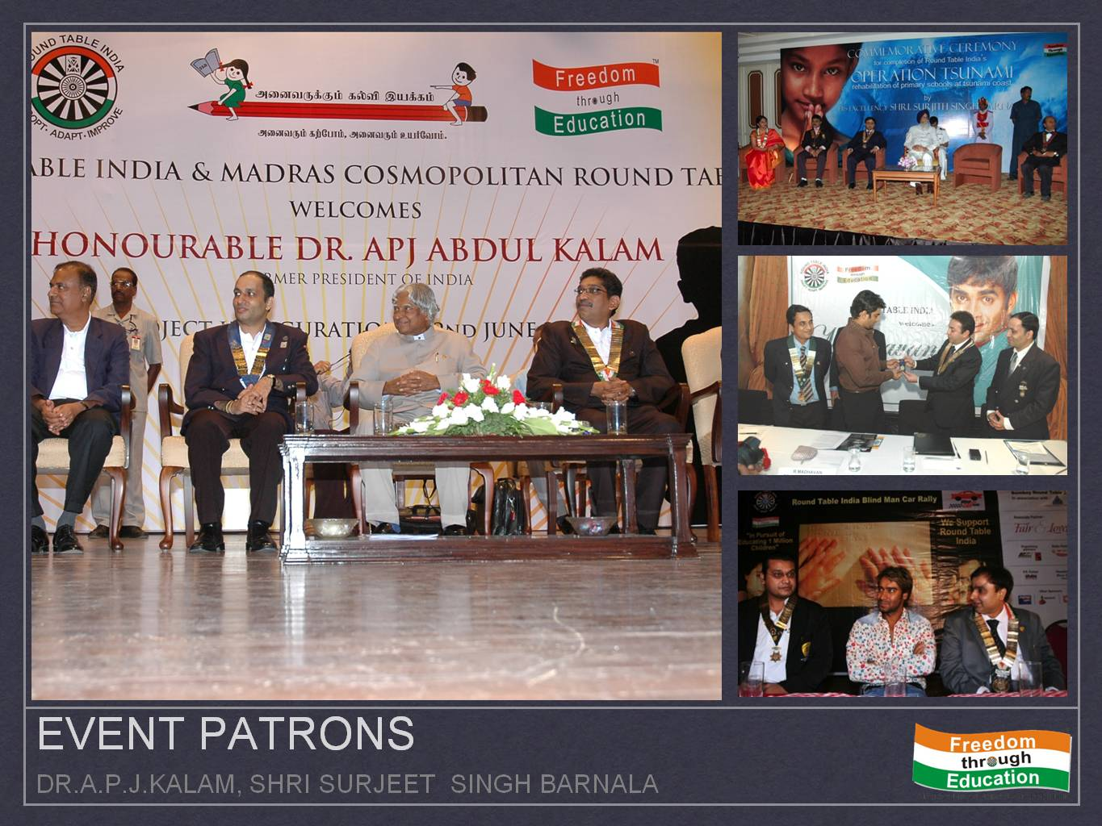

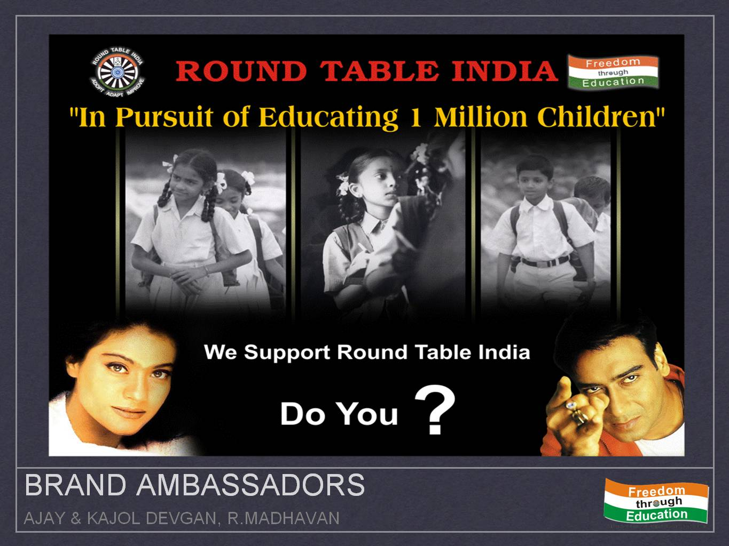

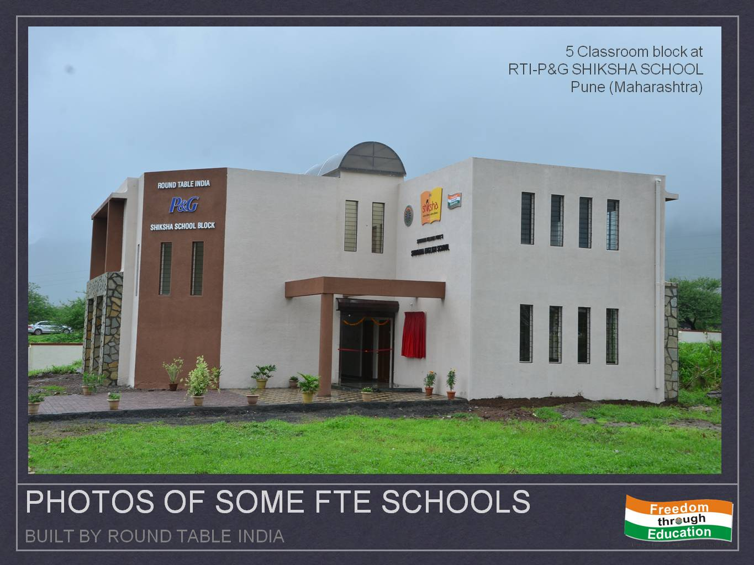

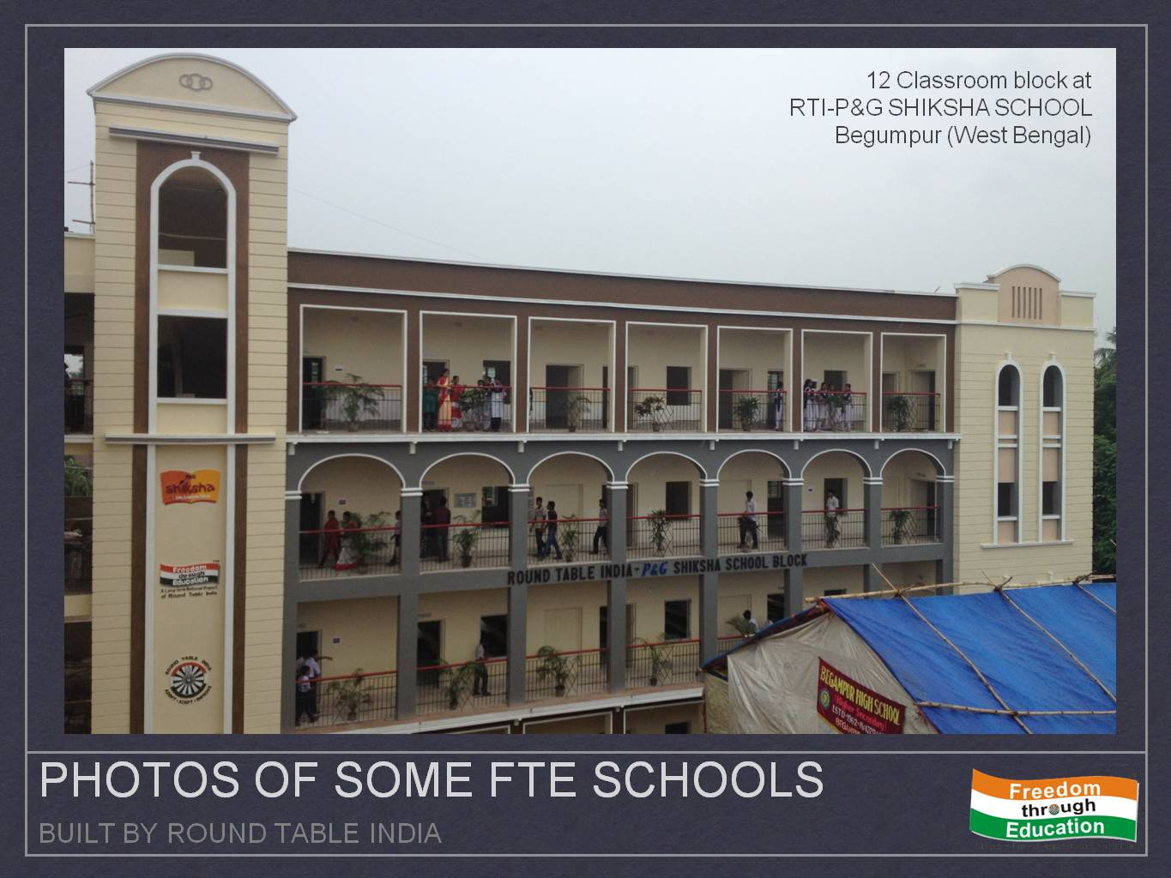

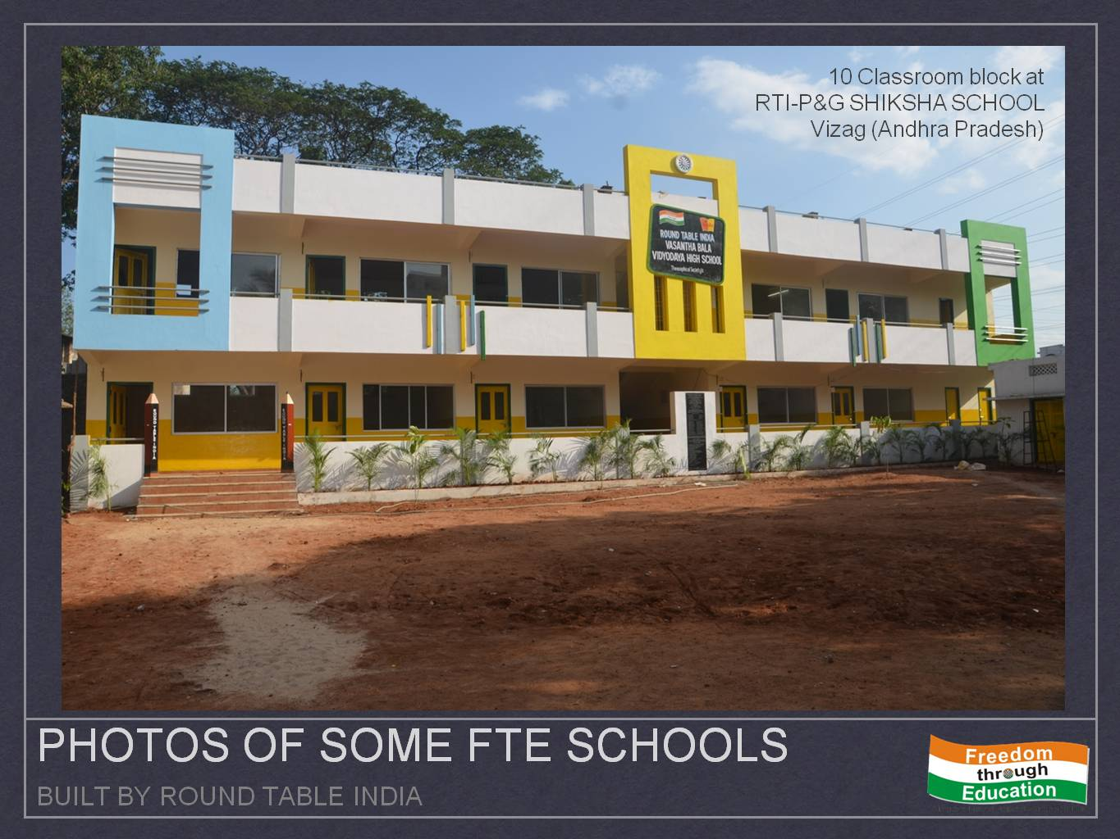

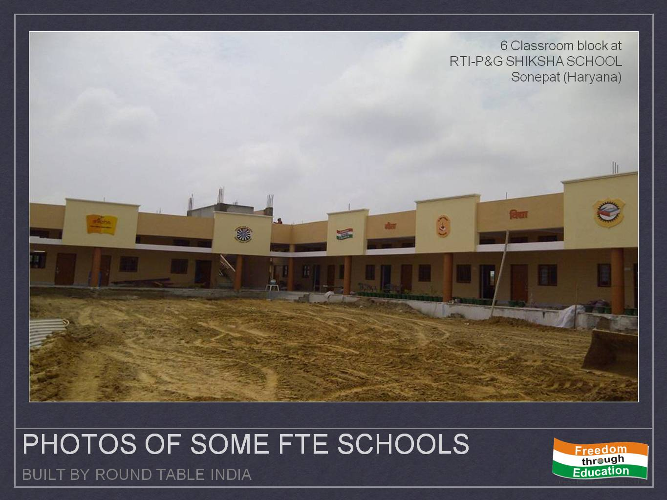

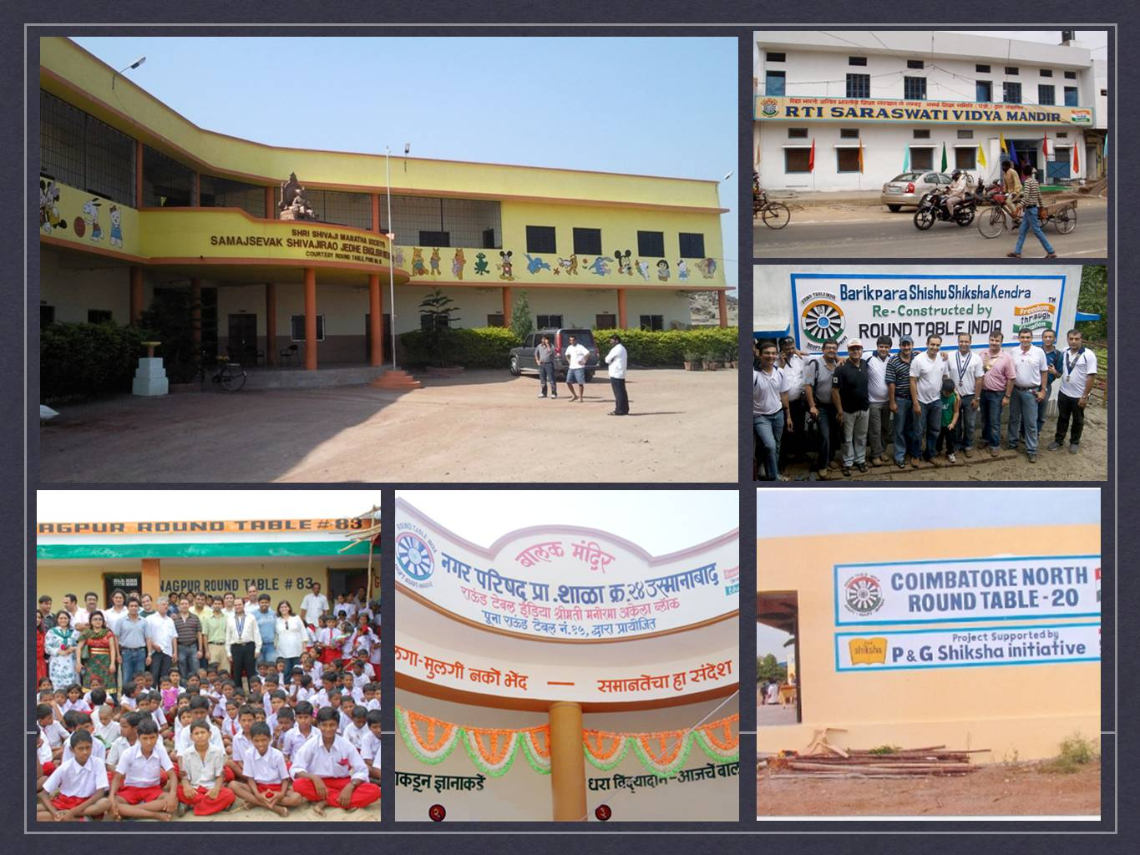

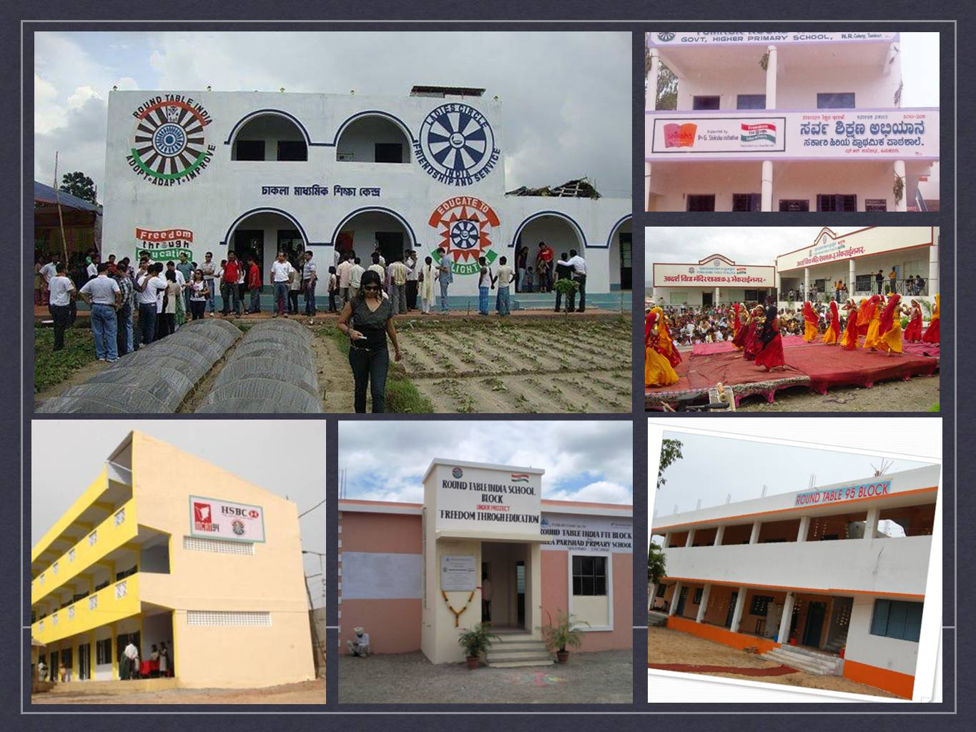

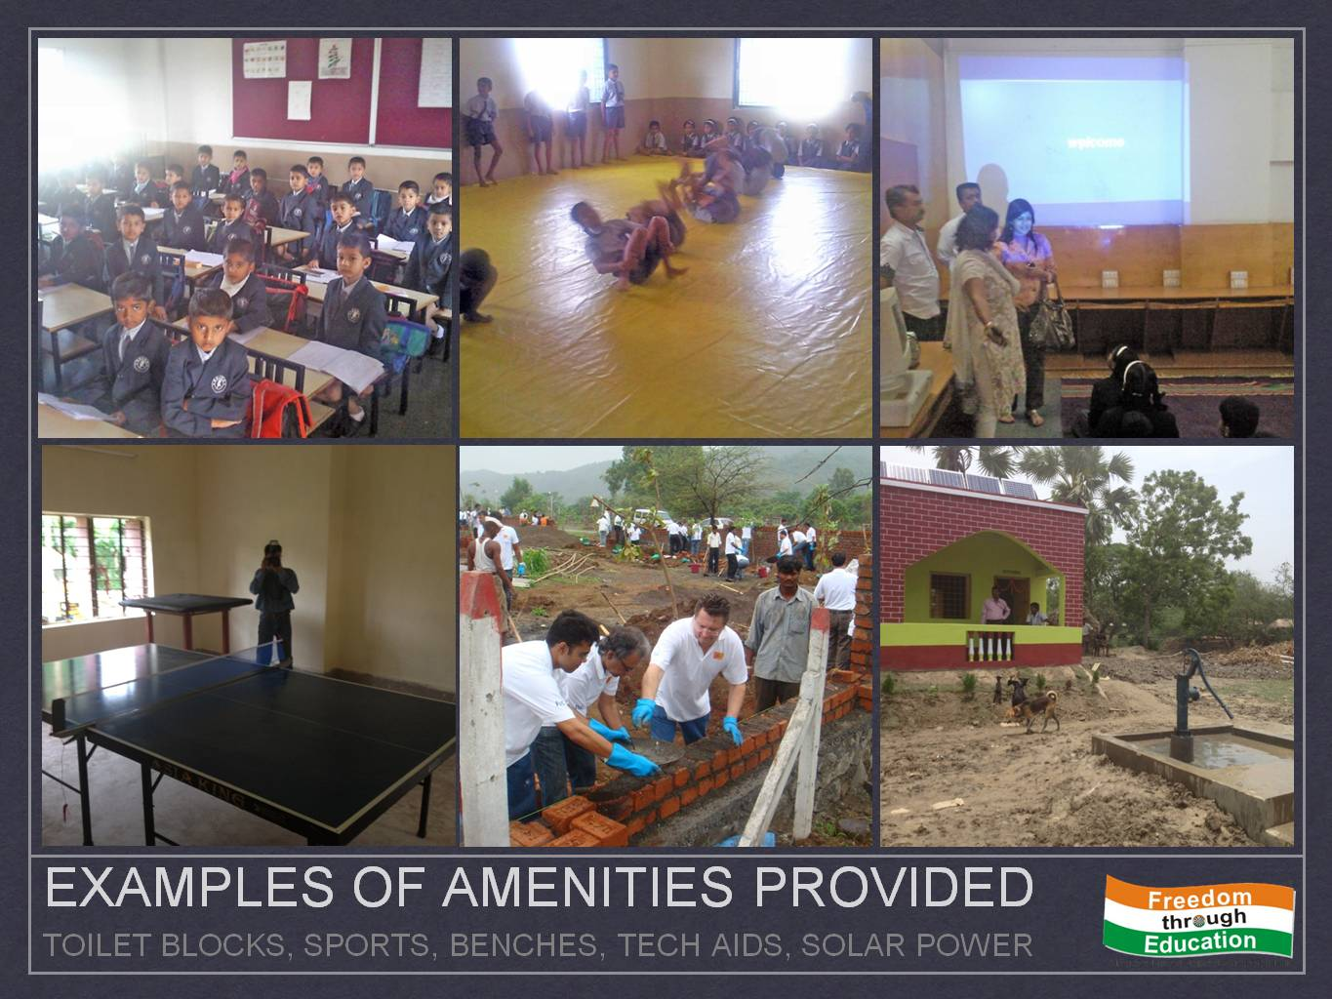

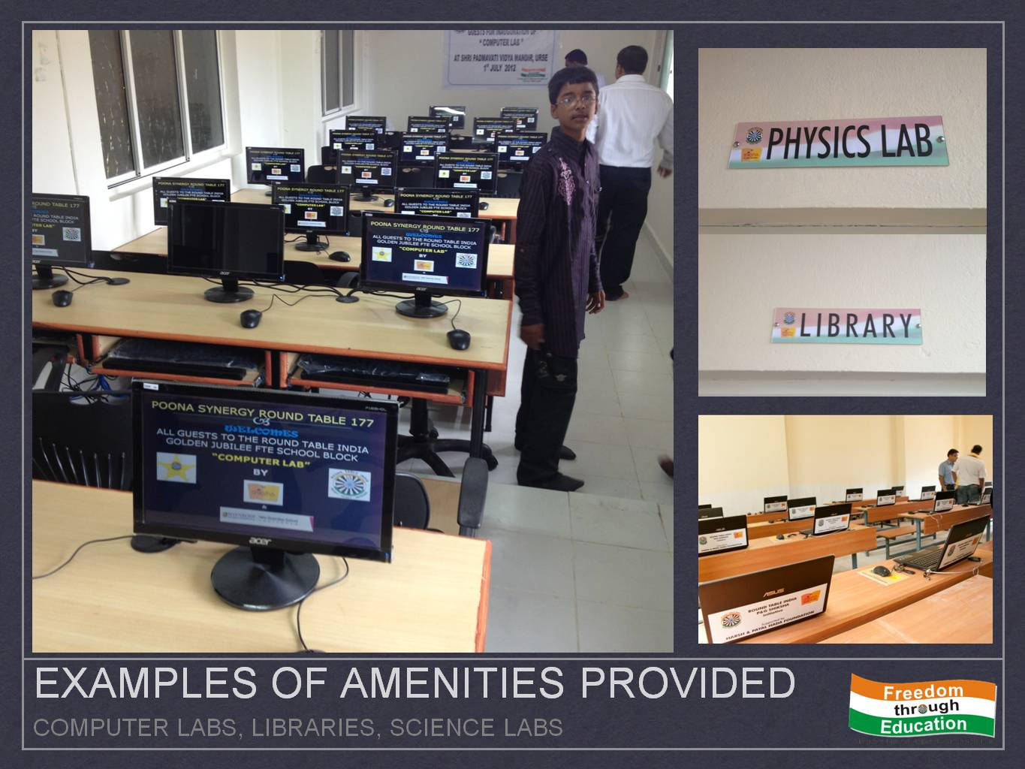

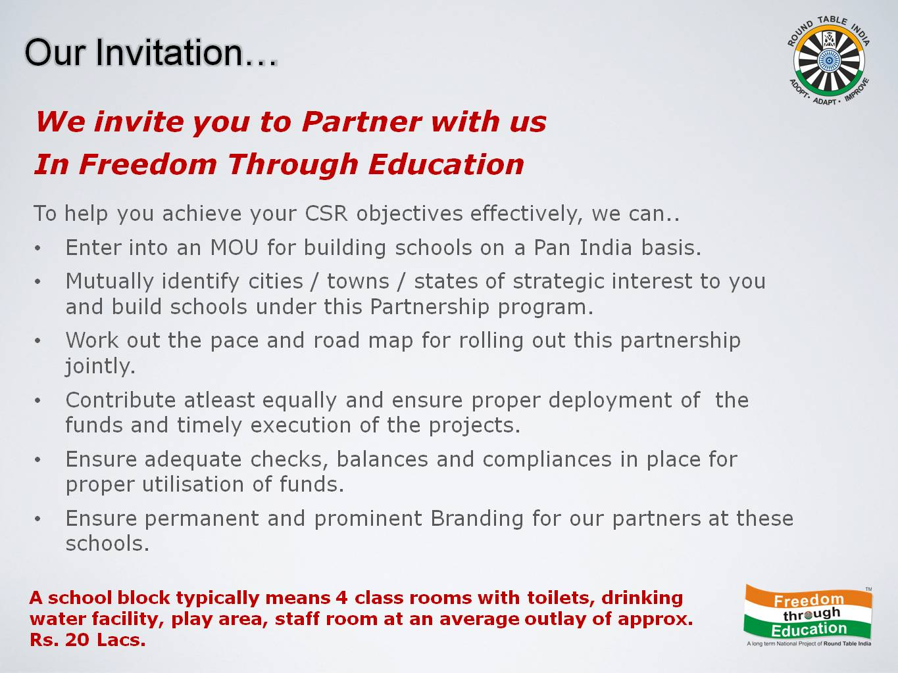

EXPERTISE, RESOURCES, GEOGRAPHICAL REACH

- Over the years RTI has gained an in-depth experience of handling FTE projects. In order to ensure that consistency in designs and norm are met across FTE projects, a well laid out Guidelines for construction is issued to all tables when a project is been sanctioned.
- Once a project is granted and as it progresses, a strict check is required to ensure that all norms and procedures are followed. This is made easy for tables by following a simple checklist. This checklist takes care of all paperwork and associated groundwork.
- A State-of-the-Art Secretariat in Chennai, doing the required follow-up for first level of compliance and maintaining Archives & Documentation related to the projects, enables the smooth functioning of the Administration.
- The numerous Builders / bureaucrats / professionals / politicians within the Round Table India only make it much easier for it to bring their expertise in, wherever and whenever required.

GEOGRAPHICAL REACH
- RTI is spread across 90+ Cities & Towns as Tabling Centers. New Centers are added each year
- Tablers understand that the need for schools and community developments initiatives are often within interiors and away from Centers. Often Donors too wish to address the lacunae within a particular location close to factories / native places etc. Hence Tablers have often identified, evaluated, commenced and completed needy projects, building School Blocks, hundreds of Kilometers away from base cities.
- Enough example exist and some of them are;
  - Raipur Round Table 169’s Gurukul School in Kondagaon… 250 kms away in Chattisgarh interiors
  - Post Gujarat earthquake, 20 schools built by Ahmedabad & Surat Tables in Bhuj… 800 kms away
  - Post Tsunami, 260 Schools were built by Tables hundreds of Kilometers along Tamil Nadu Coastline
  - Vizag RT 77 built 151 Toilet blocks across 72kms wide Rajahmundry Region, 212Kms from Vizag
- RTI is hence equipped with its expertise, systems and resources to undertake projects at any location within India as driven by the needs of a Donor or the Community

SCALE, DELIVERY AND IMPACT

- Round Table India has over the last decade achieved an average growth rate of 24%. This in itself is an indicator of the rate at which this organization is impacting its communities.
- Going by current numbers, it is projected that by the year 2020, Round Table India would complete more than 7000 Classrooms and impacting more than 45 Lac children
- Comparing Total Impact of a Contribution towards education can be misleading. Donations of a single pencil, or providing a classroom… both create an impact. Round Table India’s approach has been to contribute in field of Infrastructure, that has recurring long term gains as compared to short term benefits of donating perishables
- Additionally, the IMPACT of Building INFRASTRUCTURE is clearly MEASURABLE & Easily VERIFIABLE
  - Consider – a current cost of Rs.2.93 Lacs for building a classroom of 400 Sq. Ft with peripherals
  - 44 Children per batch per class in the first year benefited, i.e. 1100 children over a life cycle of 25 years,
  - Working out to a mere Rs.266.36 per Child required for Infrastructure.
  - Interpolating to Rupee Terms… hence @ Rs. 266.26 per child, each Rs.1 Crore spent provides Quality School Blocks for 37,600 children, impacting them directly
  - The indirect impact of creating a quality infrastructure for education within an underprivileged community is far reaching and cannot be quantified.

AUDIT

- The Charitable Activities of RTI are carried through its Registered (U/s 80G IT Act & FCRA) Trust “RTI Trust”.
- The Admin Activities are funded through contribution received from Tablers and Misc Income under “RTI”. Hence the Trust is operated as a Zero Overhead Cost, ensuring donations are utilized entirely for FTE
- Treasury Operations of Both Accounts (Admin & Charity) are maintained separately and audited each year.
- Audited Accounts are published each year as part of the Annual Report of RTI (can be made available)
- RT India maintains compliance of all FCRA regulations for receipt and use of International Funds

BRANDING / OWNERSHIP AND DONOR ENGAGEMENT

- Schools Built by RTI often consist of Donors from Corporate / Government / NGO / International Organizations. In such case the School is always branded appropriately with the Donor’s name prominently displayed externally across the block and internally on the Donor Plaque too.
- Standardized Donor Templates are made available to ensure branding continuity / uniformity.
- Agreement signed with School Trust on Building Ownership of same to dually display branding & prevent misuse

Donor Engagement
Donors are encouraged to engage themselves in manner of their choosing. Corporate Donors often do the same through their employees. Creating opportunities to interact vide visits; recurring programs, weekend training (if in vicinity), festival celebrations, short trips, Chief Guests at Inaugurations & Annual Days etc are normally a regular feature of donor engagement modules.

WORKING RELATIONSHIP – PROPOSAL

- This proposal envisages a partnership between Round Table India and you to build School Blocks for underprivileged children and /or provide Amenities to improve the Quality of Education.
- The Roadmap / Extent & Pace of moving ahead can be adopted in mutual agreement.

CONCLUSION

Round Table India is uniquely positioned with its strengths and expertise to partner with your CSR Programs in the Field of Education. The Impact measurable, monitorable, and truly making a difference to the School and Students that receive the benefits. The objectives of FTE and CSR find immense common ground and this opportunity to synergize can translate into extraordinary results… having long-term influence on Education in India
RTI’s Zero Overhead Model coupled with its scale, resources, experience and talented resources in its members and their own professional experience will take your contribution to its farthest reach.
We assure that the Contribution WILL be utilized in toto without deduction of any admin expenses or otherwise. MOREOVER RTI will further STRIVE TO AUGMENT the contribution with not only availing tablers’ resources but alsothe Tablers’ time and efforts in Implementation thatcome complimentary to the Collaboration.

For more details and information on our projects, please contact:

Tr.Rajat Bohra
National Projects Convener (2013-14)
Round Table India
Mobile: +91 9829240482
Email: npc@roundtableindia.org

Round Table India Secretariat
Bob Chandran Centre, 2nd Floor,
RTI House, New No. 80
Nungambukkam High Rd,
Chennai 600034
Tel: +91-44-28275760

URL: www.roundtableindia.org

