Project Title

To Provide Food and Medicine for 285 Disabled destitute at Seon Ashram

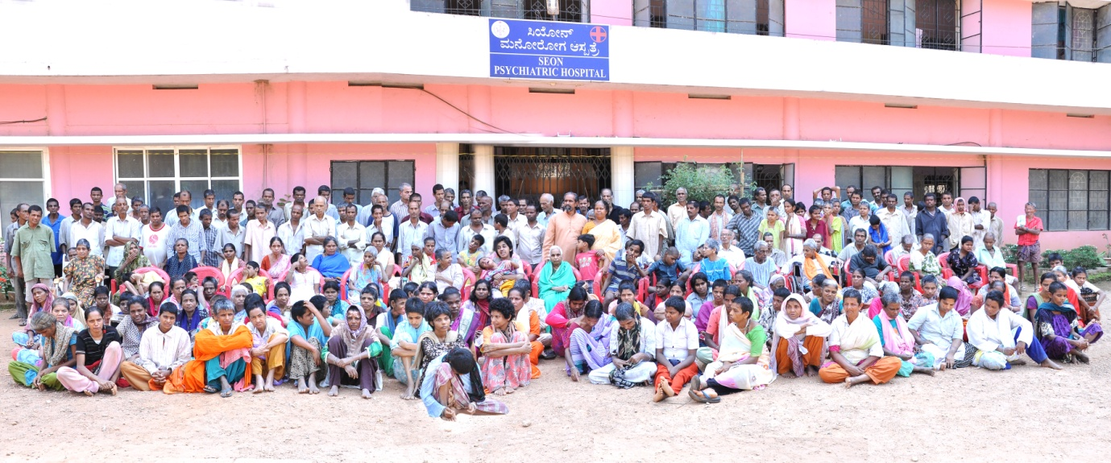

URL:
food-and-medicines-for-285-disabled-destitute at Seon Ashram
http://www.seonashrama.org/
https://www.youtube.com/watch?v=Zuoeninxo1Y
https://www.youtube.com/watch?v=w5Pxh3dmqUI

Project Summary
Seon Ashram trust®, a home for destitute and unprivileged people in the society. It is a registered rehabilitation centre for such 285 mentally challenged (Mentally ill and mentally retarded), physically handicapped, aged, misused women on street, orphan school going children and infants. The objective of seon ashram trust is to raise the quality of life of these destitute Disabled people of every caste and religion by creating an environment conducive to their physical, mental and spiritual growth in a holistic manner, to enable them as far as possible to become self reliant and their integration within the existing social structure. Ashram also provides them food, clothes, medicines along with the basic facilities to live in the Ashram for free of cost. Ashram doesn’t have any specific source of income. It depends on generous donations from individuals, organisations, individual groups from local and national. Ashram also aims to train these inmates to have good interaction with the family members, with the society and help them to learn basic life skills.

Requested Funding Amount

Dear Sir/Madam,

Sub : Project proposal for nutrition and medicine for the year 2015-16.
Seon Ashram trust®, a home for destitute and unprivileged people in the society. It is a Registered Rehabilitation Centre for the Mentally Challenged, Mentally Ill, Physically Handicapped, Aged, Misued Women On Street, Orphan School Going Children And Infants. This Ashram situated at a village named Gandibagilu, Belthangady Taluk, in Dakshina Kannada District, Karnataka State. This has been established in the year 1999 by a layman, Mr. U.C Paulose from the same village.

Seon Ashram takes care of 285 impoverished people in the society by serving them food, shelter and medicine at free of cost. Among them 115 are Mentally Ill, 53 are Mentally Retarded, 34 are Aged, 17 Physically Handicapped, 30 School going Children, 19 Orphan Children, rehabilitated. We are happy to inform you that few people are discharged and went back to their homeland and continuing normal life with their family members. At the same time, Ashram had to keep its door open for couple of new admissions whom we found on street.

Herewith we are submitting this proposal to you to obtain medical and nutritional assistance towards the inmates at our ashram. We are sure that, with the required supplement of nutrition and medicine, the person can come to normal life style and we can reach them to the mainstream of the society.
Please find herewith the attached proposal with the supportive documents. We request your support towards our mission in serving these unfortunate masses of the society.
Hoping for the favour,
Thanking you

Yours Sincerely,
Mr. U.C. Paulose,

Managing Trustee
Seon Ashram trust(R), gandibagilu

Donation Options
$156 will provide 1 time meal all 285 disabled inmates at Seon Ashram trust(R).
$445 will provide 1 day food for all 285 disabled inmates at Seon Ashram trust(R)
$92 will provide 1 day salary of all the paid employees at Seon Ashram
$16 will provide 1 day psychiatric medicines for 168 mentally challenged patients at Seon Ashram tust(R) (Rs.6/-*168=Rs.1008/-)
$16 will provide 1 day Nutritious food for 34 old age destitute at Seon Ashram (Rs.30/-*34days=Rs.1020/-)
$89 will provide 1 time breakfast for all 285 inmates at Seon Ashram
$38 will provide milk and other nutritious food for 14 handicapped mentally children at Seon ashram for 1 week.
$438 can sponsor an orphan child for the whole year (School fees and food) for his/her education.
$15 will provide 1 month pension for a helpless old age person from Neria village

Attached below the budget of the year for your reference
SEON Ashram Trust(R)
Budget Estimation 2015- 16
 | PROGRAMS |  | TOTAL Amount
A) | Recurring Expenses |  | (In Rs.)
 | Salary: | Monthly | Yearly
1 | Project co-ordinator | 20000 | 2,40,000.00
2 | Doctor: Physician | 15000 | 1,80,000.00
3 | Doctor-Psychiatrist | 20000 | 2,40,000.00
4 | Accountant | 7000 | 84,000.00
5 | Social Worker:2 Members | 16000 | 1,92,000.00
6 | Manager:1 member | 19000 | 2,28,000.00
7 | Human resource manager: 1 member | 15000 | 1,80,000.00
8 | Nursing Staff:4 member | 20000 | 2,40,000.00
9 | Office Assistants :3 Members | 12000 | 1,44,000.00
10 | Field workers:4 Members | 12000 | 1,44,000.00
11 | Cook : 1 members | 5000 | 60,000.00
12 | Warden : 4members | 12000 | 1,44,000.00
13 | Attender :1member | 2500 | 30,000.00
 | Sub Total | 175500 | 21,06,000.00
B) | Maintenance Expenses
 |  | Monthly | Yearly
1 | Building Rent, maintenance and repairs | 55000 | 6,60,000.00
2 | Medical Expenses | 52000 | 6,24,000.00
3 | Food Expenses (285*100rs)per day | 855000 | 102,60,000.00
4 | Cloths for 285 (285*200) innmates | 57,000 | 6,84,000.00
5 | Material Cost- craft, Play,other | 5000 | 60,000.00
 | Recreation meterial | 1500 | 18,000.00
 | Sub Total | 1025500 | 123,06,000.00
C) | Non Recurring Expenses |  | Yearly
1) | Kitchen Equipments |  | 60,000.00
2) | Cots, mattress, table etc |  | 1,75,000.00
3) | Supporting Instruments (like Walker, Wheel Chairs etc) |  | 60,000.00
5) | Sub Total |  | 2,95,000.00
 | Grand Total |  | 147,07,000.00

What is the issue, problem, or challenge?
Among the existing 285 patients at Seon Ashram, 90% of them are brought to Ashram from streets, bus stops and railway stations, who are suffering from various diseases, begging for food and sleeping anywhere on the road. Such destitute are brought to the Ashram, cleaned, provided food, and shelter, clothing and necessary medical treatment. This Ashram has served 1500+ people by now, providing them food/nutrition, medicine and all other basic requirement free of cost.
Major challenge that we face is lack medicines. All these patients need regular investigation. Most of the residents are suffering from chronic psychiatric illness. We have patients suffering from Schizophrenia, Depression, Mood Disorders, Personality Disorders, Mental retardation and neurotic cases. All the people suffering from the above illness need continuous medication. They need medicines regularly for chronic schizophrenia, acute schizophrenia, Bipolar disorder, Neurotic cases, Behavioural problems, depression etc. These medicines cost us heavily on each individual patient. Many times patients need to be shifted to hi-tech hospitals for more treatment as per the advice of doctor and the cost is usually very high. Referral system expenses in hi-tech hospitals are very high especially the investigations like; scanning, x-ray, specialized second opinion and also other expense like surgery, medicines, hospital bills, transportation and expense of caretakers. Many a times patients feel very isolated, so we attempt to their needs by engaging them in different activities like sports, agricultural activities, horticulture activities, community workshops and individual attention for cultural activity and craft along with medications.
The motto of Seon Ashram is to heal the broken heart and the sick and them back to the society where they can live with integrity and equality. The confronted challenge to the ashram management is to provide regular drugs and supportive nutrition to the patients which would help them to come out of their illness and to become a member of the society

For Example:
Statistics of the Food for all the patients at Seon Ashram per day given below:
Food Expense for 285 people for 1 Day:
Time | Items provided | Amount (in Rupees) per day | Amount In dollars
Morning Beakfast | Tea, Idly/Dosa, Sambar | 20 (20*285)=5700 | $89
Lunch | Rice, Sambar, pickle, fruits | 35 (35*285)=9975 | $156
Evening Tea | Tea, Rusk | 10 (10*285)=2850 | $44
Dinner | Rice/Chapathi, vegetable curry, Milk | 35 (35*285)=9975 | $156
Total |  | Rs. 28,500 | $445

How will this solve the problem?
“Whatsoever you do to the least of my brethren, that you do unto me,” are the words from Holy scripture was the inspiration for starting the home for the destitute and neglected, trusting the bountiful hands of God Almighty.
At its development, the organisation was not free from problems and financial crisis. But, at all times, the promised hands of god were upon these less fortuned children of god in the form of kind hearted people. Hence, the trust could sucessfully render its 16 years of service to the neglected mass in the socienty.
Apart from the inhouse treatment for inmates at Ashram, we also conduct montly ones medical camp for Psychiatric patients wherein, the psychiatrist diognise the problem and provide medicnes for free of cost. Lot of people from near by locations get benefit out of this camp.
It is very important to engage all the inmates in some or the other activities as per their interest. This will help them to build up their confidence level and make them active in life. Few of the Activities are as follows:
Craft Work
Stitching/ Tailoring
Candle Making
Animal Husbandry

Potential Long-Term Impact
The ultimate impact of the project will be that all the 285 existing disabled community at Seon Ashram will enjoy a sound and fulfilling and quality life towards achieving a promising life through their physical, mental, emotional, social and spiritual development and well being. More specifically:
- They will have a safe accommodation and placement where they will enjoy their time in family environment.
- Gaining adequate nutrition, Medicines, physical exercise and quality healthcare the poor helpless and destitute patients will lead a healthful life.
- Tender love and provide care will bring a pleasant and enjoyable life for this disabled community and offer them emotional and release from mental depression and anxiety.
- Finally, the Ashram will contribute to build the life of the poor helpless and destitute person so that they can be an active person having love, fellow feeling and responsibility for significantly contributing in overall development and reformation of the society, country and nation.

Project Message
Story of a Mentally challenged Lady, Bobitha:
A Pregnant Mentally retarded lady was misused by someone, infected by VDRL+ was wandering around near by kakkinje street on 28.2.2013. We got the information from the public about it and we brought her and admitted her in the ashram. She was in a condition that she was not able to remember her name or place. She talks Hindi. She tells different names at different times when we ask her the name. We named her Bobitha. We don’t have any information about her family. We started her psychiatric treatment along with the pregnancy care. In the month of May 5th 2014 she delivered a baby girl. We named her Sahana. Sahana is a beautiful, cute baby loved by everyone in the Ashram. Bobitha still under psychiatric treatment and both of them are taken care by Ashram.
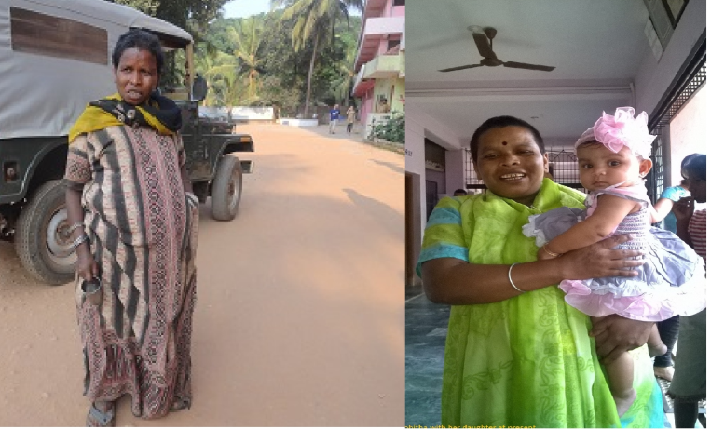
Story of Narad, Mentally ill person, became part of the mainstream society:
In 24.3.2013, we found a mentally retarded person at around 20 year old wandering on the street nearby Seon Ashram. After informing the police station, we admitted him to Ashram for the treatment and care. After consultation with our Psychiatric Doctor, he was given prescribed treatment by the ashram. His was so sick that he was not able to recollect anything. Not even his name. Over the period of time he recovered slowly and was able to remember his name & his address. Now he is recovered and on 1st January 2015, his family came and discharged him from the Ashram and took him back to his family. Now he is leading happy life by helping his parents.
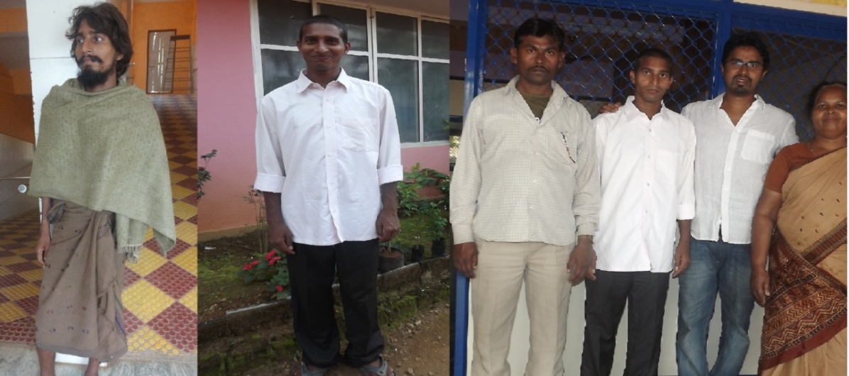
Narad, during his admission and while discharging

Keywords
Seon Ashram trust Mangalore,
seon ashram Belthangady,
http://www.seonashrama.org/,
https://www.facebook.com/seonashram

