SEON ASHRAM
Feeding and treating 302 disabled destitute from street

Our story

Have you ever thought that a dishevelled street dweller, who is mentally & physically challenged and rifles through dustbins at railway platforms could ever live a respectable life?

We have made this possible at the SEON Ashram.
Today, the ashram is home to the mentally ill, aged destitute, widows, orphans, needy children, physically challenged and sexually abused, all cared for and provided with shelter, food, clothing, medical care and other facilities. We rescue them to create incredible stories of change.

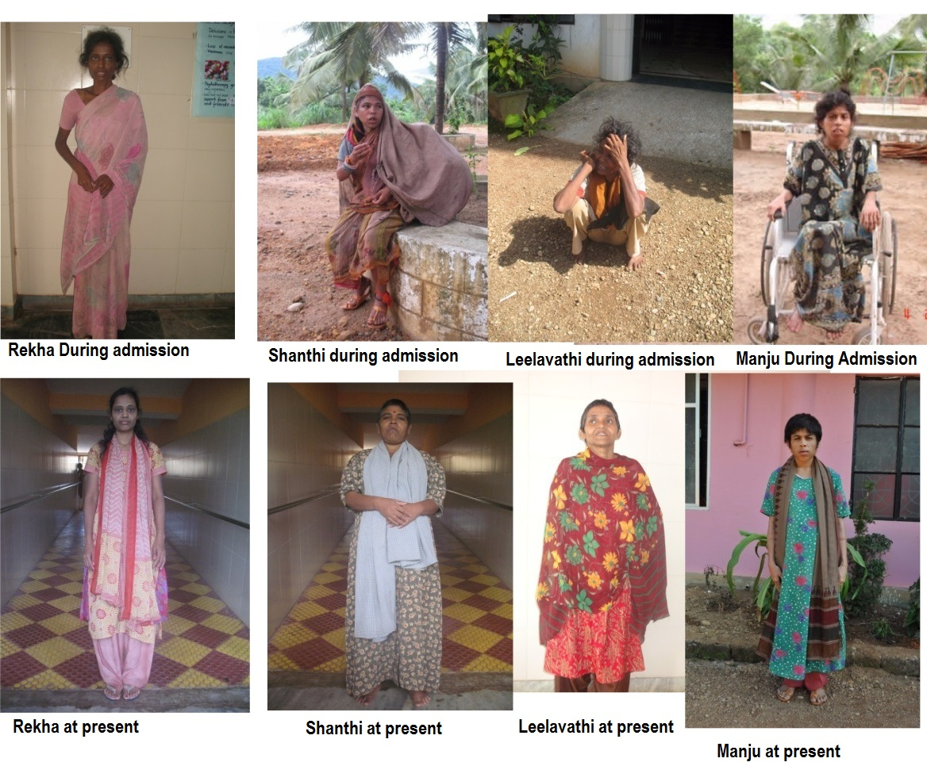

Who are we?

It was 18 years ago that Mr.U C Paulose,our founder had a life changing experience – he witnessed a sight that would define the purpose & the course of his life. He saw the heart-wrenching scene at a railway station in Kerala …… 2 mentally & physically challenged men were scouring through dustbins, looking for food among the dustbins! It moved him to see lives being lived at the cost of human dignity, in hunger and hapless abandon. Paulose felt that this has to change. He started the SEON Ashram to attempt something transformational.

SEON became the roof under which the homeless would find their chance for a better life. SEON provided them with medical care, counseling, food, clothing & shelter. Today, SEON has over 300 residents, whose lives are being transformed. We are located in Karnataka (Dakshin Kannada) at Gandibagilu in the Western Ghats - 85 kms east of Mangalore in a 10-acre plot of land. You are welcome to visit us.

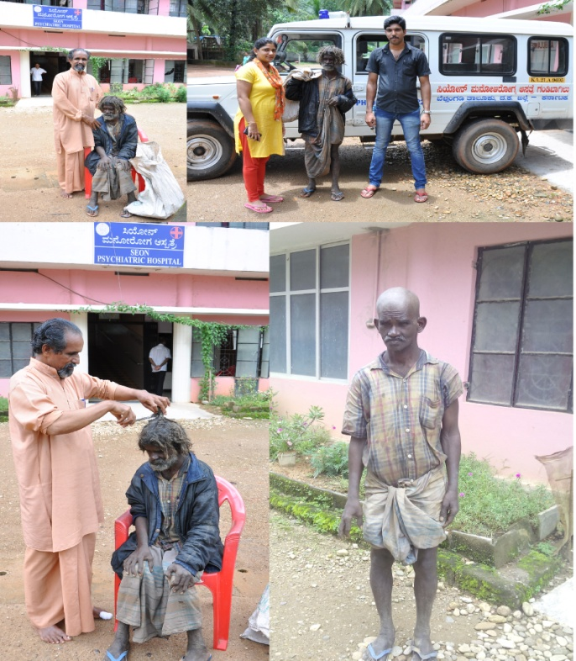

Our Vision

“To raise the quality of life of the mentally and physically challenged, old aged and depressed people of every caste and religion, creating an environment conducive to their physical, mental and spiritual growth in a holistic manner, to enable them as far as possible to become self reliant and their integration within the existing social structure. Our purpose is also to train these people to have good interaction with the family members as well as with the society and help them to learn basic life skills.

Our Objectives

- To raise the quality of life of the depressed disabled people of every caste and religion and create an environment conducive to their growth in a holistic manner physically, mentally and spiritually. Thus enable them as far as possible to become self-reliant and fit in to the society.
- To provide minimum basic needs such as food, shelter and clothing to this disadvantaged people.
- To provide basic facilities to build up good rapport among themselves and with others.
- To provide health care and close follow up of these disabled inmates and help out in their regular activities.
- To provide facility to develop some skill within them and thus enable them to lead a self sustainable life.
- To establish a vocational training centre to these disabled people. To identify, enroll and rehabilitate mentally challenged destitute individuals.
- To develop community awareness and participation towards the care of the disadvantaged group.
- To provide education for a better tomorrow for the needy children.
- To collaborate with other like minded institutions, NGOs and individuals to attain our common goals.

How can you help? Where does your contribution go?
You can support Seon by supporting the lives of our residents – all it takes is just Rs 113 per day, per resident. Your contribution will provide them with medical care, food and shelter. With your support we will be able to support and transform the lives of many more people who deserve this change.

113 INR funds a resident for a day!
35256 INR funds them for a month!

Currently we have 30 employees that include doctors (physician and psychiatrist), cooks, wardens, nursing staff, etc. that help in the care and recovery of our residents.

Seon Ashram is home to people of all types of disabilities, majorly mental illness and multiple disabilities. Most of the residents suffer from chronic psychiatric illness: Schizophrenia, Depression, Mood disorders, Personality disorders, Mental retardation and neurotic illness. All the people subjected to the above illnesses need constant medication for treatment. People suffering from mental illness are often deprived of guardian care and tender love. Being homeless and abandoned by society, they do not have it in them to participate in the world around them. This hinders with their social, mental and spiritual development.
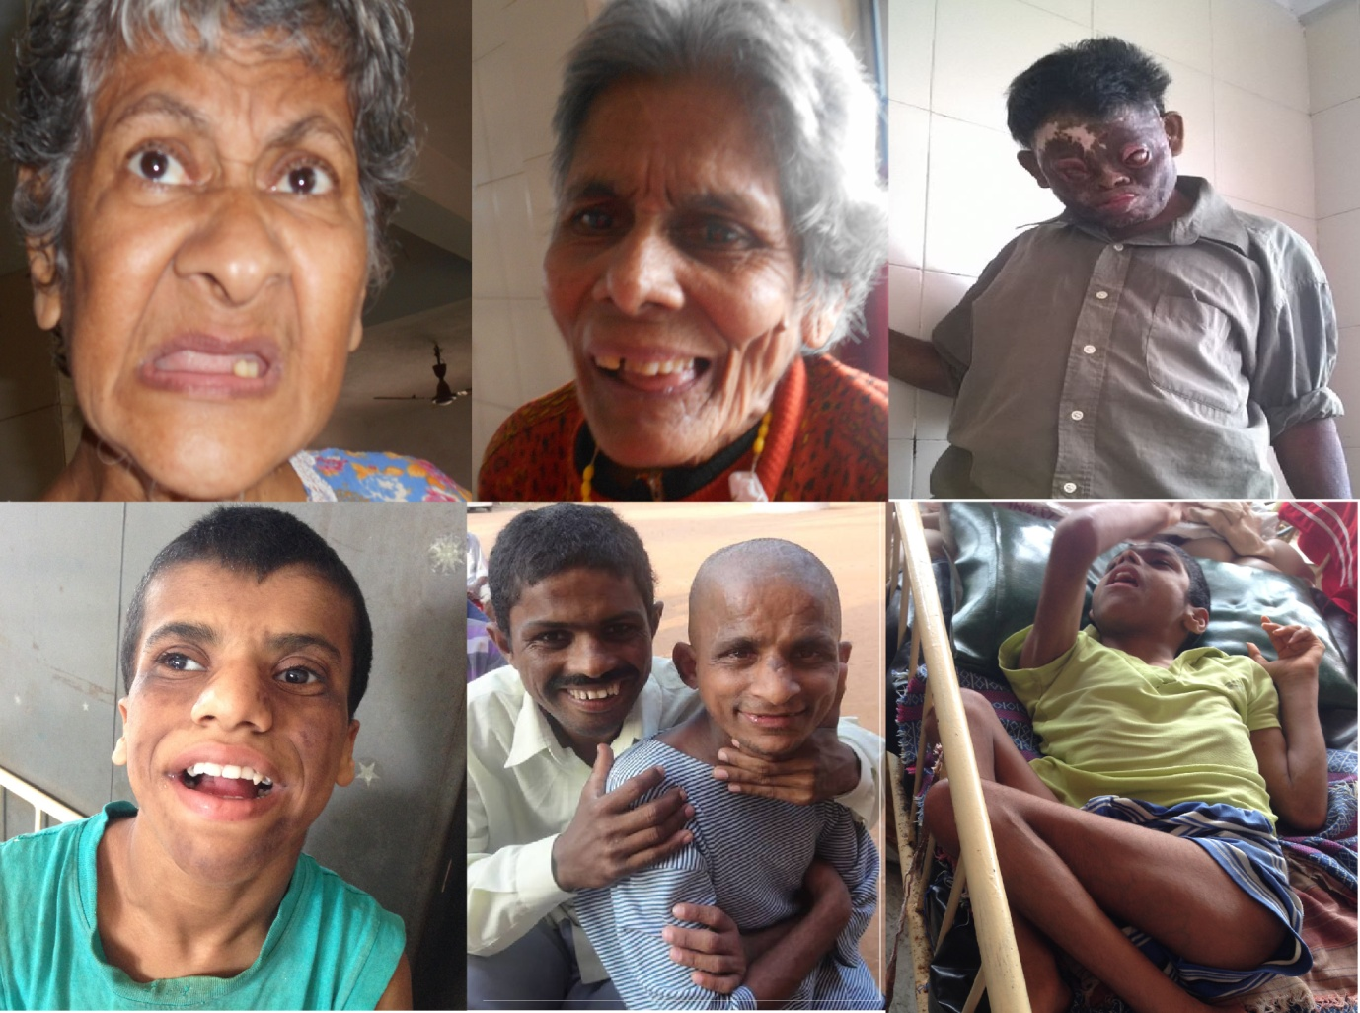

On some occasions, patients need to be transferred to better hospitals on physician advice, which also costs the ashram a high amount. Tests and various scans that need to be conducted at these hospitals along with surgery and transportation result in expensive hospital bills per patient.
Since we lack a permanent source of income to fuel the treatment of our residents, we rely completely on our generous donors for support to give these people a second chance at a normal life. We hope this project helps us provide the adequate nutrition and medicines to help them achieve that.
Various activities of our inmates

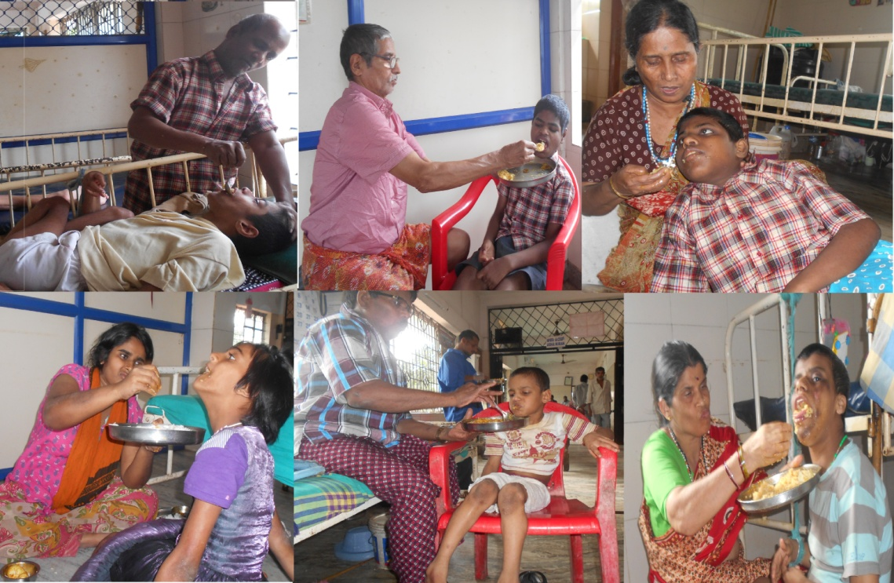

Note: All donations qualify for tax benefits under section 80G.
Note: We are FCRA certified – i.e. we can accept funding from international donors.

Success Stories

Since our inception, Seon Ashram has helped over 100-disabled residents without homes to return back to society and live a normal life.

Shreenath Pandey: 11 years ago we found Shreenath Pandey on the streets with severe mental illness. He then became a part of the Seon family and with continuous treatment and medication he was able to recollect his identity and past. He used to be a railway officer in Uttar Pradesh but unfortunate circumstances led to his situation. After seeing an astonishing improvement in his mental health, we approached his family and wrote to his two sons. Soon after, the sons visited Seon Ashram and were delighted to see their father having recovered and happy in the Ashram. His entire family then came to Seon for his discharge from our hospital and were all reunited.

Shreenath Pandey when Seon Ashram took him in and after, during his discharge with his family

Narad :Two years ago, we found a 20 something man wandering the streets around our Ashram. After informing the police, we admitted him to Seon to treat his mental illness. Our psychiatric doctor prescribed the necessary medication to him. He could not recollect anything from his past, not even his identity. Eventually over a period of time, memories of his past came back to him. He gave us the details of his home and family and we contacted them. After having fully recovered, his brother came to Seon to discharge him and take him home. We were very happy to have played such a crucial role in Narad’s life.

Narad during admission and after recovery

Bobitha

Two years ago, we took to our Ashram a sexually abused pregnant woman with mental illness. She could not remember her name or the place she was in. We named her Bobitha. Bobitha was also infected with VDRL + and we provided her with medication, psychiatric care and pregnancy care. In May last year, she delivered a healthy baby girl. Bobitha is still undergoing treatment and both she and her daughter are taken care of by the Ashram.

Bobitha during admission and now

Risks and Challenges

We have a lot of homeless people with disabilities that approach our ashram and without the necessary means to help; we cannot aid more people than we already have.
Our biggest challenges are:
- Diagnosing each resident properly to make sure they can benefit from our Ashram’s vision
- Taking more people under our wings to support and treat them
- Providing better, more professional care to residents with severe illnesses
- Incurring costs

Awards and Recognitions

Seon Ashram’s efforts have been acknowledged by the grass root level to the top rung far and wide. We have been recognized for our services with the following Awards.

2013
- ‘Sandesha Special Recognition Award’ by Sandesha, Foundation for Culture and Education® Mangalore.
- Lions Club Bantwal has honoured him with Phalapushpa, citation and cash award.
2012
- Mother Teresa Excellence Award by Integrated Council for Socio-Economic Progress (Regd.) a Voluntary organization from Trissur.
- ALL India Achievers Foundation Delhi, presented “SIKSHA BHARATHI PURASKAR” Award for the best service
2011
- Award presented by the SuddiiBidugade, News paper for its 25th jubilee celebration for the best service in the field of health.
- Honoured from Co-Operative Bank, Mundaje for the best service for the society
2009
- Honoured as Best Social worker by ICYM, Diocese of Belthangady
2007
- Shield and cash award by Kannada Sangha, Beharin
- Cash award and honour by Catholic Konkani Rakhan Sanchalan, Chikmangalore
2006
- Honoured as Anatha Bandhu by Namma Nadu TV Channel
- Kerala State 2nd Kannada Sammelana Award was accorded him for his work
2005
- Hind Rattan Award by NRI Welfare Society of India.
- Trophy and cash award by Kuwait based website www.daaiz.com
2004
- Honoured for his social work by Hon. District Commissioner Aravind Srivastav & Ms. Gertrude Veigas Deputy Director, Women & Welfare Department, Mangalore.
2003
- Shield and cash award on World Disabled Day by Chief minister of Karnataka
- Prashamsa Patra and cash award on Independence day by Governor of Karnataka
- Honoured by Rotary Club Mangalore
- Shield and Cash award by Jana Dani, Mandya
- Honoured by ICYM Udupi and Thotathady
- Honoured by Chair of Christianity, Mangalore University
- Best Social Service award by the Dakshina Kannada Rajyostava Samithi
2002
- Honoured as Best Social worker by Pattanga Fortnightly, Mangalore
2001
- Honoured by Kannada Sahitya Parishat Mangalore
2000
- Lions Club, Bantakal has honoured him by according him a “Phalapushpa” and cash award

Mr. Paulose’s efforts have also regularly featured on regional TV channels such as Kairali TV, Chandana TV, Namma Naadu and several national and international newspapers and magazines.

FAQ’s

- Who owns and manages the trust?
The Seon Ashram Trust was founded by Mr. U C Paulose and is also managed by his family. The entire family volunteers to help out in the Ashram in any way they can.

- How much money does Seon Ashram need monthly?

Currently, for 312 residents, it costs 34,320 INR/day(312*110Rs), which translates into 10,29,600 INR/month for food and medicines.

- Has your organization ever been recognized for the work you’ve done?

Yes, having been around for 18 years, we have many corporates and individuals contributing to Seon and thanks to their generous contributions and efforts; the Seon Ashram has been the recipient of multiple awards. List of awards is listed above.

