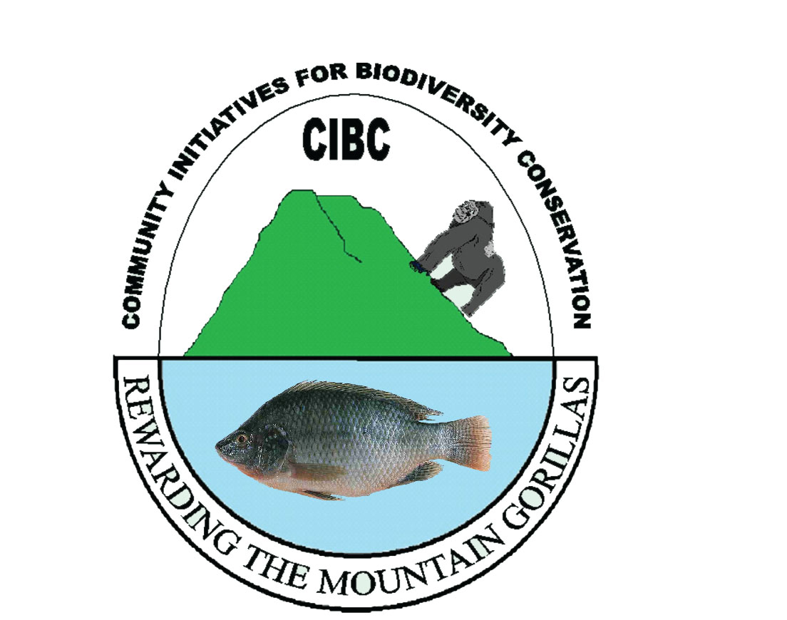
PROJECT PROPOSAL
Project Title: Bee keeping for 100 Batwa Pygmies in Uganda
Implementing Organisation: Community Initiatives for Biodiversity Conservation (CIBC)
Location: Western Uganda, Kanungu District, Kayonza Sub County, Buhoma Village
Estimated Starting Date: July 2015
Estimated Completion Date: July 2016
Budget in USD: US$ 39,920
COUNTRY: UGANDA
Project Linkages: Kanungu District Local government
Uganda wildlife Authority UWA (Bwindi Impenetrable National Park -BINP)
Batwa Development Program
Contact details:
Name: John Bosco Tusingwire
Position: Founder and Executive Director
Organisation: Community Initiatives for Biodiversity Conservation
Postal address: 171 Kanungu
City: Kampala
Province: Western
Country: Uganda
Email: tusingwirejohnbosco7@gmail.com
Website: bwindicommunityinitiatives.org

1.0 Executive Summary:
Community Initiatives for Biodiversity Conservation (CIBC) is requesting $39,920 from Global Giving to train and supporting Batwa Pygmies with the knowledge and skills necessary to manage a bee keeping project. The project will help beneficiaries get out of poverty and hunger thereby reducing poaching, and protected area encroachment in the conservation area of Bwindi. CIBC is a community based organisation limited by guarantee registered with Kayonza subcounty with registration #271/2012 and with national registrar of companies as a company limited by guarantee with registration #162266.
The organisation empowers local people in bee keeing by training and supporting them with with production technonlogy and access to market. It also provides honey, a much needed health food and medicine, and opportunity for each bee keeper to employ themselves and other members of the local community. This reduces pressure on the environment as people become economically self sufficient from income generating activity instead of hunting and gathering honey and bush meat from the park for eating and selling.
Bee keeping is an income generating activity and does not require fertile lands but rather rejected land with no futher economic use under subsistance investment – this type of land is characteristic where the Batwa Pygmies were re-ssettled. Beekeeping does not need high techology and money in regular maintenance and supervision, nor does it require high intensive inputs. It is environmetally friendly and prodcues various health products. Economically the project returns the initial investment within one year. For $39,920 the project will construct and place 500 hives in the apiaries and produce an annual gross income of $70,000. The Batwa Phygmy beekeepers will be trained to use their beekeeping income in meeting their life needs, particularly including school fees for their children and investing in other income generating projects. Since it is clear that poaching is accelerated by poverty and hunger, with this project the curent generation of poachers will be replaced by a new genration of environmental conservationists.

2.0 Problem statement
In 1991, the government of Uganda declared the Bwindi Impenetrable forest a National Park to protect the endangered mountain gorillas. The forest also had many other native residents, animals, plants and fungi. The government decided that, in order to protect the gorillas, some native residents, including the Batwa Pygmies, would have to be resettled outside the park boundaries. The Batwa people had always lived in the forest. They had no formal schooling and depended on hunting and gathering techniques handed down from their parents and grandparents. The government hoped they would be employed by the tourist trade as soon as Bwindi National Park was established. Unfortunately, that did not happen. Rather the Batwa, with no education, no money and no land were pushed out into the already congested and poor communities surrounding the new National Park. Naturally, the Pygmies returned to the forest as poachers as the only way they knew of to get the food and income they needed to survive.
Batwa Pygmy children suffer the consequence of difficulties to learn and study while hungry or sick, lack of income to sustain school fees, vulnerability to diseases due to poor body immunity caused by malnutrition, and a general lack of access to the basic needs of life. When their parents die, the double- and single-orphan population increases and is exposed to these life challenges at an even higher level. For teen girls further survival risks begin for those compelled to start working for “survival sex”.
Improving subsistence agriculture for food security and poverty alleviation provide alternative sources of livelihood and enhance environmental security. Since Batwa Pygmies have always gathered honey, among other forest products in their natural forest, as their traditional way of living, beekeeping promote an existing cultural value. To sustain this as an agricultural and business endeavor, the project will include training and supporting the Batwa Pygmies in constructing bee hives, site selection, and honey and wax processing, packaging and marketing.
It is expected that households with access to improved sources of income will yield reduced poverty effects mitigating risks of illegal encroachment on the protected area. These economically developed households will use the generated income to provide better nutrition and health care, increased school attendance with improved results, and other factors associated with an improved quality of life. The proposed beekeeping project provides a new, much-needed source of income within Kayonza Sub County in Kanungu District that will transform the current generation of poachers into a future generation of environmental conservationists.
3.0 Project description
3.1. Mission:
To empower 100 Batwa Pygmies with skills in beekeeping to alleviate poverty and improved relations between man and nature in communities neighboring the protected area of Bwindi National Park.
3.2. Project goal
Create harmony between man and nature through training and supporting 100 Batwa pygmies in alternative sustainable livelihood beekeeping project.
3.3. Project objectives
- Mobilize, sensitize and build the capacity of 100 Batwa pygmies to be self sufficient and live a happier life outside the protected area within one month
- Recruit, train and support 100 Batwa Pygmies to take bee keeping as an income generating project within three months
- Reach a productivity target of at least 14 litres per hive within one year
- Establish a bee processing and selling centre and enhance compressive value addition for increased income within one year.
3.4. Methodology
CIBC will first hold a partnership meeting with development partners and other key community stakeholders to discuss better and practical approaches that should be taken to use a bee keeping project in sustaining the lives of the Batwa pygmies. Another partnership meeting involving key beneficiaries will be held to conduct early design and planning of the project. The meetings will create an ownership spirit among beneficiaries and result in a platform from which the implementation and the success of the project will be based. For the purpose of continued learning and comparing performance with known good standards, a demonstration apiary will be established and managed by Community Initiatives for Biodiversity Conservation.
3.5. Activity plan time frame:
Activity | Scheduled time | Responsible person
Planning meeting and inviting participants for meeting | July | Mrs. Musimenta Peace in charge for mobilisation
Mobilisation and sensitization | July | BDP, UWA and CIBC community officials
Purchase of training tools equipments | July | Mr. Kwesiga Job, in charge for training
Training | July-September | Mr. Tusingwire John Bosco, Mr. Joshua Ruhara and Mrs. Aurelia
Visiting farmers for site selection | July September | Mr. Tusingwire John Bosco, Mr. Joshua Ruhara and Mrs. Aurelia
Handing over bee hives and other equipment to farmers | September | BDP,UWA and CIBC selected team
Planting flowering trees in the apiaries | Sept-October | Mr. Joshua Ruhara
Extension service to the farmers | Sept-July | Bright Tumwebaze
Regular maintenances and cleaning in the apiary | Sept-July | Apiary owners
Purchasing honey processing tools and equipment | May-July | Mr. Kwesiga Job
Value addition/packaging | May, July | Mr. John Bosco Tusingwire and beneficiaries
Establishing a group selling outlet | May-July | Mr. John Bosco Tusingwire, group leaders and other stakeholders
Evaluation | July-August | BDP, UWA and CIBC selected delegates

3.6. Organisation structure:
Mr. Tusingwire John Bosco
Executive director
General Manager
Garden attendants
Sales personnel
Board of Directors
Records manager
Training manager

3.7. Administration
The management team consists of people who have worked together on other agricultural and demonstration projects. Each team member also commands significant knowledge, skill and a history of achievements in his previous field that is useful to bee keeping.
Mr. Tusingwire John Bosco is the overall team leader, has a degree in agriculture and uses experience gained working with KIRUDI for 3 years in the same position.
Mr.Tumwebaze Bright, the sales and records manager has a diploma in accounting and finance, with a certificate in agribusiness.
3.8. Evaluation
Evaluation of CIBC programmes and activities is ongoing. In 2014 CIBC completed an institutional assessment. In 2015 CIBC began interpretive planning process through which stakeholders, directors, staff and consultants examines the site’s potential and relevance in light of creating good relationships between people and nature, evaluate the layout of the whole demonstration farm containing different active number of projects, and recommend strategies to increase our audience and engage them in pursuing our mission. Specifically on this project an internal team will be elected comprised of partners and beneficiaries. This team will be instrumental in evaluating the performance of the project against the schedule of periodic activities and their production indicators.
3.9. Sustainability
Our production objective of annually producing 14 litres of honey per bee hive in our 500 planned hives will harvest 7000 litres of filtered honey. At the current market price of $10 per litre, this provides overall $70,000 per year. In addition the project will produce other marketable bee products such as candle wax and bee propolis for medicinal uses.
This income will double as we increase the production schedule to two harvests per year. Because packed honey and other bee products do not spoil they can be stored to provide continuous daily income to the farmers year round – thus strongly motivating the bee keepers to maintain the project. Also during training and empowerment sessions, the farmers will be taught and encouraged to save and invest their income with help from CIBC open individual accounts in SACCOs where their honey payments will be deposited at the end of every month. CIBC also plans to keep on saving money on the organisation Bank account for supporting newly identified Batwa pygmies to expand the bee keeping activity. Also the existing members will be able to access seed loans based on their income providing evident repayment means.
CIBC will assess a small fee from bee product sales to pay rent, salary of the sales persons. The income provided by the CIBC demonstration apiaries will be allocated to the purpose of making the project permanent. The money raised will be proportioned in percentages; 65% of the annual income will fund the second year of the project’s new beneficiaries in foam of soft loans, 15% will maintain the demonstration apiary and 20% for the administrative costs of the project. The farmers who do not sell their honey through CIBC must purchase their additional hives and inputs through their own means or from CIBC without benefit of low-cost CIBC loans.
Furthermore CIBC will continue to do fundraising, partnering with other organisations and stakeholders doing similar project within and across the various boundaries of the country as well as overseas. This will be done through signing memorandum of understandings and presenting concept papers to various stakeholders. CIBC also have a website being used to connect the organisation to other organisation and individuals across the world. This website among others is describing our initiatives which are not limited to support Batwa Pygmies but also women and youth in growing vegetable, fish farming, piggery farms for biodiversity conservation; it is our strong marketing tool and publication for fundraising and reporting.
3.10. Relationship with other local organisation
Currently, CIBC partners with Fauna and Flora International (FFI), implementing a piggery project in one of the Batwa settlements in Uganda and is developing partnerships with Uganda Wild Life Authority (UWA) raising awareness on the Importance and benefits of nature conservation, and Batwa Development Program (BDP) to empower Batwa with alternative source of livelihood projects.
We plan to develop more partnerships with other stakeholders in development such as Bwindi and Mgahinga Conservation Trust in working together in implementing livelihood projects in communities adjacent to Bwindi National Park, Bwindi Community Hospital in helping People living With HIV/AIDS orphans and vulnerable children with income and nutritional projects and Kanungu District Local government to support the government implement some of her agricultural programs locally on her behalf. This will be through showing them interest, sending them letters and follow ups and cause meetings geared to create development relationship. We shall formalise our relationships through developing and signing (Memorandum of Understanding) MoU documents.
3.11. Conclusion
Working to create good relationship between man and nature through bee keeping for improved livelihoods, CIBC is building the capacity of the Batwa Pygmies to learn to be self sufficient. The bee keeping project is a part of the many initiatives run by CIBC including piggery, vegetables, mushrooms and fish farming at demonstration farm. Batwa Pygmies learning how to keep bees will also get passive opportunities to learn about other sustainable, income generating projects in the CIBC demonstration farm located at the bee keeping training centre.
CIBC does not only target Batwa Pygmies only but also women and Youth especially those living with HIV/AIDS in the protected area adjacent communities. The wall round circle of beneficiaries and the initiatives in one place as demonstration grounds for the community farmers aims at imparting better farming skills and knowledge, so that the growing population on static land sizes are able to feed themselves, and meet other daily life needs with less damaging impact on the natural environment.
4. The Budget in US$
Item | Unit cost | Quantity | Amount
Bee hives construction and training materials
Timbers 2”x12” | 4 | 2500 | $10,000
Nails roofing kg | 3 | 50 | $150
Nails wood kg | 2 | 70 | $140
Iron sheets | 10 | 250 | $2,500
Stirrups (rolls) | 10 | 60 | $600
Labour technical | 10 | 90 | $900
Paint | 2 | 200 | $400
Workshop Square | 1 | 10 | $10
cold chisel | 3 | 10 | $30
Craw hammers | 3 | 10 | $30
Painting brush | 1 | 10 | $10
Hand Saws | 5 | 10 | $50
Hand plane | 50 | 5 | $250
Pangs | 2 | 100 | $200
Knife cutters | 2 | 100 | $200
Hoes | 3 | 100 | $300
Spades | 5 | 100 | $500
Honey filtering machine | 200 | 1 | $200
Vail | 10 | 100 | $100
overall | 60 | 100 | $6,000
Smoker | 27 | 100 | $2,700
Honey harvesting kit | 20 | 100 | $2,000
Packaging bottles | 0.5 | 2000 | 1,000
Labels | 0.2 | 2000 | $400
Honey shop house rent | 50 | 5 | $250
Subtotal |  |  | $28,920
CIBC expenses
Mobilisation costs | 110 | 10 | $1100
Meetings and related expenses | 130 | 10 | $1,300
Travel and transport | 30 | 50 | $1,500
Training allowances | 50 | 90 | $4,500
Farmer outreach and extension services | 200 | 10 | $2,000
Evaluation | 50 | 12 | $600
Subtotal |  |  | $11,000
Grand total |  |  | $39920

