POLYCOM DEVELOPMENT PROJECT
P. O. BOX 16797 – 00100, Tel: +254737332867 NAIROBI, KENYA
Email:-polycomdev@yahoo.com; Website: www.polycomgirls.or.ke

REPORT ON TEACHERS MEETING
INTRODUCTION
Our termly teachers meeting took place on the 16th of September 2022 at Polycom Development Project office from 2:00 pm to 4:30 pm. The meeting was attended by 41 teachers from our partner schools with 8 schools failing to attend due to other commitments. Teachers meeting is always held every term to discuss our achievements as an organization with the school programs, challenges we are facing with the implementation of the program and way forward on how to solve the challenges.

DISCUSSION
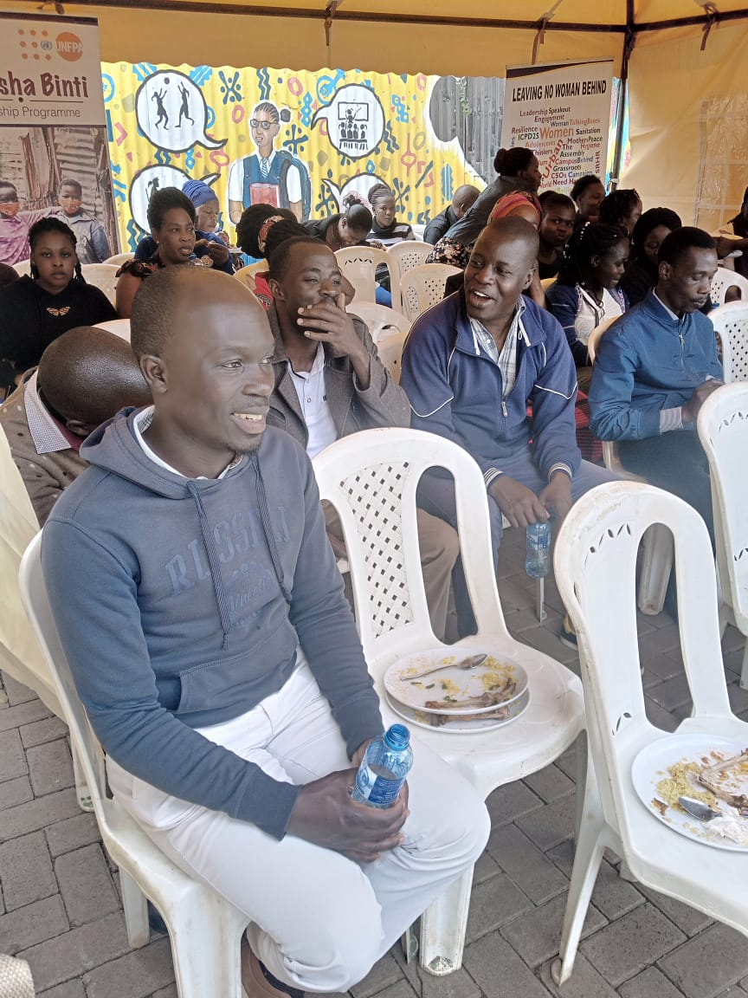
Over the years polycom has made great improvements when it comes to implementation of the school programs. Having conversations with our girls and the teachers from various schools has helped us get feedback on what has worked so well for us and what we need to improve on.
ACHIEVEMENTS
- We have done so well with soap making and distribution which has improved in terms of thickness and quality.
- We have also made adjustment on the sizes of pads produced as they were very long and girls were not comfortable using them, they are now medium sizes which are very comfortable for the girls.
- We introduced boy’s mentorship and we started with schools that needed it most and we have made impact because the boys who were rude and knotty are now calm.
- We have also managed to refer 5 girls to a youth friendly health services since July up to date.
- In this quarter we have also managed to collect 219 contents from our talking boxes.
- We have also distributed 470 liters of soap to our partner schools.
- We have distributed 280 panties to our girls who are in need of pants.
- We have also distributed 1735 emergency sanitary towels to the girls.
- We have managed to reach 735 adolescent girls from our partner schools in this quarter.

WHAT TO IMPROVE ON
- Meetings has not been frequent as it used to be before covid -19 therefore teachers suggested that we should have two teachers meeting every term instead of one.
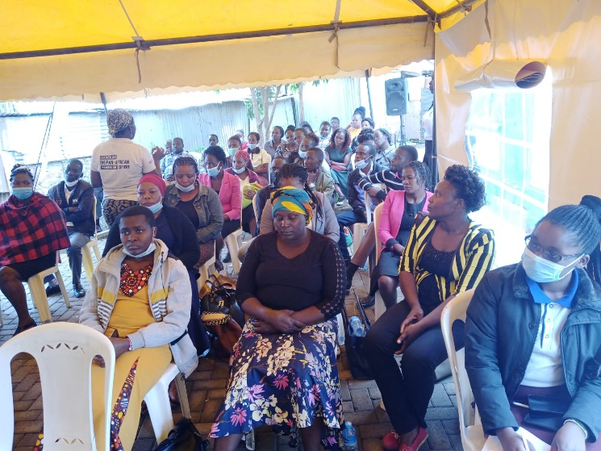
- Mentors to do early communications when they booking sessions for mentorship to give the matrons/patrons easy time to plan their selves.
- Teachers also requested that we should identify a common sport that majority are familiar with so that we can be engaging in tournaments.
- There was a request to increase the number of emergency pads distributed to schools every month.
- There is tendency that student delay when they are coming for the monthly supplies and security issues for the girl’s teachers requested that we should communicate when they leave the office so that teachers can be able follow up on how long they take to get back to school.
- Teachers also requested for counselling services in situations where they traumatized with issues, they handle every day.
- For schools that have changed management in their administration to avoid misunderstanding teachers requested the organization to do introduction gain to the administration to give patrons /matrons an easy time.
- Matrons/Patrons to inform the administration about our visit to the schools early enough to avoid misunderstanding.

WAY FORWARD
- It was agreed that termly teachers meeting will be held twice in a term as from next year that is in the beginning of the term and in the end of the term.
- As an organization we do not have the capacity to host tournaments in schools but our mentors can do simple games with the girls during mentorship sessions.
- The teachers to be sending girls with bags that can carry enough sanitary towels for the girls in their schools.
- We cannot share the contents with the teachers due to safeguarding issues but we can give general feedback on common issues raised in the contents.
- We also agreed that we will not be able to give emergency pants to schools but matron/patrons should identify students who need panties and send them to the office to come for the panties.
- We do not have counselling services in the office but for any teacher who needs counselling services should reach out to us for referrals.
- All the schools with administrative issues should communicate so that we can organize for a meeting with the administration and take them through what Polycom does.
- Matrons/Patrons should inform the administration when our mentors are coming to visit the school to avoid any kind of misunderstanding.

CONCLUSION
Feedback is very important in every implementation process as it a step to growth. Every time we have a meeting with the teachers, we get feedback for our school programs and it has helped us grow as an organization and we are hoping to make more improvements to our level best and to make adjustments where possible.

Report compiled by
Caroline Atieno

