JOPA CARPENTRY WORKSHOP AND TECHNICAL SERVICES
jopa
P.O BOX 4769, BUWENGE –JINJA (U)
TEL: +256772638312/ +256757429282/ +256778376557
Email: jopacarpentry@yahoo.com

Our Ref RP/M/15/001 Date March 2015
Your Ref…………………
A SKILLED MOTHER, A SKILLED NATION PROJECT
SUPPORTED BY US EMBASSY KAMPALA –AMBASSODOR SELF HELP FUND
REPORT FOR THE MONTH OF MARCH 2015

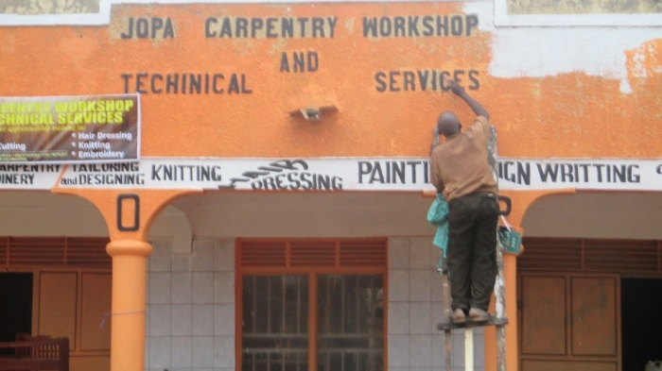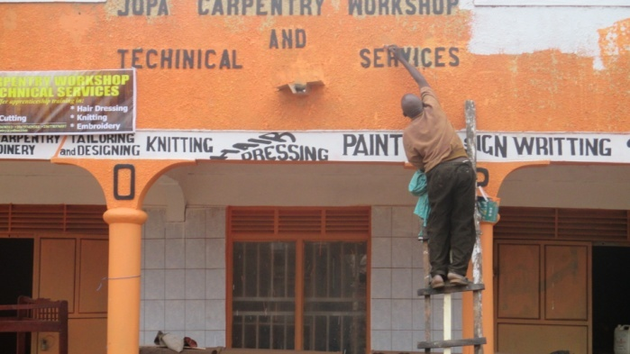
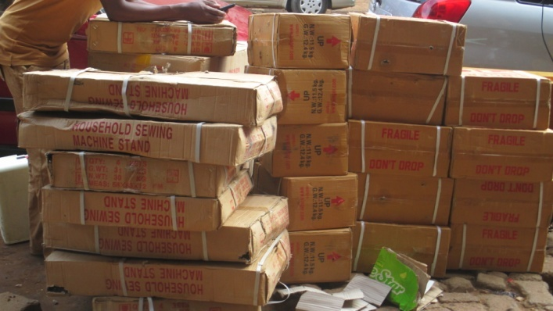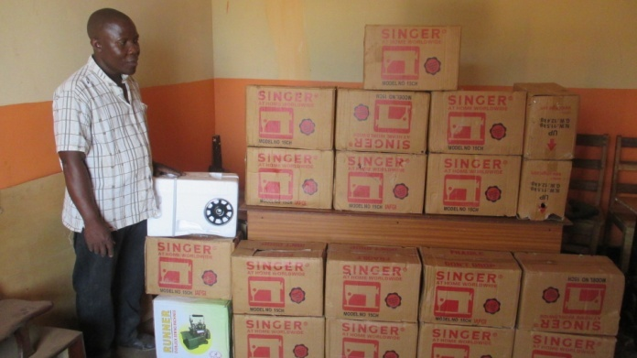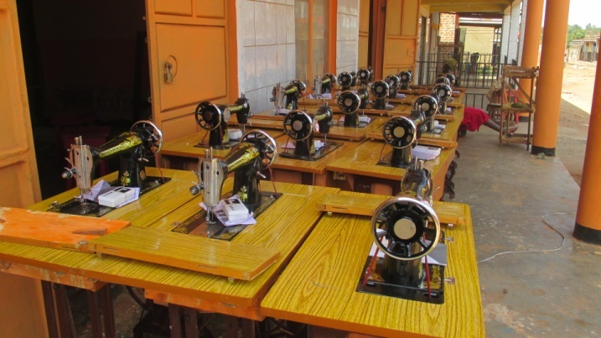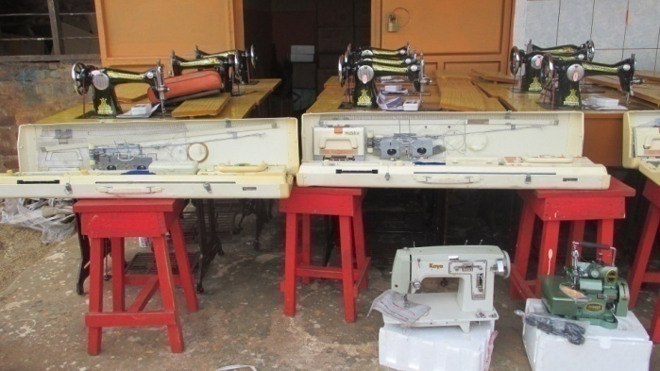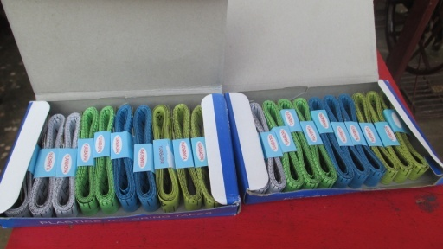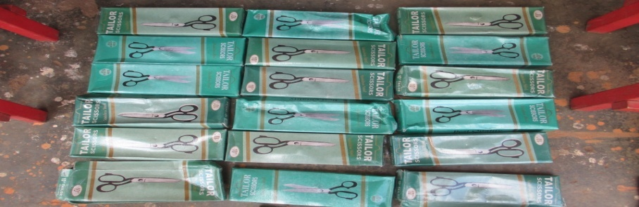

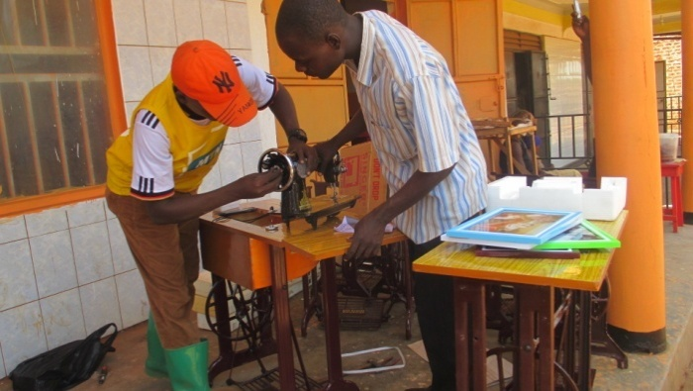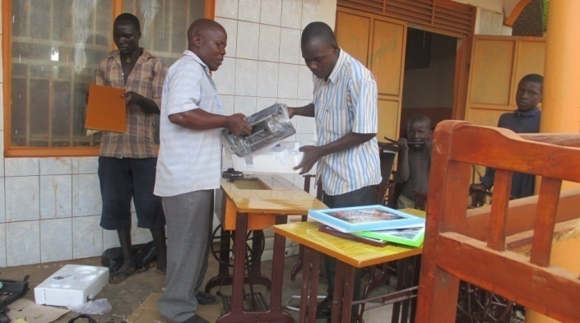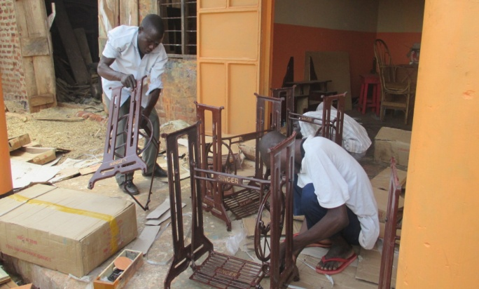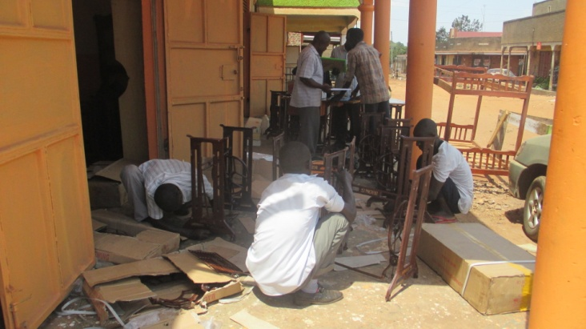
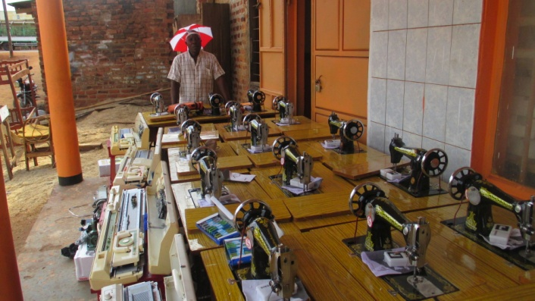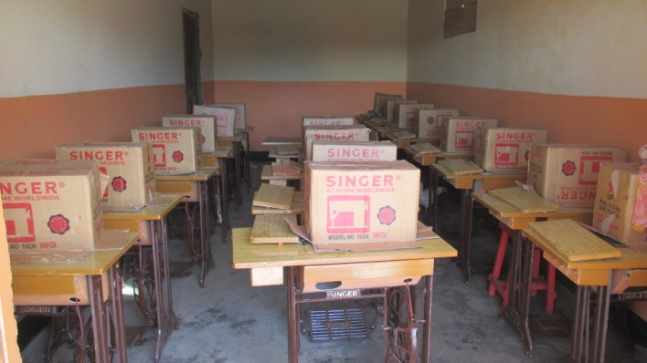
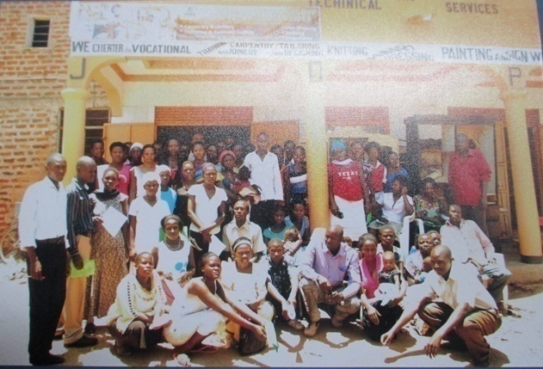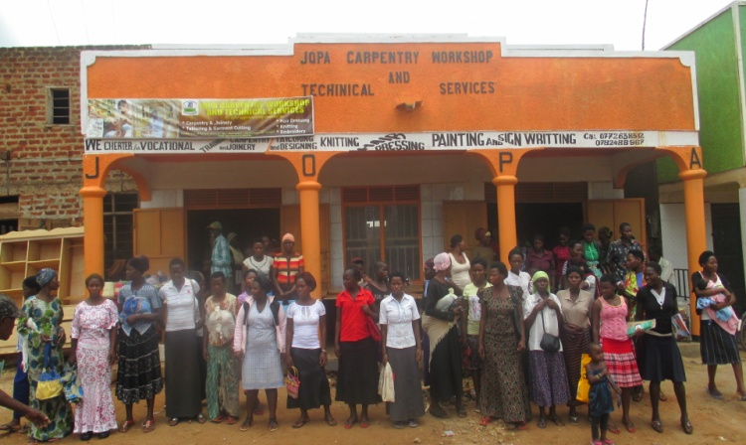
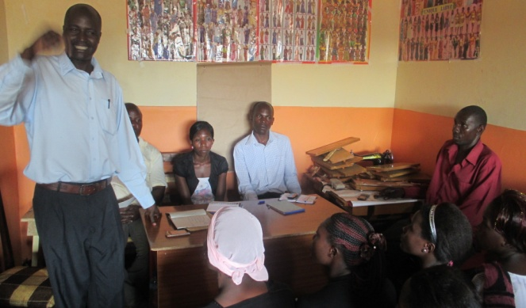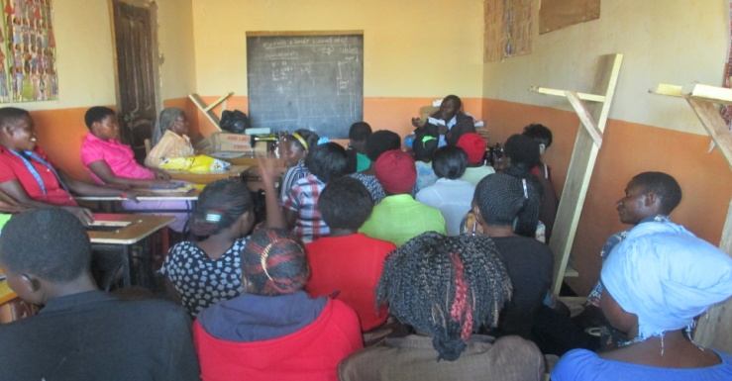
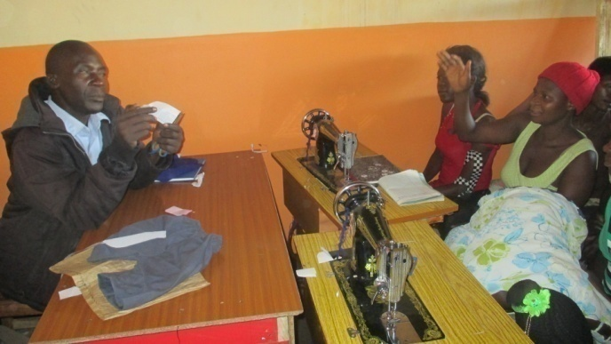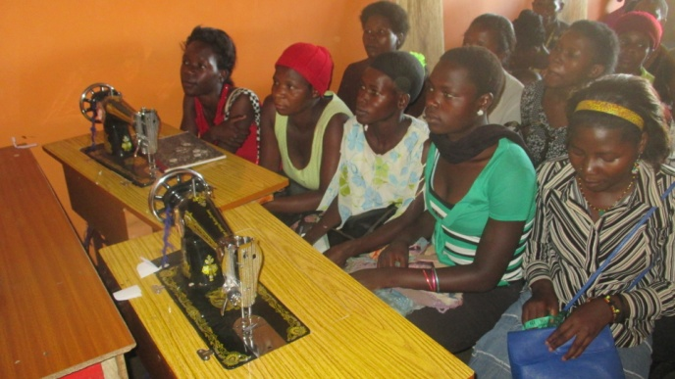
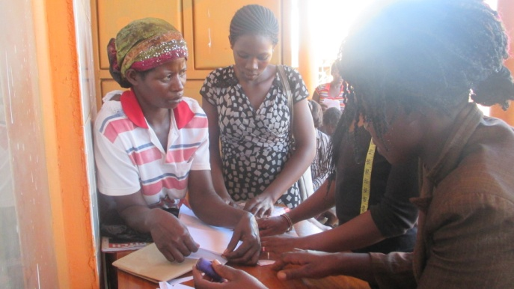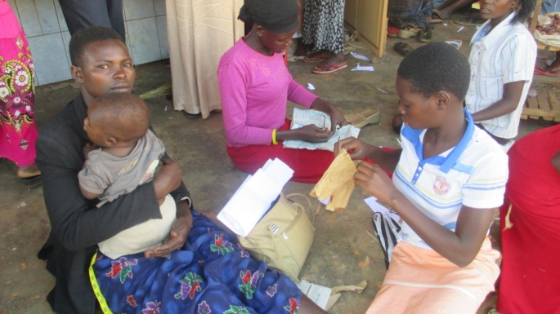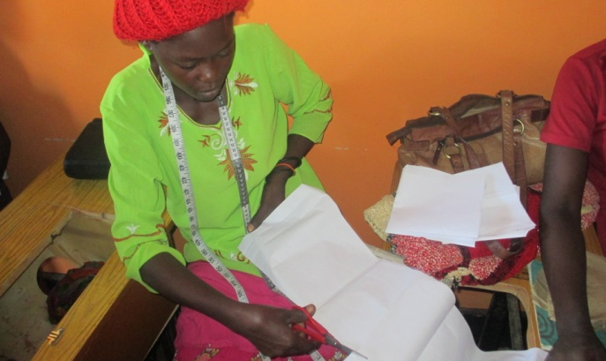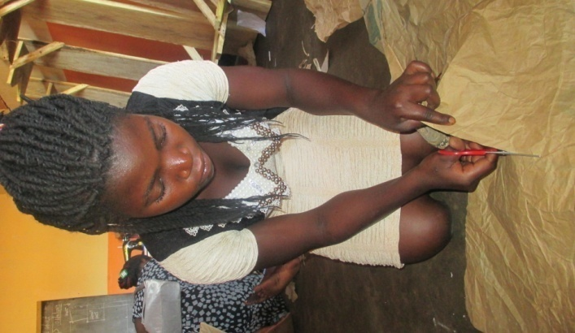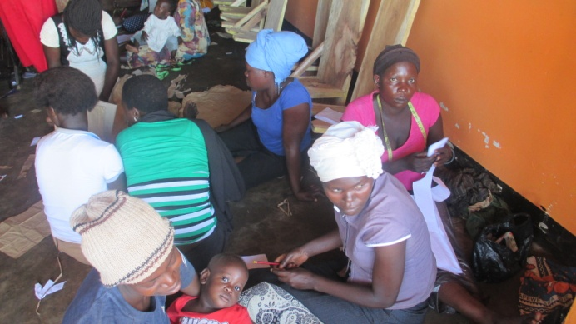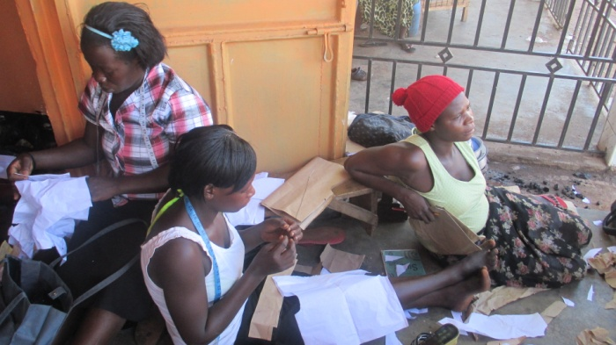
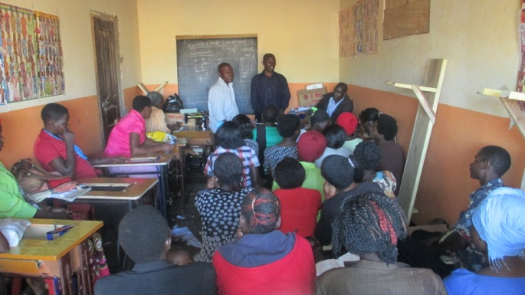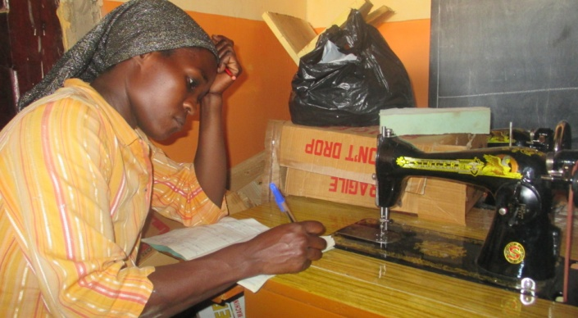

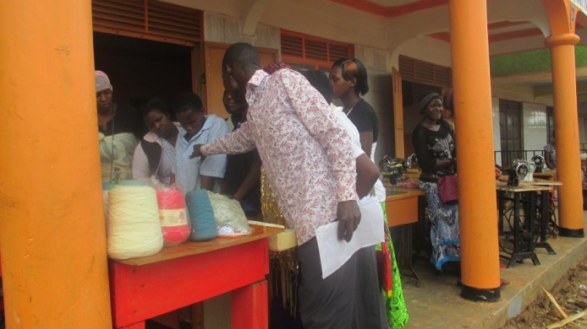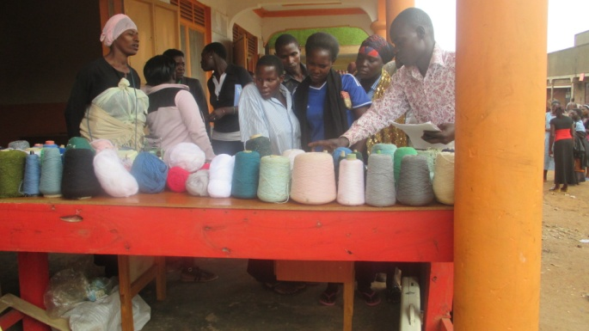
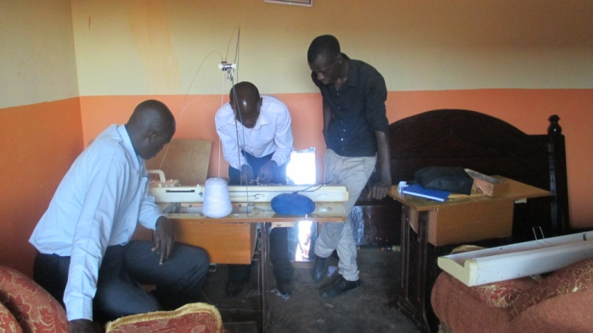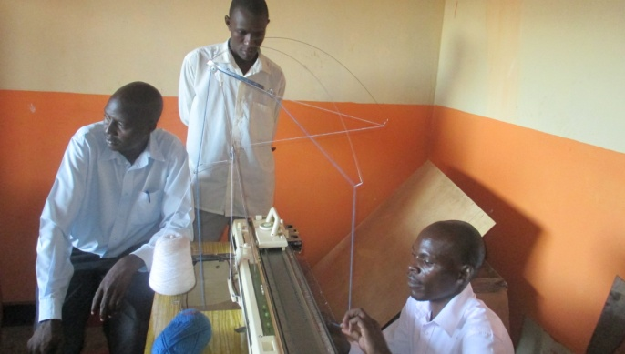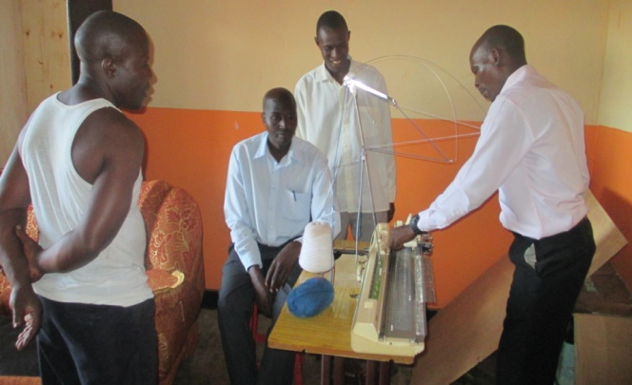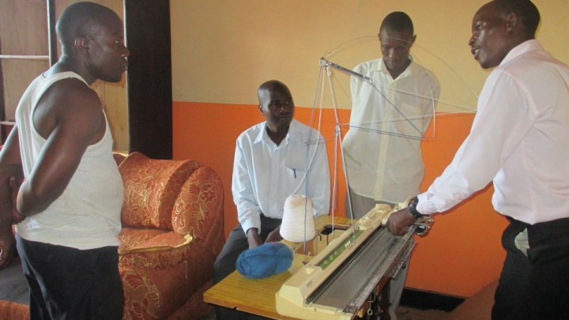
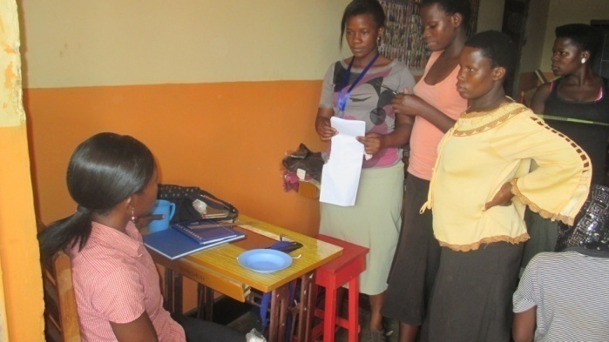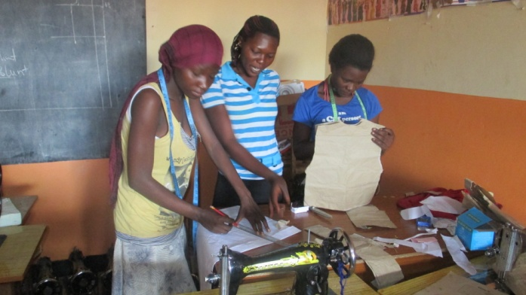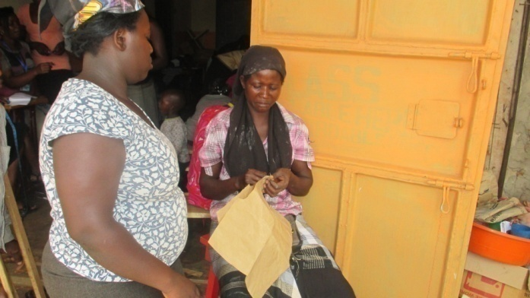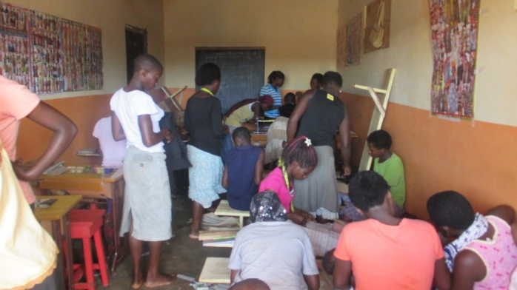
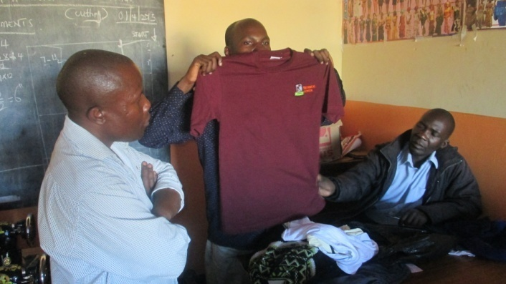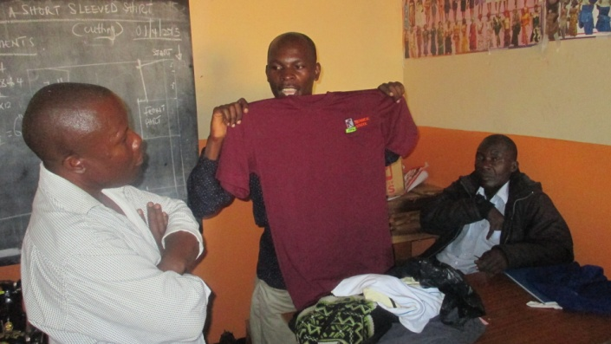
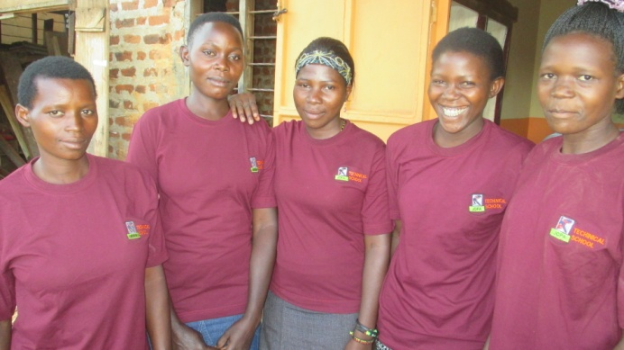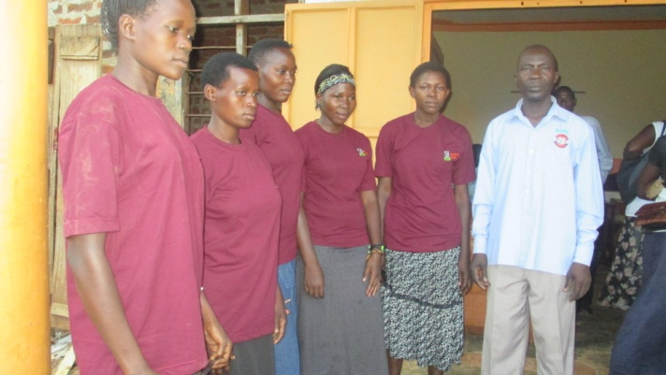

Introduction
The project is focusing on equipping young mothers and adolescent girls from low income families with vocational skills in Tailoring, Knitting and Weaving so that upon completion they will be able to set up their own income generating projects and be able to earn a living.
One hundred and four (104) trainees are undergoing training in Tailoring, Knitting and weaving and out these there are only two male youth. The is going to go on for a period of 6 six months

Overall objective of the project
The overall objective of the project is to equip the adolescent girls and young mothers with vocational skills in Tailoring, Knitting and Weaving so to enable them set up their own projects

Highlights of the Project
.
- Painting and renovation of the rooms and premises and organizing it to make it ready for training was done. . All the necessary renovation, facilities, refreshments and support was ensured in the training centre.
- Procurement of furniture which included Benches, Stools, Working Tables and offices desks
- Recruitment of Qualified trainers was done on the basis of their skillfulness, experience and education. etc.
- Identification and registration of trainees (beneficiaries) was carried out with help of the local leaders basing on the set criteria. The assessment was very effectively carried out and the most deserving and appropriate trainees from extremely low income families were selected.
- A briefing meeting which involved the trainees, their parents/ guardians/ spouses/relative and some local leaders was carried out to stress the importance of the project ,the regulations, the role to be played by each party and the code of conduct while on training, the time of arrival, time of departure, number of hours to be studied, number of sessions to be conducted each day, the requirement for each trainee and the programmes to be conducted
- Psycho- social counseling session for the trainees was conducted..
- Purchase of training tools and machines was done
- Assembling of the machines with help of the youth was done
- Training of beneficiaries in Tailoring, Knitting and Weaving is going on at JOPA site in Buwenge town council, Jinja District , Busoga sub region and one training center for the training is being used

UPDATES ABOUT THE ACTIVITIES DONE IN THE MONTH OF MARCH

Painting of training of premises and training rooms
- Painting and renovation of the rooms and premises and organizing it to make it ready for training was done. . All the necessary renovation, facilities, refreshments and support was ensured in the training centre.
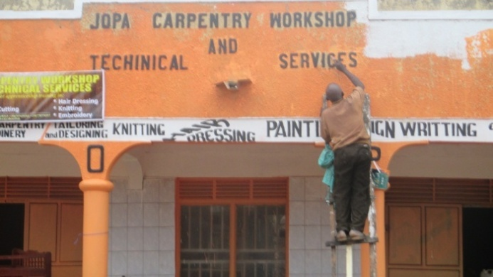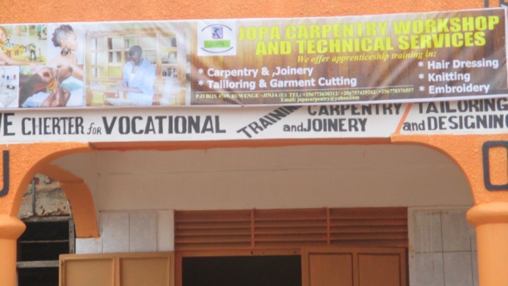

Purchase of furniture
- Procurement of furniture which included Benches, Stools, Working Tables and offices desks

Recruitment of trainers
- Recruitment of Qualified trainers was done on the basis of their skillfulness, experience and education. etc. Two full time and two part time trainers were recruited. However their recruitment posed a serious challenge because the salary we budgeted for was far below their expected and it took us some time to get those who accepted a fairer pay. What we are paying them is twice what we had budgeted for .

Registration of beneficiaries
- Identification and registration of trainees (beneficiaries) was carried out with help of the local leaders basing on the set criteria. The assessment was very effectively carried out and the most deserving and appropriate trainees from extremely low income families were selected. However we were overwhelmed by number of those who needed help and we ended up registering one hundred and four(104) beneficiaries, a figure which is far beyond our targeted number

Below are the photos showing registration going on at our offices;

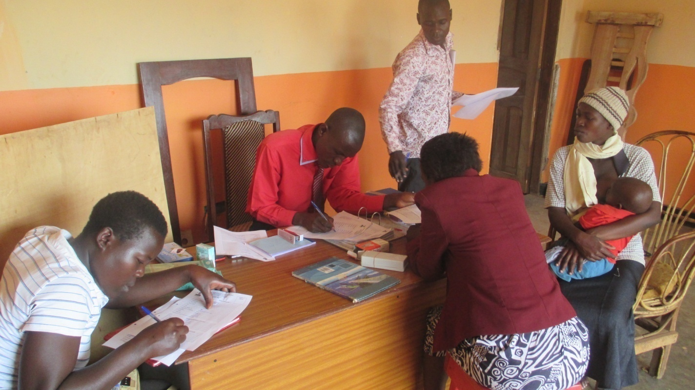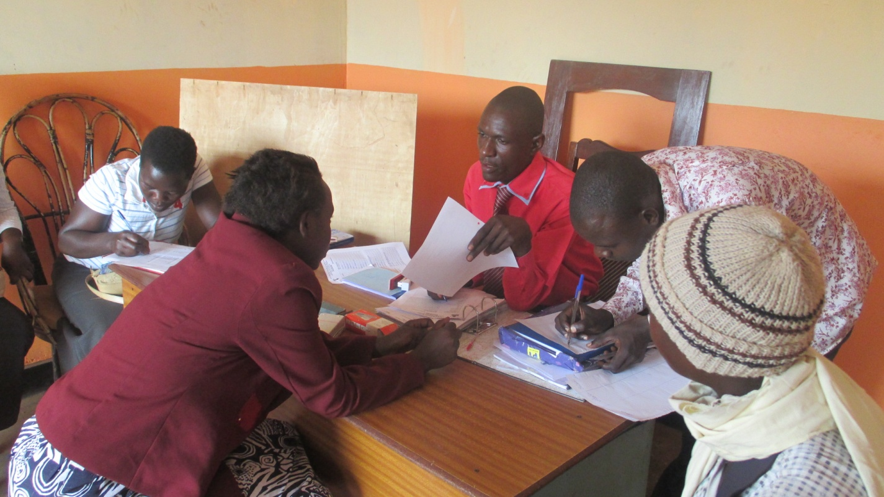

Briefing with beneficiaries, their relative/ spouses/parents and local leader
- A briefing meeting which involved the trainees, their parents/ guardians/ spouses/relative and some local leaders was carried out to stress the importance of the project ,the regulations, the role to be played by each party and the code of conduct while on training, the time of arrival, time of departure, number of hours to be studied, number of sessions to be conducted each day, the requirement for each trainee and the programmes to be conducted
Below are photos showing the briefing going on
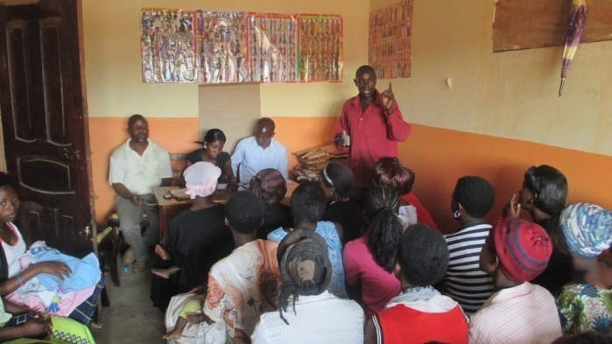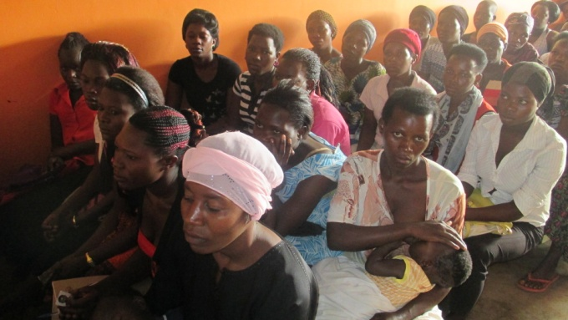
After the briefing
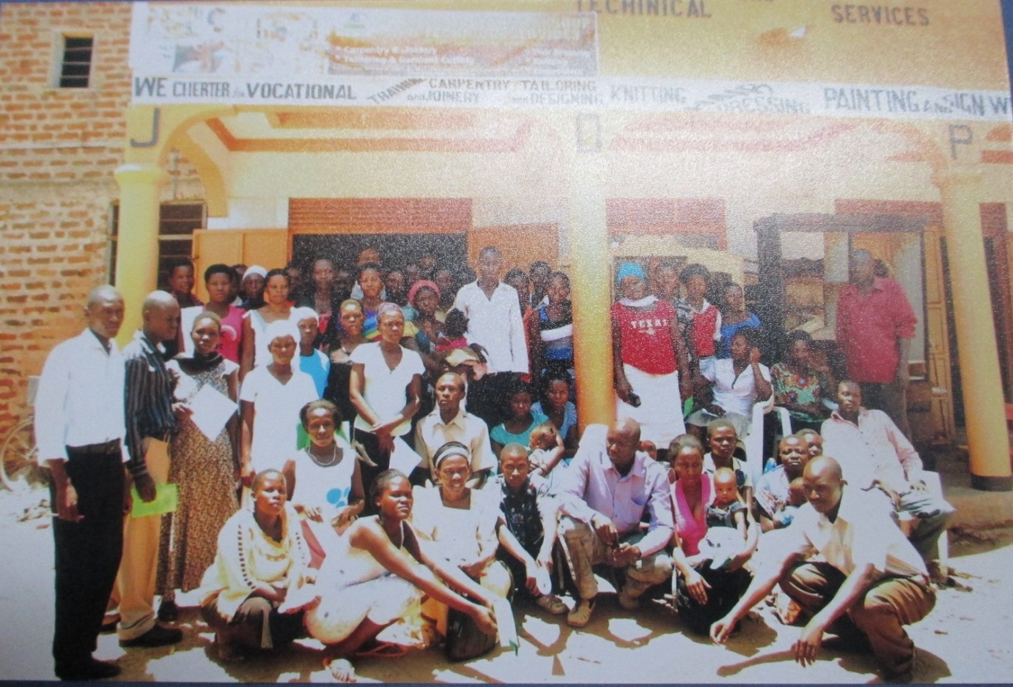

Psycho –social Counseling to the beneficiaries
- Psycho- social counseling was done to the beneficiaries and this was intended to prepare them mentally for the training and to change their attitude towards vocational training. We took them through the social challenges that may come their way in the due course and how they can manage to overcome such challenges, the perception of the people in their community about a married person undertaking training and how they should handle such perception. Four counselors took them through this exercise and by the end of the session they had developed a positive attitude and were all mentally prepared for the task head of them.

Purchase of training tools and machines
- Training machines and tools were successfully bought from Kampala and delivered to our site in Buwenge. Eighteen (18) Singer Sewing machines, One(01) Over lock sewing machine, One (01)Design electric sewing, One(01)Electric motor for the sewing machine, Four(04) Knitting machines, Twenty (20)pair of Scissors, Twenty (20)Tape measures, Twenty( 20) Drive belts, One hundred(100) Needles, four (04) Sim lepers, One (01)Small box of Pins, two (02)Bottles of lubricating oil, one(01) Screw driver were bought. BELOW are photo of some of the items bought.
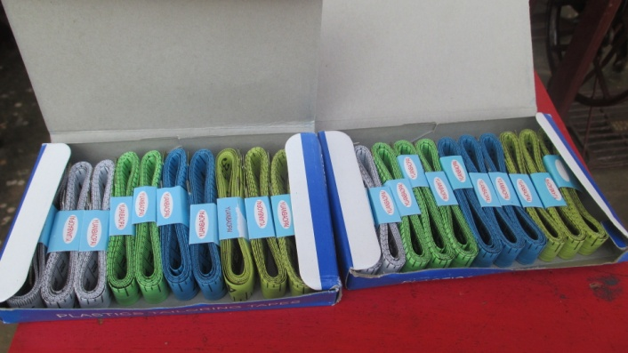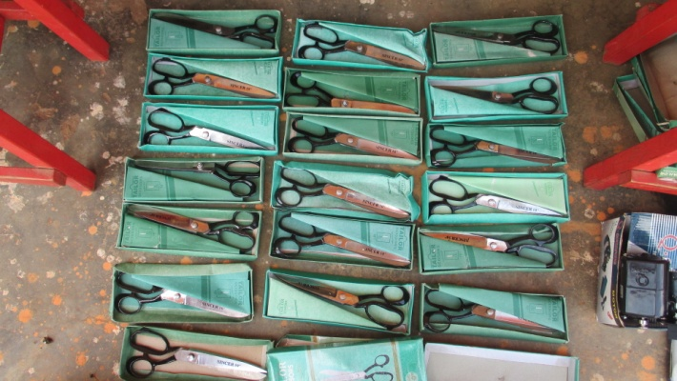
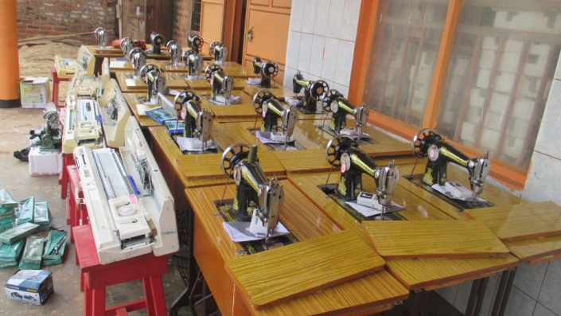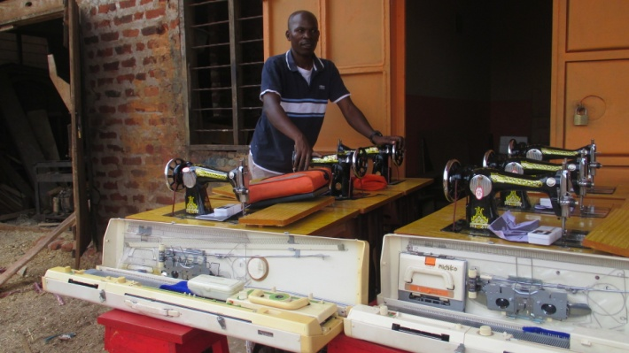

Assembling of the machines
- This exercise involved putting together the different components of the machines to make them functional. This exercise was successfully done with the help of Jopa Members, the youth and one technical person in the area of Tailoring. After assembling the machines they were properly arranged in the training rooms. BELOW are the photos

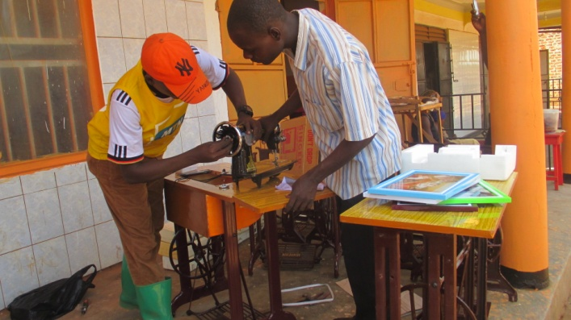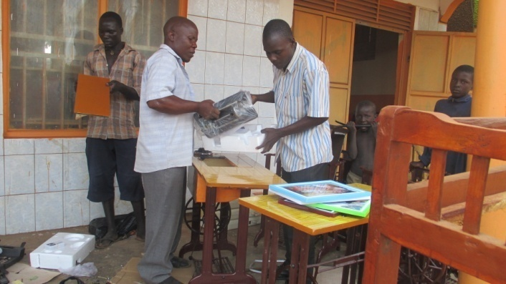
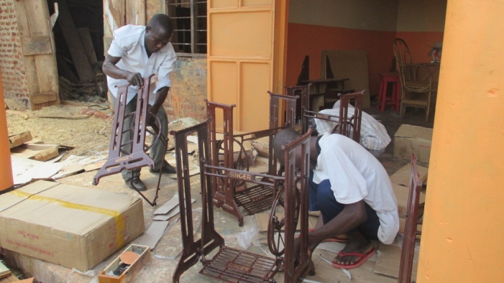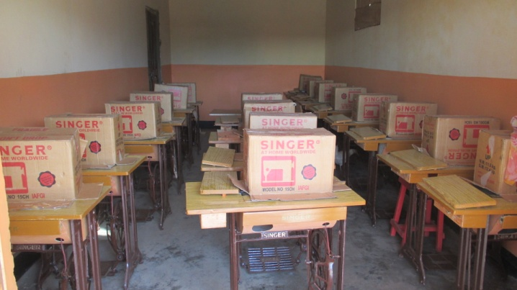

Training of beneficiaries
- This exercise according to our implementation plan was supposed to begin in May but since we through with the preliminary activities, we could not wait, we had to begin immediately because everything was set and ready.
Training of beneficiaries in Tailoring, Knitting and Weaving is going on at JOPA site in Buwenge town council, Jinja District, Busoga sub region and one Training center for the training is being used

Each trainee undergone (5) Training hours each day, and (25) Training hours a week which is above the earlier planned Fifteen (15) training hours a week. Two (02) main groups were formed out of one hundred (104) participants but these are further subdivided during training according to the level of proficiency. Each group attends a particular session. We have the morning session which runs from 8a.m up 1pm and the afternoon session that runs from 2pm to 5pm

The trainees are being trained in all the three (03) important aspects of the course such as drafting, cutting and stitching. The participants are taking keen interest in the Tailoring Training Course. The course content is very helpful in opening individual and group enterprises at their household level.

Training is 90% practical due to the fact that most of the trainees uneducated.
Two hundred and two (102) adolescent girls and young mothers and two male youths (02) are successfully undergoing training in tailoring and garment cutting. The level of skills of each trainee is being enhanced to a satisfactory level,

For example after two days of training in Knitting, one of the trainees was able to make a complete sleeveless sweater; almost all trainees can measure, cut and make a piece of attire using a hand needle.
By the end two they are to well vast with all the content in Knitting and weaving and they will ready to start a business of their own.

By the end of the six months all will be equipped with the skills in tailoring.
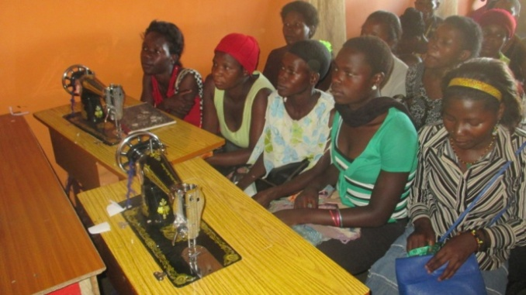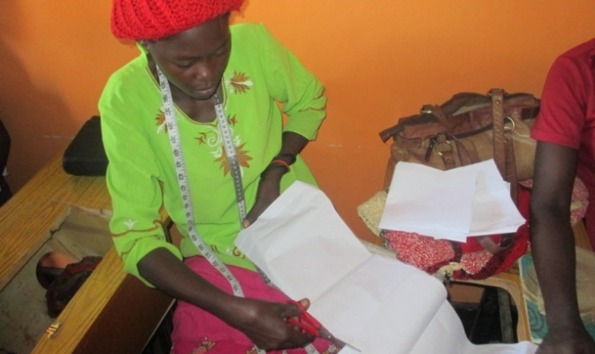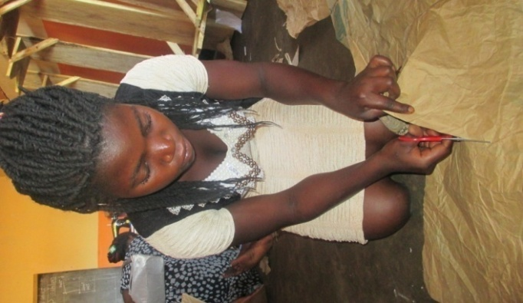

SUCCESSES
We have managed to executive the above activities success fully in time and I believed the project will completed before December as we had planned earlier
The level of proficiency of the trainee is beyond the expectation of everybody and is very promising
We have secured the support of the local leader

Challenges
The major challenge so far is payment of the trainees whom we paying more twice as we had planned. We are incurring the accommodation cost of one of the female trainees

