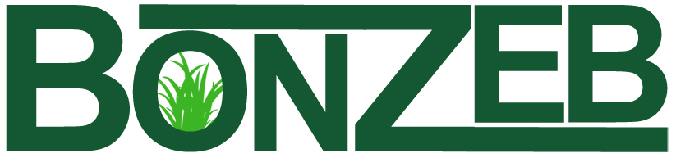

The good grass solution
Edify Haiti’s People, Economy, and Environment
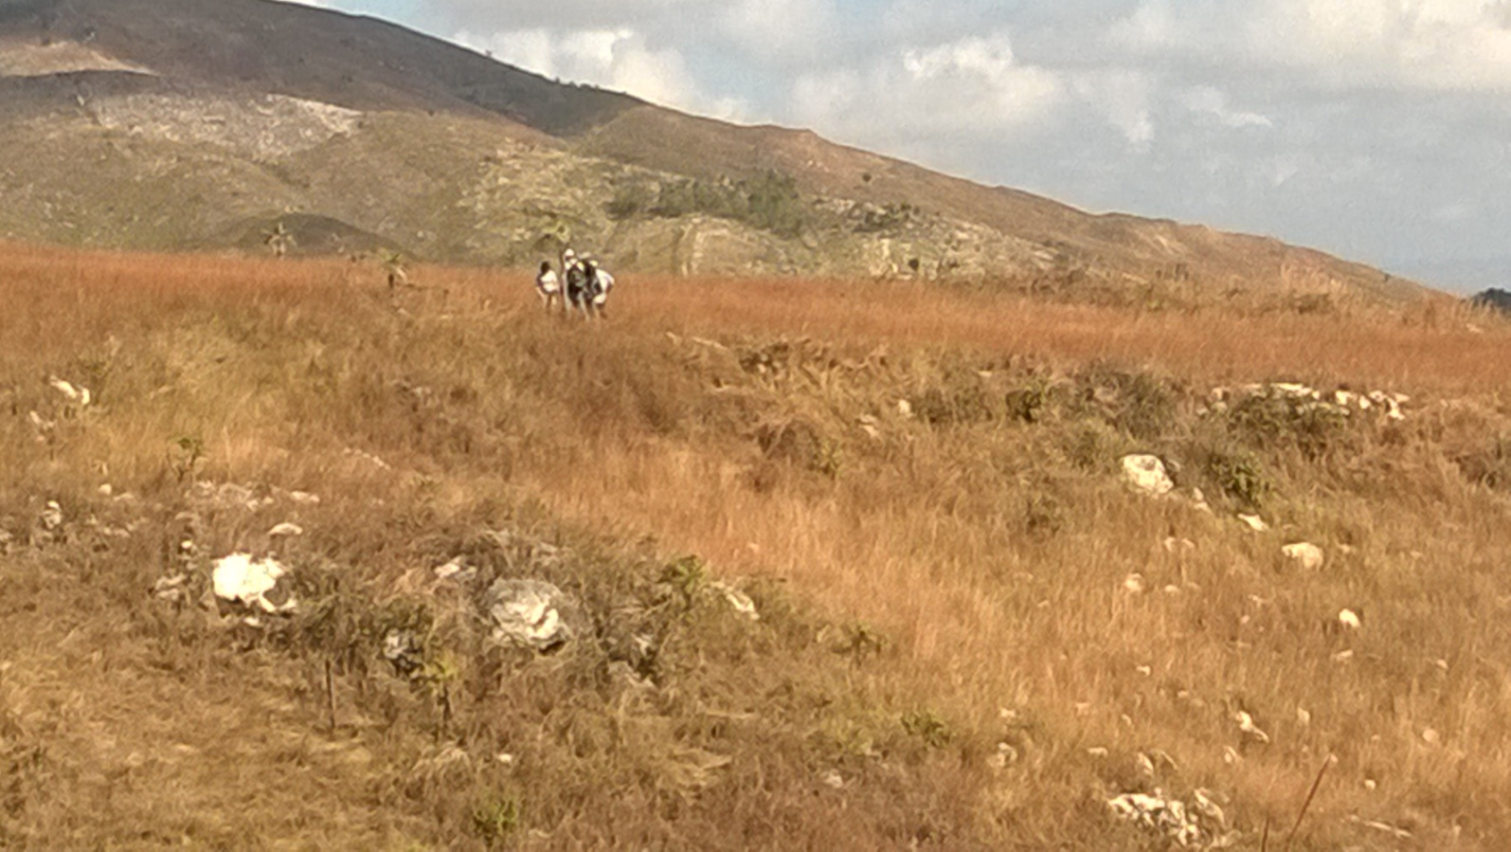
Thomonde property

BonZeb, Inc. P.O. Box 3553, Gresham, OR 97030 503-333-5959 tom@bonzeb.ngo www.bonzeb.ngo

Mission

Through production of affordable charcoal using environmentally sustainable biomass and a financially sustainable business model, partner with the people, NGOs, other organizations and communities to establish Haitian owned and operated small businesses to create living wage jobs and educational opportunities that empower and enable them to maximize their God given potential.

Vision
To provide an environment that enables and encourages right-relationships with God, other people, and God’s creation.
To increase the awareness of the plight of Haitian people through service and immersion projects and mission trips.
To collaborate with national and international businesses and organizations working in Haiti adding value to the joint effort via our renewable energy technology and methods and through the creation of educational opportunities.
To use these relationships to support self-sufficient businesses throughout Haiti which provide services to people of every economic status and develop educated, capable professionals from within the local community.
Facilitate the creation and growth of truly sustainable charcoal businesses in Haiti and internationally.

Core Values
In order to fulfill our mission, achieve our goals and implement our vision, we believe that treating others with Dignity, Respect, Compassion and Integrity are keys to success. We also believe that proper Stewardship leads to true Sustainability and long term success.

Building quality lives and strong communities through...
DIGNITY
We
• treat everyone as we ourselves want to be treated
• treat others with honor and appreciation
RESPECT
We
• demonstrate our esteem for the worth of all life and creation through our acceptance and appreciation for all
• believe in the inherent dignity of all people
• honor ourselves and others through words and actions
COMPASSION
We
• strive to help eliminate the suffering of those we employ, serve and collaborate with
• understand the circumstances and viewpoints of others
• develop the capacity to forgive others and ourselves
• promote a peaceful, caring and safe community
INTEGRITY
We
• say what we believe and do what we say
• are honest with ourselves and others
• demonstrate fairness in our judgments and actions
• fulfill our commitments and promises
STEWARDSHIP
We
• are all responsible for overseeing and protecting all our resources, human and natural
• take ownership of our behavior
• strive to be reliable and trustworthy
SUSTAINABILITY
We
• believe that true leadership begets leaders
• find positive ways to contribute to the broader
community
• share our time and talents with others

The Situation
The average American only thinks of Haiti when the country is wracked by natural disaster. A hurricane or earthquake can move many to action, but these sudden bursts of attention and aid do little to address Haiti’s underlying issues. Haiti has been listed – countless times – as the poorest country in the western hemisphere. Years of political instability and economic hardship have left the population desperate. As a result, the very land they live on has been squandered to meet basic needs.
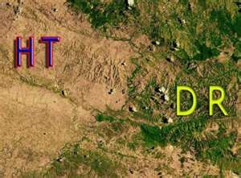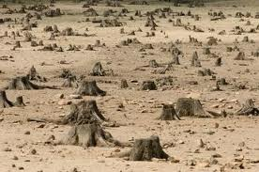
Haitian/Dominican Border Deforested Land

Natural disasters dramatically impact both the agricultural and economic state of the country, which in turn contributes Haiti’s poverty level. Nearly 98% of the country’s forests have been destroyed for construction and energy, compared to only 40% in 1923. Deforestation has a direct effect on soil erosion, with an estimated 15,000 acres of topsoil washed away each year. Erosion damages more than plants and trees; it also damages productive infrastructure such as dams, irrigation systems, roads, and coastal marine ecosystems. Soil erosion also lowers the productivity of the land, worsens droughts, and eventually leads to desertification, all of which increase the pressure on the remaining land and trees. As famines ravish various parts of the country, it is obvious that something must be done to curb deforestation.

The major cause of deforestation and environmental degradation in Haiti is charcoal production. Haiti has extremely limited access to modern energy services; over 70% of the energy used in Haiti is derived from wood and other biomass. Several million trees are cut to produce millions of tons of wood charcoal every year. (It takes approximately two average-size trees to produce a ton of charcoal). Charcoal is then sold for use in cooking and baking. The wood charcoal industry is a source of income for many Haitians. They understand that their actions are ruining the country’s environment, but, at the same time, they have no other choice for survival.
Charcoal is a leading cause of deforestation, but it also consumes a large proportion of income. Approximately 70% of Haitian household energy comes from firewood and charcoal; and at least 30% of family income is spent on charcoal in Port-au Prince. Converting from wood charcoal to alternative cooking fuels has the potential to both save the environment and lower energy costs for the average Haitian.

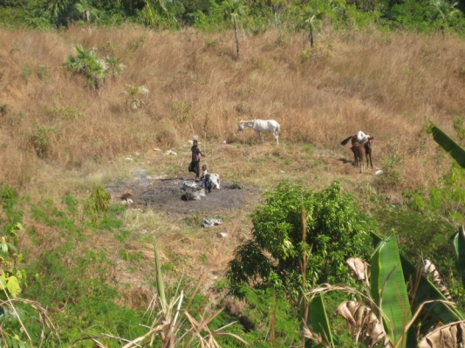
Carbonization of wood

The Solution
BonZeb is seeking to bring a truly affordable and sustainable solution to Haiti. It is inevitable that the current charcoal industry, will completely deforest the country within the next 2-3 years. They are already cutting down mango trees for charcoal. Without an alternative source for cooking fuel, the cost of charcoal will skyrocket beyond the present cost of $1.25 per day. With 25% to 40% of average income being spent on cooking fuel, any increase in cost would be devastating.

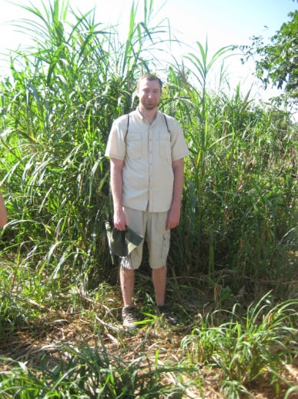
BonZeb has developed a low-tech method for processing various feedstocks—native grasses grown by local farmers—into charcoal briquettes. This process has to potential to lower the cost of charcoal by 40% to 50% and will decrease the need to use trees for charcoal.

BonZeb will work with local farmers, landowners, small business entrepreneurs, NGO’s and communities to grow these feedstocks and will utilize local labor for manufacturing. This process will create new small businesses, jobs and new skill sets (management, processing, storage, shipping, marketing, and sales) and will foster economic development within rural communities.

BonZeb’s initial focus has been to develop relationships with Haitian businesses, government agencies, as well as other NGOs. Liaisons from Bonzeb have met with the ministries of agriculture, energy, and environment. Haitian entrepreneurs from Jedco and other companies have expressed interest in the project. BonZeb members have also met with other NGOs working in the agricultural field such as Double Harvest and Much Ministries.

BonZeb has developed a process that is 95% human-powered for the conversion of feedstocks into high quality and low-cost charcoal.

BonZeb has partnered with the Shiley School of Engineering at the University of Portland to improve our kiln that can produce tons of charcoal a day using only human labor. The first kiln will be shipped to Haiti in June and a new set of students will design a second generation kiln to follow.

In the fall of 2015, the first fields of feedstock were planted near Thomonde. 15 acres were prepared and planted by 91 employees. In April an additional 75 acres is scheduled for preparation and planting.

BonZeb foresees that in three years, the company will be in position to create at least ten small business opportunities and to continue to expand operations until each Department has sufficient plants to sustain that region. With each small business employing approximately 125-175workers (at full capacity) and producing 1,500 metric tons of charcoal annually, the overall goal will involve 250 small businesses creating approximately 40,000 jobs (F.T.E.) and producing over 400,000 metric tons of charcoal per year. This amount of charcoal is enough to service over 1,200,000 homes, while lowering the projected cost to the end-users significantly.

BonZeb has the potential to revolutionize the way Haitian people live by lowering the cost of fuel for cooking; creating new skilled jobs; and, eventually replanting the forests and improving the environment. Although this product will not solve all of the complex and engrained issues that Haiti is experiencing, it will impact the lives of millions.
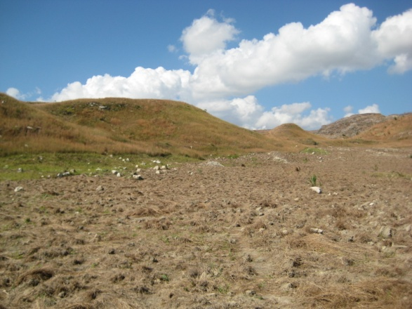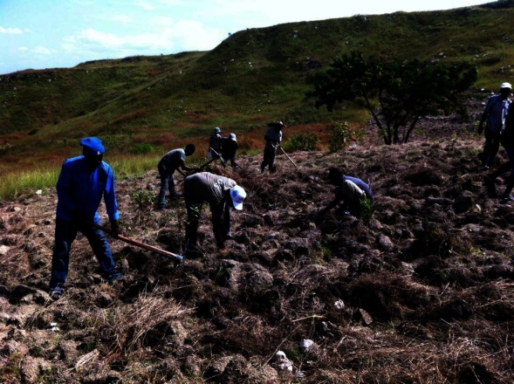
New farm in Boucantis
Marketplace

Goals
Job Creation

- Job creation will primarily be in agriculture (planting, harvesting, and transportation); unskilled and skilled factory workers; construction (infrastructures); administration; marketing; and sales.

Economic Development

- Create 40,000 jobs paying a living wage in rural areas for the greatest economic impact.
- Donate 50% of net revenues by build infrastructure, which will add additional jobs to local economies.
- Allow end users to spend money on other goods and services.
- Facilitate the use of fuel efficient stoves (current models are most efficient using briquettes).

Agricultural Development

- Facilitate the cultivation of approximately 18,000 hectares of perennial feedstock using approximately 10% of the unused arable land in Haiti.
- Increase soil fertility and improve reforestation survival rates after the first 10-year rotation of the feedstock.
- Utilize a non-invasive crop that is indigenous to Haiti.

Educational Components

- Agricultural education through face-to-face interaction with BonZeb’s professional agronomists.
- On the job training for unskilled, semi-skilled, skilled and professional workers.
- Applied business management and administrative programs for staff, professional workers, and interns.
- Ecological and environmental internships.
- Financial and economic stewardship for vendors, suppliers, employees and local community.
- Disseminate new forms of fuel and energy-efficient cooking methods.
- Partnering with educational organizations to provide educational opportunities to the people of Haiti.

Ecological and Environmental Development
- Improve soil fertility through use of unused arable land and perennial feedstock.
- Reduce deforestation by providing a viable alternative.
- Assist in reforestation efforts by building soils and soil fertility and encouraging conversion of feedstock land into forest at the end of the first feedstock rotation (12 years after planting).
- Reduce Greenhouse gas emission.
- Create lower carbon footprint than current feedstock and production methods.
- Reduce erosion through additional land-coverage with feedstock and reduced demand for trees as feedstock.
- Utilize a crop that is not in competition with food crops or land used for food crops.
- Work with and through government liaisons in the Departments of Agriculture, Energy, Environment, and Ecology.
- We will work with suppliers, local vendors and public markets currently selling wood charcoal.
- Work closely with other non-profits and NGOs in order to educate the general public about the need to conserve current forest lands and replant the denuded areas.

Country Profile: Haiti. Library of Congress Federal Research Division (May 2006).
Malik, Boulos A. "Forestry."
Activity Data Sheet: Haiti – Environmental Degradation Slowed.
Replacement of Wood Charcoal in Haiti, By Max Massac, P.E., 1998.

