Project Proposal of Computer Center at Chitwan District from Volnepal

- Name of Project: Computer Center for public school and for community people

- Project Site: Janakalyan Secondary School , Kalyanpur, Madi , Chitwan

Madi is situated south west part of Chitwan district which is 45 kilometers far from the district head quarter. It is surrounded by the part of Chitwan National Park and northern border of India. It seems like separate district. There are four VDCs in Madi. The population of Madi is more than 70,000.00 .There are no good health, electricity; communication facility, good transportation facility, no black topped road and so many other developmental infrastructures. Literacy rate is poor and the literate people are so called upper classes. The dwellings/settlement is dominated by the socially excluded and economically poor indigenous group (Chaudhary/tharu) as well as the dalit and other janajati. There is land dominated by unproductivity. No well managed schools with computers in Madi. Government has not turned its eyes for development of Madi. Rewa River is the burden of Madi. Because of not being the bridge over Rewa River, people of Madi have to face problems in rainy season and in other times. There are more than 9 streams over which bridges have not been constructed yet. Students have to go to Bharatpur, the district headquarter, to learn computer education as well as better education of school level and also of campus level.
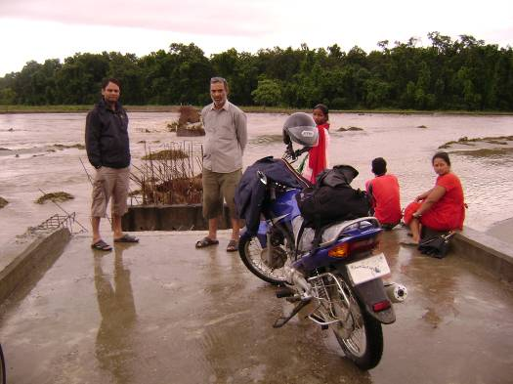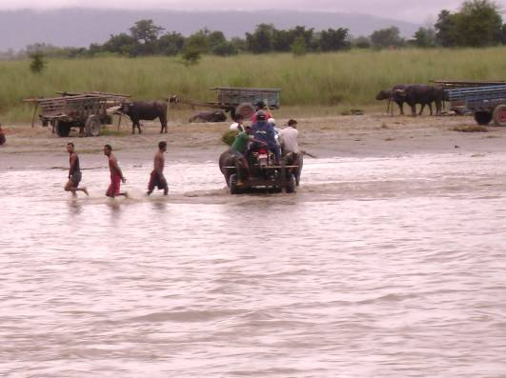

- Project Period ( Completion of Installation ): Three months from project approval

- Introduction of Project Site(Janakalyan Secondary School , Kalyanpur, Madi , Chitwan)
Janakalyan Secondary School was established in 1989 and is situated at Kalyanpur-4, Madi, and Chitwan. This school consists of 6-10 classes. This school doesn't have computer facility. The total no. of the students of this school is 580 in this academic year. Students are of different castes and groups. Madi is like a valley and there are four secondary schools in Madi. Janakalyan secondary school is the youngest & poorest of them. No one school has computer facility in Madi. Adequate government facility is not in this school. Only six teachers are supported by the government. The rest eight teachers are school based or guardians have to pay expensive fee for education of their children. The school has 15 rooms but it is not sufficient for quality education. School has the facility of ground, toilet but not of pure drinking water. In spite of being such type of problems, students of 8-10 classes are seemed to have computer training. There is not electricity in Madi.

5 Burning Problems of the Project Site (Janakalyan Secondary School):
- Average Learning Achievement of the students is not satisfied.
- Students are ignorant of computer education.
- All of the teachers are not trained of computer training.
- Teachers & students are poor in information & technology.

6 Objectives of the Project Proposed:
- To give training of computer education to the teachers & students of the school.
- To develop the school as the computer center as well as communication center especially internet service.

7 Targeted groups of the project:
Students of 7-10 classes of Janakalyan Secondary School are the targeted groups of the project. Also the teachers of the school and the youth of the community people are targeted group.

8 Expected Achievements of the Project:
- Teachers & students of the school will be trained in computer education.
- School will be developed as Information & Technology center.
- Environment arounding the school will be computer educational.

9 Procedure of conduction of the Computers:
Especially, students of 7-10 classes will learn the computer education as well as the teachers. Students of senior classes will teach the new comers or the students of lower classes. School will manage the computer teacher if required. Local Village Development Committee will support and coordinate the computer center. One focal person of the project will be appointed in the Club. The focal person will take care of the computer center till three months of the installation of computers and the focal person will assist for running the project.

10 Sustainability of computer center:
Fund for repairing & maintenance of computers will be managed by the school in the future. In the initial stage, computer teacher is required for teaching computer education. After that, students of senior classes will teach the new comers. This process will continue onwards. Sometimes local village development committee and other institutions will support the computer center. As well as local youth club and the community people will make the center sustainable the project. Because school management, local government body and the youth of the community will directly benefited from this computer center.

Volnepal will choose the local organization to run and manage the center.

11 Process of Reporting of the project:
Completion of Installation of computers and solar power will take a month. This organization will send financial and installation report within three month of the project approval. Volnepal will send the report of computer center as per the donor requires. The organization will prepare the report of computer center itself periodically or if needed.

12 Estimated budget of the project:

S.N. | Particulars | Unit | Quantity | Rate (NRs) | Total in NRs | Total in $
 |  |  |  |  |  | (1$ =NRs 63.25)
1 | Computer Set P4 | Number | 8 | 50,000.00 | 400,000.00 | 6,324.11
2 | Solar Power | Watt | 720 | 1,095,000.00 | 1,095,000.00 | 17,312.25
3 | Furniture | Number | 8 | 7,500.00 | 60,000.00 | 948.62
4 | Printer (photocopy, fax, scanner) | Number | 1 |  | 45,000.00 | 711.46
5 | Focal Person | Number | 3 months | 10,000.00 | 30,000.00 | 474.31
 | Total (A) |  |  |  | 1,630,000.00 | 25,770.75
6 | Organization Overhead 15% (B) |  |  |  | 244,500.00 | 3,865.61
 | Grand Total (A+B) |  |  |  | 1,874,500.00 | 29,636.36

* The total price of the solar power is as per the quotation of Rural & Alternative Energy Pvt. Ltd., main office, Damauli, Tanahu district, Nepal. Also the total amount consists of other materials required for installation of the solar power.

13 Contact person:
Name: Anish Neupane, Director
Organization: Volunteer Nepal National Group
Address: Jhaukhel -4, Bhaktapur, Nepal
URL: www.volnepal.np.org
E-mail address: info@volnepal.np.org

Short information about volnepal

VNNG is a newly developed association designed to enhance educational opportunities in an impoverished area in Nepal.

Vision
Become a leading innovator of effective inclusion of poor and marginalized children into high quality private education institutions. Effectively create an integrated learning community wherein students, teachers, parents, social development and community leaders actively work together to enhance the learning process for school students and the overall community. Promote a sense of social responsibility and create avenues for effective community solutions to issues in education.

Mission
To promote excellence in education as well as an experiential approach to learning and service to others. In addition, to provide educational opportunities to children and young people who currently have none.

“EDUCATION FOR ALL” this is the slogan of 21st Century. As Education being the key for development of any nation, we can say: one of the fundamental requirements for a nation to be a developed one is “Educated People”. Nepal, being a developing country has realized that for development Education is the most important thing. The educated group or the Intellectuals of Nepal are dedicated to provide Education to the Nepalese people. Government organizations, non-government organizations and civic society, are working side by side to develop an educated man power for the nation.

As Nepal is going through a situation of financial crisis, substantial funding by the government on Educational programs is not currently reliable. Though, Nepal believes in Education for all but due to the political instability and various other reasons like Maoist insurgency, the educational programs have not yet reached the people below the poverty line. The civic society of Nepal and other non-governmental organizations are currently working on their own in providing education to the poorer people. Nabin School is one of the organizations that adheres to the motto that education is the building block of a Nation, and the light of education should reach those people.

The success of any group or nation depends on both the success of its individuals as well as the ability of those individuals to cooperate for the common good. We are inspired by John Nash’s Nobel prize winning proof of mutual gain-- a group of individuals competing solely for personal gain suffer a net loss, whereas a group of individuals who compete for personal gain through cooperation enjoy a net gain.

Population to Be Served

We want to reach: The new computer center wants to reach to those students who do not have access to information technology at all, such as poor Tamangs, Damains, Kamis, in the area. We also target to reach to those families who cannot afford to send their children to good schools.

- Socially backward and economically backward by providing quality education
- Lower Caste
- Low income rate people
- Orphan
- Physically unhealthy people
- Women

