
(Francisca serving a customer at her shop)
Miss Francisca benefited from the Turing Trust scholarship scheme and computer training for two academic years and completed her formal vocational and technical training at the Amoawi ICCES Training Centre last year (2018/19).
She happily graduated with two nationally recognized certificates namely:

- NVTI foundation Certificate
- GES/NABPTEX Certificate.

Upon completion she took part of an entrepreneurship training and challenge program called ‘YIEDIE’ organized by global communities.
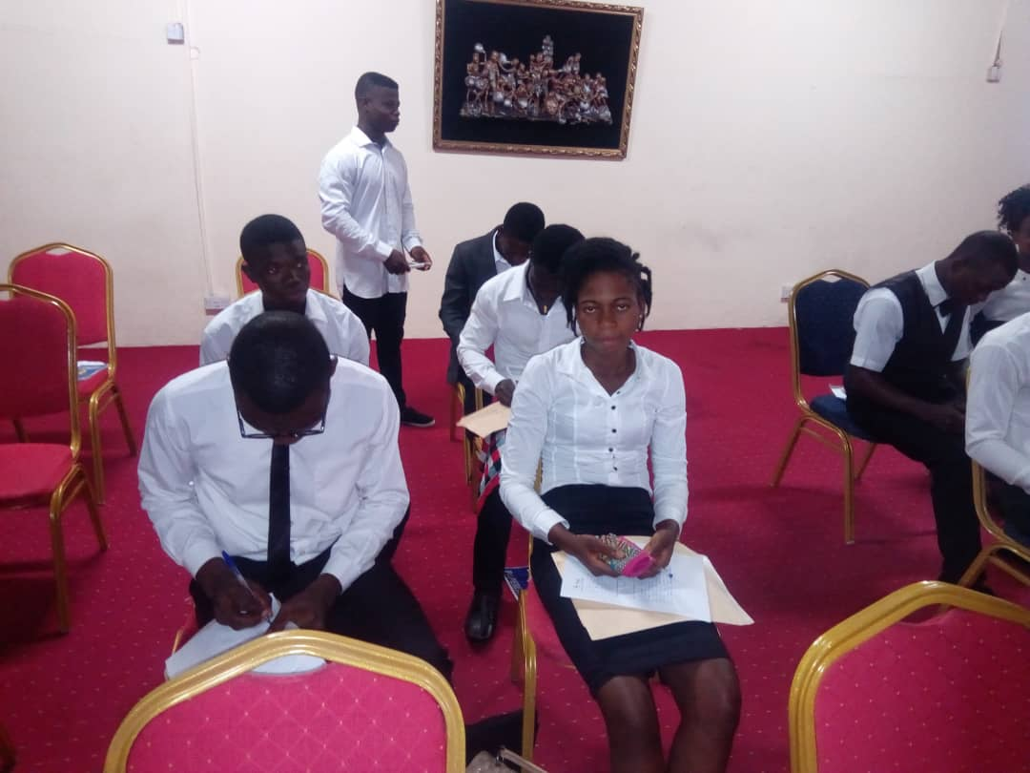
(Francisca –second from left on the front roll during the yiedie training)
This was a very challenging contest with several other young, talented and ambitious artisans competing for the limited slot available for the grant. Through hard work and dedication Francisca emerged as one of the best among the 700 participants who took part of the training. She was given a grant of GHS: 6,500.00. to start her own basic electrical equipment sales and repairs shop at Offinso municipality where she hails from.
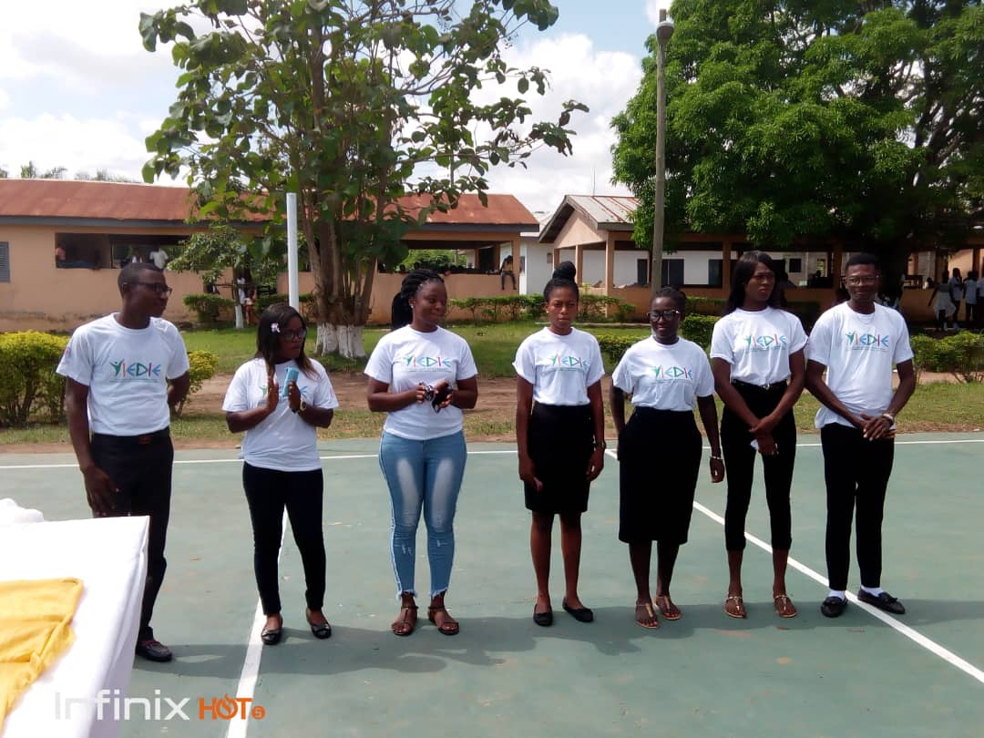
(Francisca –middle with her other colleague winners of the YIEDIE grant)
Besides her personal dedication and commitment towards achieving her goal, I believed her beautiful success story saw the light of day due to your support and contributions. We are very grateful to all the donors and we believe you would continue to help assist suchlike ones to become self-empowered.

