WELCOME TO CANDYLAND
HERE WE START COMPUTER TRAINING VERY EARLY

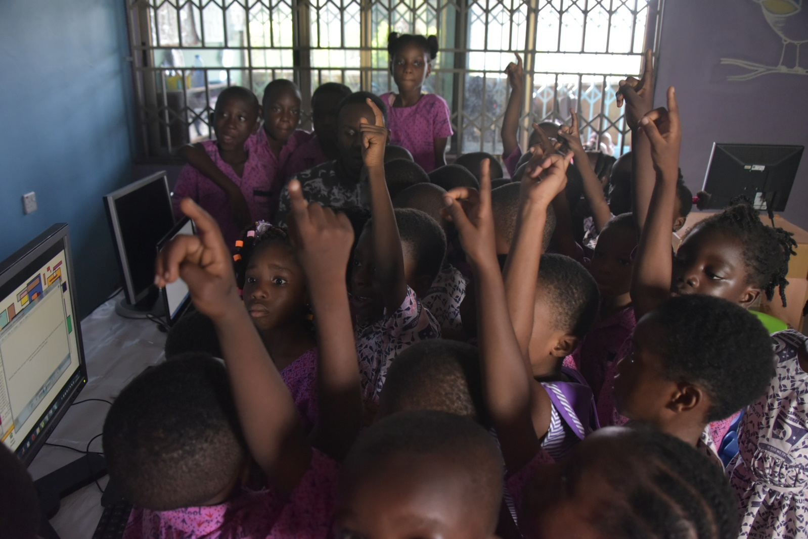
(ICT lessons at the Candyland pre-school and primary)

Candyland if a pre-school and primary located at Ejisu in the Ashanti region of Ghana. The vision of the school is to exceptionally train young talents to become very useful to society in later years. In view of this they have included ICT training as part of their basic development curricular.
Candyland can boost of over 200 pupils between the ages of 6months and 12 years
Our visit to the school brought some amazing experience with these lovely kids. Though a full class of the pupil’s outnumber the number of computers available, we witnessed some lovely kids who were so keen to learn more about computers. They were happy and ever ready to answer the basic questions we asked about their computer studies so far.
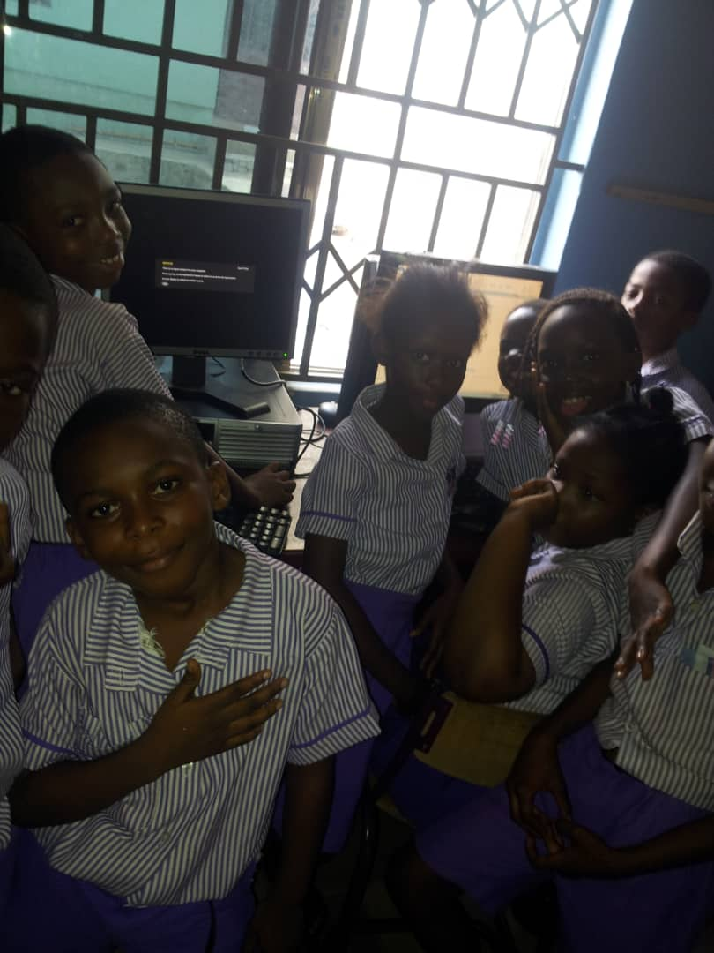
These very young students were able to individually create folders that bear their names and navigate conveniently through all documents. (This might not too surprising, but in our part of the world, it is awesome)
Each one of them would want to have a feel of the keyboard and that was very encouraging, hopefully we shall see a new crop of computer scientists from these young ones.
A scheduled training (December, 2019) for all our teachers in Ashanti would address a few teaching methodology challenges observed during our visit. These teachers are very committed and we believe such training would help bring out the best in the teaching and learning processes.
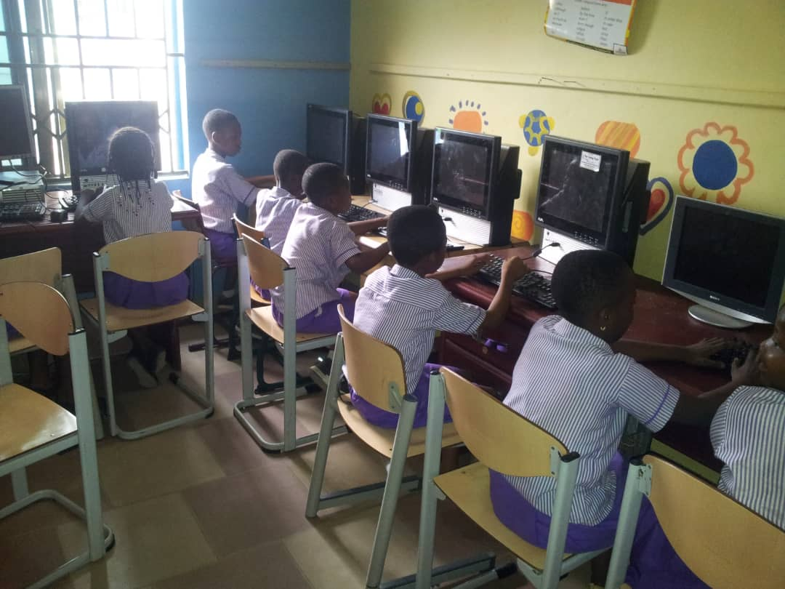

We are always grateful to all our lovely donors. We believe every contribution you are making towards this course would surely produce some wonderful future leaders in our country and beyond.
These projects and all the work of the Turing Trust would not be possible without the generous donations. Thank you very much for everything that has been contributed, we and all of the students are very grateful.

