A VISIT TO OUR PROJECTS IN THE CENTRAL REGION OF GHANA
(NEW EBU ICCES)
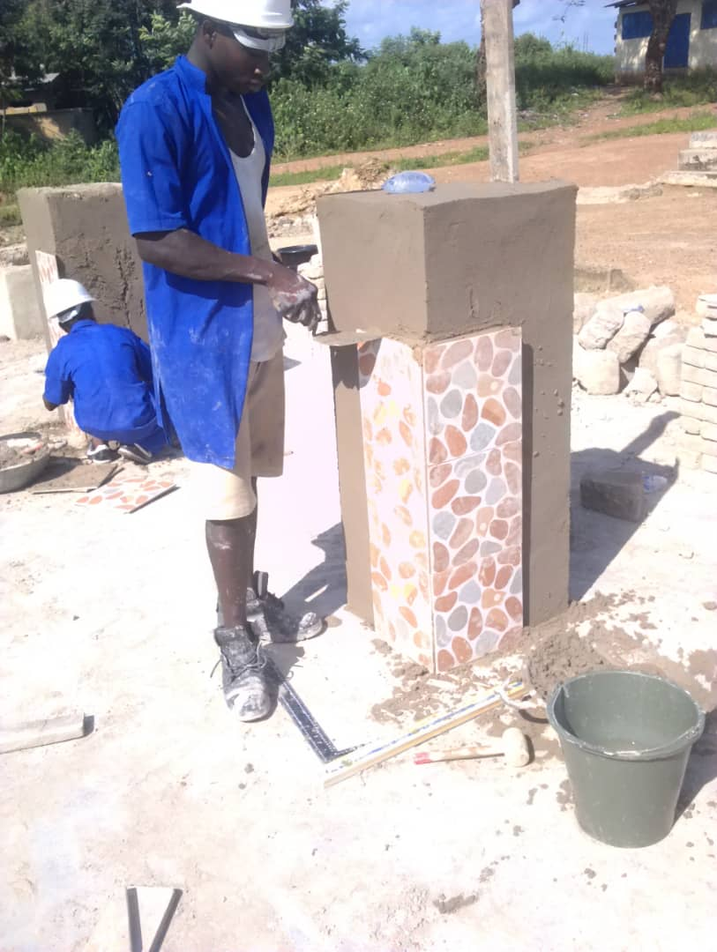
(Building construction students of New Ebu ICCES CENTRE )

New Ebu ICCES is one of our partner schools in the rural part of the Central region of Ghana, and a visit to the school this term revealed some inspirational stories from some first years building construction students.
Richard, a first year building construction student from the Assin Ngeshie community expressed his joy after enrolling at the New Ebu ICCES Centre. He says ‘after just six months of practical training at this centre, am able to mould bricks, lay them basically and even erect brick pillars. Am very happy to be here, as my training will surely give me a better future and l would be able to fulfil my dream of becoming a building contractor in the future’.

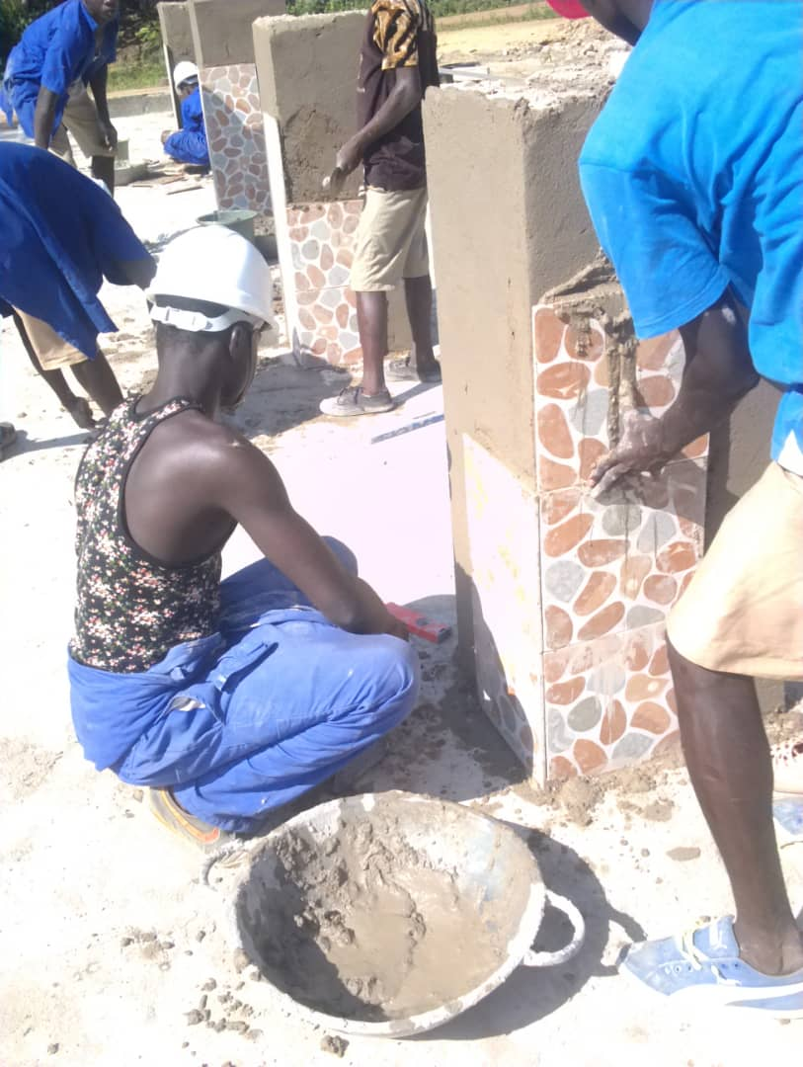

UPDATES FROM TEACHER TRAINING
With the introduction of ‘COST’ Committee Of Same Trade, within the ICCES fraternity, the Teachers from various schools within a region are able to meet regularly to share ideas on the currents trends in their various trade area which are then taken back to their respective schools to improve their teaching and learning methodologies.
This positive impact is surely seen and felt during a visit to the New Ebu ICCES centres and an observation of a masonry practical class gave us more hope for further improvements. The photos shows the students outputs during the practical lessons.
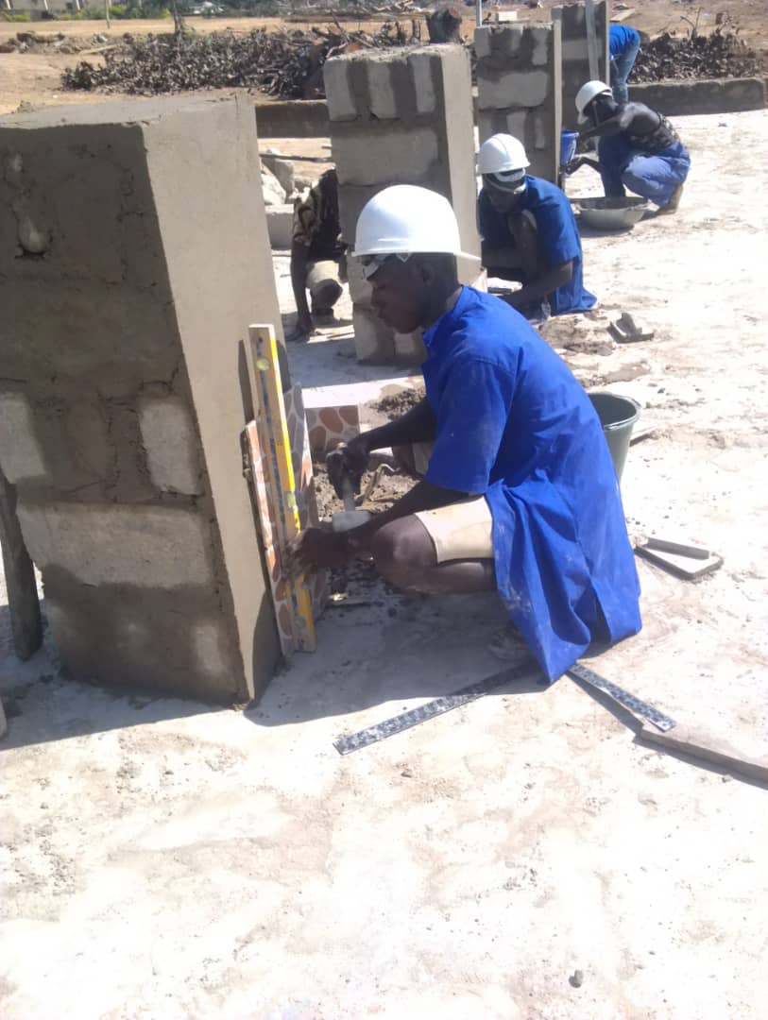
These projects and all the work of the Turing Trust would not be possible without the generous donations. Thank you very much for everything that has been contributed, we and all of the students are very grateful.

