AWESOME BEGINNING – WITH YOUR HELP
(PRABON JHS)
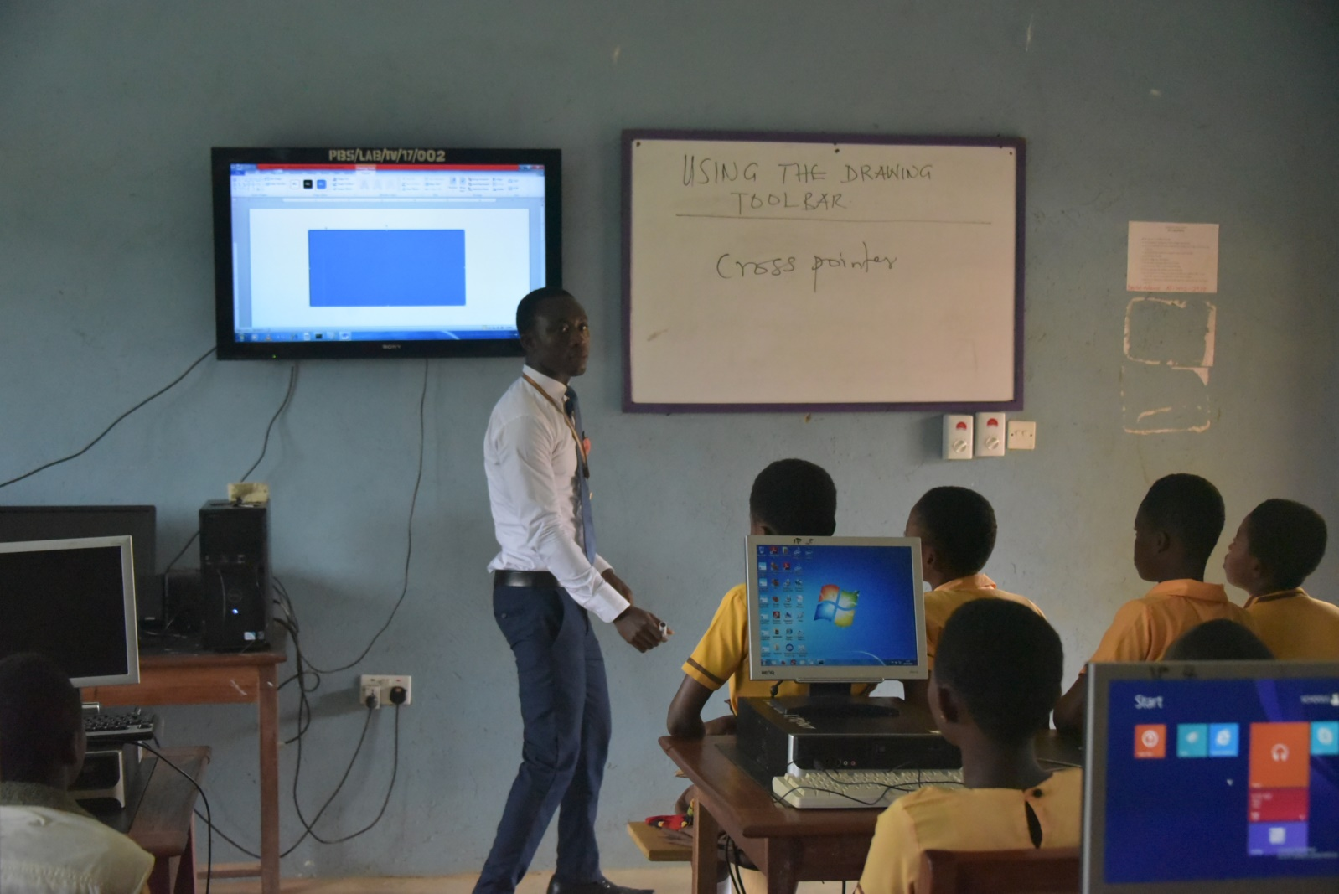
(ICT lessons back at the Prabon JHS )
UP CLOSE WITH THERESA.
Our team visited to one of our past students at the secondary level now. During the visit we asked about how her earlier training at the junior secondary school level is helping her now at the senior high school level. The following are her comments:
“My first contact with a computer started at the basic level at Prabon JHS when The Turing Trust donated computers to our school. And this has really helped me a lot on my road to the senior high school. Over here at the senior high school most of our training is done with the computer so my beginning has been extremely beneficial to me personally and all my friends as well”.
When asked how we can further assist her to achieve her dream, this was her reply:
“I wish we started much earlier at the junior level because those of our colleagues here who started at their primary schools are a bit ahead of us, though we are working very hard to catch up with them. Also if you can further provide laptops for us to use after school, we can do much more to catch up very quickly because the love and desire to do more in IT as a female is already there. You will surely see a female IT expert in me in the very near future.”
She further stated that we should be organizing periodic training for them during vacation and also provide regular internship opportunities for them.
In view of this we are organizing training for both students (current/past) and their teachers next month to prepare them for the next academic year.

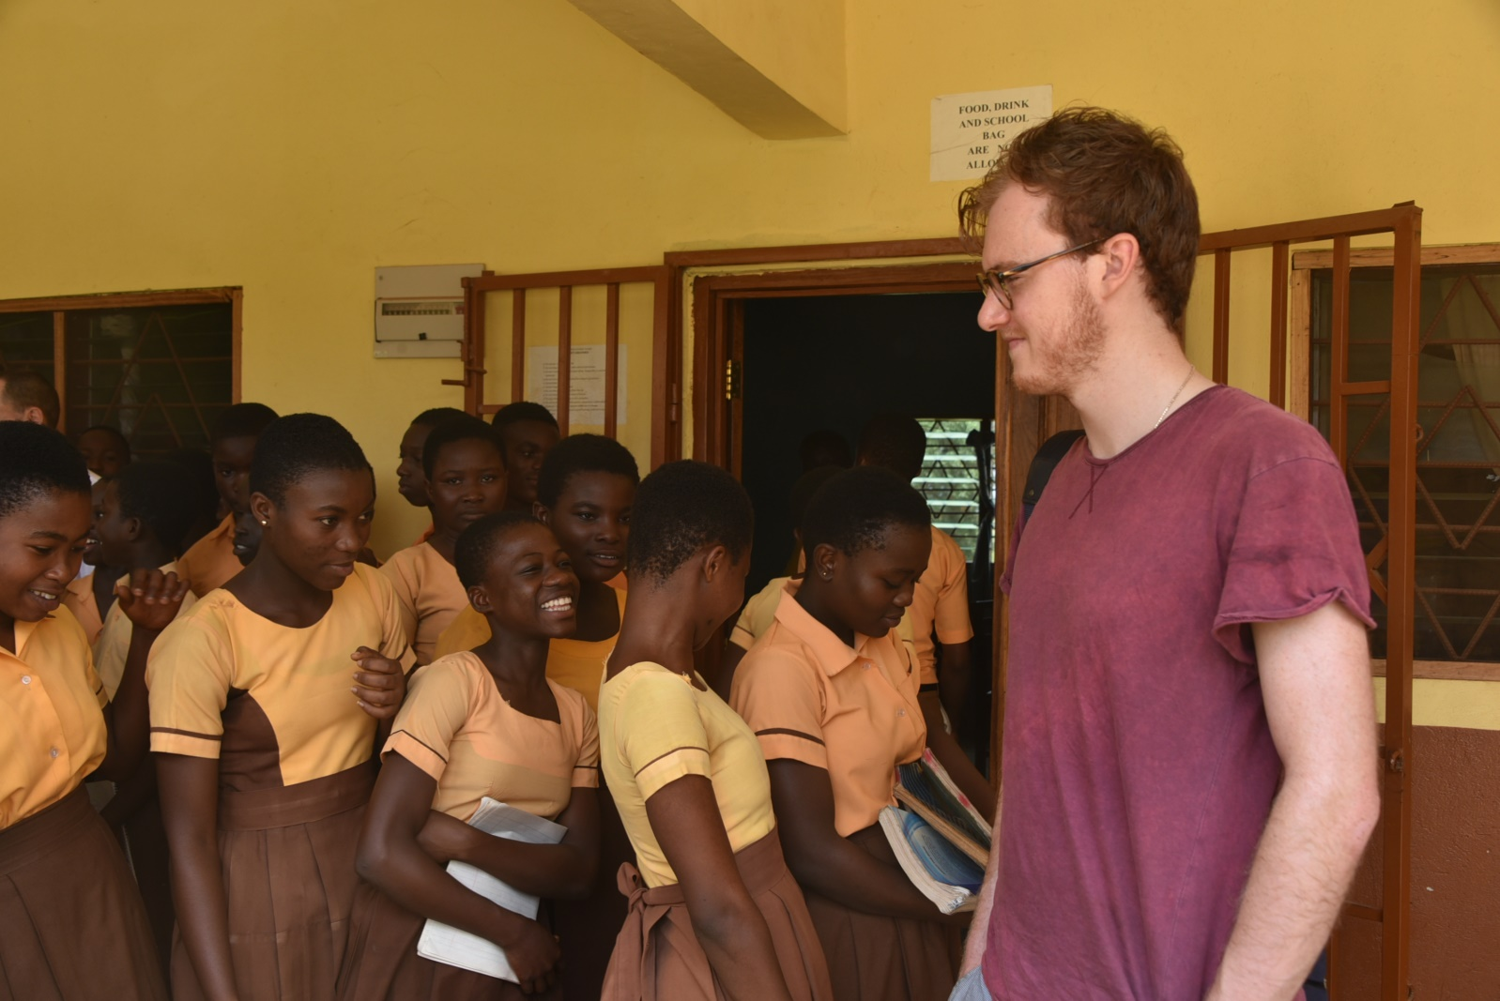
(Theresa and her colleagues going for an IT lesson’s with one of the Turing Trust’s volunteer’s)
UPDATES FROM TEACHER TRAINING
Our teacher training programme have been very encouraging, helping the teachers with the basic technical knowhow on how to equip the young student’s with the necessary IT skills to prepare them for secondary IT knowledge. Teachers are being helped not only with basic IT teaching skills but also with basic troubleshooting and maintenance skill to help them with the maintenance of the computer laboratories before technical support are requested.

These projects and all the work of the Turing Trust would not be possible without the generous donations. Thank you very much for everything that has been contributed, we and all of the students are very grateful.

