NATIONAL SKILLS EXHIBITION 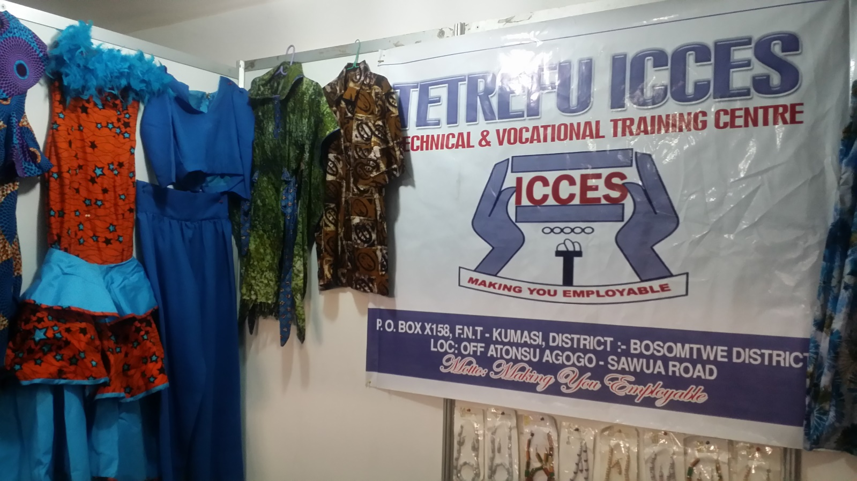
Tetrefu ICCES represented the whole of ICCES during the national skills exhibition organised by the Council for Technical and Vocational Education and Training in collaboration with the Kumasi Technical University Ghana with the theme ‘SKILLS DEVELOPMENT TO IMPROVE YOUTH DEVELOPMENT’
This exhibition saw participant from selected vocational and technical schools across the country so showcase what they have been teaching at the various schools. And we are happy to inform you that one of our beneficiary schools pariticipated in this important exhibition with some amazing works (products) from the students.
Below are photos of some of the student’s products:
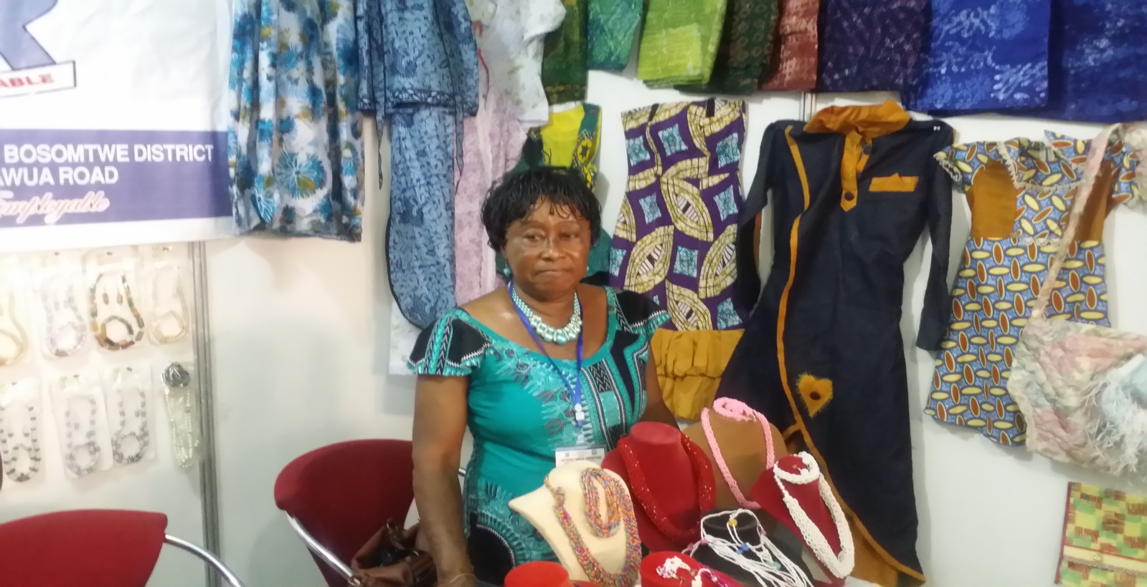
Products from Dressmaking department.
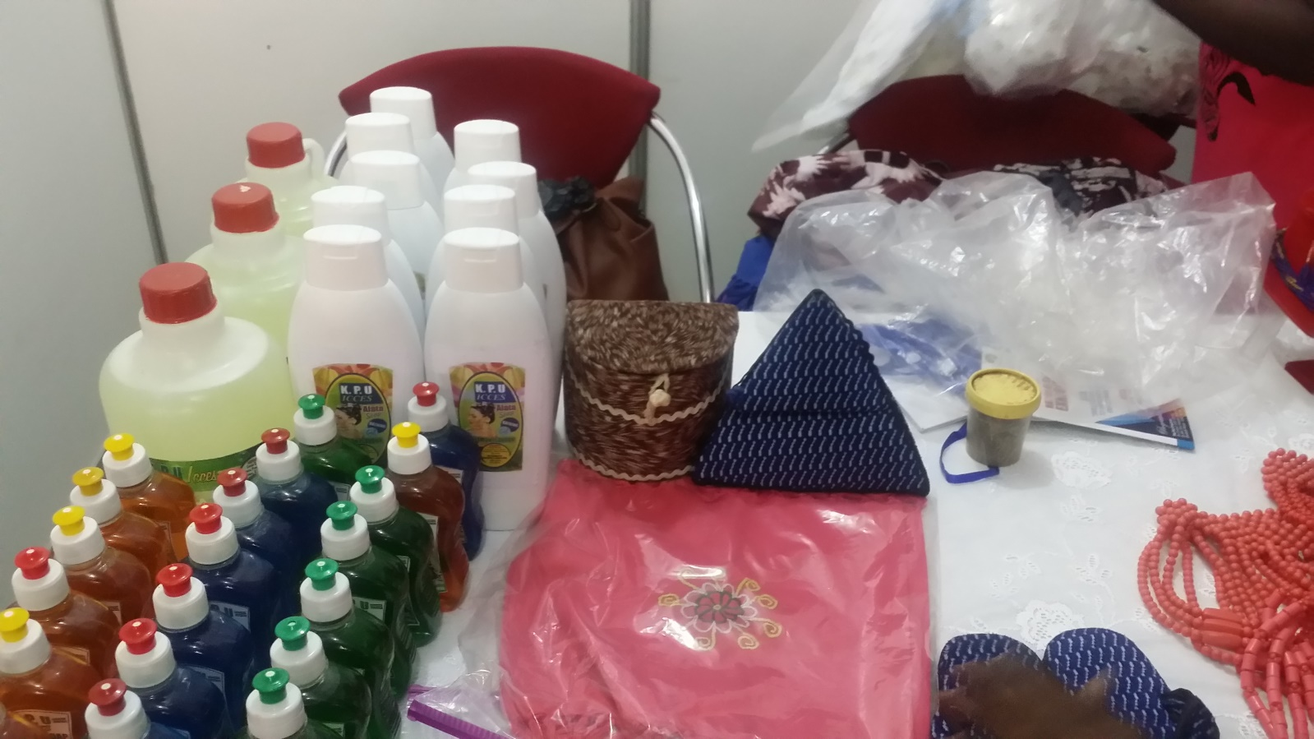
Products from soaps and hand cream section

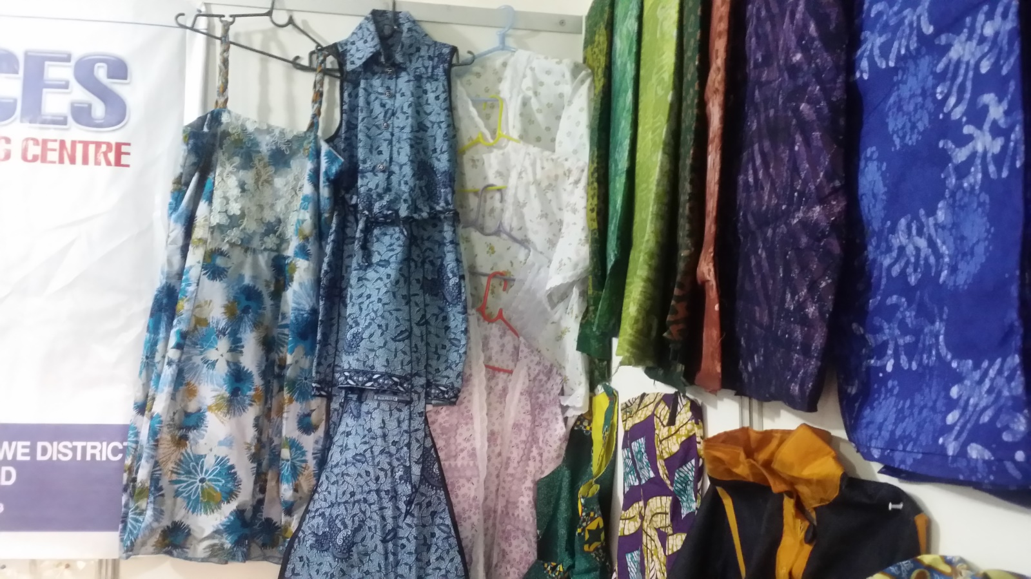
(They were also taught how to practically troubleshoot basic computer faults and rectify them)

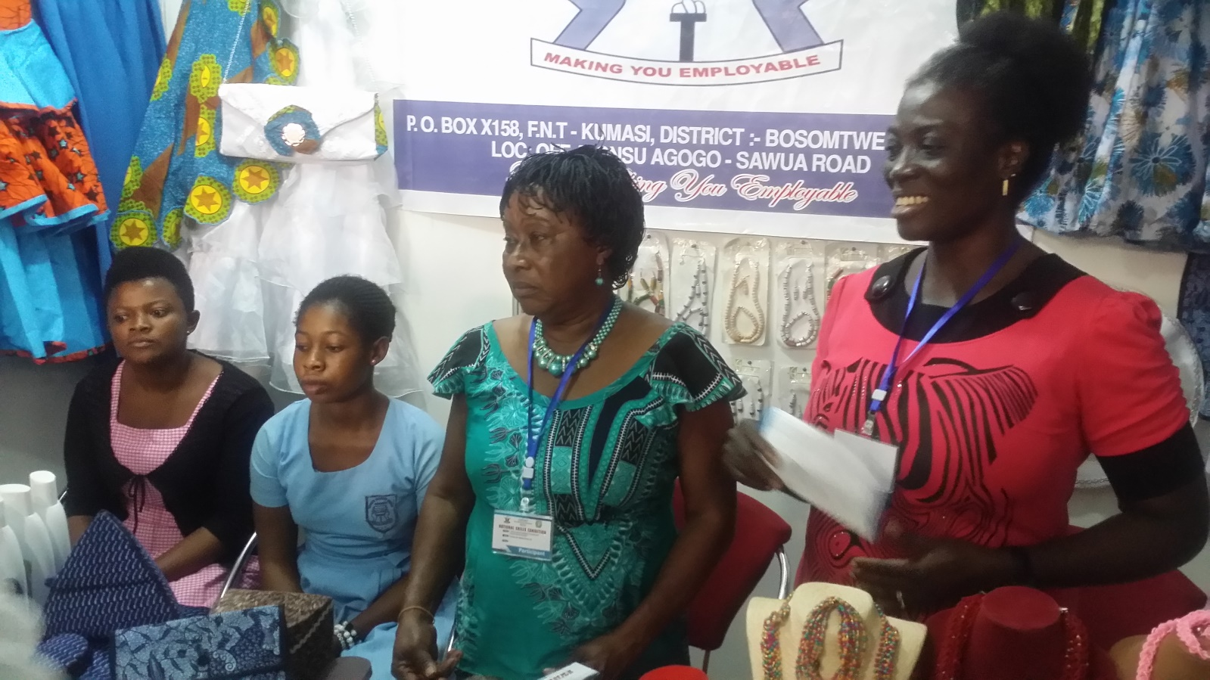
Students and staff of ICCES explaining how these items are made to some observers at the exhibition.
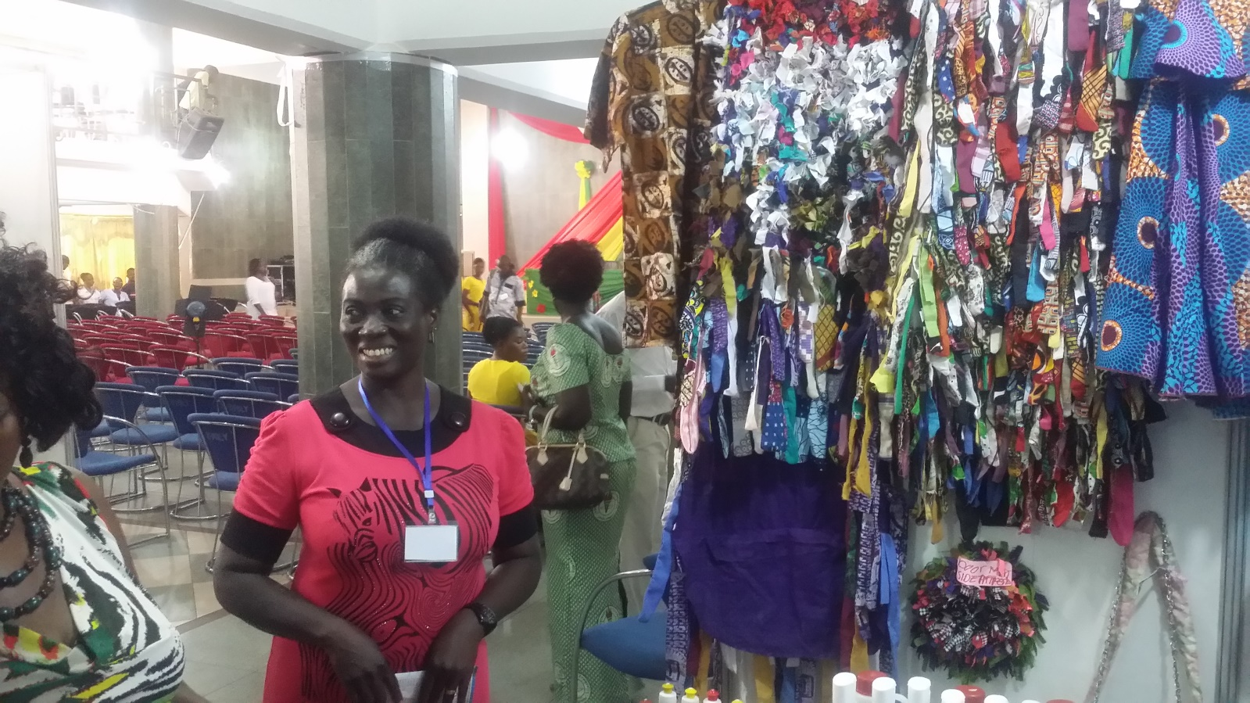
Some of our dressmaking Instructor’s at the exhibition

These projects and all the work of the Turing Trust would not be possible without the generous donations. Thank you very much for everything that has been contributed, we and all of the students are very grateful.

