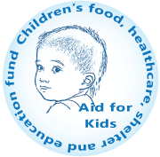
PROJECT PROPOSAL

Project title: AID FOR KIDS NUTRITION PROJECT FOR DISADVANTAGED CHILDREN
Name of organization: Aid For Kids (AFK) | www.aidforkids.org/vietnam
USA office: 18 Market Square, Houlton, Maine 04730 USA
Vietnam office: 38 Tu Xuong, Q3. Ho Chi Minh City, Viet Nam
E: Vietnam@aidforkids.org | T: (84) 168 99 22 599 - 934 104 988
Date of implementation: December 2015
Location: Vietnam
Beneficiaries: Children aged 1-12
Estimated number of beneficiaries: 1,000 children
Grant Request: USD 23,300 for the 1st phase in 2015 – 2017, and USD 13,600 each year after

Introduction of Aid for Kids
Established in 2005, Aid for Kids is a registered, licensed, non-profit 501c.3 with headquarters in Maine (USA) and an office in Vietnam. Aid for Kids is an NGO approved by the Combined Federal Campaign – No. 73141 (Federal Employees Charity Fund) as one of America’s Best Charities, and also approved by Independent Charities of America, and Children’s Charities of America. Most of the staff are volunteers and most services are donated (including office space, supplies, etc.). Our overhead is usually less than 2% and sometimes under 1 percent. We feed hungry children living in poverty, send doctors and medicines, build shelters, send children to school and find opportunities and training for their parents.
Our Mission: We work to improve the lives of children worldwide.

Executive Summary

The Nutrition Project of Aid for Kids is to serve children in the 4 poorest provinces of Vietnam (Ha Giang, Lai Chau, Dien Bien and Son La), children of Tu Xuong Center of Rehabilitation and Support for Handicapped Children (HCMC), and children of the only public school in District 4 (HCMC) that provides free elementary education to street children.
This project features a sustainable targeted method of delivering vitamins and minerals to fill the nutrient gaps in the diets of the children. The method was jointly developed by the Global Alliance for Improved Nutrition (GAIN), Vietnam’s National Institute of Nutrition (NIN) and Irish Aid. It highlights the role of micronutrient powders, which have proved to be successful in tackling childhood malnutrition in Vietnam. Thus, by distributing micronutrient powders to disadvantaged children and improving local people’s awareness about the role of micronutrients in children’s development, Aid for Kids aims to improve health status of the children, reducing the rate of malnourished and stunted children in Vietnam.

Situation Analysis
There are 26 million children in Vietnam today. A Vietnamese child’s diet typically does not provide enough energy, nutrients and micronutrients for their optimal growth and development. As a result, (according to NIN) one third of children under-five suffer from stunted growth due to chronic malnutrition and twenty percent are considered underweight. Because malnourished children grow up with worse health and lower education achievement, the Vietnamese Government has made the reduction of malnutrition a priority. It has achieved considerable success in encouraging exclusive breastfeeding. Local organizations that encourage breastfeeding are becoming more common in Vietnam. That has contributed to a dramatic rise in breastfeeding, from just 19 percent of babies in 2010 to 63 percent in 2013. School milk programs for preschool children have been launched in a few localities, with support from dairy companies. However, micronutrient deficiency, especially in children of poor provinces, remains prevalent. According to the World Bank, the stunting rates of Ha Giang, Lai Chau, Dien Bien and Son La in 2013 are 35.4%, 36.8%, 32.2% and 34.7%, respectively.

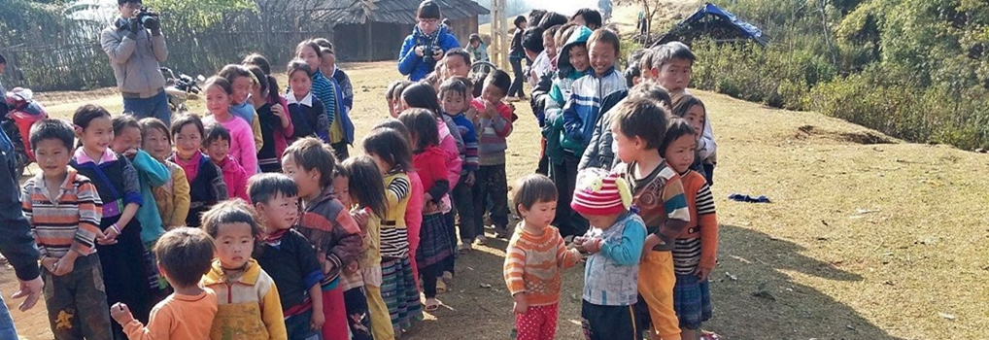
While milk supply is a good nutrition solution, it costs much higher than micronutrient products in improving children’s health conditions. Therefore, Aid for Kids is going to provide the children with micronutrient products that are easy to distribute and have been proved by GAIN and NIN to tackle malnutrition in Vietnamese children effectively.

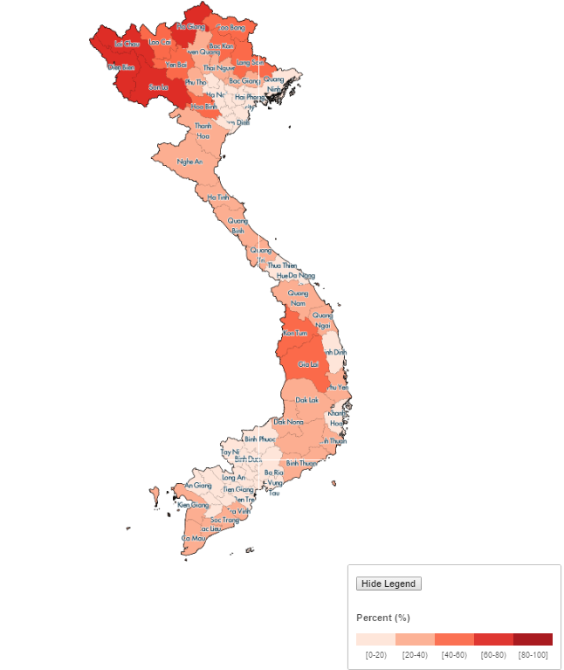

2009 Vietnam Poverty Headcount Map, by World Bank
Project Strategy
Aid for Kids considered a variety of nutrient products and analyzed several nutritional reports. While we would welcome the donation of nutrient products of all types, we especially encourage the donation of Bibomix micronutrient boxes. It has several advantages over other micronutrient boxes.

Bibomix is a 15-ingredient micronutrient powder developed and produced by NIN with support from GAIN and Irish Aid. It meets WHO standards and is the first locally manufactured product for sale via the health system. Having the government directly associated with the manufacture of the vitamin and mineral powder was a major advantage in terms of product reputation and credibility. Another important consideration was sizing, using a range of selling units. One box of 60 sachets is a six month supply for a child. Thus it needs only 2 boxes of the micronutrient powder a year (USD12) to help a child grow up away from malnutrition risks.

In the first phase, (2015 - 2017) with an annual budget of USD 23,300, Aid for Kids will offer 192,000 sachets of Bibomix micronutrient powder to approximately 1,000 children in 4 most difficult provinces of Vietnam (Ha Giang, Lai Chau, Dien Bien and Son La) and 2 schools for disadvantaged children in HCMC.

In the phase, we will organize 10 nutrition workshops to improve local health staff, parents and children’s awareness on the importance of nutrition in children’s growth, role of micronutrients and nutritious food choices.

To evaluate the effectiveness of the program, a randomly selected sample of benefiting children is to be assessed each year in terms of height and weight development. After the first phase, which is to be launched with training sessions on nutrition, the annual cost for continuing the nutrition project would be approximately USD 13,600.
Work plan for period 2015 - 2017

No | Tasks | Unit | Qty | Target by quarter (2015-2017)
 |  |  |  | 3 | 4 | 1 | 2 | 3 | 4 | 1 | 2
1 | Distributing nutritious supplies to Ha Giang | Box | 800
2 | Training on micronutrients & health care – Ha Giang | Session | 2
3 | Distributing nutritious supplies to Lai Chau | Box | 800
4 | Training on micronutrients & health care – Lai Chau | Session | 2
5 | Distributing nutritious supplies to Dien Bien | Box | 600
6 | Training on micronutrients & health care – Dien Bien | Session | 2
7 | Distributing nutritious supplies to Son La | Box | 600
8 | Training on micronutrients & health care – Son La | Session | 2
9 | Distributing nutritious supplies to HCMC | Box | 400
10 | Training on micronutrients & health care – HCMC | Session | 2
11 | Assessment & reports | Dossier | 8

Budget
2015 - 2017
No | Content | Unit | Qty | Cost | Amount | Remark
1 | Purchase of Bibomix products | Box | 3,200 | $6 | $19,200 | 1,000 beneficiaries in 2015 - 2016
2 | Transportation & Distribution | Amount | 1 | $1,700 | $1,700 | 24 trips to 8 locations
3 | Training sessions on nutrition | Session | 10 | $160 | $1,600 | For local health staff & parents
4 | Assessment on children’s health improvement & Administration | Amount | 1 | $800 | $800 | Implemented by local health staff and AFK
 | Total |  |  |  | $23,300

Expected output

Short term output
- 192,000 sachets (3,200 boxes) of micronutrient supply to be distributed to 1,000 children from Q3/2015 to Q2/2017
- Deliver vitamins and minerals to fill the nutrient gaps in the diets of poor children in Vietnam

Long-term output
- Increase weights and heights of the children in normal development speeds
- Decrease the total number of undernourished and stunted children in Vietnam

References

1. World Health Organization. Guideline: Use of multiple micronutrient powders for home fortification of foods consumed by infants and children 6–23 months of age. Geneva: 2011.

2. Rah JH, dePee S, Kraemer K et al. Program experience with micronutrient powders and current evidence. J Nutr., 2012.

3. De -Regil LM, Suchdev PS, Vist GE et al. Home fortification of foods with multiple micronutrient powders for health and nutrition in children under two years of age. Cochrane Database Syst Rev, 2011.

4. Troesch B, Van Stuijvenberg ME, Smuts CM et al. A micronutrient powder with low doses of highly absorbable iron and zinc reduces iron and zinc deficiency and improves weight-for-age Z scores in South African children. J Nutr, 2011.

5. Alia Poonawala. Powder Power. The Guardian. April 01, 2015. http://www.theguardian.com/global-development-professionals-network/gain-partner-zone/2015/apr/01/powder-power (assessed April 21, 2015).

6. Sight and Life. Micronutrient Status in Vietnam. In Sight and Life Vol 26 (2). Klaus Kraemer (ed.), 56-67. UK: 2012.

