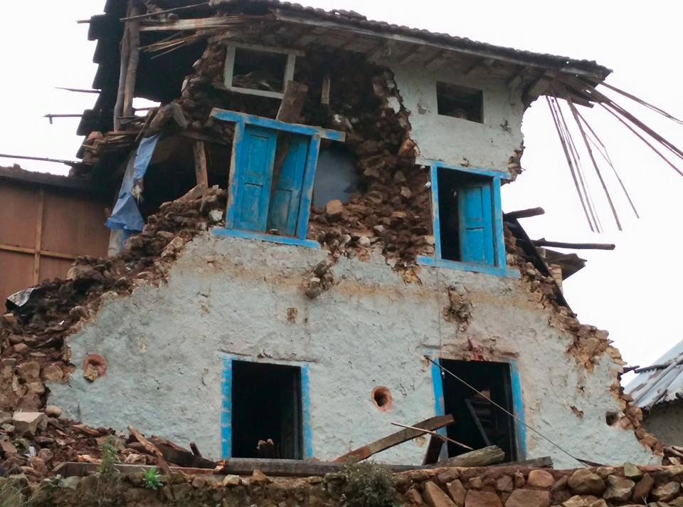
PROPOSAL FOR TEACH FOR NEPAL’S RELIEF EFFORTS IN EARTHQUAKE IMPACTED AREAS

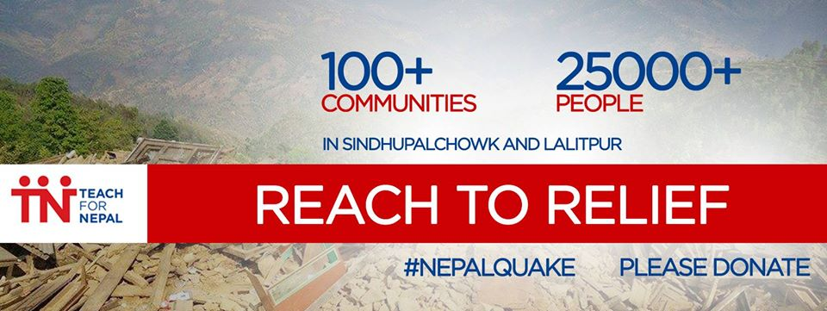
Teach For Nepal Shisir Khanal
Kupondole-1, Lalitpur Nepal CEO
Phone: +97715012014 shisir@teachfornepal.org
Web: www.teachfornepal.org

Introduction

Teach for Nepal is an independent initiative of Sarvodaya Shramadana Nepal, a non-profit and nongovernmental organization. Established in 2008, Sarvodaya Nepal is inspired by Gandhian philosophy of non-violence, service and sacrifice and takes the model developed Sarvodaya Shramadana Movement of Sri Lanka. Sarvodaya, a word coined by Mahatma Gandhi from two Sanskrit words ‘sarva’ and ‘udaya’ is literally translated as upliftment of all. The fundamental belief of Sarvodaya, however, is the “welfare and awakening of all”.

Human values, culture, and spirituality are at the center of Sarvodaya’s model of development. Sarvodaya believes that at the core of all our social and political problems such as poverty, environmental degradation, war and conflict, corruption, inequality, is human consciousness. Thus, Sarvodaya aims to transform societies and resolve the problems through transforming our consciousness from being self-centered to one that of love and compassion to all beings.

Teach for Nepal is developed as an independent movement to enhance the quality of education at public schools in Nepal and to bring fundamental transformation in Nepal’s education sector.

We believe that Nepal’s public education system is in crisis.

Most children in Nepal do not have a real choice to define their life opportunities. Over 70% of students between Grade 1 and 10 drop out of school. Less than 50% of the students who take the School Leaving Certificate Exam (SLC), taken after 10th grade, graduate. The graduation rate for private schools is over 90%, while that for the public school system is less than 30%. Since excellence in the SLC examination defines one's college choices and life path, most children who attend public schools lack basic opportunities, their peers in private schools may take for granted.

Teach for Nepal and the two fold mission

The mission of Teach for Nepal is to extend access to quality education to all children in Nepal by training outstanding university graduates and young professionals to become effective teachers and life-long leaders. Guided by this mission, Teach for Nepal, recruits and trains outstanding university graduates and young professionals to teach in public schools for two years and create immediate impact in classroom. Over the long period, TFN envisages building a movement of TFN alumni who, transformed by their classroom experience, develop a life-long commitment to ensuring education equity.

Established in August 2012, Teach For Nepal placed its first cohort of Fellows in April 2013. Currently, 87 Fellows and Alums are working in 32 schools across three districts – Sindhupalchowk, Lalitpur, and Dhanusha. 18 additional alums are working at Teach For Nepal and other organizations serving disadvantaged populations.

Nepal Earthquake
On Saturday, 25 April 2015, a power 7.8 Richter scale earthquake struck Nepal. The quake and over 100 aftershocks have already claimed over 5,000 lives and over 10,000 people have been injured. An estimated 2.8 million Nepalese are displaced and over 70,000 homes completely destroyed and another 530,000 homes damaged across 39 affected districts (OCHA). Accordingly OCHA, 3.5 million people need immediate food assistance and over 1.4 million will require continuous food support for the next three months.

Earthquake Impacts Teach For Nepal and Its placement communities
The earthquake has severely impacted Teach For Nepal placement communities in Sindhupalchowk and Lalitpur districts. Sindhupalchowk district is one of the hardest hit districts with over 1,000 deaths reported. One of the Teach For Nepal Fellows perished in the quake in the district and another one sustained injury. Our Fellows who work and live in the rural areas across these two districts witnessed the havoc created by the earthquake and were directly impacted by the destruction of their homestay homes in the villages and loss of lives and property of their students, colleagues, and people they deeply cared about in their placement villages. They report that over 70% of the houses in their communities have been destroyed. Immediately after the quake, they were one of the very few reaching out to support their community members in spite of personal loss that they sustained.

Immediate Relief and Rehabilitation
Given that Teach For Nepal Fellows live and work with the members of community, who have been devastated by the earthquake, Teach For Nepal has begun a relief effort to support the communities where we place our Fellows in.
Currently, Teach For Nepal reaches to over 112 communities and villages through our 28 placement schools in the two districts. Teach For Nepal Fellows, live and work in these communities for at least two years as full time teachers, and have built strong relationships with the members of the community and have knowledge of the on the ground situation. This places Teach For Nepal in a very strong position to carry out effective relief and rehabilitation support.

Furthermore, we are benefited by the experience of tsunami relief work of Sarvodaya Shramadana Movement in Sri Lanka, as Teach For Nepal CEO Shisir Khanal worked with Sarvodaya’s award wining work after tsunami destroyed Sri Lanka’s costal communities. We work in continuous collaboration with the Sri Lankan Movement, which adds to technical knowledge and support on working community based disaster relief efforts.

As the 28 Schools as base of operation, Teach For Nepal will work in following areas of two districts:

SN | Name of the schools |  | VDC | VDC Household |  | TFN served Household | TFN served population
District: Sindhupalchowk
1 | Kalika Chetana Sec. School |  | Fatakshila |  | 894 | 400 | 1,804
2 | Mahakali Sec. School |  | Bansbari |  | 1102 | 300 | 1,353
3 | Terse Sec. School |  | Talamarang |  | 716 | 716 | 3,141
4 | Indreswori Higher Secondary School |  | Melamchi |  | 1,179 | 600 | 2,706
5 | Nawalpur Sec. School |  | Nawalpur |  | 797 | 797 | 3,471
6 | Kundaladevi Sec. School |  | Thulosirwari |  | 1,331 | 400 | 1,804
7 | Bhimsen Sec. School |  | Sangachowk |  | 2,128 | 2,128 | 9,577
8 | Janajagriti H. Sec. School |  | Sangachowk
9 | Janabikash Sec. School |  | Sangachowk
10 | Ramdevi Sec. School |  | Sangachowk
 |  | District Total |  |  | 8,147 | 5,341 | 23,856
District: Lalitpur
11 | Siddhimangal Higher Secondary School |  | Siddhipur* | 1,484 |  | 100 | 500
12 | Mahalaxmi H. Sec. School |  | Lubhu* | 2,365 |  | 100 | 500
13 | Jyotidaya Cooperative Secondary School |  | Chapagaun* | 3,710 |  | 250 | 1,250
14 | Udayakharka Sec. School |  | Chapagaun*
15 | Ganesh Secondary School |  | Dukuchhap* | 555 |  | 300 | 1,500
16 | Buddha Sec. School |  | Chhampi* | 1071 |  | 750 | 3,750
17 | Baghbhairab Sec. School |  | Chaughare | 380 |  | 380 | 1,884
18 | Buddha Bhagwan Sec. School |  | Manikhel | 396 |  | 396 | 1,947
19 | Baghbhairab H. Sec. School |  | Kaleswor | 296 |  | 296 | 1404
20 | Saraswoti Vidhyashram Sec School |  | Chandanpur | 222 |  | 222 | 1,071
21 | Narayani H. Sec. School |  | Gimdi | 461 |  | 461 | 2,299
22 | Janak Sec. School, Katuwa |  | Gimdi
23 | Bidhyadhiswori H. Sec. School |  | Ashrang | 277 |  | 277 | 1,411
24 | Kalidevi H. Sec. School |  | Pyutar | 382 |  | 382 | 2,056
25 | Chandeswori Sec. School, Simle |  | Pyutar
26 | Janajagriti H. Sec. School |  | Ikudol | 387 |  | 387 | 1,878
27 | Gothbhanjyang H. Sec. School |  | Dalchoki | 269 |  | 269 | 1,167
28 | Bhimsen Adarsha Sec. School |  | Devichour | 577 |  | 250 | 1,250
 | District Total |  |  | 12,832 |  | 4,820 | 23,867
 | TOTAL |  |  | 20,979 |  | 10,161 | 47,723

While Teach For Nepal will prioritize all placement communities in Sindhupalchowk, in Lalitpur TFN will prioritize working in rural and difficult to access communities beyond Lele. Communities in the outskirts of Kathmandu valley and close by are expected to receive support from other organizations as well. However, hard to reach communities in rural areas are likely not to have same attention from national and international organizations.

Therefore, Teach For Nepal’s priority will be in serving about 5,341 households in Sindhupalchowk and 3,070 households in rural Lalitpur reaching to 8,411 households in the two districts.

Based on the field observation by our Fellows at least 70% houses in these communities have sustained damage and need immediate support. Therefore, Teach For Nepal anticipates directly serving about 5,888 households with about 29,440 people with the current relief efforts.

Relief Plans & Priorities
Our current priority is to engage in immediate relief work in the affected communities where our Fellows work. Based on the current assessment of our Fellows and request from villages, people immediately need temporary shelter, given continuous rain, for the people who were displaced from their houses. Similarly, people also need immediate support of basic food, lights, and sanitation supplies. Our estimates are that all displaced families will need food assistance for a month, with significant number of households will need continuous support for up to three months.

Our Fellows will play a critical role in ensuring proper distribution of the relief supplies working with local community leaders.

At each community, Fellows will work with local Relief Committee. Where the committee hasn’t been established, they will work with school Principal, Chair of School Management Committee, and other local leaders to form such committees for efficient distribution of the supplies.

The Fellows will work with local committees to create strong tracking and distribution system and coordinate with other local government and non-governmental agencies to avoid duplications and mismanagement of resources.

The pre-established relationship and credibility that the Fellows have established with students, parents and local leaders means that they can play instrumental role in securing and distribution of resources required for their communities.

To leverage on these strong relations, Teach For Nepal has launched immediate relief work with the Fellows to supply essential food, water, sanitation and materials required for shelter. The food item would be items from Food Basket recommended by the World Food Program (WFP) for disaster areas to meeting minimum of 2,000 Kcal.

Essential Supply Item

Items | Per Person Per Day | Per Family Per Day | One Month
Food
Rice | 400 gm | 2,000 gm (2 KG) | 60 KG
Pulses | 60 gm | 300 gm | 9 KG
Oil | 25 gm | 125 gm | 3.75 Liters
Fortified blended foods (Corn soya blend) | 15 gm | 75 gm | 2.25 KG
Sugar | 15 gm | 75 gm | 2.25 KG
Iodized Salt | 5 gm | 25 gm | 0.75 KG
Instant Noodles or Dalmots | 1 packet | 5 packets | 150 packets
Chiura (Beaten Rice) | 100 gm | 500 gram | 15 KG
Other Essentials
Water Purifier | 1 bottle | 5 bottles | 150 bottles
Soap | 0.2 bar | 1 bar | 30 bars
ORS | 1 sachet | 5 sachets | 150 sachets
Candles or solar lights | 0.5 | 2.5 | 75 Candles
Matches | 0.2 | 1 box | 30 boxes
Shelter
Tents/Tarpaulins + Ropes | 1 | 1 | 1

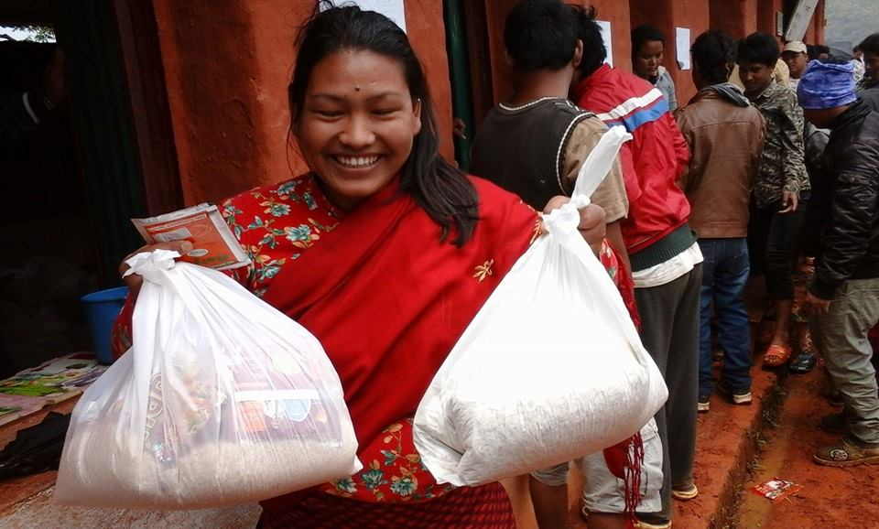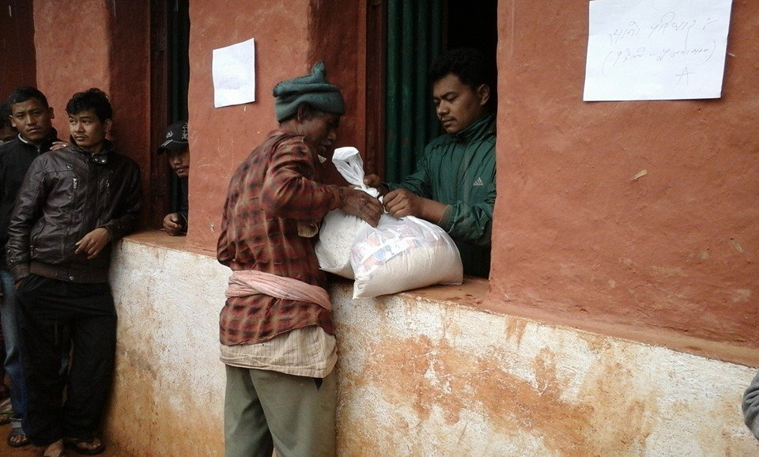Leveraging pre-existing grassroots reach we were able to distribute relief supplies to communities. The photos are from Shikharpa, Lele VDC-7, Lalitpur district. Over 90% houses in Shikharpa have been damaged and 3 individuals lost their lives with several others sustaining injuries.
Long Term Rehabilitation:

After immediate relief, we expect to shift our plans for long-term rehabilitation of the communities. Given that Teach For Nepal works in the schools, our focus will be in partnering with the communities to renovate, and reconstruct schools and create adequate learning environment.

In doing so, we will be mobilizing community assets and resources based on Sarvodaya philosophy and practices of shramadana (gift of labor).

Our Fellows can also play a critical role in psycho-social counseling and healing of children and community members that they teach. Therefore, we plan on doing training for trainers sessions with our Fellows on psycho-social counseling in collaboration with our local and international partners.

The nature of rehabilitation work is yet to be decided.

Estimated Budget For Immediate Relief
One-month budget plan for immediate relief for 5,888 families or 29,440 individuals.

Items | One month  Quantity per Family | Unit Price per KG/Unit in Rupees | Total Price in Rupees | Cost for 5,888 families
Food
Rice | 60 KG | 70 | 4,200 | 26,496,000
Pulses | 9 KG | 150 | 1,350 | 7,948,800
Oil | 3.75 Liters | 170 | 637.5 | 3,753,600
Fortified blended foods (Corn soya blend) | 2.25 KG | 60 | 135 | 794,880
Sugar | 2.25 KG | 68 | 153 | 900,864
Iodized Salt | 1 KG | 20 | 20 | 88,320
Instant Noodles or Dalmots | 150 packets | 15 | 2,250 | 13,248,000
Chiura (Beaten Rice) | 15 KG | 70 | 1,050 | 6,182,400
Other Essentials
Water Purifier | 150 bottles | 20 | 3,000 | 17,664
Soap | 30 bars | 30 | 900 | 5,299
ORS | 150 sachets | 10 | 1,500 | 8,832
Candles | 75 Candles | 20 | 1,500 | 8,832
Matches | 30 boxes | 12 | 360 | 2,120
Shelter
Tents/Tarpaulins + Ropes | 1 | 2,500 | 2,500 | 14,720,000
Transportation of Supplies per day | 2 | 20,000 | 40,000 | 1,200,000
 |  | Subtotal |  | 75,375,611
Management & Support Cost | 5% of the costs |  |  | 3,768,781
 | Total |  |  | 79,144,391
USD $ 791,444 EURO €719,494 UK Pounds £510,609

Teach For Nepal will make attempts to create partnership with local and international businesses to receive in-kind or at costs support to minimize the need to raise funds. We are currently working in collaboration with Federation of Nepal Chambers of Commerce (FNCCI)’s relief effort and are distributing supplies received in kind to the communities we serve.

How to Support?
In Nepal, individuals and organizations donate to Teach For Nepal office in Kupondole, Lalitpur and deposit to:
Account Name: Sarvodaya Shramadana Nepal
Account Address: Kupondole - 1, Lalitpur, Nepal
Bank Name: Sanima Bank
Bank Address; Narayan Chaur, Naxal, Kathmandu
Bank Account Number: 0140000031901
SWIFT Code: SNMANPKA
Internationally, individuals and organizations can donate online at: www.sarvodayausa.org or send check to: Sarvodaya USA, 1127 University Avenue, Madison, WI 53715, USA.
In other countries, our partner organizations are also facilitating the fundraising efforts. Please reach out to Shristi KC, TFN Partnership Coordinator (shristi@teachfornepal.org)

As of 30 April 2015
http://www.unocha.org/nepal
Includes school catchment area of ward no of 7 and 8 of Lele VDC * Communities close to Kathmandu valley
Quantity is based on WFP’s food basket recommendation to meet min of 2,000 Kcal requirement. http://www.wfp.org/nutrition/WFP
When possible solar lights will be distributed
Estimated unit price is based on current market price in retail store
When possible solar lights will be distributed
Rates based on Nepal Rastra Bank’s Exchange rates for 30 April 2015

