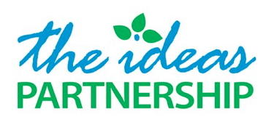

The Widows Fund, Fushe Kosova – ensuring that when a father dies, the chances of his children’s education don’t die with him

Contents

1) Background and short description of the aims of the activity
2) Our approach
3) Our monitoring procedures
4) Our track record
5) Budget

1) Background
This project is inspired by the untimely death of Agron Krasniqi of Fushe Kosove, aged 39. He left six children, all under the age of 13, and we saw at first hand how vulnerable his family was, and in particular what the emotional and economic pressures were on his older children to drop out of school to contribute to the family income.
Agron was, like most men in his community, a rubbish-picker. It’s work which children, able to shinny into skips, can do easily, and we saw the real risk that Agron’s sons and daughters would drop out of school to take up the handles of his wheelbarrow to go through the garbage in order to support their mother and younger siblings.
Founded as a Kosovan charity in 2009, The Ideas Partnership started working in Agron’s community of Fushe Kosove in 2010. This project builds on our successful work over the past five years in safeguarding the right to education by registering over 200 Roma, Ashkali and Egyptian children (from Fushe Kosove/ Kosovo Polje and elsewhere in Kosovo) in primary school, and offering holistic support to them and their families to ensure that they continue to attend school and succeed there. We now see the need of making small one-off grants to widows in Agron’s community who have been left with children all of school-age, with the aim of ensuring that their children continue in school.
Since 2011 we’ve administered a small monthly fund for medical expenses. Applicants for prescription costs, transport to hospital or contribution to the cost of tests are considered by a panel of local activists who know their community well. An average grant is 12 euro and decisions are made on who should receive these based on:
- Whether the family has received previous support
- Size of household
- Support from outside, such as family members abroad
- Number of family members available for work
- Impact of the medical support on the quality of life and access to schooling of the patient/ carers/ other family members

2) Our approach
We will use the same approach to assessing applicants to the Widows’ Fund as we are used to with the medical fund.

Decisions will be made by a respected member of the community, based in our centre in Fushe Kosove, with the right of appeal for unsuccessful applicants to a member of The Ideas Partnership’s board.

The person making these decisions will work voluntarily, as a form of ‘payback’, for a bursary which he receives to support him to continue at university. He will have weekly liaison with our trained mediator whose work is primarily focused on keeping children in school, through communication between the child, its family and the school.

We aim to make about 15 grants of 12 euros per month which will be reserved for widows whose children are all of school age.

3) Our monitoring procedures
Records will be kept of what money is disbursed to which families every month.
The Ideas Partnership has excellent project management systems so we will be undertaking ongoing evaluation of administration of the Widows’ Fund. These processes enable us to ensure course correction where necessary, and to share the successes of our projects as we implement them. Examples of our systems include:
- Weekly minuted team meetings with all staff involved in Fushe Kosove agreeing actions for the week and reviewing action points from the previous meeting
- Weekly meetings between the Executive Director and a member of the board to review progress
- Monthly reports from all staff to the board identifying progress again six monthly development plan
- Minuted meetings of the board with the Executive Director to review monthly reports and discuss any matters arising
- Monthly volunteer meetings sharing highlights of the month and areas where help is needed
4) Our track record
We were proud to win the European Commission’s prize for Roma integration in Kosovo in the autumn.
In the past we have received funding from
- NDI and Unicef’s Innovation Lab on environmental projects
- the British Embassy on two projects from 2011, including one to support Roma, Ashkali and Egyptian women
- the Austrian Development Agency for two grants, from 2011, both on our work in Fushe Kosove
- the US Embassy for three grants, from 2012, each relating to educational project work in Fushe Kosove
- United Nations Volunteers on a number of projects, most recently (2013-4) on youth and women’s literacy and numeracy in the Roma, Ashkali and Egyptian communities of Fushe Kosove and Obilic and to develop the Changemakers group
- The Dutch Embassy for three grants including supporting our work in Fushe Kosove last year
- Kosovo Foundation for Open Society for a 2012 income generation project in Fushe Kosove
- The Rockefeller Foundations’ Forum Iniciativ per Qytetare on two projects, most recently (ongoing) to develop the social enterprises we’ve set up for women from the Roma, Ashkali and Egyptian communities of Fushe Kosove and Istog/k. We won their 2014 award for Sustainable Development
- The Finnish Embassy (2013-4) to develop the social enterprises for women from the Roma, Ashkali and Egyptian communities of Fushe Kosove and Istog/k
- Save the Children project to get Roma, Ashkali and Egyptian children in Mitrovice/a and Peja/ Pec into school (2013-4)

5) Budget

Item | per month (euro) | number of units | total (euro) | total (USD)
a) Fund available to widows | 200 | 6 | 1200 | 1320
b) phone costs for administration of the fund | 4 | 6 | 24 | 26
c) Contribution to mediator’s salary | 10 | 6 | 60 | 66
d) Contribution to centre rent | 21 | 6 | 126 | 138
e) Contribution to centre manager’s salary | 8 | 6 | 48 | 53
Subtotal |  |  | € 1458 | 1604
15% GlobalGiving costs |  |  | €219 | 241
Total |  |  | €1677 | 1845

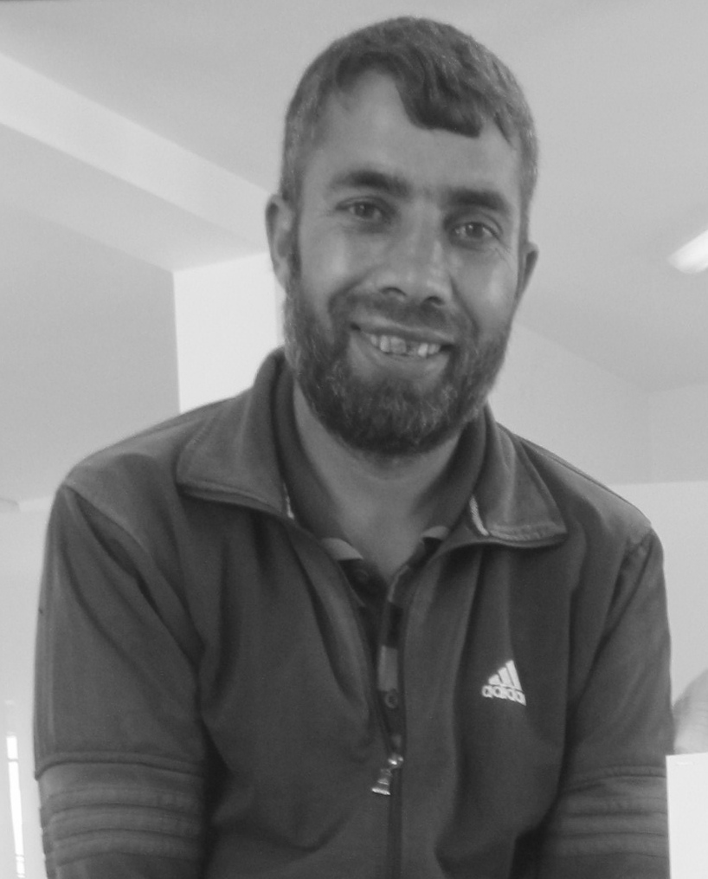

Agron Krasniqi, 1976 - 2015

