PROJECT PROGRESS REPORT
Lifesaving Care: Volunteers for Rural Communities
Location: Gulu, Northern Uganda
Submitted By: Herbert Onen

1. THE HEARTBEAT OF THE VILLAGE
In the remote villages of Northern Uganda, where dusty roads stretch for miles and the nearest health facility is a day’s walk away, hope arrives on foot. It arrives in the form of a neighbor, a mother, a farmer—someone who chose to carry not only their own burden, but the burden of their entire community.
They are the Village Health Team members; they are the heartbeat of rural healthcare.
We believe that no one should be left behind. Through Lifesaving Care: Volunteers for Rural Communities, we are walking alongside 20 of these remarkable volunteers, strengthening healthcare access from within. This is not simply a project. It is a movement of community-led care.

2. THE TEAM BEHIND THE CHANGE
Today, 20 Community Health Volunteers are actively serving their villages. Ten are attached to each of our two local health facilities, and between them, they reach families scattered across deep rural settlements. Each village is supported by two to ten volunteers, working under the stewardship of a respected Parish Leader who has lived among these families for years.
They are the first to arrive when a child has fever. The ones who walk a pregnant mother to the clinic. The voices that remind a family to sleep under a mosquito net. They are not outsiders. They are the community.

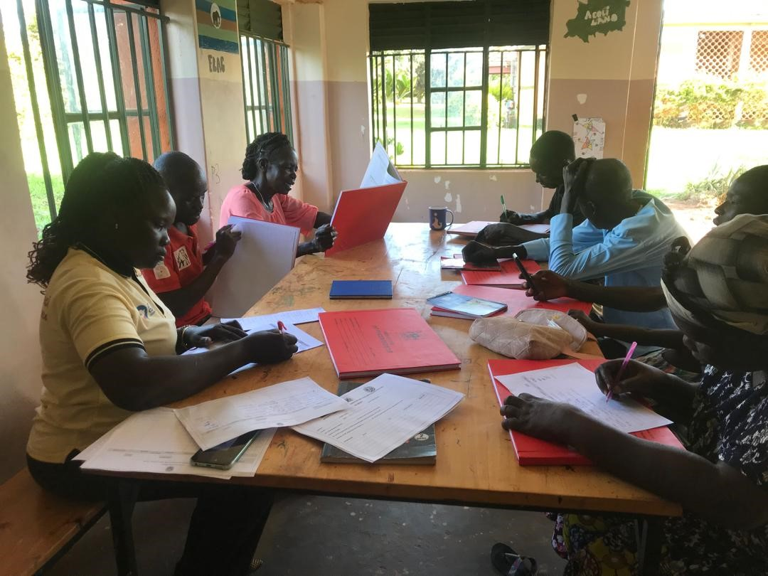
A quarterly review meeting with our Village Health team

3. WHAT THEY HAVE DONE: STORIES OF PROGRESS

3.1 Mobilizing a Community That Once Stayed Away
When we began, many families did not trust formal healthcare. Some had never attended an immunization outreach. Today, that has changed.
The volunteers went door to door. They sat under trees and listened. They answered questions, dispelled myths, and invited their neighbors to come and see. Slowly, attendance grew. Mothers began bringing their children for vaccines with now over 3000 children being fully vaccinated. Families started coming to health dialogues. Trust—once broken—is being rebuilt, one conversation at a time.

3.2 Teaching Prevention Before Sickness
Under huge mango trees, volunteers gather small groups under shade. They talk about malaria, how it spreads and how to stop it. They demonstrate handwashing. They counsel mothers on nutrition.
These sessions are quiet, unglamorous, and deeply effective. Families are adopting safer practices. Children are sleeping under nets. Sanitation is improving. Prevention is taking root.

3.3 Treating What They Can, Referring What They Cannot
When a child has a simple fever, a volunteer is there with a malaria test kit. When diarrhea threatens dehydration, they administer ORS and zinc. When a wound needs cleaning, they offer first aid.
This is not hospital care. It is frontline care—quick, local, and lifesaving. For severe cases, the volunteers act as guides, escorting patients to the nearest facility and ensuring they are not turned away. They are the bridge between the village and the clinic.

3.4 Identifying the Vulnerable, Before It Is Too Late
There are families in these villages that the health system has never reached. Elderly guardians raising grandchildren. Malnourished children whose growth has stalled. Pregnant women who have never attended a single antenatal visit.
The volunteers know who they are. They find them, visit them, and bring them into care. Through their eyes, the health system sees what it would otherwise miss.

3.5 Holding Space for Mothers and Babies
Every month, volunteers conduct nutritional assessments. They weigh children under five, check for signs of wasting, and counsel mothers on breastfeeding and complementary feeding. They remind families when vaccines are due. They track growth, not just in charts, but in the cheeks of a once-fading child.
Mothers are coming back. Babies are thriving. The silence around malnutrition is breaking.

3.6 Reporting What Matters
Behind every home visit, every referral, every cured child, there is a record. The volunteers submit monthly and quarterly reports, contributing real-time data that helps health facilities plan better. They are not just caregivers. They are the eyes and ears of the public health system.

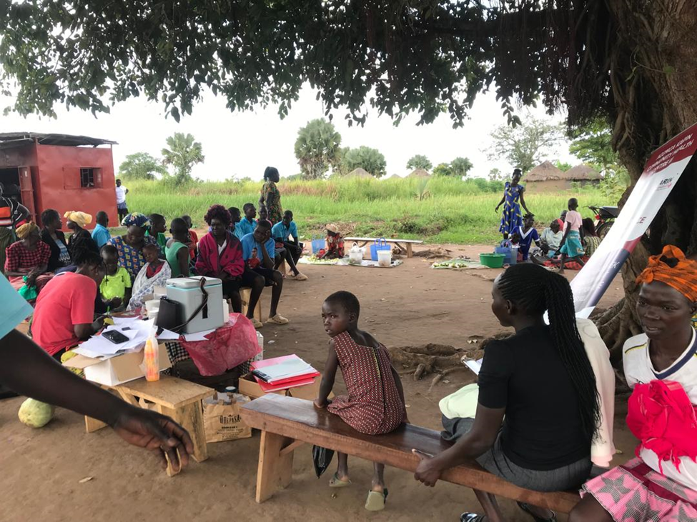
An outreach in one of our villages mobilized by our VHTs

4. THE IMPACT: WHAT THE COMMUNITY SAYS
It is one thing to report numbers. It is another to hear what the community whispers among themselves.
“When my child was sick at midnight, I didn’t panic. I knew who to call.”
“Before the volunteer came, I did not know my baby was too thin. Now she is growing well.”
“We used to fear the clinic. Now we go because our neighbor walks with us.”
The Parish Leader, himself a volunteer, reflects quietly on the journey:
“The team does a phenomenal job. They are active in so many areas—malaria, nutrition, maternal health, referrals. It is not easy. They sacrifice time, money, and energy. But the community has learned to trust us. They see us as their own. With more training, more supplies, and a little support to keep going, we could do so much more. Please, do not stop walking with us.”

5. THE WEIGHT THEY CARRY: CHALLENGES ON THE FRONTLINE
To be a volunteer is to give freely, endlessly. But even the strongest shoulders grow weary.
Our volunteers face shortages of the most basic tools. Malaria test kits run out before the week ends. ORS sachets are rationed. There are no nutritional scales in some villages, so mothers are assessed by sight alone.
Transport is a constant struggle. A volunteer may walk kilometers to mobilize a community, with no fare, no bicycle. Communication is limited; airtime is bought from their own pockets.

6. WHAT SUSTAINED SUPPORT CAN BUILD
This project is already working. The foundation is strong. What we need now is to build upon it.
With adequate medical supplies, volunteers will not have to turn away a sick child for lack of a test kit. With refresher trainings, they will be equipped with the latest knowledge to manage common illnesses. With transport support, they will reach the unreachable. With modest incentives, they will feel seen, valued, and sustained.

7. LEAVE NO ONE BEHIND
The Lifesaving Care project is proof that ordinary people, given trust and tools, can achieve extraordinary things. In the remotest villages of Northern Uganda, hope is not a slogan. It is a volunteer, carrying a small bag of medicines, walking down a dusty path toward a family waiting to be seen.
You have already put medicine in that bag. You have already trained those hands. You have already saved lives.
With continued partnership, we can ensure they never walk alone.
Thank you for believing in them. Thank you for walking with us.

