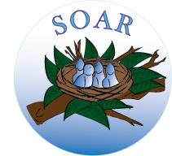
_____________________________________________________________________________________
Gyumri «SOAR» charitable dental clinic

Quarterly report – 1Q2019
- The dental clinic served 127 visitors in December, January, and February: December (9); January (63); and February (55).
- Services have been provided to beneficiary children from different care centers and boarding institutions of the region as well to many community children: Care Centers (79) and community children (48
- Children have been provided with hygienic supplies (as needed), toothpaste and brushes. Consultation on improvement of oral cavity was held.
- In February 2019, a visit was organized to a village school located in Shirak Marz
- The dentist, dental nurse and dental hygienist examined 17 children from 1st grade (13 boys and 14 girls) and 19 children in 7th grade (9 boys and 10 girls). The 1st grade children had a short presentation about oral cavity, teeth cleaning, proper care, and fluoride.

