Profit for Poor Farmers
Annual Progress Report, 2012
Submitted to
Global Giving
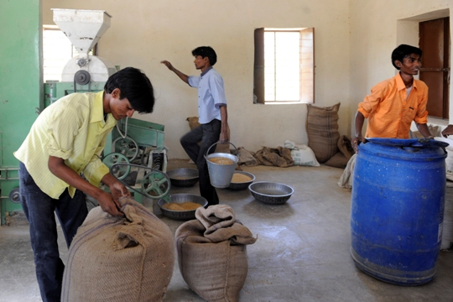

Presented by
SEVA MANDIR
Udaipur Rajasthan, India

info@sevamandir.org
www.sevamandir.org

Introduction
Encouraged with the past experience of dal mill, it is clear that the project is viable and can make profits if certain factors can be checked. For example, due to heavy wear and tear, the machine has nearly broken down which affects negatively on the production cost. It has been decided to purchase a new machine and a stone separator. In addition, it has been realized that the fixed costs can be minimized if the project is undertaken on a viable scale. It is felt that product portfolio can be enhanced by including other pulses (black gram, green gram and gram) for procurement and processing. It is also important to minimize the operating costs. The cost of processing is higher due to diesel consumption. We had applied for electricity connection but the electricity department is keeping the connections on hold for some unknown reasons.
Following are detailed description of each factor contributing towards the functioning of Dal Mill Project:

Functioning of the Mill:

- 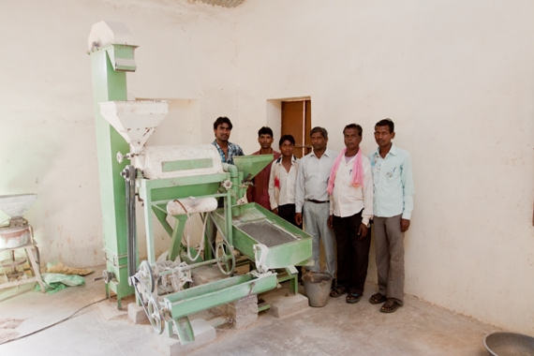Reliable daily opening hours of the Mill: It was learnt that a number of times, the mill was not open in a month. It therefore discouraged the farmers to sell their produce at the mill and instead they went straight to Khedbrahma to sell their produce despite they didn’t get better prices there. To address the issue it was decided to appoint a permanent worker at the mill from within the village to ensure timely opening of the mill and to perform other daily tasks. An attendance register has also been introduced at the mill for recording the daily opening of the mill. The results have been encouraging with more farmers turning up to the mill.
- Quality of raw material: The process of separating the tuar grains from the bean pod is performed manually by the farmers. During this process pieces of stones and impurities get mixed with the raw tuar. The existing grading machine which separates the impurities from the raw dal can only separate minute stones/impurities (light-weight that can be thrown away by the pressure of air) but it cannot separate smaller stones (heavy-weight). Due to these stones the machine is often subjected to minor breakdowns. The stones damage the roller (two stone slabs in the machine that splits the raw tuar into two pieces) and affect the quality of the final product. Despite intensive manual work of separating the stones, the problem persisted and buyers would complain of the presence of impurities. To address the problem, it was decided to buy a stone separating machine. The machine has been ordered costing Rs. 150,000 (USD 3,333) which would be installed in March next year.
- Machine: Over the years, the machine has not been functioning well. A technical expert from the manufacturer was called for to look at the machine. He repaired the machine and trained one of the farmers to operate it correctly. Though the machine was fixed for temporary, he suggested that the expected functioning life of the machine has come to an end. To get a second opinion, another engineer from OSAW Industrial Pvt. Ltd. Ambala Cantt, Haryana (manufactures similar machines) was called for. After analyzing the current condition of the machine the engineer recommended a replacement of the machine. He clarified that the raw material with impurities are causing the damage to the machine and frequent breakdowns. He strongly recommended buying a stone separating machine.

- 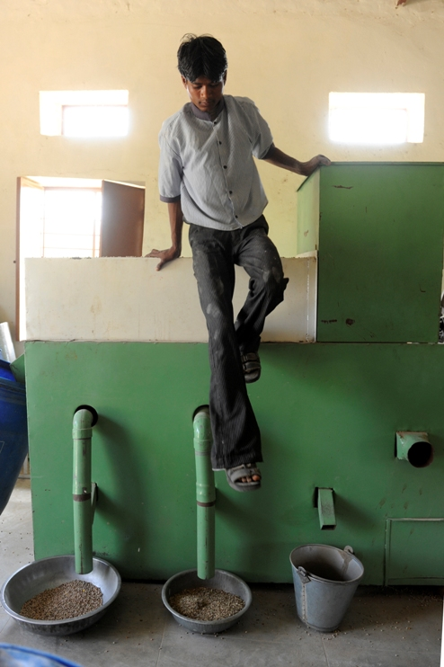 Members: A group of seven villages (Medi, Koldara-Bavbiran, Hansreta, Dehri, Ghodamari, Bhimtalai and Nakola) was formed in 2008 and named as Medi cluster. From these seven villages, only 86 farmers have become the members of the collective Dal Mill and are called as “Nala Dal Utpadak Sangh”. The members have appointed a full-time worker who is responsible for the daily operations of the mill. There are also 4-5 workers who support him for the functioning of the mill and are paid a daily wage for their support.
In December 2010, in a meeting of “Nala Dal Utpadak Sangh” the members discussed several issues including procurement, processing, selling and distribution of the profits. The members decided to have Dal mill as the only purchasing center for raw material so that there is some control on the quality. In the past, there were five purchase centers which cost a lot of money and time in procurement of the dal. Everyone agreed that procuring the material at one central location is an efficient way of functioning.
In the same meeting the profit of Rs. 18,500 (USD 411) for year 2008 and 2009 was distributed amongst the 86 members. However, there was some dissatisfaction since some farmers were actively involved with the dal mill in terms of selling their produce while the rest never participated in any activity of the mill. It was realized that that a systems needs to be placed wherein community participation can be increased. There are discussions on how can we motivate the farmers and increased the membership of the communities in Dal Mill. We hope to devise strategies and systems in the next couple of years to increase ownership of the farmers.

- Training and Capacity Building: In April 2008, in association with the Post Harvest Technology Dept. of Maharana Pratap University of Agriculture and Technology (MPUAT), Udaipur, one training programme was organised for a group of selected farmers to orient them towards comprehensive processing technology of pulses. The training helped the farmers in getting exposure to practical aspects vital to run the processing unit.
In August 2011, there was training from a technical expert from Sri Ram Associates, Akola Maharashtra who trained the full-time worker at the mill to operate the machine efficiently in order to minimize the chances of breakdowns and to achieve good quality of final product.

- Vi. Electricity connection: Till now, we do not have electricity in Medi village. The mill is run with the help of a generator set, with diesel. It increases our operating costs from Rs.2 to Rs.2.5 per kg affecting the profitability of the enterprise. We have attempted to commission a grid for the mill from the electricity board, Government of Rajasthan but it is very costly as it requires us to bear the cost of installing the entire grid. However, now Medi has been included for electrification by the Government under the scheme of ‘Rajeev Gandhi village electrification’. Our application is in the process and as per the officials of the electricity department, by next year we will get a connection.

To become a member one has to pay Rs. 100 as a life-time membership fee.

