Newsletter
A warm hello from Barb, John, and the Technology Partnership team,
As spring is starting, TP has a lot to be grateful for and we want to share a couple of our successes with you.

1. Our shipment of 160 refurbished computers that arrived in Meru Dec. 10 have been distributed to 13 of our partner schools. The teachers in each of these schools are now receiving computer training and will begin using the computer labs with students when school begins again in the fall!

2. John Kamwara, our Kenyan director, learned how to drive our van, funded by a grant from Douglas Wyoming Rotary Club and Rotary international. When I was in Meru this past summer, I was very impressed with how well John was driving in the crowded streets of Meru. Imagine learning how to drive at the age of 47, in an environment where rules of the road are non-existent. Kudos to John!!

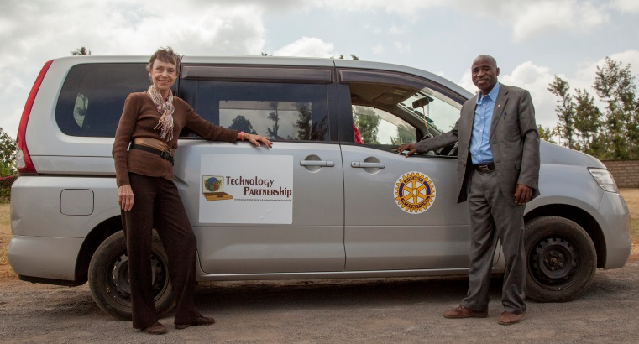

3. During my visit to Meru for teacher training this past summer, we initiated a teacher leadership team who will be responsible for holding teacher training sessions using our newly created webinar curriculum tool. A superstar volunteer, Ann Marie Elaqua, has developed a 4-module training curriculum using PowerPoint slides, my voice, and short video clips to help our leadership team as they present the computer curriculum to their peers. Although our leaders volunteered their teaching time, our gracious board has allocated some of our funds to provide a small stipend for the teachers who elect to do some training.
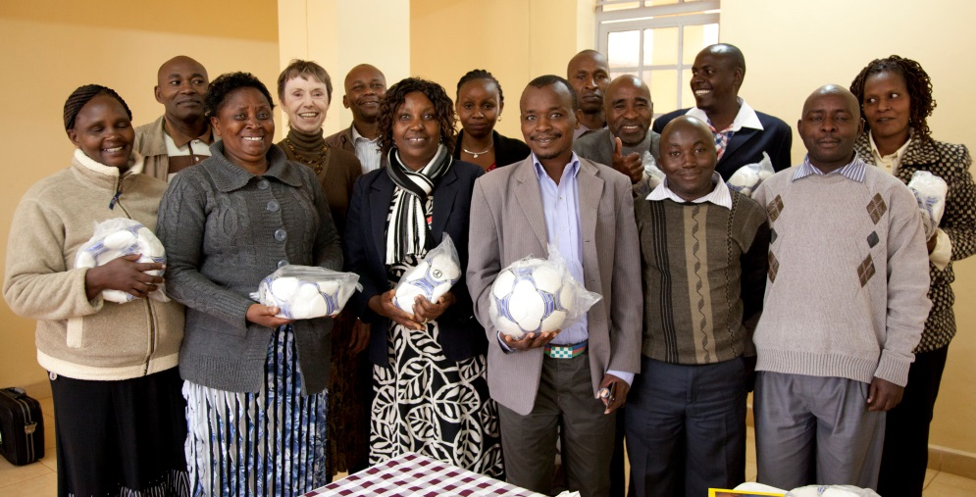
4. A very successful fundraising event, our first, was well-attended and lots of fun! The 70 people who came out to support us had a great time and were exceptionally generous in their financial support. We raised $5000. and now have funds to support our projects and our workers in Kenya who run the projects and take care of more than 500 computers in our 35 partner schools.
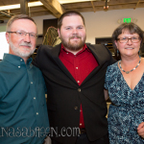

As tax season has just ended,, we would love to remind you that .our 501c3 non-profit is a wonderful match for your donation needs;-) All our donations go to our Kenyan programs and partners. Our goal is to bridge the digital divide between Kenya and the developed world so that our friends and partners in Kenya can learn those crucial technical skills that will enable them to join the world of global enterprise and lift themselves out of poverty.
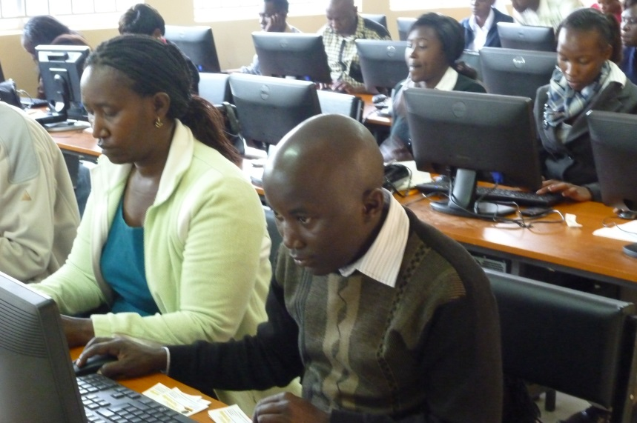
Your donation makes a difference in Kenya!!
- Your $25.00 donation pays for a 32 Gig flash drive for one school computer lab loaded with "Rachel" which we call "internet on a stick"
- Your $50.00 donation pays for a refurbished computer, which 20 students will use throughout the day to learn computer skills
- Your $150.00 donation pays for a computer projector allowing 1 teacher to demonstrate computer skills to a class of 44 students.
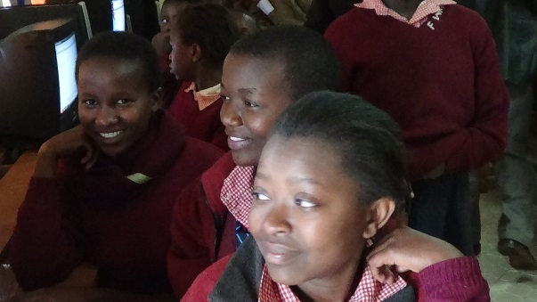

Thank you for your continued support of Technology Partnership and our partner students and teachers in Kenya!

Happy Spring,
Barb, John, and the rest of the TP Team.

