**September 2015 Report Alzheimer Mexico Global Giving**

Since our last report and update, a lot of things happened we are very glad to share with you.

First of all in our Day Care Center, Alzheimer Mexico I.A.P., we improve the quality of life of people with Alzheimer's disease or similar dementias and their families. Our comprehensive and interdisciplinary model (Geriatric care, Nursing, Physical Therapy, Social Work and Psychology), is recognized by the INN, (National Institute of Neurology), and provides tools to slow the process of the disease.

During this annual Alzheimer’s awareness month (September), our Day Care Center was visited by many radio and TV channels. They wanted to share with the general public what Alzheimer’s is all about and how the population and society may take action towards worthwhile life conditions for elder people with dementia, and how to try to prevent dementia.

Thus, the Televisa news channels transmitted three parts of a deeper research on Alzheimer’s in Mexico and in the United States on World Alzheimer’s Day (September 21) and the two following days; this special feature was called “Alzheimer’s- the memory of the loss”, and we invite you to take a look at these stories, some of them are from our patients:

**Nota (1)**

[**http://noticieros.televisa.com/programas-primero-noticias/1509/alzheimer-memoria-olvido-parte-1/**](http://noticieros.televisa.com/programas-primero-noticias/1509/alzheimer-memoria-olvido-parte-1/)

**Nota (2)**

[**http://noticieros.televisa.com/programas-primero-noticias/1509/alzheimer-memoria-olvido-parte-2/**](http://noticieros.televisa.com/programas-primero-noticias/1509/alzheimer-memoria-olvido-parte-2/)

**Nota (3)**

[**http://noticieros.televisa.com/programas-primero-noticias/1509/alzheimer-memoria-olvido-parte-3/**](http://noticieros.televisa.com/programas-primero-noticias/1509/alzheimer-memoria-olvido-parte-3/)

The second great news was that we were invited by the Mexico City government and the Mexico City Health Ministry to perform once again a great event to raise awareness about Alzheimer’s and other forms of dementia. Being this event originally planned for September, we had to move it to October and on Sunday, October 18th, at 9 o’clock in the morning we built a huge human brain with the participants of the “Alzheimer’s Learn and Act” event at the *Monumento a la Revolución* (Revolution Monument) in Mexico City. 4,000 persons joined us for the opening ceremony and about 16,000 persons stepped by during the whole day to participate in a very broad range of activities: from general information, live internet broadcasting, physical activities, playing, brain exhibition, family support, basic activities of daily life to a wrestling match against stigma, discrimination and fear; a professional theatre play called ‘Don’t forget me’, and lectures from experts on all relevant dementia subjects.

As you can see and imagine, it was a great event which proved once again the lack of information about dementias and the great interest of the people to learn more in order to have tools to act adequately caring for a beloved one with dementia.

We invite you to look at some of the pictures of this extraordinary event: The original date was September 27th and we had to move to October 18th.

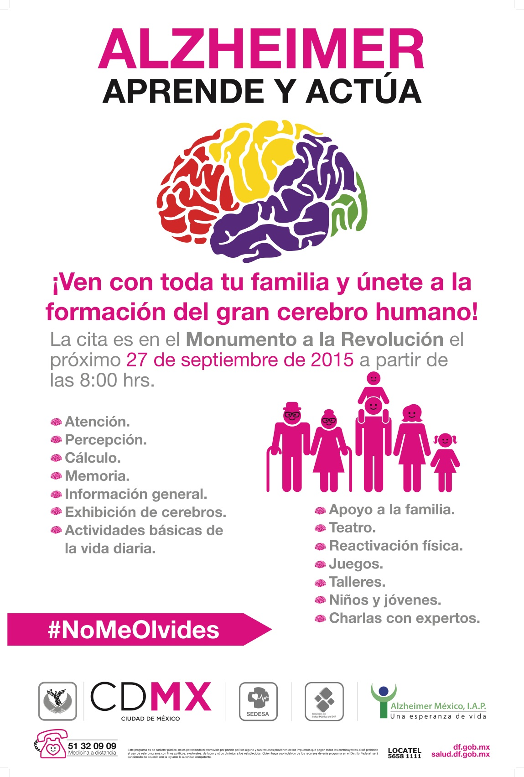

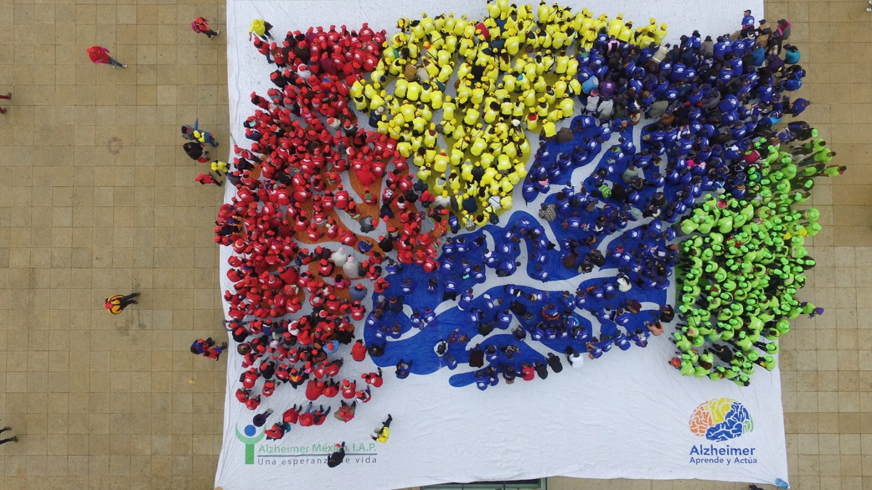

The huge human brain formed by participants

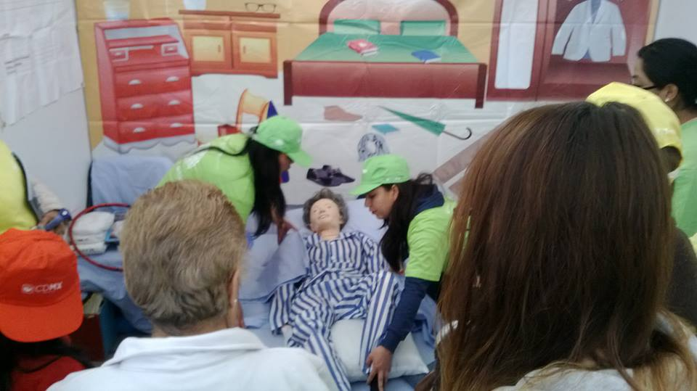

Basic activities of daily life

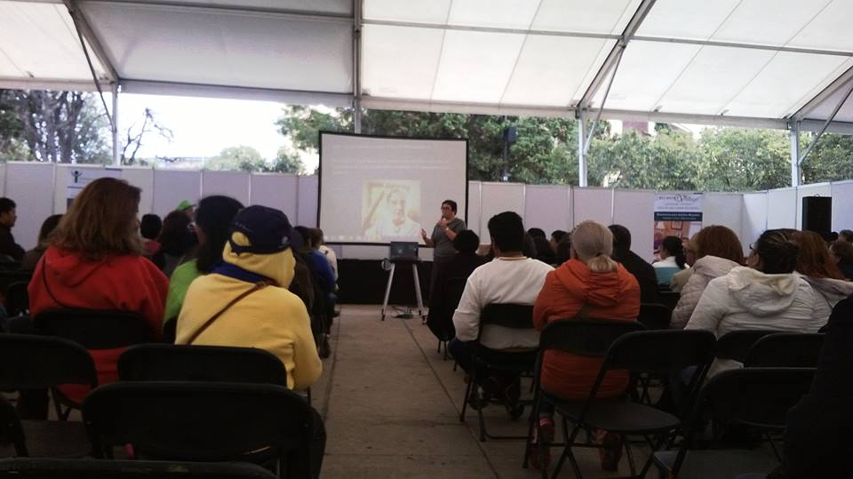

Lectures from dementia experts

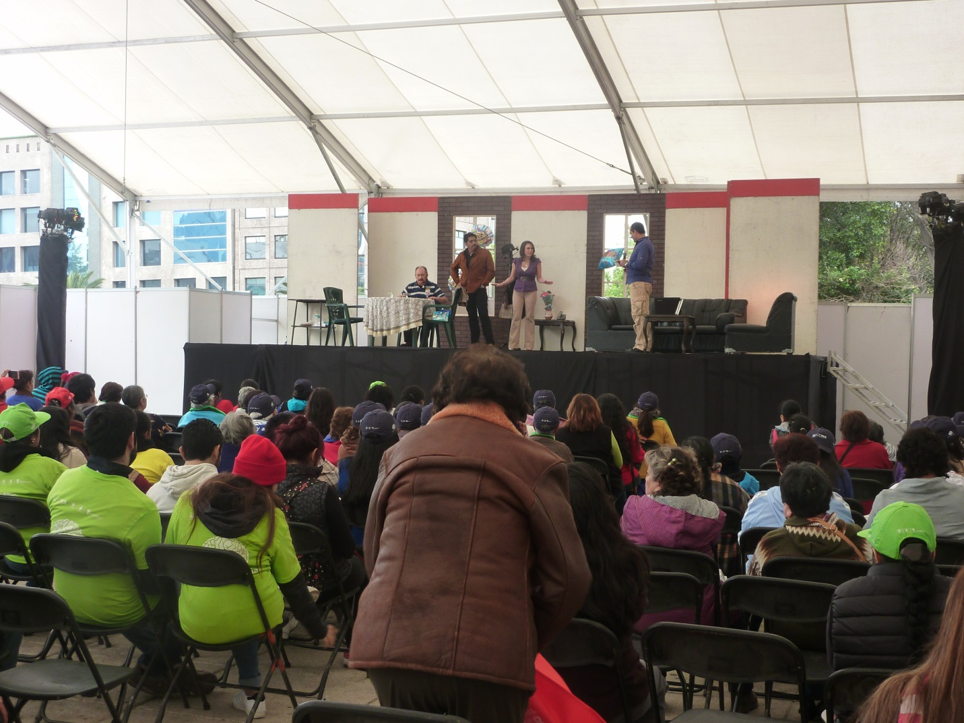

Theatre plays ‘Don’t forget me’

The third and last news is that some days after this huge event we moved onto our new facilities! Now, our Day Care Center has pretty more space and we can develop all our activities in a more idle way.

Our first event at our new Center was the traditional celebration with all our patients and staff of the Mexican Day of the Dead where we remember through beautifully decorated altars with flowers, candles, baskets of food offerings the lives on earth of the beloved ones who passed away.

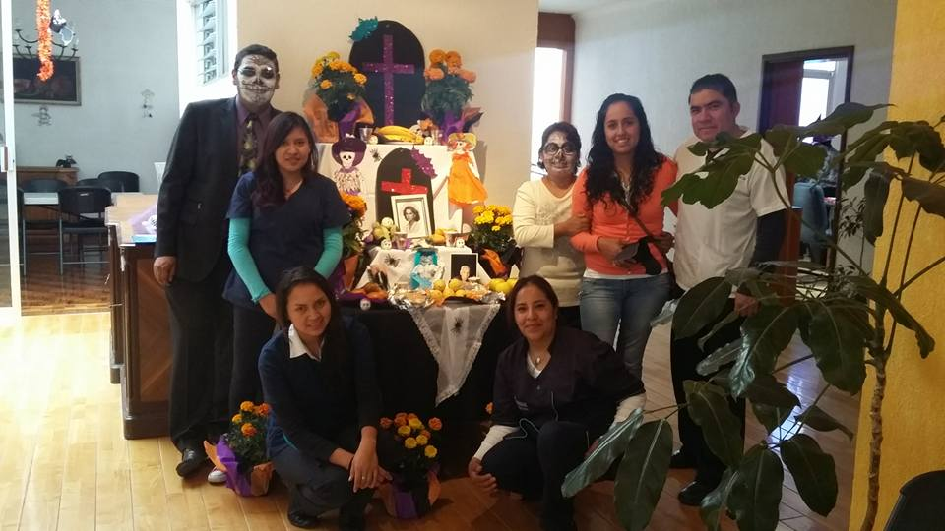

The Dead Altar



Our homemade Dead Bread