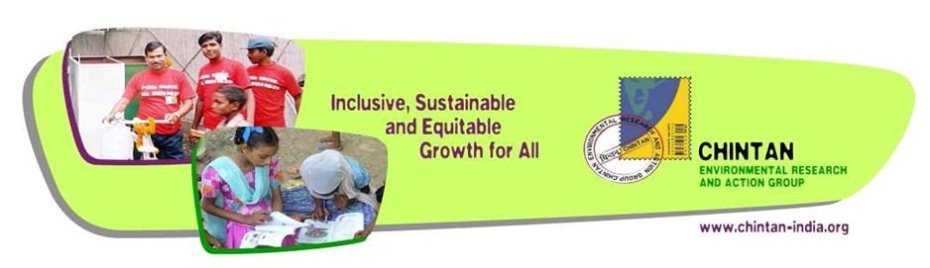
No Child in Trash: a Proposal to Enable Wastepicker Children in Delhi NCR to continue Education and Stay out of Wastepicking
Proposal submitted to
Global Giving

The Background
India is a country where over a billion people live in two centuries at the same time.

On one hand, there is a growth rate of 8.6% in recent years, and there is a spurt in consumption. There is a 300 million strong middle class, the subject of excited global discussion. These are the consumers of global luxury brands, the mall-goers, the writers and software whiz kids that typify a New India.

On the other hand, there are almost 700 million people living on less than 2 dollars a day. Of these, 300 million live on less than a dollar a day. As workers who either till their own land or sell their muscle power, they are highly vulnerable. Factors ranging from ecological disasters, environmental crises and landholdings simply too small to sustain them anymore create enough economic shocks for them to leave their ancestral lands. Many of them are Dalits, or people from the lower castes that have been deprived for generations. Such people form the bulk of migrants who travel to India’s urban regions in search of work and hope.
Indian cities are the places where the two worlds meet. Almost 30% of India’s population lives in cities today. A World Bank estimate is that almost 1% of the population of a city in a developing country is engaged in recycling. Most of them are abjectly poor, former farmers and their young children, foraging in urban trash. In India, recycling is almost entirely undertaken by an army of the poor, called wastepickers.
Picking trash is a popular occupation in Delhi because of the sheer amount of trash there is. Statistics from Delhi, the Indian capital, show how much more waste is produced. From 3500 metric tons in 1995, Delhi generates over 8000 tons today. Of this, there are more plastics and paper than ever before. This provides work to the unskilled, the underage and the poor. The combination of large amounts of waste and abject poverty creates the ideal condition for children to be pushed into work.
But working as a wastepicker comes at a cost, especially if you’re a child.
It’s one of the easiest professions to slide into, and hard to get out of. Middle men sometimes, enslave the children, and escape can only be through another middleman. Working in this hazardous work stops children from studying. The prices of commodities like paper and metals make it more lucrative, as does the increasing quantity of waste. The works deprives children of their health. Studies in Delhi show that 84% of such children are severely anemic. Most have worms, and suffer from respiratory distress. Their childhood is diseased. Waste-picking, as we know, also leads to exposure to toxics, which are transferred inter-generationally both in their chemical form and through a range of medical disorders. It also leaves such children more vulnerable to economic or environmental crises, and therefore, to poverty.
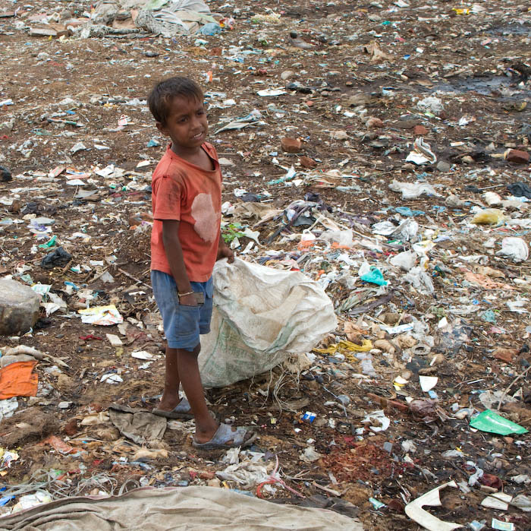
A child picks trash on a landfill in Delhi
What Chintan Does for Wastepicker Children
Chintan’s ‘No Child in Trash’ programme enables such children to move from dumpsites to schools. In a nutshell, Chintan identifies wastepicking children in an area, hold bridge classes, incentivize children to attend these, and then finally, help children to move to mainstream education. In order to do this, we use the learning centres as sites to prepare the children and their families, where these exist, for a formal education in multiple ways: pedagogically, emotionally and through legal processes.
Children’s wastepicking in India is not going to decline without strategic interventions. Indeed, it will increase, because there are several perverse incentives set up for it. A key emerging challenge in this context is the waste-to-energy plants that have become a popular new investment. In Delhi’s Okhla waste-to-energy plant, some serious trends came to light through a Chintan study. The plant-and most such plants-require plastic, paper and cardboard to burn, and create energy from. These are also the materials wastepickers earn their livelihoods from. As the plant came online, and waste began to be supplied directly to it, wastepickers lost their source of livelihoods. Loss of income resulted in children being pulled out of school and back into the work force. Over 67% of the out of school children who had dropped out were at work on account of the plant.

The Proposed Programme
Program Goal
To enable children living in extremely violence-ridden, poor, and socio-culturally marginalized waste-picking community in India to reach their full potential through access to and retention in formal education, and by building community support.

The Proposed Programme’s Objectives
The proposed program will aim at the following :
- Enabling access to formal education for 100 wastepicker children
- Ensuring retention in formal education system for at least 50 children in the first year
- 60% of these children will be girls
- Organizing parents of the children to make the daily shifts that will help the children go to school as well as learn to monitor quality schooling.

Our learning centres work to enable communities to build capacity to educate children. As children enter schools, the biggest challenge is to retain them there, and to ensure they do not slip back into wastepicking. This proposal will target 100 such children.

Approach
      - Education through non-formal learning centres:
The main elements of the No Child in Trash program would be the three types of classes which will be held daily (five days a week). The classes are as follows:
- Balaangan or an early childhood education – This will be provided to ensure that every child of educable age enters the formal school system at an early stage. Through these classes young children will be provided with essential social, physico-motor and cognitive skills to enable them make a stronger headstart in formal schools. A typical child here will be under 6 years of age. The key advantage of running this is that children are removed from the possibility of wastepicking before they are firmly ensconced in it.
- Bridge class – These classes are run to enable out-of-school wastepicker children reach the level of an age-appropriate class in a nearby formal (municipal or government) school. In these classes essential literacy and numeracy skills will be provided to children between the age group of 6-14 years. Once children go through this class for a period of one-year, they will be mainstreamed into formal schools
- After-school Support Study Class – Education in Delhi is premised on children accessing after school tuition and help from literate parents. Our schools will enable them to overcome this challenge and deprivations through support studies, preparation for exams, motivation and peer support for continuing in school. The support study class will provide children with life-long learning skills. Emphasis would be laid on developing study skills like note taking, observation, analytical and presentation skills. The support study class is critical for wastepicker girls from many aspects including increased retention, delayed marriage; prevent sexual violence due to early marriage, and economic empowerment.
      - Mother-Teacher Meetings
Wastepicker girls are particularly vulnerable to drop outs, as any crisis at school acts as a push for them to revert back to work. As they grow older, families expect that a girl at home must run the house and seek a marriage partner for her. Hence, girls suffer significantly more due to lack of support to stay in school. Monthly meetings and one-to-one interactions will be done with the mothers to motivate and mobilize them to continue education of the girl children and to prevent early child marriage for girls.
      - Extracurricular Activities
In addition to regular classroom activities, Chintan holds various extracurricular activities for children. These activities are an opportunity for Chintan to celebrate the children and their community as well as inculcate leadership, team work and an out of class education experience.
      - Tracking Children
Teachers pay home visits to the students’ homes, in order to stay in touch with the families, identify any crises which may result in drop-outs and report them, as well as understand why a particular child, who may have not come to class, is unable to do so.

Time
Chintan’s proposal is for 1 year, but it will have to continue till each child in school gets atleast 2 years’ support to stay in school.

Budget
S.No | Budget Line | Cost per Unit | Total Units | Months | Monthly Cost | Yearly Cost
I | Personnel
1 | Teacher | 3300 | 2 | 12 | 6600 | 79200
2 | Field Officer (50% of Time) | 12000 | 0.5 | 12 | 6000 | 72000
3 | Data Manager (20% of Time) | 18000 | 0.2 | 12 | 3600 | 43200
II | Other Expenses
1 | Travel for Teacher | 500 | 2 | 12 | 1000 | 12000
2 | Travel for Field Officer | 500 | 0.5 | 12 | 250 | 3000
3 | Rental for Classrooms | 9000 | 1 | 12 | 9000 | 108000
4 | Stationary | 450 | 100 | 1 | 45000 | 45000
lll | Parent-Teacher Workshop
2 | Mother Teacher Meeting | 30 | 50 | 12 | 1500 | 18000
 |  |  |  | Sub Total | ₹ 72,950.00 | ₹ 380,400.00
 | Admin |  |  | 10% |  | ₹ 38,040.00
 |  |  |  | TOTAL |  | ₹ 418,440.00
 |  |  |  | USD | $6,749
 |  |  |  |  | USD to INR | 62

