Rural Area Development Trust run by
Manjari Special School for Mentally challenged children theni District of Tamil nadu

Background of the programme

This Day Care Centre was started in the year 2005 at Uthamapalayam, Theni District. This centre provides therapeutic support to children who are physically and mentally challenged. This day care centre consists of 29 children. Physiotherapy and special education are regularly given to the children. Physiotherapists help children with disabilities to develop their functional ability and life style changes. Our Service is in the form of exercise, education, consultation, or the recommendation of adaptive devices.

1. Special Education (Pre – Primary, Primary and Secondary)

Money, time, season, and color concepts, ADL skill, life surviving ability training.

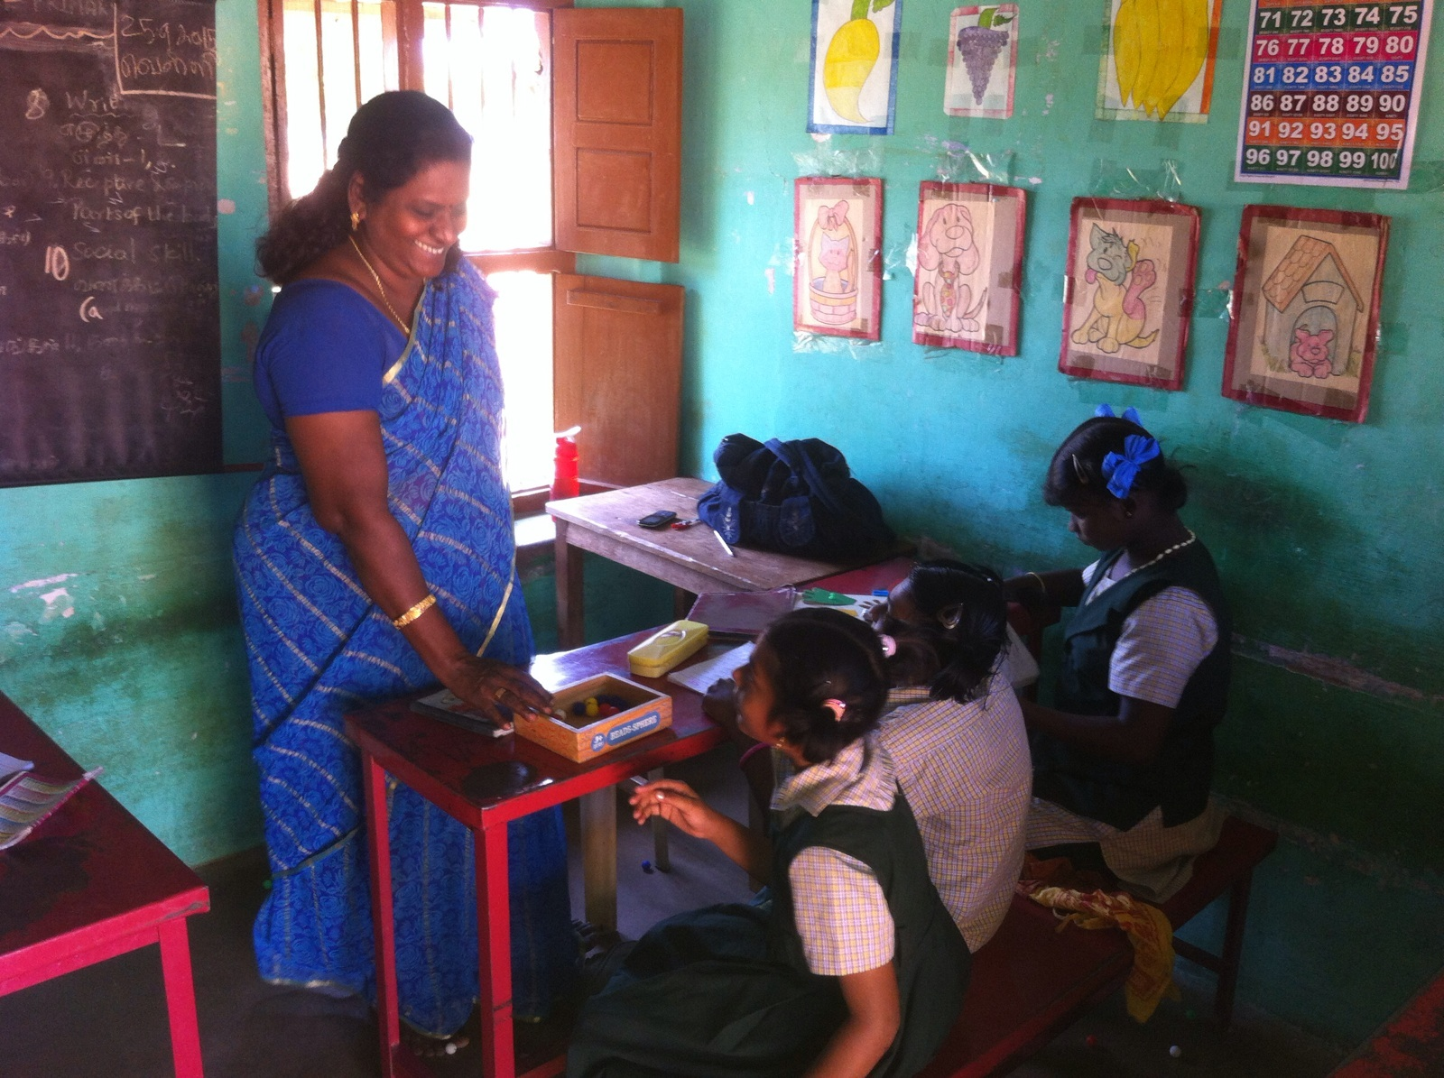
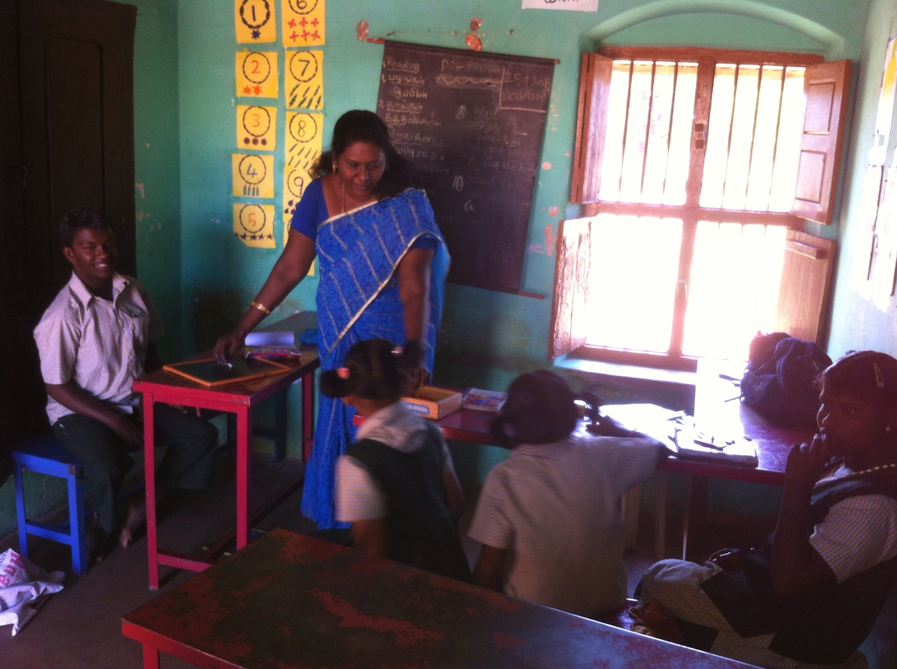

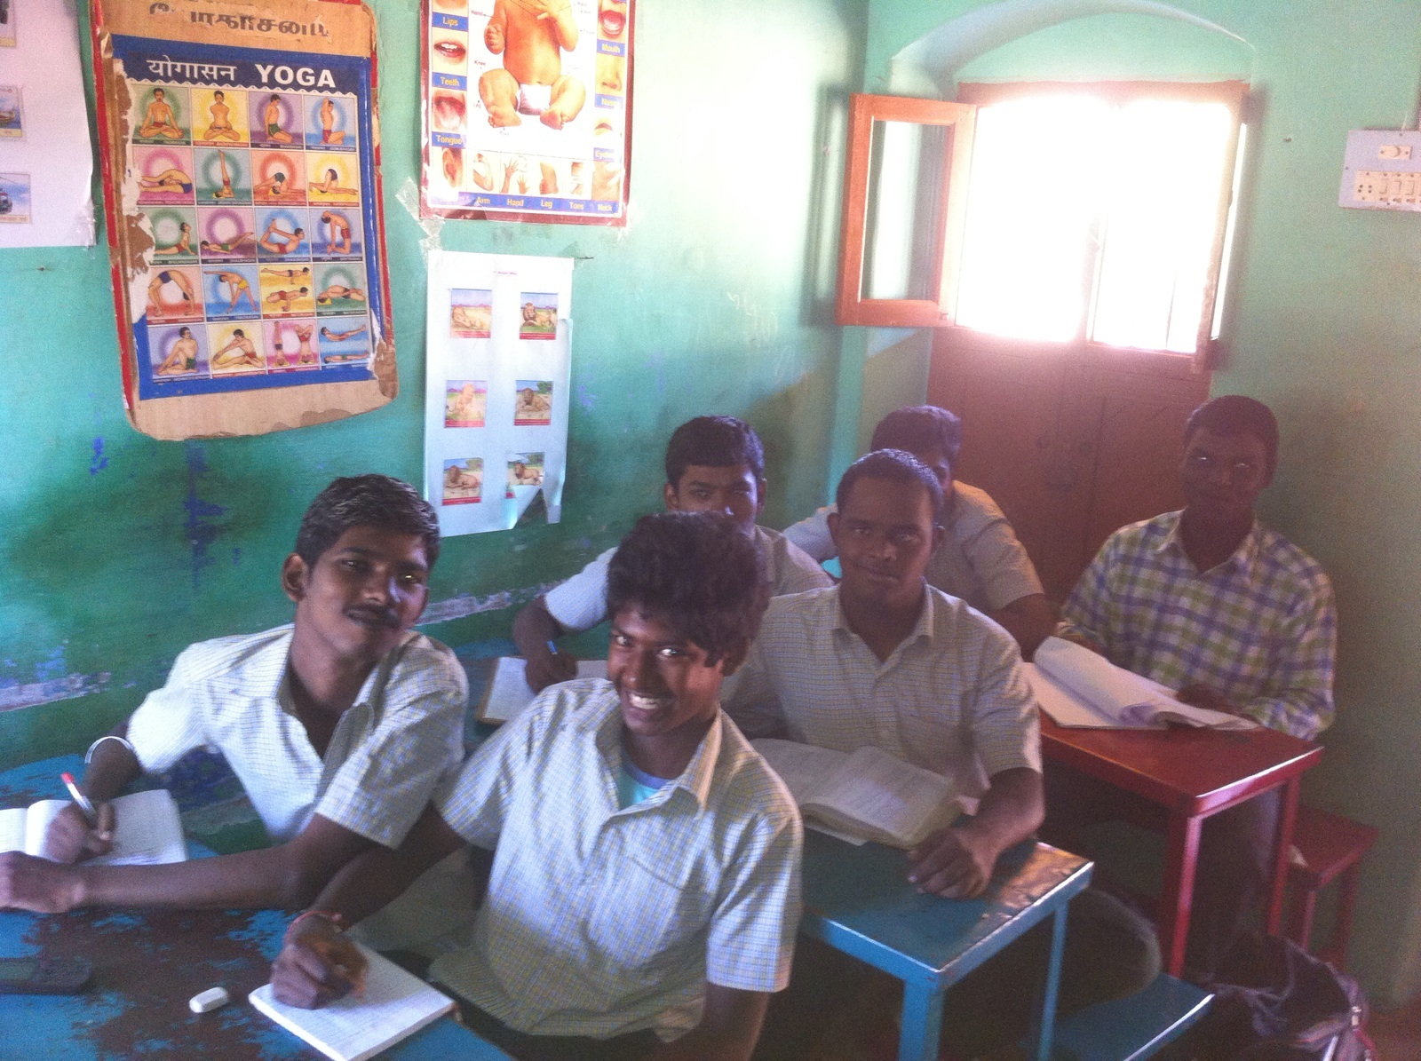

2. Physiotherapy

Improve Muscle tone flexibility and strength, Balance and coordination, Mobility-gait training movement within the school and community (walking, use of wheelchair and walking aids).
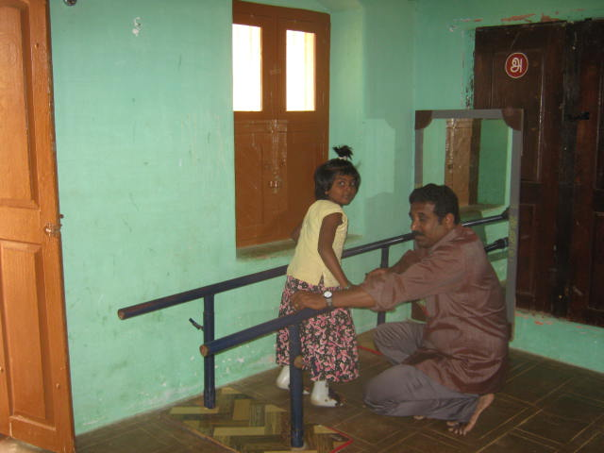
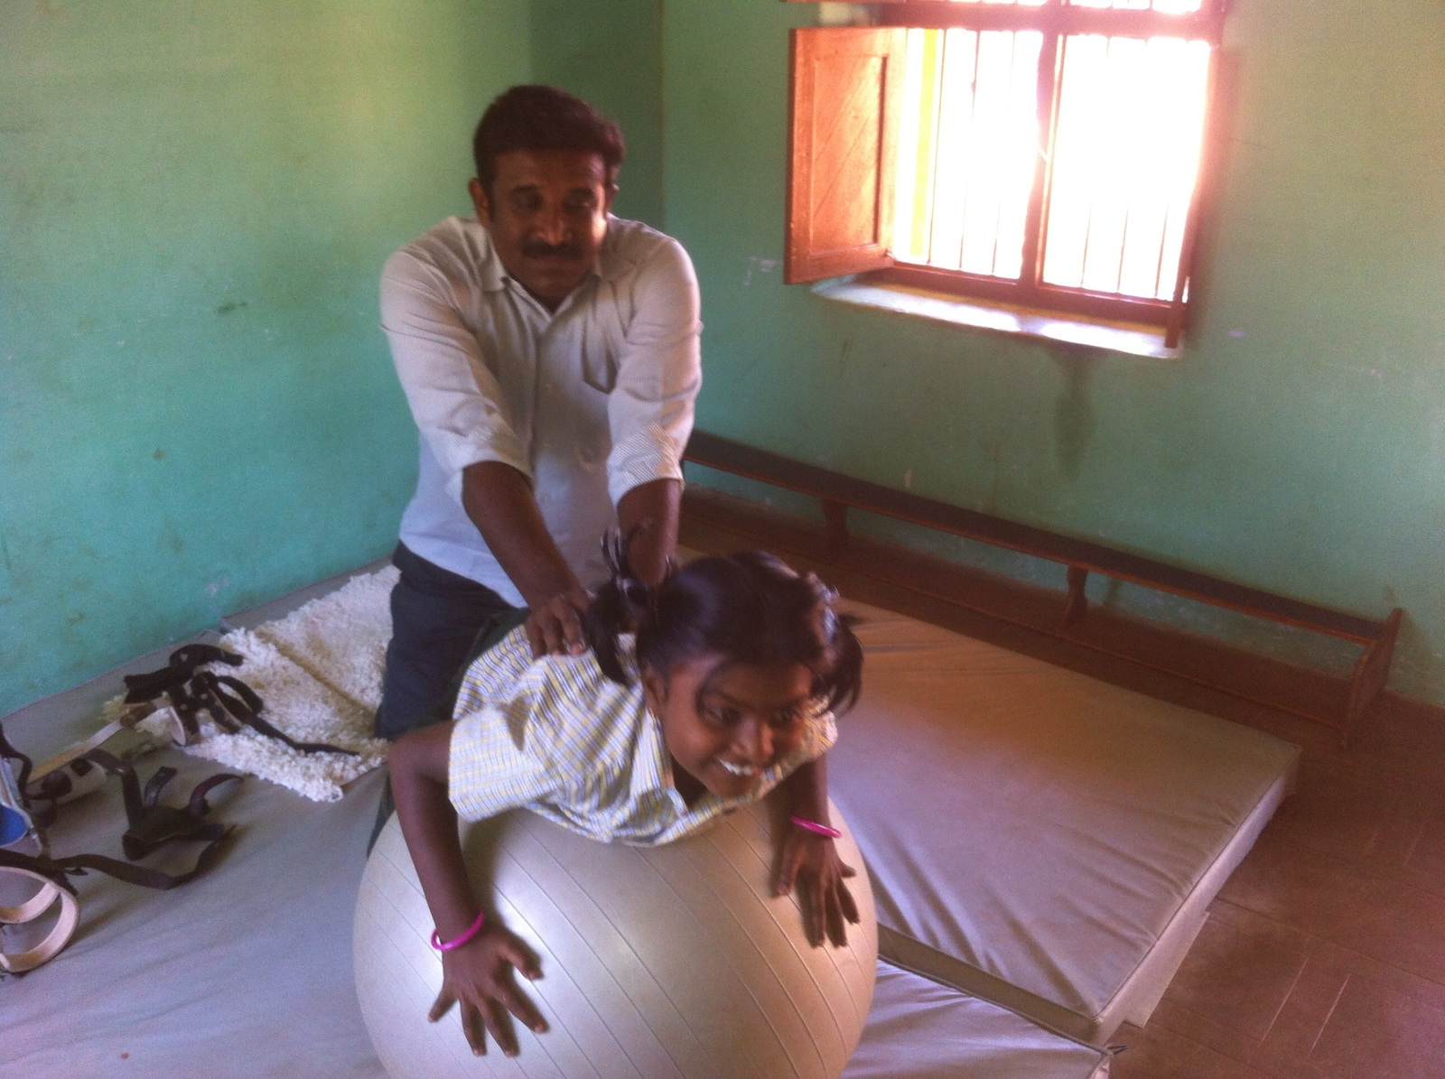

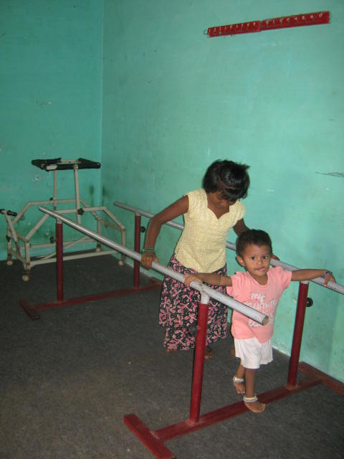

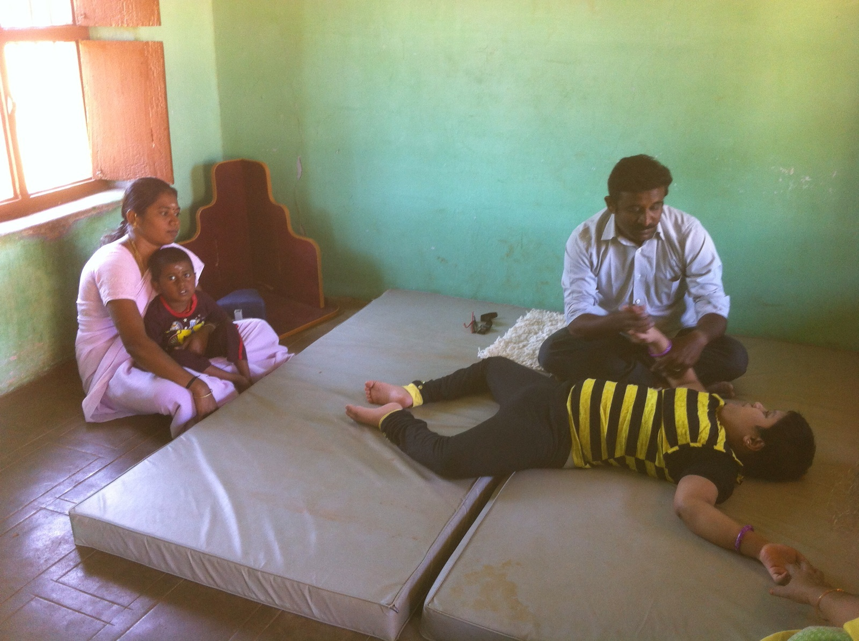

Children getting peanut ball exercise in the physical therapy session

3. Social inclusion

Children’s are integrated in their peer group through the way of indoor and outdoor play activity. This is for their psychological well being & social inclusion

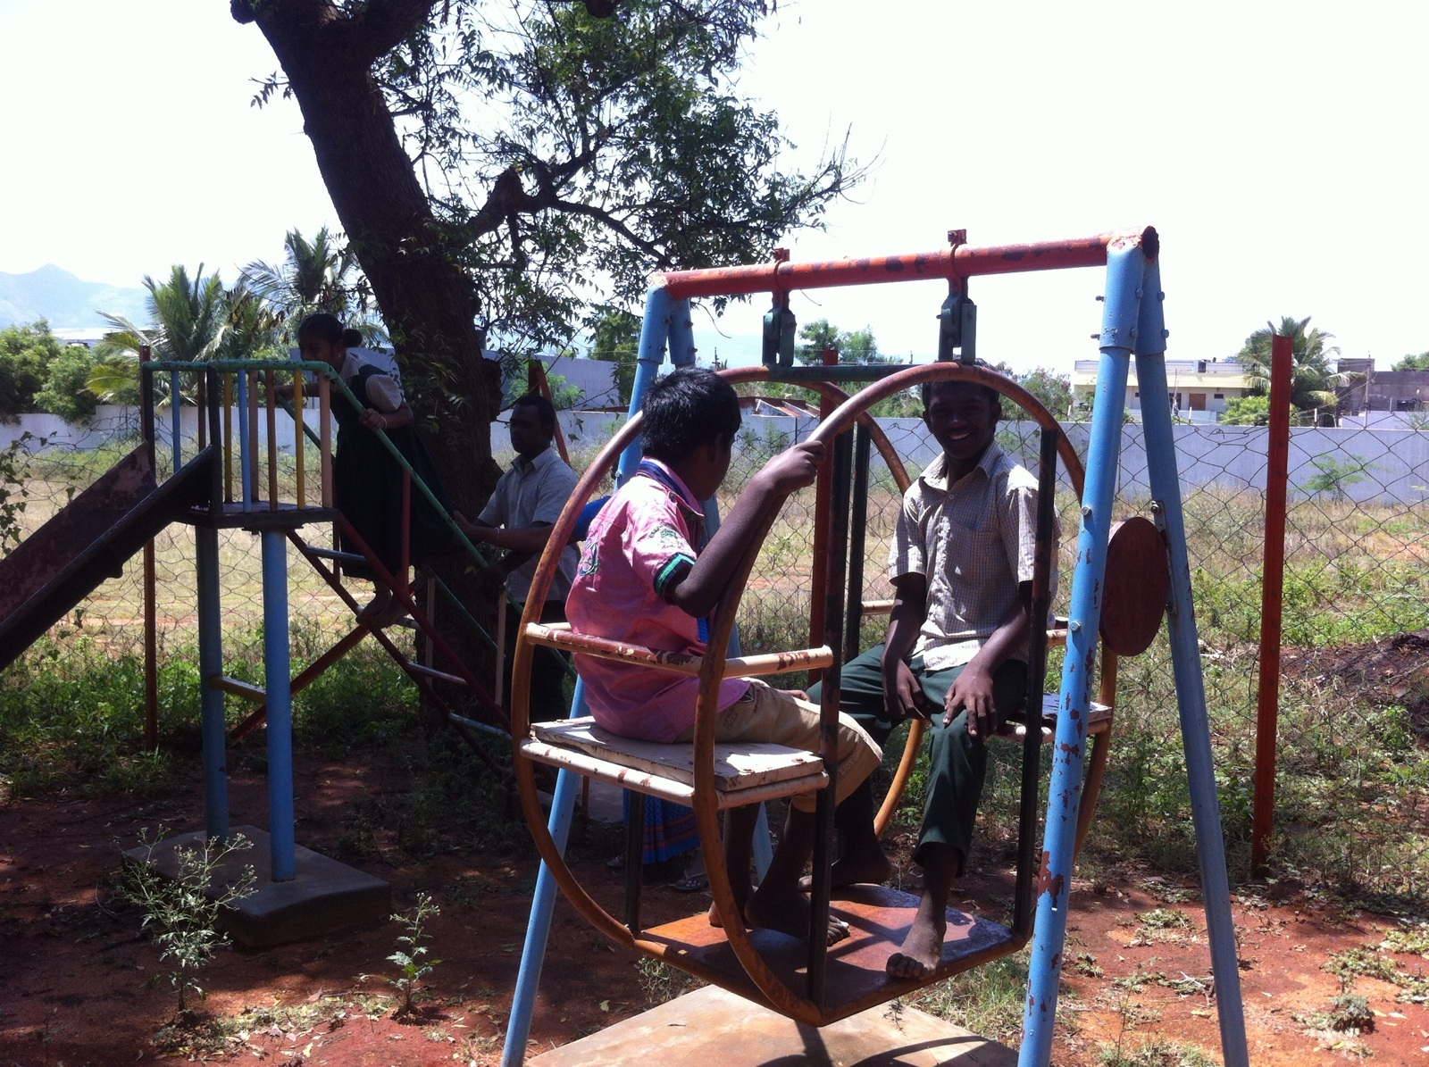
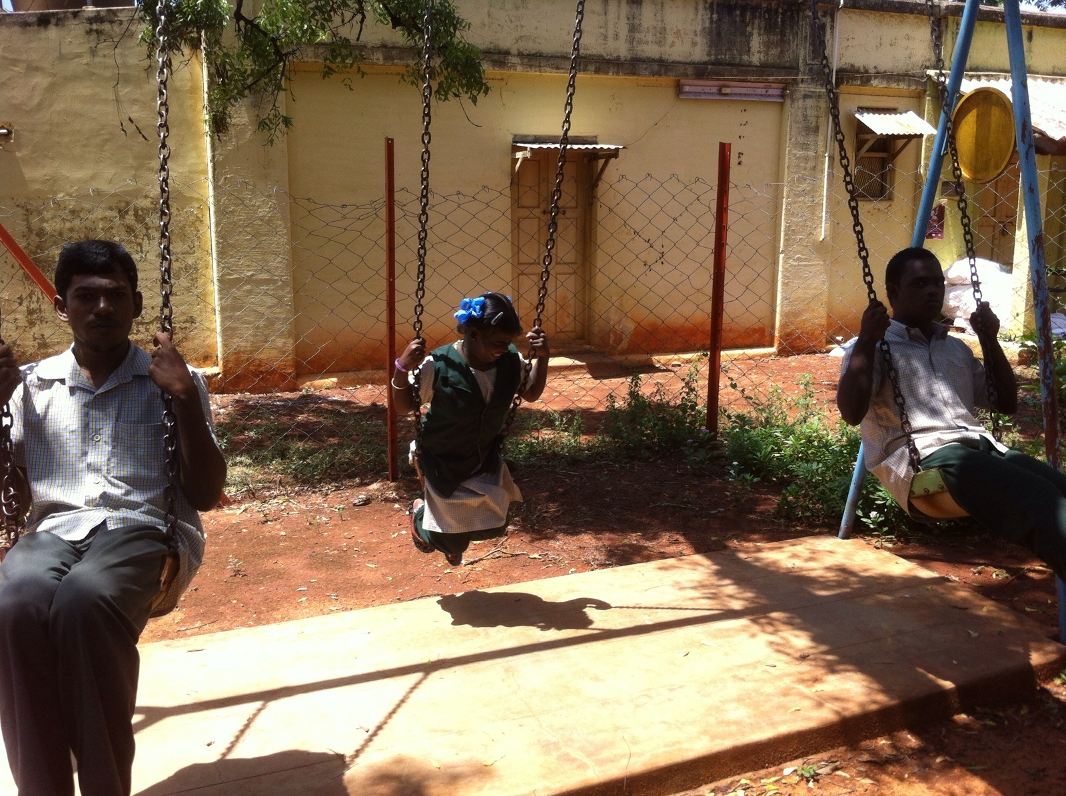

Play therapy

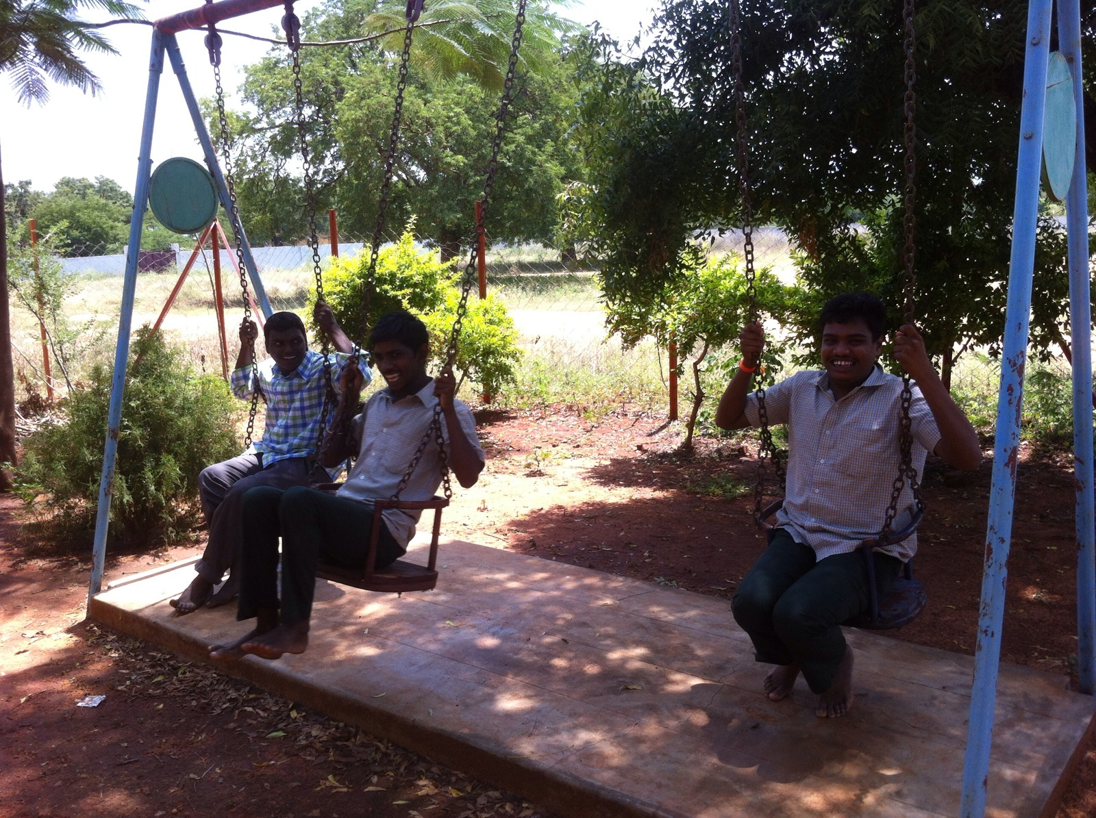
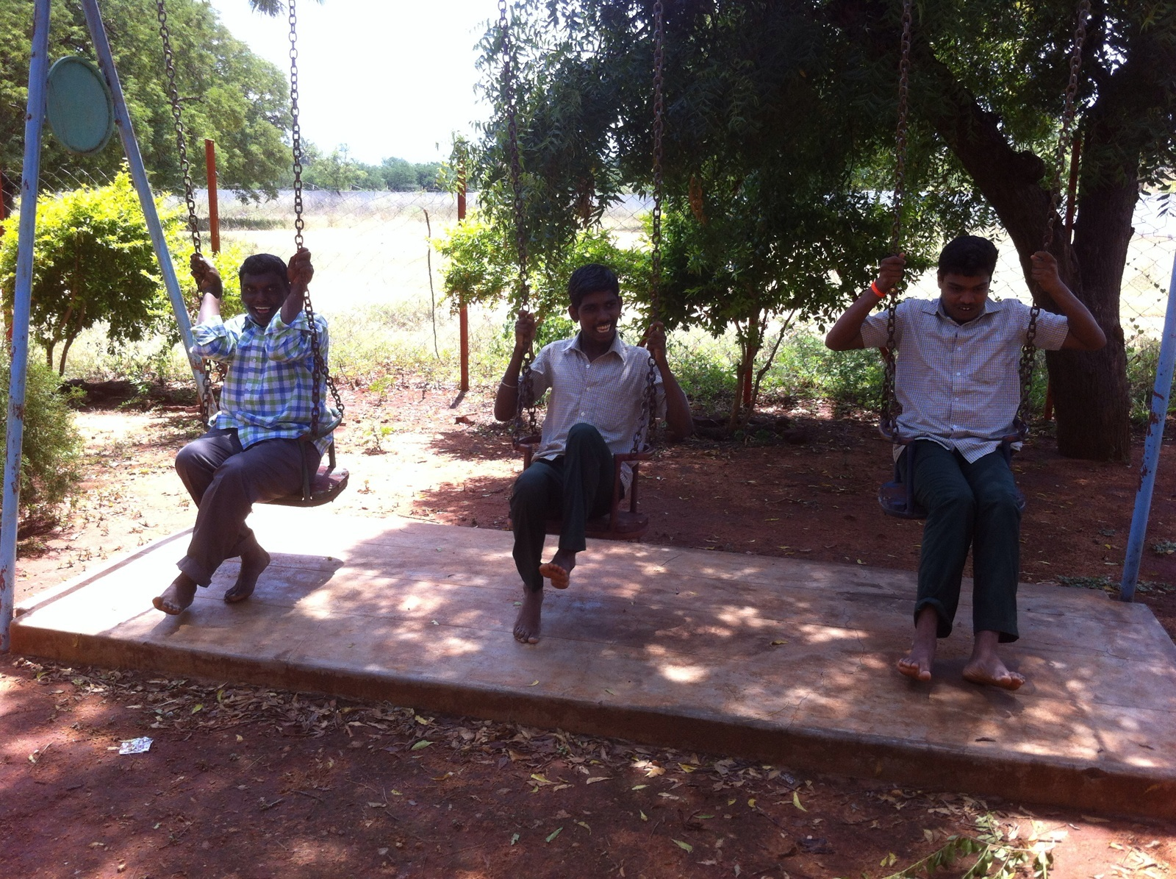

Play therapy

