Spinal Cord Injury Association-Nepal (SCIAN)
Project proposal for one year

1. Title of the project:
Skill development training to handicapped

2. Name of the applicant organization/group:
Spinal Cord Injury Association-Nepal (SCIAN)

Name of the contact person:
Mr. Hari Krishna Sharma

Mailing address:
Pokhara Sub-Metropolitan City Ward no. 5, Malepatan, P.O. box 148 Pokhara, Nepal.

Visiting address:
Same as above

Telephone number:
++ 977 61 551115 (O)
++ 977 61 535384 (R)

Mobile: 9804148499

E-mail address:
hksharmanp@yahoo.com

3. Overall objective of the project:
To provide comprehensive rehabilitation services to physically disabled people because of spinal cord injury and other reasons by maximizing available local resources and sharing expertise with other organizations working in the field of disability.

4. Total amount of funds requested from Global Giving $ 75,000

5. Brief Summary of the project:
In Nepal Spinal Cord Injured or paralyzed persons are regarded as burden of the family and community mainly because of mobility problems. Because of inaccessible structure they are denied of basic human rights. Integration within the family is also not so convenient for them and therefore they have to be confined in their bed doing nothing.
Therefore this project aims to create awareness in the community about the need and human rights of these people. We aim to establish a independent living center for physically disabled especially paralyzed person. Advocate for making accessible structure in public and private places and providing necessary assistive devices for mobility and income generating opportunity to make paralyzed people productive and self-reliant. This is an unique project in reference to Nepal as till now no organization have initiated any such project for paralyzed persons.

6. Signature, Stamp, Date and Place

Signature of contact person Date Place

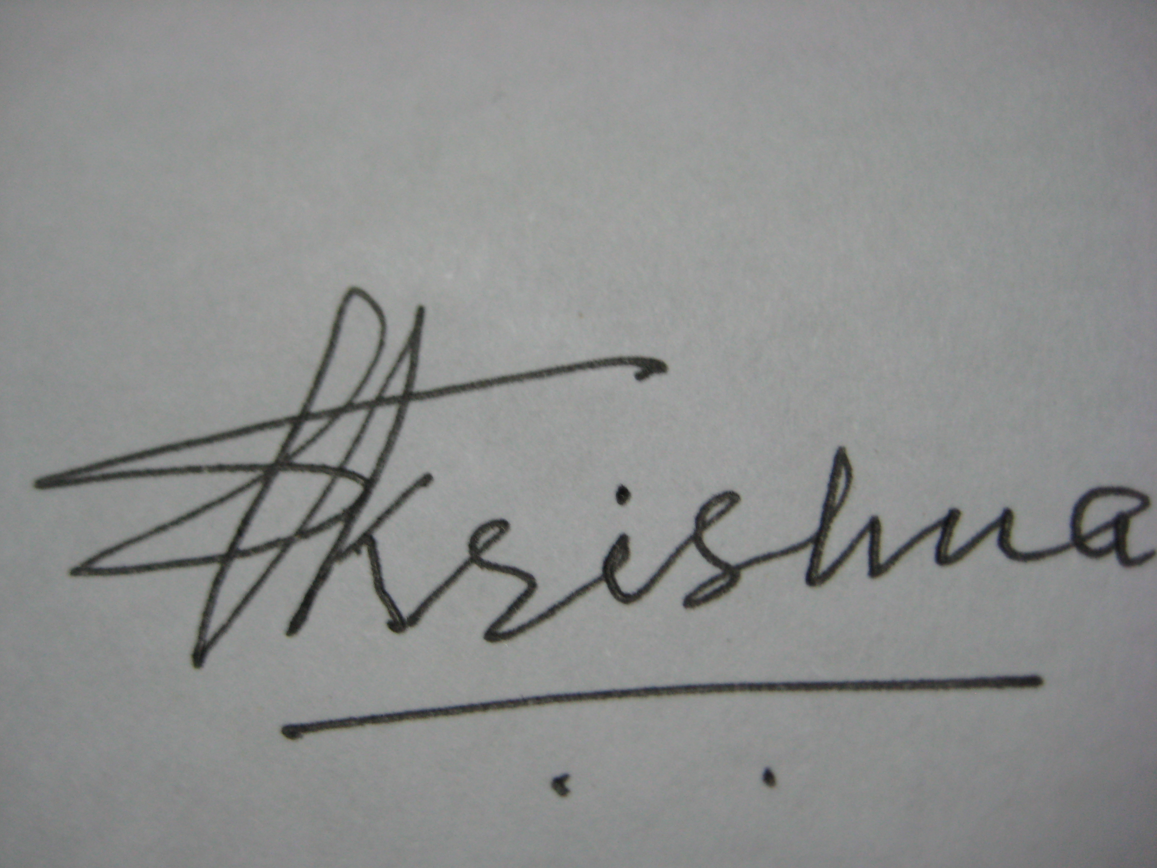
…………………………. 13th Jan. 2008 Malepatan, Pokhara

7. Short Description of the Project:
Spinal Cord Injury Association-Nepal is a group of like-minded people with physical disability mostly people with spinal cord injury. The people came into contact in a program organized to celebrate International Day of Disabled Persons. We discussed about having one organization of wheelchair users, as there was no any organization of such people. Moreover, there is no any organization to provide rehabilitation services to spinal cord injury and paralyzed persons with severe mobility problem. The organization was started with a mission.
SCIAN represents all the people having any type of paralysis including spinal cord injury and severe mobility problem because of multiple disabilities.
SCIAN provides the following services to its target people:
- Awareness raising about disability in general and especially about problems faced by paralyzed persons and their human rights.
- Health education for prevention and early identification of disability.
- Counseling to disabled and family.
- Basic and advance skill development training.
- Establish Income generation program.
- Referral services to the appropriate service institution.
- Scholarship support.
- Physiotherapy services.
- Business creation/promotion.
- Assistive device supports.
- Networking for sharing and learning from local, national and international level.

8. Co-operating partners:
The project will be implemented in co-operation with Municipality and District Development Committee. The co-operating partners will provide space for training, training materials and financial support in some cases. District Development Committee has its own network throughout the district.
The Village Development Committee will support us to carry out our projects/ activities in village level.
We are part of local disability network of Kaski District where we can share resources especially human and materials.
SCIAN is a member of National Federation of the disabled (NFD-N)
SCIAN is a member of CBR National net work.
SCIAN is a member of Asian Spinal Cord Network (ASCoN), Bangladesh
The Abilis Foundation, Finland.
The Embassy of the Federal Republic of Germany, Kathmandu.
The Australian Embassy, Kathmandu.
The chairperson of SCIAN is a member of International Spinal Cord Society (ISCoS) UK and Spinal Cord Society (Indian Chapter).

9. Involvement of Woman with disability:
We have woman with disability as our executive members in the board who are involved in important decision making of the organization. We have formed a planning and fund raising committee and one of our woman executive committee member is the head of the committee. Besides we have considerable numbers of woman with disability as life members, general members and volunteers.

10. Beneficiaries:
The direct beneficiaries of the project are people with physical disability with mobility problem but all types of people with disabilities will be benefited through awareness raising, health education and can get opportunity to participate in the training provided by the organization and become a member of the groups.

11. Background/Problems Addressing:
In Nepal disability is regarded as form of punishment given by the god. Having a disabled member in the family affects the social reputation and relations of the whole family. The social physical structure is not accessible to PWDs and they are denied of basic human rights i.e. education, health care employment etc. Particularly for persons with spinal cord injury, most of them have to be confined within their house. Because of the negative social attitude these people are not welcomed for social participation and build structure of the public and private houses are totally inaccessible to such persons. Therefore they do not get any opportunity to participate in day-to-day family/social life, schooling and job. Assistive /mobility devices are also not available in the country and few imported items are out of reach of poor disabled persons. Therefore we are addressing the problems that generally every PWD is facing and the problems faced by Spinal Cord Injury and paralyzed persons because of unique nature of their disability.

12. a. Overall objective of the project:
To increase self esteem of people with disabilities by creating awareness in the community and by providing various skill development training and income generating opportunities to people with disabilities especially paralyzed persons.

12 b. Immediate objectives:
To create positive social attitude towards people with disabilities.
To provide basic and advance skill development/vocational training to people with disabilities.
To develop self-help groups of people with disabilities for mutual help advocacy and awareness raising.
To advocate for making accessible public places for wheelchair users.
To make people with disabilities aware of their human rights and advocate for the protection of their human rights.
To provide computer education for the disabled.
To provide assistive devices.
To business promotion.
To provide scholarship supports.
To provide physiotherapy services.
To provide peer counseling.
.
13. Overview of the activities (where, when and how):
Activity (what) | Where | When | How
Awareness raising | Pokhara Municipality, Hemja Village Development Committee, Lekhnath Municipality | 5th April. 2008 | Community meeting, Organize awareness raising workshop, Pamphlet display, Posture distribution etc.
Vocational Training | Pokhara Municipality | 15th April. 2008 | Carry out vocational assessment of the person. Make home assessment Place in appropriate training institute.
Scholarship support | Pokhara/Lekhnath municipality | 21st April 2008 | Identity poor disabled children of poor people with disabilities. Discuss with school teachers. Provide stationary/dress to the students.
Assistive devices | '' '' '' '' | 2nd May 2008 | Organize a camp. Establish link with the public and private hospitals to find persons in need of assistive devices.

14. Work Plan:
Activity | Where | When | Who | Comments
Recruit project staff | Pokhara | 1st April 2008 | Chairperson/  Secretary General | Priority to be given capable disabled persons
Make annual action plan | SCIAN Office | 9th April 2008 | Project Co-ordinator
Made a sample survey of people in need of assistive devices | Pokhara and Lekhnath Municipality | 14th April 2008 | Project co-ordinator/  community workers
Call a co-ordination meeting among hospitals | SCIAN Office | 15th April 2008 | PC | Share about project and establish referral mechanism
Advertise for application for computer training, scholarship, independent living and other services offered from SCIAN | Pokhara | 18th April 2008 | PC | Use local FM radios and print media
Run a computer training for wheelchair users/disabled. | Pokhara | 28th April 2008 | PC to find trainer | Explore possibilities to integrate in existing training institutions
Craft production and training center | Pokhara | 15th May 2008 | PC/CWs | The centre  will be continued  once after established
Annual review | Pokhara/  Lekhnath | 20th May. 2009 | Executive members, PC

15. Time Line:
Activity | Apr-Mat 2008 | Jun-Jul | Aug-Sept | Oct-Nov | Dec-Jan | Feb-Mar | May 2009
Hire Co-ordinator and community workers | x
Discuss Annual Action Plan with staff | x
Find out people in need of assistive devices | x
Identify training need for PWDs |  | x
Organize co-ordination meeting |  | x
Identify children of parents with disability for scholarship support |  |  | x
Call for application for computer training |  | x
Carry out home/vocational assessment |  | x
Fabricate and distribute assistive devices |  |  |  | x
Start computer training |  |  | x
Start skill development training | x
Annual review |  |  |  |  |  |  | x

16. Spinal Cord Injury Association Nepal is registered with "The Government of Nepal", "District Administrative Office". A photocopy of registration certificate with unofficial translation is enclosed with this application.
a. The treasure of the organization Mrs. Basanti Baral is responsible for funds. An office assistant will hired afterward s/he will be the in charge of storing bills and receipts and maintaining double entry book keeping system.

b. The funds will be kept in:
Standard Chartered Bank Nepal Ltd.
Pokhara Branch, Nepal.
Account Title: Spinal Cord Injury Association-Nepal (SCIAN)
Account No. Current A/C No. 01-1276913-01

c. A quarterly financial report will be produced and the same will be presented in the executive board of SCIAN for approval and after approving by the board the statement will be submitted to funding partner. At the end of the year an independent and registered auditor will audit the project fund and the report will be submitted to HMG-Nepal, Social Welfare Council and District Administration Office of Kaski District and funding partner.

17. SCIAN had received small funding support from overseas in the past.

18. Expected results of the project:
By the end of the project period (1 year) we expect the following:
▪ 400 people with disability will get sill development training and 120 of them will be involved in income
generating activities.
▪ 5 government offices will make ramp in their offices.
30 disabled person will get assistive devices and 15 of them will get an employment opportunity.
▪ 160 disabled students and children of paralyzed parents will get scholarship support for their study.
▪ 20,000 disabled /students and general community people will be benefited from awareness raising
Program.
▪ 250 paralyzed disabled will benefited from peer counseling.
▪ 220 paralyzed, disabled and general community people who are suffering from neurological problem will
benefited from physiotherapy services.
▪ 30 disabled and their family members will be benefited from small scale business programs.

19. Land:
SCIAN has two hector (40 ropani) land in Vherat Pokhari VDC ward no 4 Kaski district. It is located 15 KM. far from Pokhara Sub Metropolitan City. It is located outside the Pokhara Sub Metropolitan City and inside the Pokhara Valley. We can use the land for sub centre. We can use the land for Vegetable farming, fissuring, . We are requesting public land inside the Pokhara Sub Metropolitan City, but we can't get.

Organogram of the organization:

Executive Board
Coordinator
Physiotherapist
Occupational therapist
Administrative officer
Rehabilitation Facilitator
Peer counselor
Accountant
Volunteers

Office assistant
Helper
Trainer

20. Sustainability:
SCIAN has established good relationship with the government at the local level i.e. District Development Committee and Pokhara Sub Metropolitan City. This year we have got a small funding support from municipality and we have got words from DDC and municipality to extend their support in future. Besides we are trying to get funding from INGOs working in Nepal and some out side the country funding agencies. We will charge minimal amount according to the ability of the person and family, which will enable to establish some fund internally. Therefore we are sure that our project will be sustained socially and financially.

24. Financial details:

Spinal Cord Injury Association-Nepal (SCIAN)
Proposed budget for one year

Expenses (in US $) US $1=NRS 62.90 | Self  Financed | Other Fund Raising | Global Giving supports | Total | Remarks
Staff cost
Project Co-ordinator | 4,000 | 0 | 0 | 4,000 | Including festival allowance
Counselor | 2,000 | 0 | 0 | 2,000 | '' '''
Physiotherapist | 2,000 | 0 | 0 | 2,000 | '' ''
Field supervisor | 1,200 | 0 | 0 | 1,200 | '' ''
Accountant (part time) | 1,000 | 0 | 0 | 1,000 | '' ''
Office assistant | 1,200 | 0 | 0 | 1,200 | '' ''
Rehabilitation Facilitators-2 | 1,600 | 0 | 0 | 1,600 | '' ''
Trainer-2 | 1,600 | 0 | 0 | 1,600 | '' ''
Helper-2 | 1,200 | 0 | 0 | 1,200 | '' ''
Volunteers-18 (on call) | 2,200 | 0 | 0 | 2,200
Sub total staff cost | 18,000 | 0 | 0 | 18,000
Capital cost
Computer training cost
Computer -10 | 0 | 3,500 | 0 | 3,500
Printer/Photo Copier | 0 | 1,700 | 0 | 1,700
Physiotherapy equipments | 500 | 0 | 3,800 | 4,300
Filing cabinet | 1,500 | 0 | 0 | 1,500
Chairs and table | 2,500 | 0 | 0 | 2,500
Subtotal capital | 4,500 | 5,200 | 3,800 | 13,500
Utility cost
Office rent | 3,200 | 0 | 0 | 3,200
Water and electricity | 600 | 0 | 0 | 600
Sub total Utility | 3,800 | 0 | 0 | 3,800
Rehab Program Cost
Scholarship support | 1,000 | 0 | 4,500 | 5,500
Awareness raising | 150 | 60 | 2,000 | 2,210
Skill developing training | 200 | 150 | 55,000 | 55,350
Assistive devices | 150 | 50 | 3,500 | 3,700
Small scale business | 100 | 6,365 | 3,700 | 10,165
Traveling/home visit cost | 50 | 1,000 | 0 | 1,050
Peer counseling | 0 | 0 | 2,500 | 2,500
Communication | 700 | 0 | 0 | 700
Transportation | 50 | 1,500 | 0 | 1,550
Stationary | 0 | 700 | 0 | 700
Projector | 0 | 1,800 | 0 | 1,800
Mike/sound system/battery/sound box etc. | 0 | 1,200 | 0 | 1,200
Printing/digital camera/VDO camera /photos | 0 | 1,000 | 0 | 1,000
Telephone/Internet | 1,000 | 0 | 0 | 1,000
Audit & tax | 0 | 200 | 0 | 200
Sub total Adm/rehab cost. | 3,400 | 14,025 | 71,200 | 88,625
Grand total for one year  (in US dollar) | 29,700 | 19,225 | 75,000 | 123,925

