# Let Her Fly 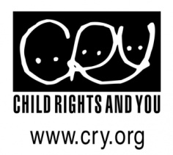
The Girl Child in India.....discrimination at every stage of life
The sex ratio in India stands at 914 females to 1000 males. What is perhaps even scarier than this number is that the ratio has actually fallen from 927 in the last ten years. The nation’s girls are indeed at risk and the subject of neglect and discrimination.
Millions of girl children in India face challenges every step of the way and many of their rights are not upheld be it – health, nutrition, education, protection or simply a space to be heard. Communities in India are still largely patriarchal and girls always end up taking the second place to the male members in their families, be it their brothers, husbands or even sons. The female literacy rate for women in the country which hovers around 65% as compared to the male literacy rate which is over 80% - is a direct reflection of this situation.
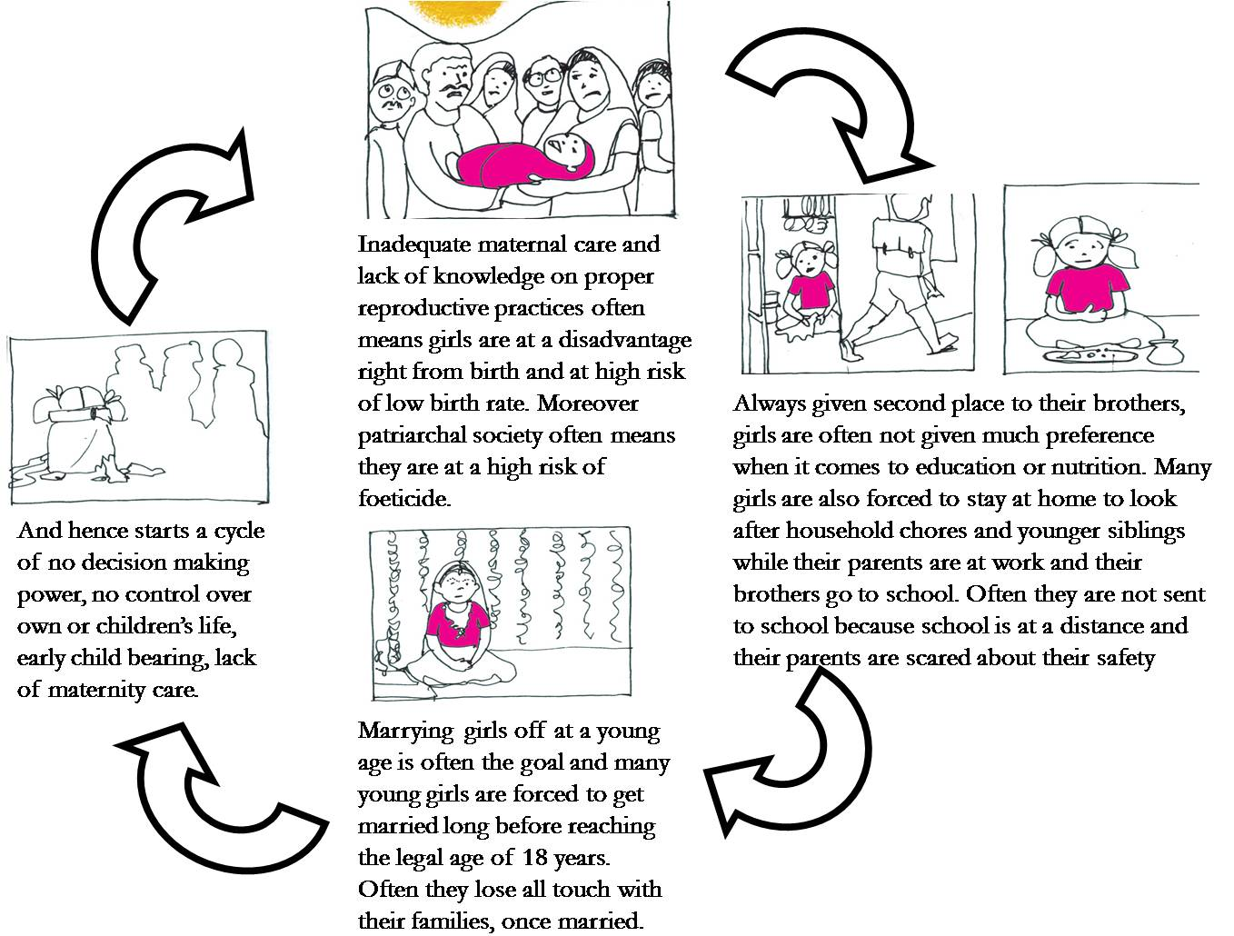
Lack of proper health care and immunizations, malnourishment, child labour, no access to education, early marriages leading to early pregnancies and health issues and a total lack of voice or opinion on their own lives – are some of the many issues that girls in India face today.

CRY’s approach & implementation
Across the different stages of a girl child’s life – there are multiple influencers who take decisions on their behalf. To therefore bring about a change in her situation, it is necessary to engage with all these stakeholders.
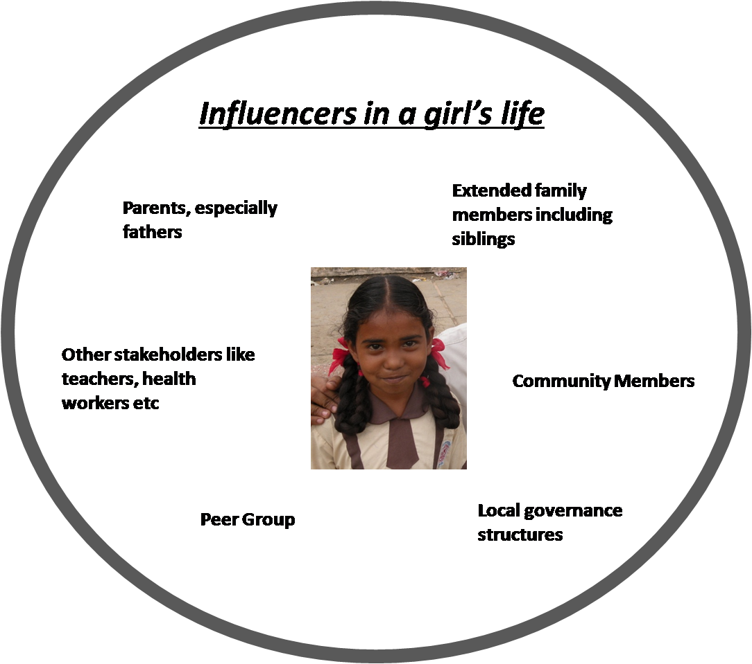

Therefore, CRY’s work includes working with families, community members, local governance and even boys who would grow up tomorrow to have an influence over their sisters’, wives’, daughters’ lives and therefore their behaviour would have a direct impact on the girl child’s life.
CRY works in the proposed intervention areas, by engaging and mobilizing the community and activating government machinery. The project team is normally a grassroot NGO and often come from the same background and roots as the community in which they work. The project team creates in-roads and builds relationships with the community to involve them in the whole process and enable them to take control of making their lives, and their children’s lives better.
Identifying leaders from the community, women’s groups, children’s groups and adolescent girls groups are activated and the process of sensitization is started to help them understand their rights and what they can do to ensure those rights are ensured to them.
CRY believes in activating government machinery and not creating parallel services since the former model makes the change that is brought about more permanent and sustained. Even if CRY were to pull out of the intervention area in a few years time, with government services functioning actively and the community themselves monitoring those services, the work can continue irrespective.
Also since a lot of CRY’s work is about changing mindsets and attitudes, there is a sense of permanency that is brought about.

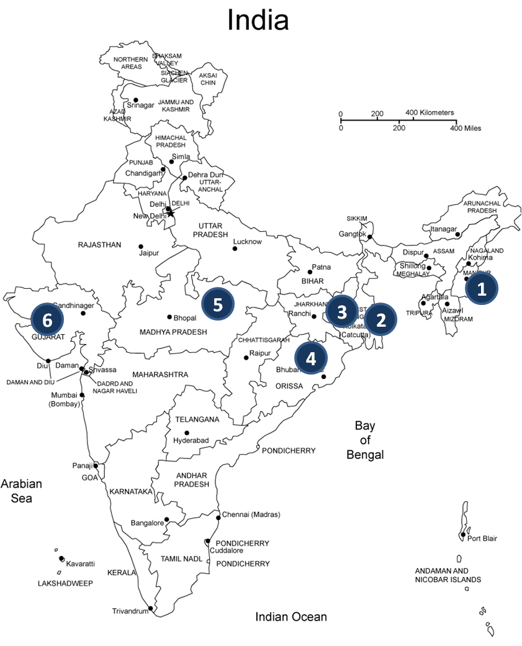

Health: Project teams have been working with the community to ensure that health centers are demanded and activated so that more and more families have healthcare within easy reach. Once activated these centers are also regularly monitored to ensure that they are well stocked, medical staff is in attendance and the community people are being provided adequate attention when they access these services. Since some of the intervention areas are in very remote areas – the teams are also working towards improving the mobile heathcare services at these places. Through these efforts last year.
Malnutrition: Given the extreme poverty and the lack of proper government services – many children in these areas suffer from malnourishment at various levels. While identifying these children is easily done – the process of connecting them to rehabilitation centers, educating their families and slowly getting them out of this status and back to being normal and healthy is a long process indeed and takes time. Once they are safely out of their malnourished state – they are also regularly monitored to ensure that they remain healthy
Participation: Since most of these girls lack confidence and have never been able to talk about the issues that they face and the challenges that they live with – the project team forms children’s groups in the project which encourages children to come forth and express themselves. These groups have regular meetings and through art, music, dance, conversations and interactions help children gain confidence, open up and discuss the issues and challenges they face. These groups work in such a way that over time children become confident enough to take up issues themselves and talk to the community to bring about change.
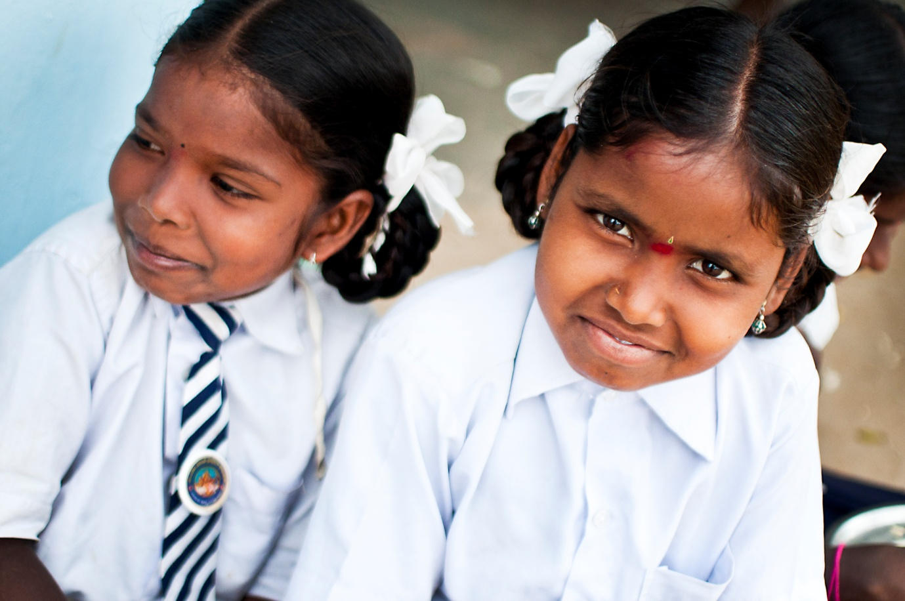
Today Sandhyarani is where each child rightfully belongs and can dream of a brighter future
Education: This being the cornerstone of any successful future a lot of time and effort of the project team has gone into ensuring that children can access education across these intervention areas. The work that the team does with regards to education involves not only motivating children to enroll into school but also work with parents and the concerned authorities to ensure that children remain in school and do not drop out and lose touch with education. They have also worked towards demanding and activating schools where necessary and monitoring existing schools to ensure that it functions as per the norms – teachers attend regularly, mid day meals are served, proper materials, drinking water, toilets are available
Situation at the intervention area:

12 year old Sandhyarani’s home is in CRY’s intervention area in the Thoubal district of Manipur - with her parents and 7 siblings. When she was 8 years old she was taken out of school and sent off to the nearest city as a domestic help.
At this young age she had to learn how to cook, wash clothes, sweep and work from dawn to dusk at the many jobs around the house.
When CRY workers came to know about her – they immediately wanted to rescue her from her predicament and enrol her into school where she rightfully belongs. However her parents were reluctant to bring her back. The process of changing their mindset and convince them that their child would be better off in school – was a long and hard one from the CRY project team.
However, eventually the parents did realise the ill effects of child labour on their daughter and her chance at a better future through education. They brought the child back and with the help of CRY, enrolled her into school. Today Sandhyarani is where each child rightfully belongs and can dream of a brighter future

Conclusion :
Global Giving help in #LetHerFly Campaign has helped us continue our efforts to ensure that 3,61,612 girl children across CRY-supported projects, get a childhood where they are cherished, nurtured and protected. Because every girl child has the right to survive, develop, be protected and participate in decisions that impact her life.

