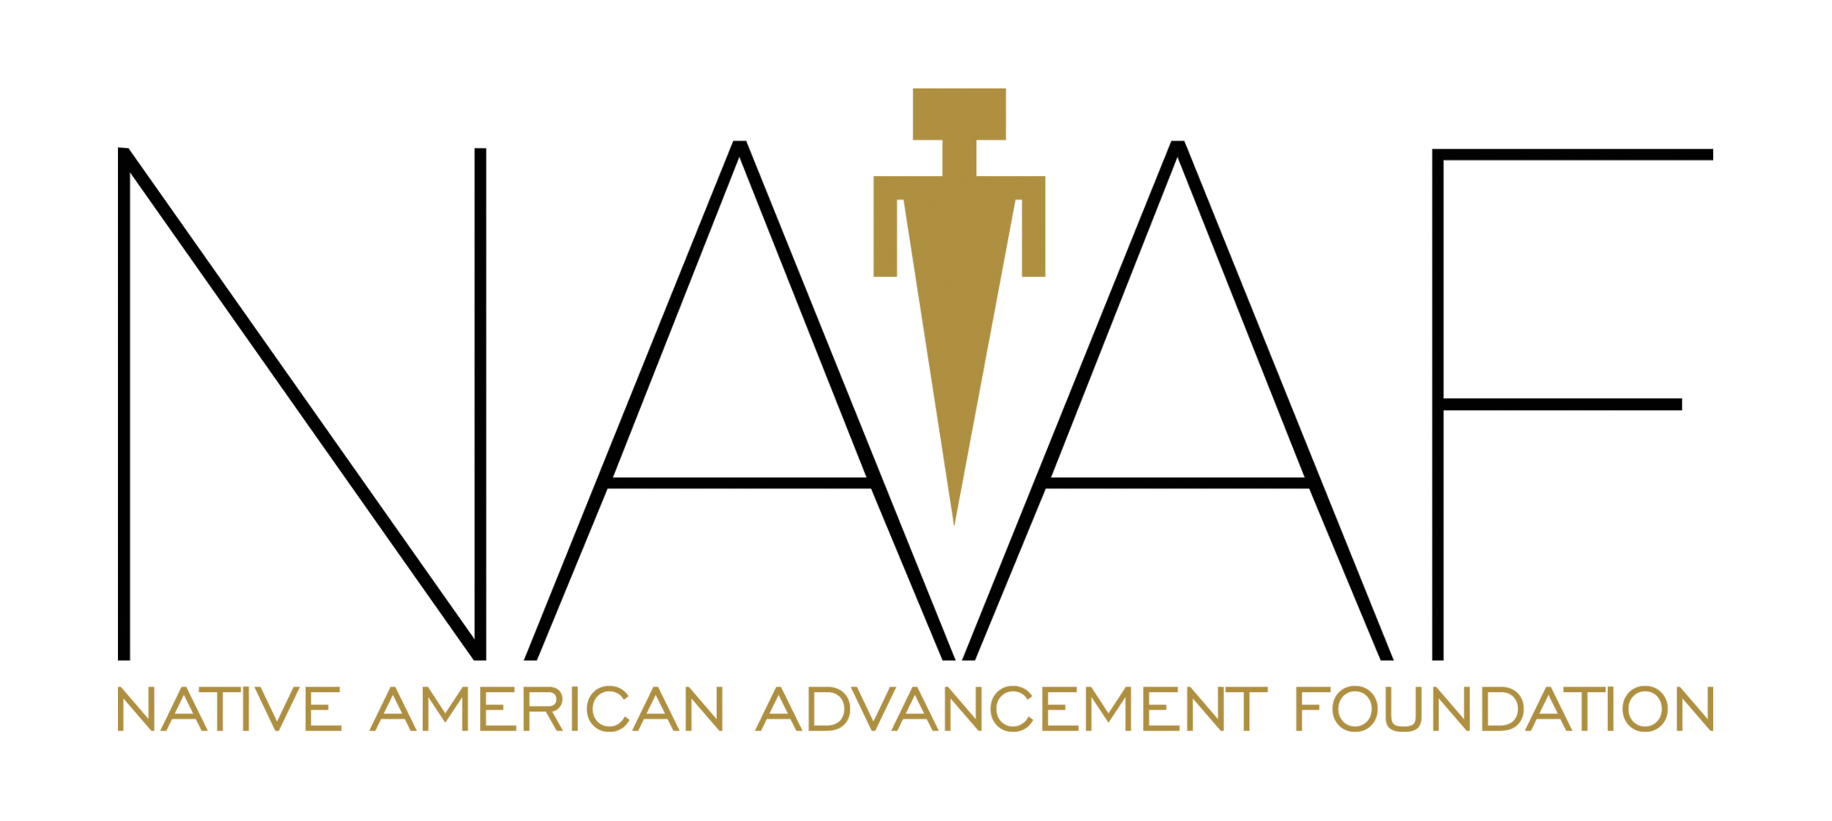
Organization: Native American Advancement Foundation

Priority Area: Under Privileged Children

Fewer than half of the Tohono O’odham community’s adults have completed high school, the lowest rate of all U.S. Native American tribes. A dropout rate in excess of 50% continues to be the norm. Lack of education has an enormous impact on the future, since the population is statistically young: 52.2% of the population is under 25 years-old (compared with 35.3% of the United States).

It is the belief of the Native American Advancement Foundation (NAAF) that through strong, supportive, encouraging after-programs for the youth, these numbers can begin to turn in a positive direction with more members of the Nation becoming high school graduates and pursuing higher education. The youth of Gu Vo need access to resources that are crucial to furthering their education and inspiring them to stay in school. NAAF provides these resources in the Gu Vo Youth After- School Program.

NAAF is the only nonprofit to provide an afterschool program to communities within the Tohono O’odham Nation. After four incredibly successful years, in August 2015 the Gu Vo Youth After-School Program will enter its fifth year. It is the hope of NAAF that moving forward other Districts will partner with the organization and implement their own after school programs based on the Gu Vo model.

Community members from the District develop and manage the program, which includes extracurricular activities designed to keep students scholastically engaged as well as physically fit. Students begin each daily session with study hour where instructors provide tutoring in reading, math, science, and even the study of computer programming and robotics. Students receive help with their homework onboard NAAF’s Virtual Learning Center (VLC), a mobile computer lab in partnership with Sunnyside Unified School District with 18 laptops and a WiFi hotspot.

Arts and crafts classes are also part of the curriculum including painting, sewing, ceramics, and beading – skills that are incorporated into the making of traditional Tohono O’odham clothing, medicine pouches, jewelry, pottery, and holiday handicrafts such as cascarones. Also offered will be instruction in dance, pottery, cooking, language, and gardening. The idea is to teach students subjects such as math and science, but also focus on the history and practices of the Tohono O’odham Nation.

The Healthy O’odham Promotion Program (HOPP) offers fitness clinics and wellness counseling to the students. In September of 2012, HOPP was nationally recognized by the American Diabetes Association for its work towards prevention of diabetes and obesity. Their approach is culturally based and engages the students in physical fitness and nutrition. Nutritional dinners are prepared daily using The Mayo Clinic Kids’ Cookbook. Team sports, such as flag football, soccer, and softball are played to build character, boost self-esteem, and further teach the students to come together and work as a group. The goal of the Gu Vo Youth After-School Program is to establish a safe, fun, active learning environment for the students, giving them the support and incentives they need to remain enrolled in school, improve their study skills, and increase their grade point averages.

The primary goal of NAAF is to promote education and open economic opportunities on the Reservation. This is currently being done in the Gu Vo District through the After-School Program, the Gu Vo Youth Summer Program, the GED Program, on board the Virtual Learning Center, and through the promotion of education, healthy living, and economic development.

Funding for the Gu Vo Youth After-School Program would allow NAAF to continue this successful program that has kept the children involved, smiling, and eager to learn. Education is fun, and the strongest tool one can have for growing and leading a fulfilling, successful life. Often, this is difficult to realize at such a young age. The Gu-Vo Youth After-School Program has been so successful because it is designed to seamlessly combine fun with learning, to keep the students engaged and excited about what new knowledge will come with the next lesson. If funded, NAAF will provide detailed grant reporting on how the funds were used as well as updates
with measurable results showing the success of this strong educational program.

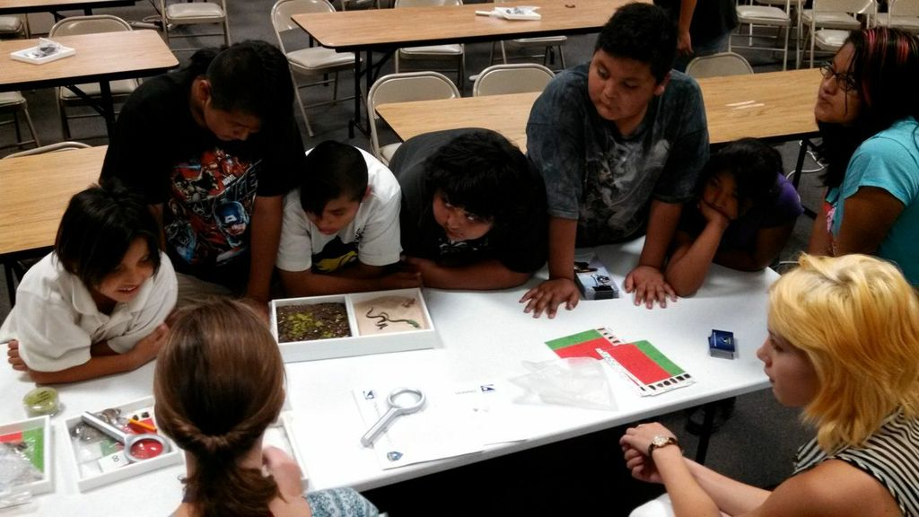

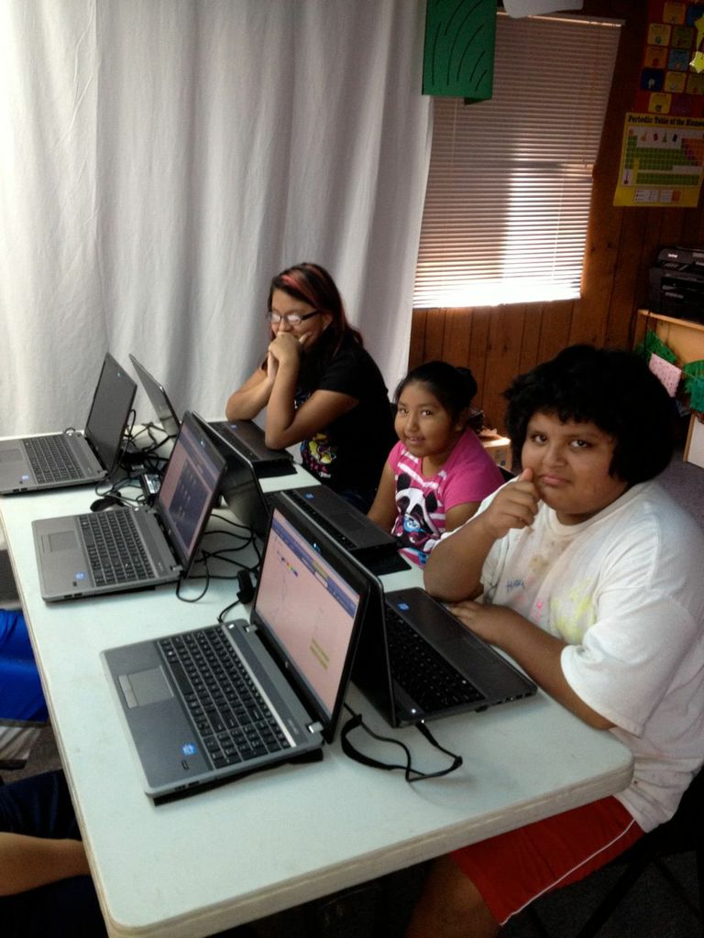

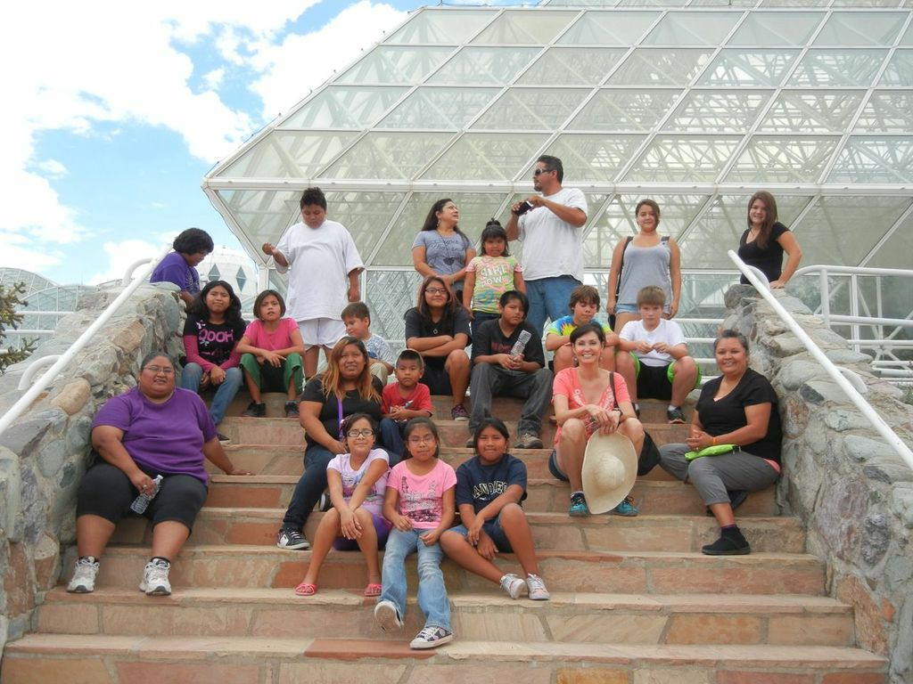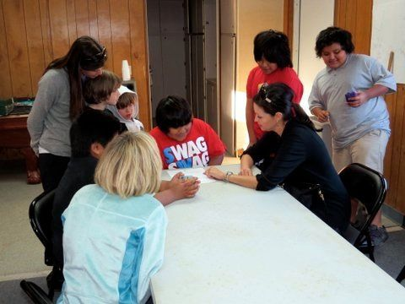
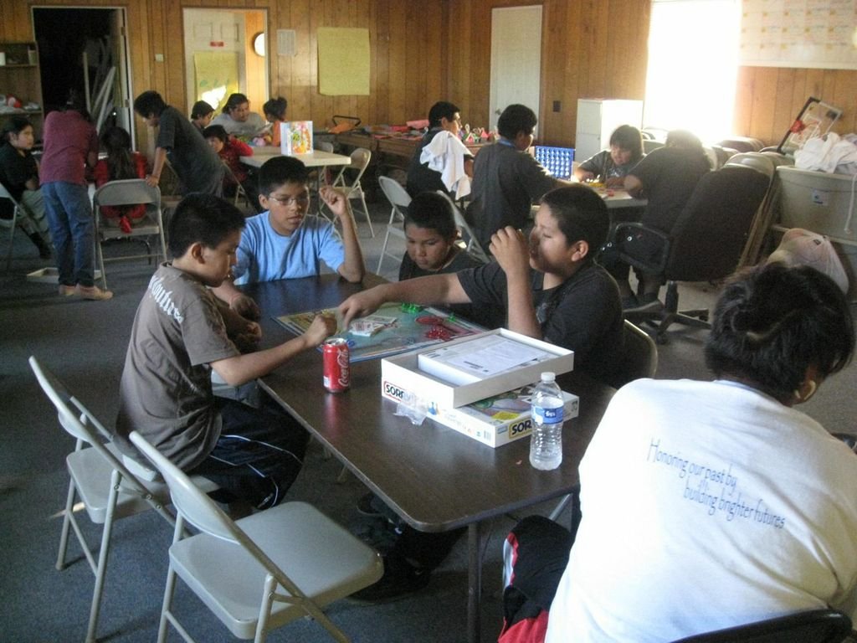

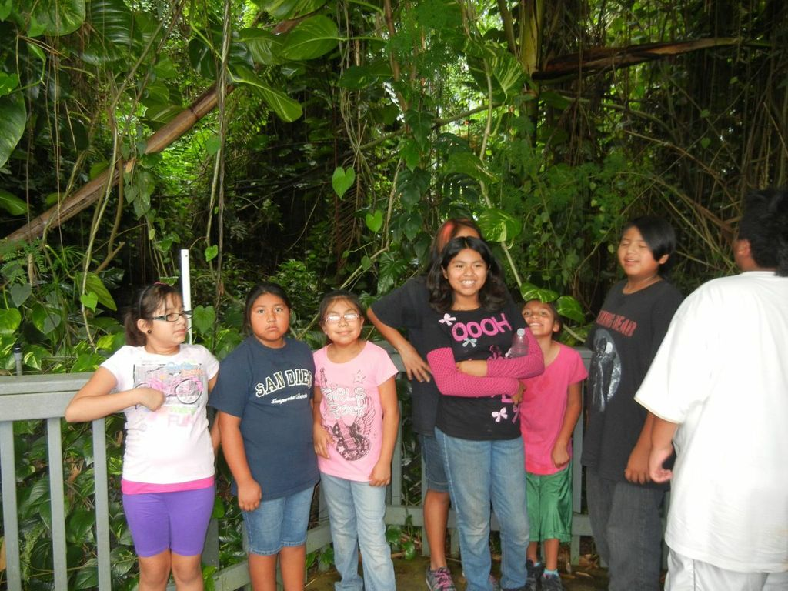

Thank you!

