Stories of business class participants Breaking Ground last Batch business class
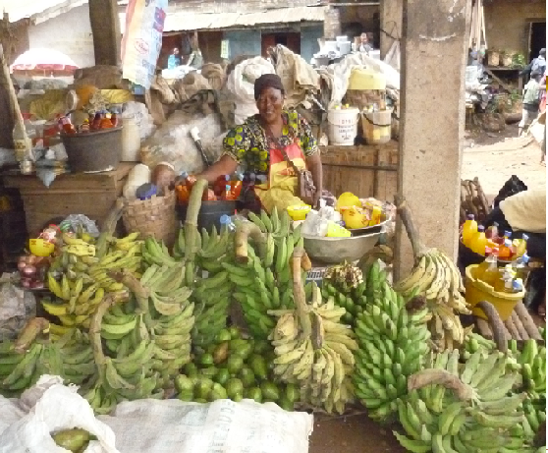
Marthe , 52 years- old, Married and mother of 5 children. She produces , buys and resells raw food such as bananas and plantain in Dschang market in West Cameroon . She has operated this business for 16 years. The benefit of these 16 years allowed her to buy a farm where she produced some food to consume and sell.
She learned how to allocate her time, manage her income and attrack more customer in business class. She applied for 400 000 fcfa($714.29) funding. Now she expects the funding to expand her business in order to support her children in school and hopefully allowing her to buy a plot to build her own house.

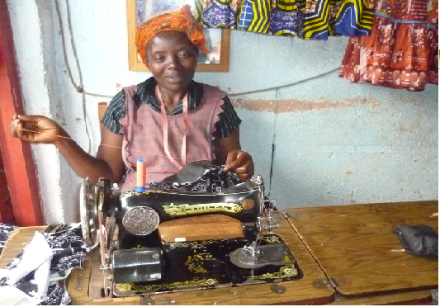
Syvie , 40 years old,Married. Mother of 5 children. She started business as seller of raw food. But it was difficult for her to leave her young kids every day to go for supplies in village market. There was not appropriatesupervision for her kids. She decided to change. She began a sewing business 8 years ago. The business is growing and she has save money to buy two additional sewing machines.
Attending business class enabled her to better keep her business books, follow the income of business, make better decisions on the investment and use of money in the business and her household. She also now has a clear vision on how to develop her business.
She applied for 500 000 fcfa($893). She has been sharing a workshop with an other woman. With the funding, she will like to open her own shop, buy a new sewing machine and recruit and train young girls. By doing this she expects to earn more income to feed her family and gain respect in her neightbourhood.

