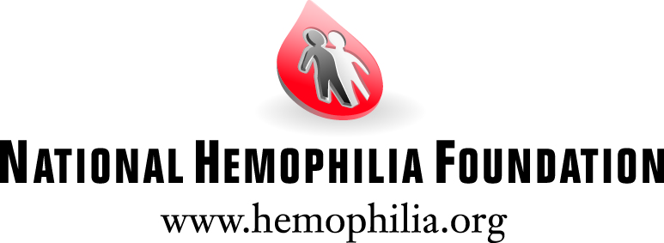

Introduction
Imagine receiving news about your health – or the health of a loved one – that will impact you for the rest of your life. You have a bleeding disorder. Your career, hobbies, where you live, family planning, and many other life decisions are now all affected. Your doctor can prescribe a treatment regimen, but where do you turn for help in between office visits? Who has the most relevant experience or practical knowledge to help you navigate life with a chronic illness? Where can you share your concerns?

Being part of a community that shares experiential knowledge often means the difference between effectively managing a chronic illness like hemophilia or von Willebrand disease, or being debilitated by it. Similarly, patient education is the cornerstone of patient self-management and self-care. These two fundamental principles are at the core of the National Hemophilia Foundation’s Connections for Learning Program.

Need
A bleeding disorder such as hemophilia affects approximately 20,000 people in the U.S., classifying it as a rare disease and putting patients at higher risk of geographic and social isolation. NHF has identified additional barriers that isolate our patient population and prevent them from receiving the support they need to manage their disease. Some of these barriers include language skills, ethnicity, and socioeconomic factors. For example, although bleeding disorders are not more prevalent in any one ethnicity, the graph below depicts stark disparities in attendance at NHF’s annual meeting, with African Americans making up less than 20% of all attendees over the last four years.

NHF Annual Meeting Attendance

[PLEASE SEE GRAPH BELOW]

In an effort to overcome these obstacles and reach marginalized individuals, NHF created the Connections for Learning Program. Through this program, patients have the opportunity to attend NHF’s Annual Meeting where they will meet and learn from those affected by bleeding disorders as well as experts in the field – physicians, nurses, physical therapists and social workers.

NHF Annual Meeting is the largest gathering of people affected by bleeding disorders in the country. It offers a wealth of information from the nation’s foremost clinicians in a prescribed, customized curriculum to address every aspect of living with a bleeding disorder. There are educational workshops, sessions, and networking opportunities that can only be found in this forum. According to past participants, it is a life-changing experience for everyone, regardless of gender, age, race, religion, or hometown.

Program Description
The Connections for Learning Program has two main components - a customized experience at the NHF Annual Meeting, August 13-15, 2015 in Dallas, TX, and follow-up activities, all organized and implemented by NHF’s Education Coordinator.

Individuals and families can apply by filling out an online or paper application that assesses participant needs and their reasons for wanting to attend the meeting. Using a scoring system, NHF staff review the applications to determine those most in need and then pass a round of finalists on to NHF’s Cultural Diversity Working Group who review applications and choose the recipients. The CDWG is a volunteer working group of individuals from all over the country who are impacted by or work with those with bleeding disorders, and they work to ensure an inclusive environment for all NHF initiatives. Applications for the Connections for Learning Program are due by May 1, 2015 and people are notified of decisions by June 2015.

Once selected into the program, participants have one-on-one calls with the Education Coordinator to:
- Assess knowledge, level of social isolation, self-efficacy regarding disease management, readiness for behavior change, and to identify each individual’s key learning objectives
- Match educational needs and socializing opportunities with educational offerings
- Provide information about the annual meeting, logistics, and help in managing their travel arrangements
The Education Coordinator greets participants upon arrival at annual meeting with a welcome packet and suggested list of sessions to attend, 3-4 sessions per day, based on their individualized needs. Examples of past sessions include New Families Reception; Basics of Hemophilia/von Willebrand Disease, Coping with School Issues; In Case of Emergency: Disaster Preparedness; and Music Therapy for Pain Management. At the close of annual meeting, participants report on the sessions attended, their learnings and what behavioral change they will make as a result of attending the sessions.

One participant of the Connections for Learning Program in 2014, a mother of three children from rural Larned, Kansas, described her experience:
This was the first time our children have ever flown, so they were nervous to say the least…. Once we arrived…and witnessed all of the attendees…walking around with their lanyards, we had this sense of comfort. We knew we were amongst individuals there for the same reasons…. While my husband and I have upstanding careers, we have so much medical debt that our credit has been affected negatively. I literally cried the day I received the email stating our family had been chosen….We have been home now for 3 days and we are still talking about our experiences on the national level….Thank you again for this opportunity, I can never express in words the amount of gratitude we have to NHF for choosing to give our family such an amazing gift!

NHF continues the educational and support experience after the meeting through local programming and online programming, such as webinars, Twitter chats and being added to our e-blast mailings. Participants complete a post-annual meeting assessment that will then be analyzed and compared to their answers on their application and knowledge gained. A first person narrative that outlines valuable sessions, learnings, and other benefits of attending is included in the assessment. Participants also will receive a ‘Stay In Touch’ packet in the mail with toolkits, informational brochures, and other materials based on their individual needs.

Outcomes and Evaluation
The goal of the Connections for Learning Program is to address educational and social barriers that affect people with bleeding disorders in order to improve health outcomes. Participants in the Connections for Learning Program will answer questions during the application process and complete a post-event assessment, as well as write about their experience at annual meeting. This data will be collected and analyzed by the NHF Department of Education staff. In addition, NHF staff will develop indicators for participants to achieve. For example, these can include levels of self-efficacy and isolation, as well as participation in local events near their hometown and any behavior changes they’ve made in their approach to disease management. Follow up with all participants will take place 6-9 months after the annual meeting to see if participants achieved any of these indicators, thus impacting behavior and health outcomes. Success will be based on at least 80% of participants completing at least 50% of the indicators.
About the Organization
Bleeding disorders result from the inability of the blood to clot due to a defect in, or an insufficiency of, one or more key clotting proteins. The National Hemophilia Foundation is dedicated to finding better treatments and a cure for all inheritable bleeding disorders. Through its national office and chapters across the country, NHF provides support to the bleeding disorders community through education, advocacy and research. Since 1948, NHF has been at the forefront of the nation’s health agenda as it relates to bleeding disorders. As a leader in research, advocacy, and service, some of NHF’s current programming includes Steps for Living, a multimedia educational program; National Youth Leadership Institute, a leadership training program for youth affected by bleeding disorders; Victory for Women, educational initiative for women with bleeding disorders; and annual meeting, the most comprehensive educational event in the US for bleeding disorders.

